**Dummy Credit Card for Purchasing SSW Products**

During a test of purchasing SSW Products, you come to the **Payment** section of [**Checkout**](http://www.ssw.com.au/ssw/shop/checkout.aspx) page.

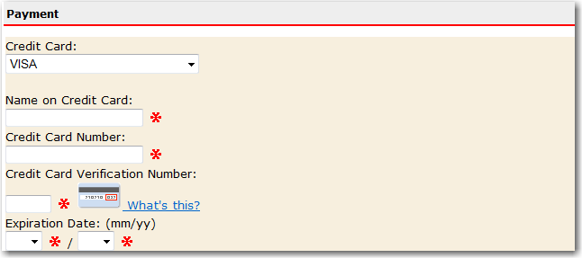

You need VISA card for testing ‘**VISA**’ payment. Here’s the dummy one.

|  |  |
| --- | --- |
| Field | Value |
| Name on Credit Card | Any text.  You can put your name, e.g., david bian |
| Credit Card Number | 4111111111111111 (one ‘4’, fifteen ‘1’) |
| Credit Card Verification Number | Any three numbers |
| Expiration Date | Any date. |

Here’re two examples.

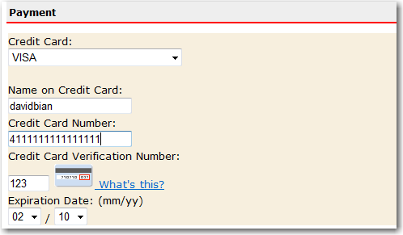

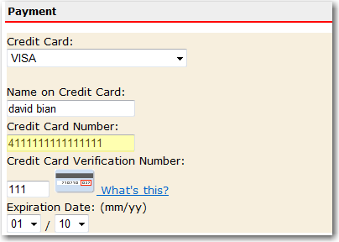

**Note: This dummy credit card should be used only for testing.**