What is new in Access 2007 2
Access 2007 Specifications 2
General 2
Differences between the ACCDB and MDB file formats 2
New features of the Office Access 2007 file format 3
File extensions 4
Workgroup Information Files (MDW) 4
Locking files 4
ACCDE files 5
Linked tables 5
Replication 5
Insert or add a rich text field 5
Create a rich text field 6
Create a memo field to store rich text 6
What to do when the TextFormat property gets out of sync 6
Using calendar control for fields date/time 7
Create a custom field template for the Field Templates pane 8
Add or change a lookup column that lets you store multiple values 9
Guide to multivalued fields 9
Collecting Data through Email 9
Introduction to integrating data between Access and a SharePoint site 20
Ways to work with data 20
Integrating and managing data 21
Tracking your data and workflow 22
Publish a database to a SharePoint site 22
Publish your database to a SharePoint site 22
Republish a database to a SharePoint site 23
Import from or link to a SharePoint list 23
Work offline with tables that are linked to SharePoint lists 24
Overview 24
Take SharePoint list data offline 24
Synchronize your offline lists with data from the server 25
Resolve data conflicts 25
Limitations of SharePoint integration to Beware of 26
Performance 26
Migrating Access Data to SharePoint 26

What is new in Access 2007

Access 2007 Specifications

General
Attribute |  | Maximum
Access database (.accdb) file size |  | 2 gigabytes, minus the space needed  for system objects
Why was it created
Should we use it?
Office Access 2007 employs a new file format that supports a number of product enhancements. When you create a new database in Access 2007, the database uses the new file format by default and is given the .accdb file extension.
You should use the new file format whenever possible because it supports new features, such as multivalued fields and attachments. However, the new file format cannot be opened or linked to with earlier versions of Access, does not support replication, and does not support user level security. If you need to use the database with earlier versions of Access, or if you need to use replication or user level security, you must use an earlier version file format.
What changes to Macros
http://office.microsoft.com/en-us/access/HA012264571033.aspx?pid=CH100728921033

New macro features in Office Access 2007
In earlier versions of Access, many commonly used functions could not be performed without writing VBA code. In Office Access 2007, new features and macro actions have been added to help eliminate the need for code. This makes it easier to add functionality to your database and helps make it more secure.
- Embedded macros You now have the ability to embed macros in any of the events provided by a form, report, or control. An embedded macro is not visible in the Navigation Pane; it becomes part of the form, report, or control in which it was created. If you create a copy of a form, report, or control that contains embedded macros, the macros are also present in the copy.
- Increased security When the Show All Actions button is not highlighted in the Macro Builder, the only macro actions and RunCommand arguments that are available for use are those that do not require trusted status to run. A macro built with these actions will run even when the database is in disabled mode (when VBA is prevented from running). Databases that contain macro actions that are not on the trusted list —or databases that have VBA code — need to be explicitly granted trusted status.
- Error handling and debugging Office Access 2007 provides new macro actions, including OnError (similar to the "On Error" statement in VBA) and ClearMacroError, that allow you to perform specific actions when errors occur while your macro is running. In addition, the new SingleStep macro action allows you to enter single-step mode at any point in your macro, so that you can observe how your macro works one action at a time.
- Temporary variables Three new macro actions (SetTempVar, RemoveTempVar, and RemoveAllTempVars) allow you to create and use temporary variables in your macros. You can use these in conditional expressions to control running macros, or to pass data to and from reports or forms, or for any other purpose that requires a temporary storage place for a value. These temporary variables are also accessible in VBA, so you can also use them to communicate data to and from VBA modules.

Differences between the ACCDB and MDB file formats
This Office-specific version of Jet, called the Access Database Engine,
- enables integration with Microsoft Windows SharePoint Services 3.0
- Microsoft Office Outlook 2007
- creation of multivalued lookup fields
- and other improvements.
http://office.microsoft.com/en-us/access/HA100678311033.aspx?pid=CH100645711033

New features of the Office Access 2007 file format
Multivalued lookup fields Most database programs, including prior versions of Access, only allow you to store a single value in each field. In Office Access 2007, however, you can now create a lookup field that allows you to store more than one value in each field. In effect, it creates a many-to-many relationship within the field, and hides the details of the implementation using system tables.
For example, suppose you have a Task table with a lookup field that you used to assign the task to an employee. What if you have a task that you need to assign to several employees? In earlier versions of Access, you would need to set up a new cross-reference table to store each combination of task and employee, then revise your forms and reports to use the new data structure. In Office Access 2007, this is made much easier by implementing a multivalued lookup field. Instead of being able to select only one item from a drop-down list, now each item in the list has a check box next to it so that you can select as many as you like. The multiple selections are displayed in the field, separated by commas.
Find links to more information about multivalued lookup fields in the See Also section.
Attachment data type The new Attachment data type lets you easily store all types of documents and binary files in your database without unnecessary database bloat. Attachments are automatically compressed when appropriate to maximize space usage. You can attach a Microsoft Office Word 2007 document to a record, or save a series of digital pictures. You can even have multiple attachments attached to a single record.
For more information about attaching files to records, see the links in the See Also section.
Integration with Microsoft Windows SharePoint Services 3.0 and Microsoft Office Outlook 2007 In the past, Access files have been blocked from Windows SharePoint Services 3.0 and Office Outlook 2007 due to the fact that unsafe code could be included within an Access database. Office Access 2007 implements a new format that allows code to be either verified as safe or disabled. This makes it possible to integrate Access databases much more fully with Windows SharePoint Services 3.0 and Office Outlook 2007, and it also allows anti-virus programs to inspect Access database files much more easily.
Work with your SharePoint data offline You can take your SharePoint lists offline with one click using Office Access 2007. Work on your data in Access and then synchronize your changes, or reconnect with the SharePoint site at a later time.
Memo field history tracking Memo fields are useful for storing large amounts of information. Starting with Office Access 2007, you can set a property (AppendOnly) that forces Access to retain a history of all changes to a Memo field. You can then view a history of those changes. This feature also supports the versioning feature in Windows SharePoint Services 3.0 so that you can use Access to track changes in a multiple lines of text field stored in a SharePoint list (provided that the field has the Append Changes to Existing Text option set to Yes).
Top of Page

File extensions
Office Access 2007 introduces a few new file extensions:
- ACCDB The file extension for the new Office Access 2007 file format. This takes the place of the MDB file extension.
- ACCDE The file extension for Office Access 2007 files that are in "execute only" mode. ACCDE files have all Visual Basic for Applications (VBA) source code removed. A user of an ACCDE file can only execute VBA code, not modify it. ACCDE takes the place of the MDE file extension.
- ACCDT The file extension for Access Database Templates.
- ACCDR ACCDR is a new file extension that enables you to open a database in runtime mode. By simply changing a database's file extension from .accdb to .accdr, you can create a "locked-down" version of your Office Access 2007 database. You can change the file extension back to .accdb to restore full functionality.
Top of Page

Workgroup Information Files (MDW)
Workgroup Information Files store information for secured databases. No changes have been made to the .mdw file format for Office Access 2007. The Office Access 2007 Workgroup Manager will create .mdw files that are identical to those created in Access 2000 through Access 2003, and .mdw files created in those earlier versions can be used by Office Access 2007 databases.
Top of Page

Locking files
When a database is opened, file locking is controlled by a locking file. When you open an .mdb file, Access creates and opens an .ldb locking file. This is true even if you use Office Access 2007 to open an .mdb database file. For example, if you open the file Db1.mdb, Access creates and opens a file named Db1.ldb — this .ldb file controls locking. For files created in the Office Access 2007 file format (.accdb files), Access controls locking by creating and opening a file with a file name extension of .laccdb. For example, if you open Db1.accdb, Access creates and opens a locking file named Db1.laccdb. As with .ldb files, .laccdb files are deleted automatically when the database has been closed by all users.
By maintaining separate locking files for Office Access 2007 files and for files created in earlier versions of Access, it is possible to have both Db1.mdb and Db1.accdb open in Office Access 2007 at the same time without creating any conflicts in the locking file, because two different locking files are created. It is possible to have the same .mdb file open in Office Access 2007 and in an earlier version of Access at the same time, with both versions using the same .ldb locking file.
Top of Page

ACCDE files
An .accde file is the Office Access 2007 version of the .mde file in earlier versions of Access. It is a locked-down version of the original .accdb file. If the .accdb file contained any VBA code, only the compiled code is included in the .accde file — as a result, the VBA code cannot be viewed or modified by the user. Also, .accde file users do not have permissions to make design changes to forms or reports. You create .accde files from .accdb files by using the following procedure:

Create an ACCDE file in Office Access 2007
- In Office Access 2007, open the database you want to save as an .accde file.
- On the Database Tools tab, in the Database Tools group, click Make ACCDE. 
- In the Save As dialog box, browse to the folder in which you want to save the file, type a name for the file in the File name box, and then click Save.
Top of Page

Linked tables
You can link a table from an earlier Access format to a database in a later version of Access, but you cannot link a table from a later version of Access to a database in an earlier version of Access. For example, you can link from an .accdb database to tables in another .accdb database, or to tables in an .mdb database; but you cannot link from an .mdb database to tables in an .accdb database.

Replication
Replication is not supported in the Office Access 2007 file format. You can use Office Access 2007 to replicate a database that was created in older file format, but not one that was created in the Office Access 2007 format.

Insert or add a rich text field
http://office.microsoft.com/en-us/access/HA100140971033.aspx
In Microsoft Office Access 2007, you can store rich, formatted text in a database. You do this by using a memo field and setting the field's TextFormat property (new in Office Access 2007) to RichText. You can apply formatting to all or part of the contents of the field by editing the field through a bound control in a form, or when the field is displayed in a datasheet. You can also apply formatting to all of a field when viewing a report in Layout View (new in Office Access 2007).

Create a rich text field
You store rich text in a field that uses the Memo data type. This is the only data type that has built-in support for displaying and storing rich text. To create a field that can store rich text, you first create a memo field and then set the TextFormat property of the memo field to RichText.

Create a memo field to store rich text
- Click the Microsoft Office Button , and then click Open.
- In the Open dialog box, open the database to which you want to add the field.
- In the Navigation Pane, right-click the table to which you want to add the rich text field, and then click Design View.
- In the table design grid, locate the first empty row. Then, in the Field Name column, type a field name.
- In the Data Type column, select Memo.
- Under Field Properties, click the General tab.
- Click inside theText Format box and select Rich Text.
- To save the table, click Save . on the Quick Access Toolbar.
After you create the memo field, you can enter and format rich text in Datasheet view or in Form view. For information about formatting rich text, see the section Apply formatting options to text, later in this article.

What to do when the TextFormat property gets out of sync
For rich text support to work correctly, you must set the TextFormat property on both the memo field and any text box control that displays the memo field. Typically, these TextFormat properties should be the same. For example, the TextFormat property for both the field and the control should be set to RichText if you want them to support rich formatted text. If you don't want rich text, the property for each should be set to PlainText. If the TextFormat property on the memo field is set to RichText and the TextFormat property on the text box is set to PlainText, you'll see the full rich text HTML in the text box in Form view and in Datasheet view.

Using calendar control for fields date/time
Sometimes, the values you need are stored in another table. For instance, suppose you have an issue tracking database and you want to keep track of the employees and contractors to whom you have assigned an issue. Information about these people is tracked in the Contacts table. You can create a multivalued lookup column that displays names in a combo box or a list box control. When you select the people to whom you want to assign an issue, their contact ID values are stored in the issue record.
http://office.microsoft.com/en-us/access/HA100140981033.aspx

Add a columnDateCreated in the table ClientContact
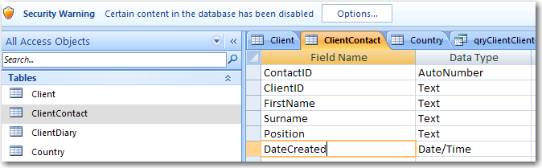

On the form you will see a calendar control icon next to a text box bound to that column
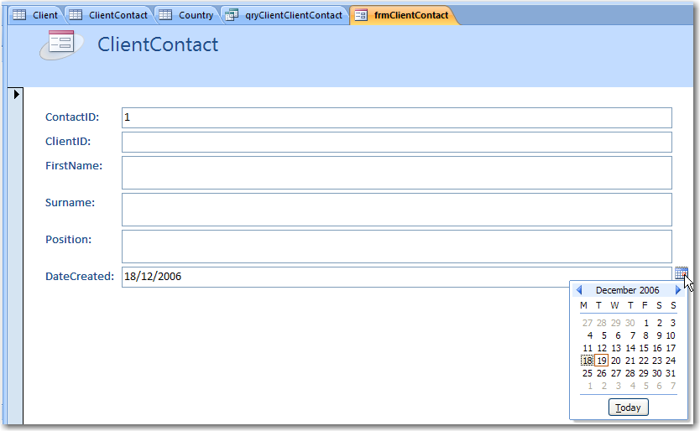

Create a custom field template for the Field Templates pane
Sometimes it is easier to choose from a predefined list of fields than to manually create a field. You can use the Field Templates pane to choose from a list of predefined fields. You can also create your own custom defined field templates and then add them to the Field Templates pane. Microsoft Office Access 2007 comes with a set of built-in field templates that can save you considerable time when you create fields. To create a new field by using a field template, you display the Field Templates pane and then drag one or more templates to a table that is open in Datasheet view.
This article introduces field templates and explains how to insert a field that is based on a prebuilt template into your table. The article then provides detailed instructions about how to create and insert your own custom field templates.
http://office.microsoft.com/en-us/access/HA102006861033.aspx?pid=CH100645691033

Add or change a lookup column that lets you store multiple values
Sometimes, the values you need are stored in another table. For instance, suppose you have an issue tracking database and you want to keep track of the employees and contractors to whom you have assigned an issue. Information about these people is tracked in the Contacts table. You can create a multivalued lookup column that displays names in a combo box or a list box control. When you select the people to whom you want to assign an issue, their contact ID values are stored in the issue record.
http://office.microsoft.com/en-us/access/HA100140981033.aspx?pid=CH100645681033

Guide to multivalued fields
In most database management systems you can store only a single value in a field, including earlier versions of Microsoft Access. In Microsoft Office Access 2007, you can also create a field that holds multiple values, such as a list of categories to which you have assigned an issue. Multivalued fields are appropriate for certain situations, such as when you use Office Access 2007 to work with information stored in a Microsoft Windows SharePoint Services 3.0 list, and that list contains a field that uses one of the multivalued field types available in Windows SharePoint Services.
http://office.microsoft.com/en-us/access/HA012337221033.aspx

Collecting Data through Email

Let’s open Access and create two tables Client and ClientContact.
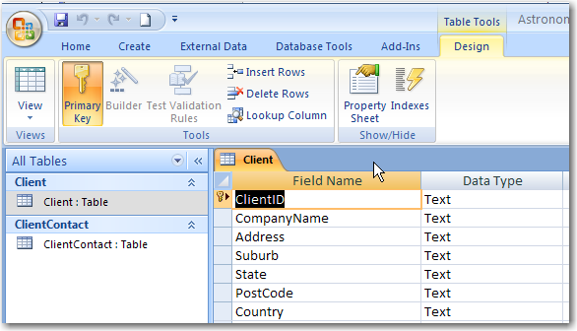
Figure 1. A Table Client

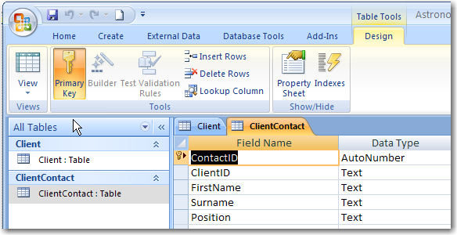
Figure 2. A Table ClientContact
Add a relationship between Client and ClientContact
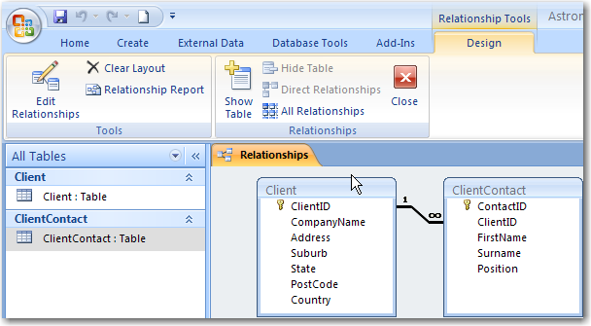
Figure 3. A relationship between Client and ClientCOntact
In the Access 2007 database, click on the table we want to gather information for and then select the External Data tab on the Ribbon and click on the Create Email icon.
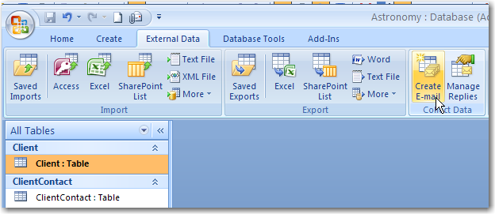
Figure 4. Collecting data through email
This then opens up the “Collect Data Through Email Messages” Wizard.
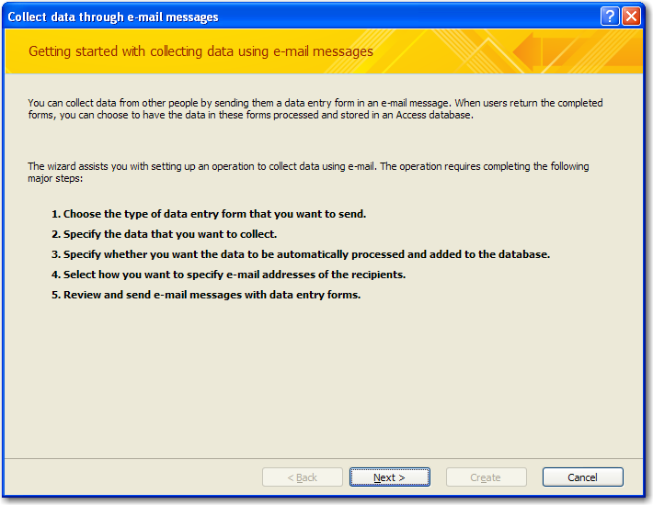
Figure 5. Getting started with collecting data using email messages
Click Next and we have the option to create an HTML Form or an InfoPath form. In our example we will create an InfoPath form, and our next choice is to create an InfoPath form to either Add or Update data in our table.
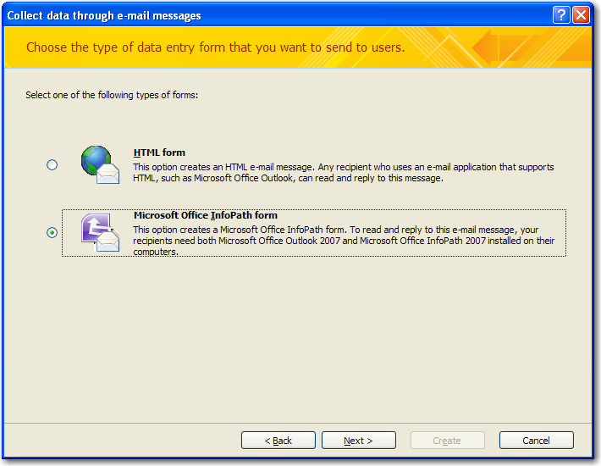
Figure 6. Choose the type of data entry form that you want to send users
The ‘gotcha’ here is that in order to update data, the email address of the recipient of the email must be stored against the data in the table. If we only want to add data we do not need the recipient email
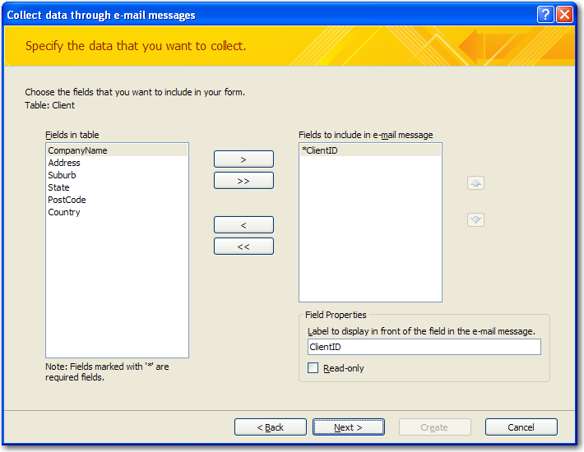
Figure 7. Specify the data you want to collect
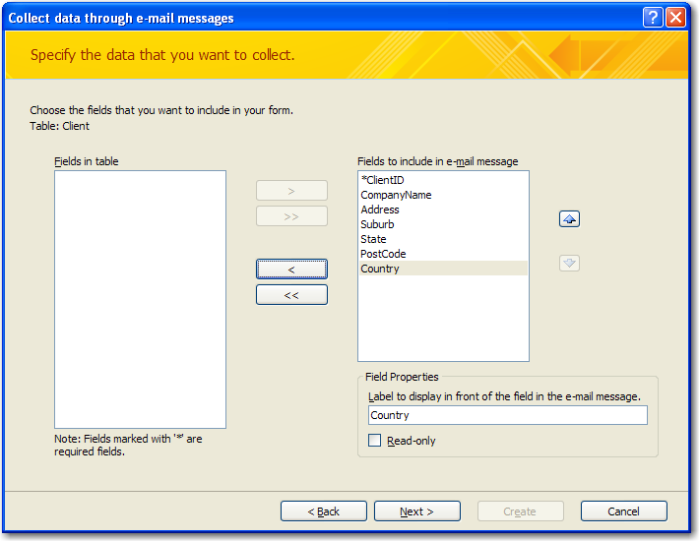
Figure 8. Choosing fields to filled by recipients of the form
address. We can select the fields we want to collect data for and decide whether or not we want the data to be automatically added to the database, and whether or not we want to restrict data collection to updates only.
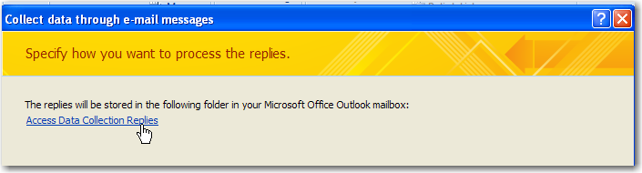
Figure 9. An outlook folder used to store replies
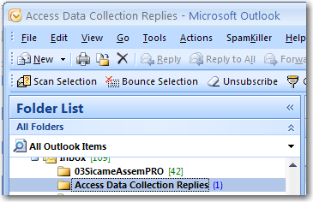
Figure 10. Folder list in Outlook
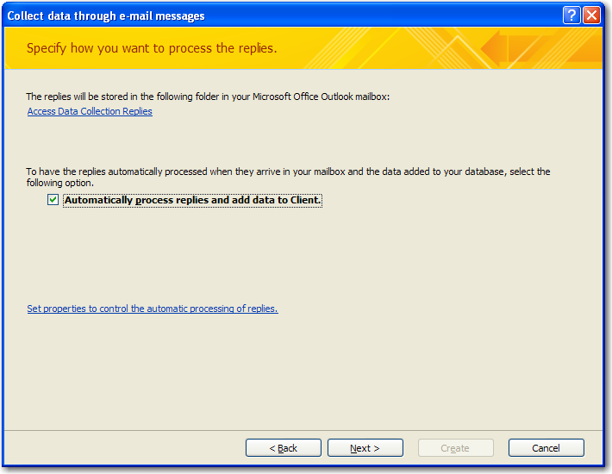
Figure 11. Specify how you want to process the replies
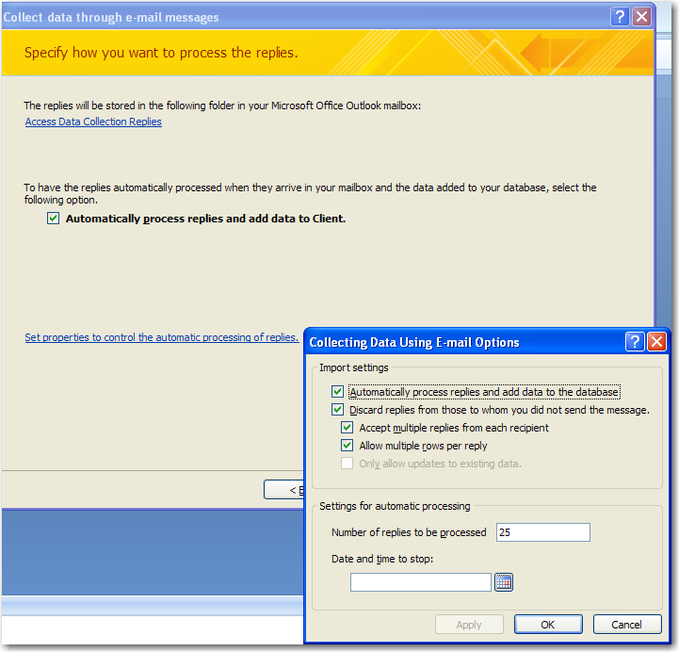
Figure 12. Configuring options for processing results
Next (if we have selected to update existing data) we are quizzed about where to find the email address of the recipient and finally we are asked to pick which email addresses to send the data gathering emails to. At this point we are now ready to start the data collection by email. The final step in the wizard is to send the emails in this case the emails will come from our own logged on user.
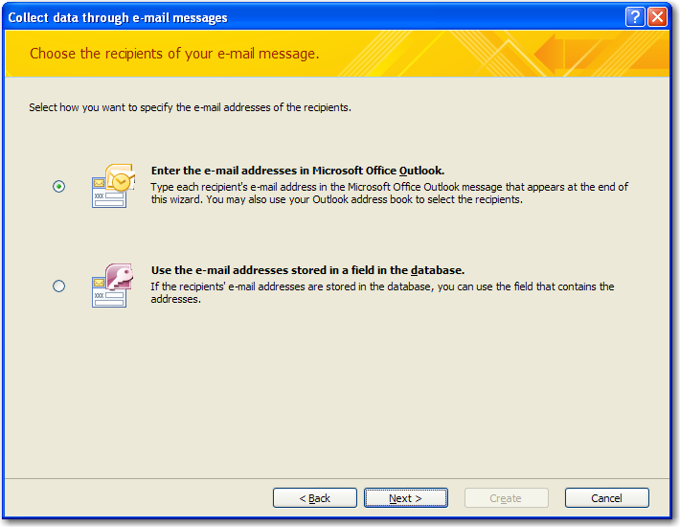
Figure 13. Choose recipients of your email message.

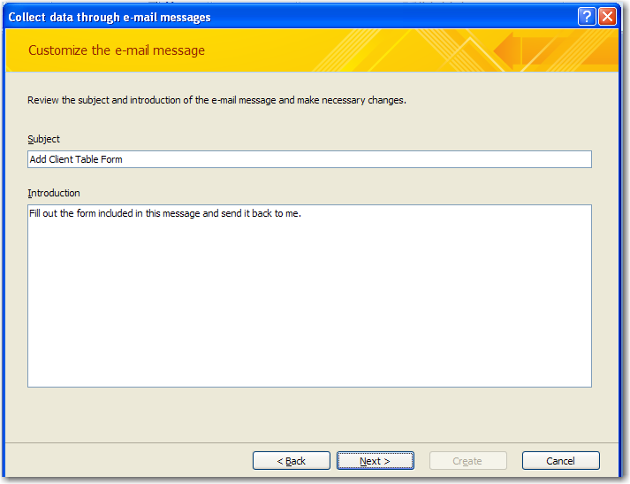
Figure 14. Customize the email message

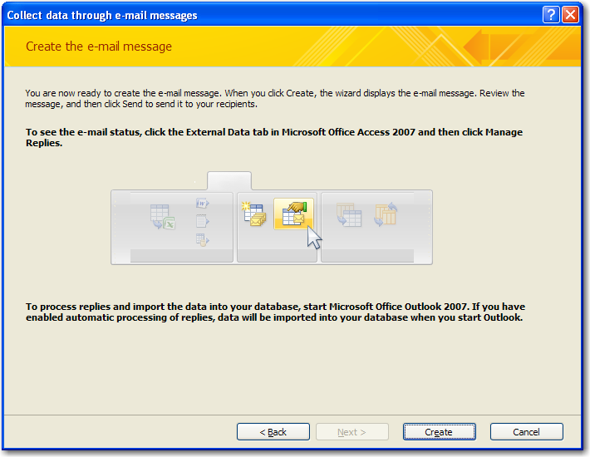
Figure 15. Create the email message
So let’s say in our example we have sent an email to adamcogan@ssw.com.au.When Adam opens up Outlook 2007 he/she will see an email in the inbox sent by sergei@ssw.com.au. The mail item will contain a form of to be filled. Once the data is added, then Adam submits the email, which sends the email back to sergei@ssw.com.au If sergei@ssw.com.au (i.e us) now opens Outlook 2007 we will see in the Inbox a folder called “Access Data Collection Replies”.
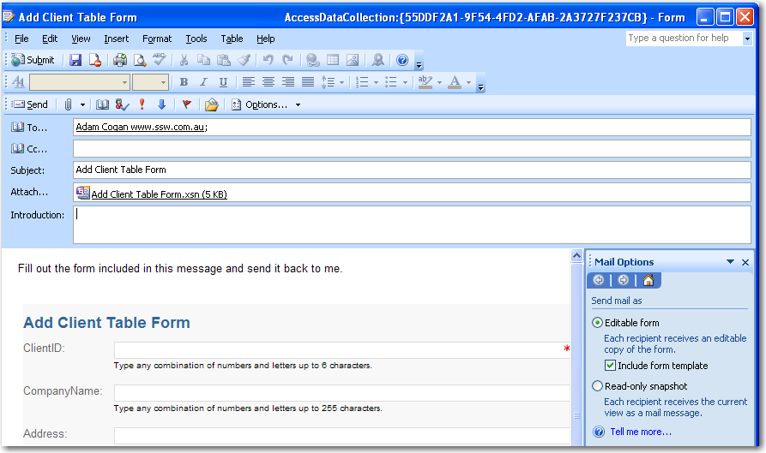
Figure 16. An email item is created
Because ClientID is a primary key a validation warning is displayed (can’t be blank)
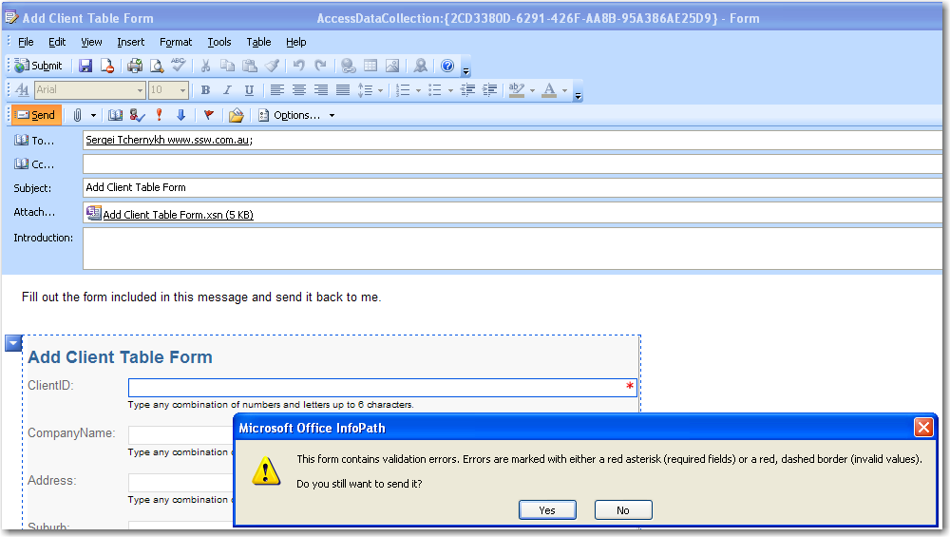
Figure 17. A Validation error is displayed (ClientID is primary key)

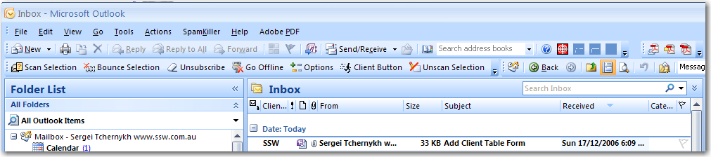
A recipient fills this form and submit this form
Figure 18. A recipient submits this form
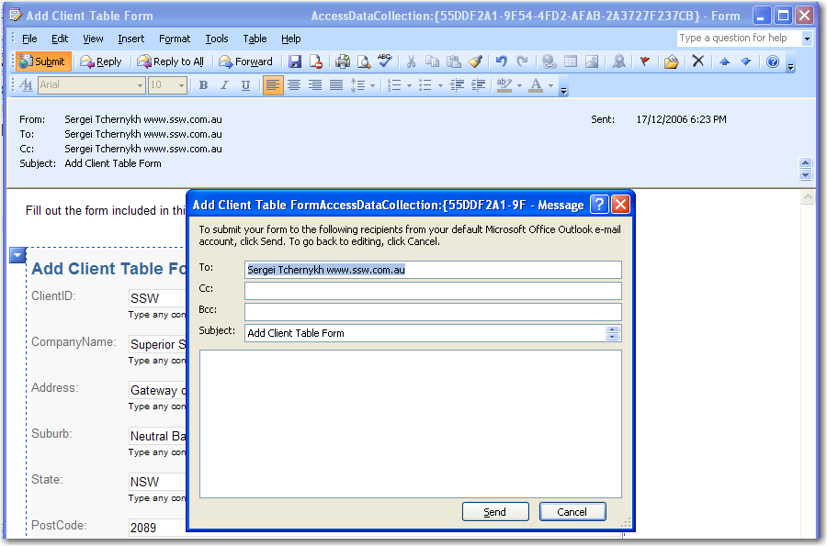
Figure 19. A recipient can cc others
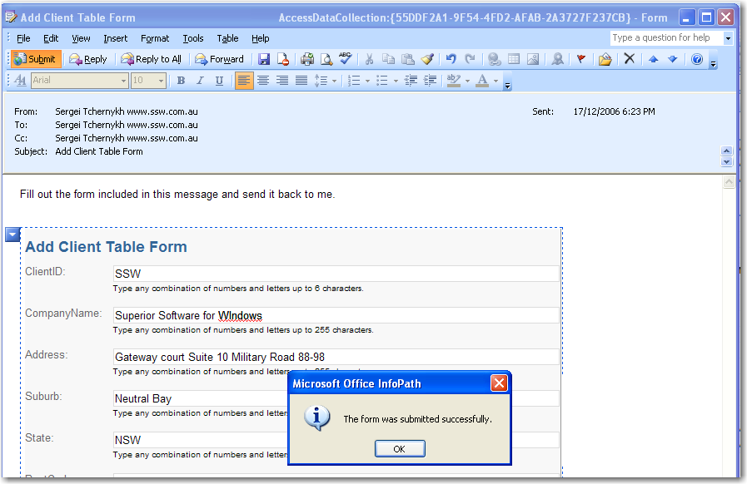
Figure 20. Confirmation after submitting this form

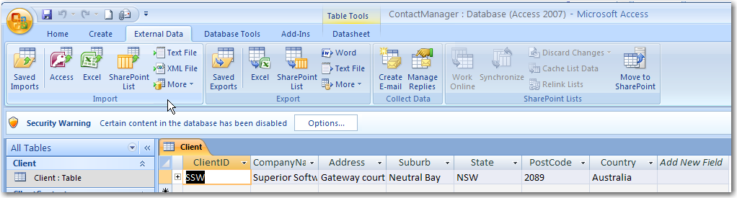
Figure 21. The table CLient was populated

Introduction to integrating data between Access and a SharePoint site
http://office.microsoft.com/en-us/access/HA101314631033.aspx?pid=CH101741461033

Ways to work with data
When you use Office Access 2007, you can share, manage, and update data from SharePoint sites in several different ways.

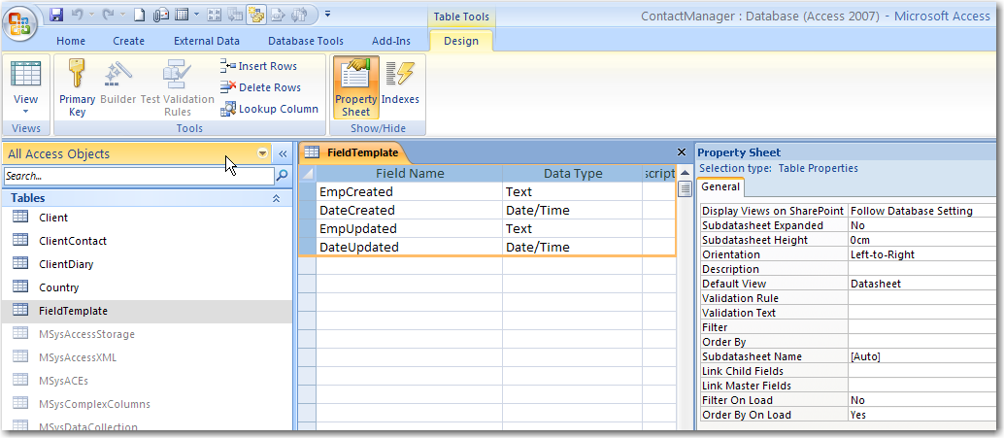
Move data to a SharePoint site When you move a database from Access to a SharePoint site, you create lists on the SharePoint site that are linked as tables in your database. When a database is moved, Access creates a new front-end application that has all the old forms and reports and the new linked tables that were just exported. The Move to SharePoint Site Wizard helps you to move the data from all your tables at the same time.
After the SharePoint lists are created, people can work with the lists on the SharePoint site or in the linked tables in Access while they use the features of a SharePoint site to manage the data and stay updated with changes. As an administrator, you can manage permission to the data and versions of the data so that you can see who changed it or restore previous data.
Publish data to a SharePoint site If you are collaborating with others, you can store a copy of a database in a library on a SharePoint server and continue to work in the database by using the forms and reports in Access. You can link lists as tables in the database, which is helpful if you want to track data on the SharePoint site, and then you can create forms, queries, and reports to work with the data. For example, you can create an Access application that provides queries and reports for SharePoint lists that track issues and manage employee information. When people work with these lists on a SharePoint site, they can open the Access queries and reports from the View menu for the SharePoint lists. For example, if you want to view and print an Access issues report for a monthly meeting, you can do it directly from the SharePoint list.
When you publish a database to a server for the first time, Access provides a list of Web servers that makes it easier to navigate to the location where you want to publish, such as a document library. After you publish the database, Access remembers the location so that you don't need to locate the server again when you publish your changes. When you publish a database to a SharePoint site, the database becomes available to people with permission to work with the SharePoint site.
Open Access forms and reports from a SharePoint site Users can open lists in rich Access views from a SharePoint site. Access forms, reports, and datasheets can appear alongside other views on a SharePoint site. When you choose an Access view, Access starts and opens the requested form, report, or datasheet. This makes it easy for you to run a rich Access report on a SharePoint site without having to first start Office Access 2007 or navigate to the right object.
Create databases from SharePoint lists You can open a SharePoint list in Access. If a database doesn't exist, you can create it in Access and then create a set of forms and reports based on your list.
Take SharePoint lists offline with Access If you need to take some work home with you, you can take your SharePoint lists offline with one click by using Access. You can work on your data in Access and then synchronize your changes or reconnect with the SharePoint site at a later time.
Import or link to a SharePoint list You can bring a SharePoint list into Access by importing or by linking. Importing a SharePoint list creates a copy of the list in an Access database. During the import operation, you can specify the lists that you want to copy, and, for each selected list, you can specify whether you want to import the entire list or only a specific view. Linking lets you connect to data in another program without importing that information, so that you can view and edit the latest data both in the original program and your Access database without creating and maintaining a copy of the data in Access.
Top of Page

Integrating and managing data
After you move your Access data to a SharePoint site, you can manage who views the data, track the versions, and recover any data that is accidentally deleted. Better data integration between Office Access 2007 and SharePoint sites enhances performance and application design.
Manage permissions on SharePoint sites You can assign varying levels of permission to lists and Access databases on SharePoint sites. You can assign limited reading permissions or full editing permissions to groups, and you can selectively allow or deny access to certain users. If you need to limit access to just a few sensitive items in a database, you can set permissions on specific list items on a SharePoint site.
Track and manage versions on SharePoint sites You can track versions of list items and view the version history on a SharePoint site. You can recover a previous version of an item if needed. If you need to know who changed a row or when it was changed, you can view the version history.
Retrieve data from the Recycle Bin You can use the new Recycle Bin on SharePoint sites to easily view deleted records and recover information that was accidentally deleted.
Improved performance for tables linked to SharePoint lists Optimizations were made to the internal processing of tables that are linked to SharePoint lists to enable a faster and smoother experience than with previous versions.
Enhanced mapping of Windows SharePoint Services data types With new support for multivalued fields and attachments, Access now supports more of the data types found on SharePoint sites, making the design and building of shared applications much simpler.
Top of Page

Tracking your data and workflow
You can use Office Access 2007 with information from SharePoint sites to track your organization's data, issues, and workflow.
Tracking Access now has a tracking template that interacts directly with the Issue Tracking template on a SharePoint site. The schemas are the same, and the Access solution can be used as a front end — for example, with forms and queries — against data from a SharePoint site.
Tracking the history of Memo fields Memo fields are useful for storing large amounts of information. You can set a property that tells Access to retain a history of all changes to a Memo field. You can then view a history of those changes. This feature also supports the versioning feature on SharePoint sites, so that you can also use Access to view the changes that were made to the SharePoint list.
Integration with workflow on SharePoint sites You can now use Access to interact with and report on workflows so that you can better gauge the project's status and evaluate your business processes. The workflow reports can span multiple lists as well as information from multiple workflows.

Publish a database to a SharePoint site
When you publish a Microsoft Office Access 2007 database to a Microsoft Windows SharePoint Services 3.0 site, other members of your organization can work with the database.
http://office.microsoft.com/en-us/access/HA101314691033.aspx?pid=CH101741461033

Publish your database to a SharePoint site
When you publish a database, you can start with an existing database or build a database by using the lists on the SharePoint site.
- Click the Microsoft Office Button , point to Publish , and then click Document Management Server.
- Type the URL of the SharePoint site where you want to publish the database.
If you used the same location the last time you opened Access, the database appears in the Publish to Web Server dialog box.
Note This option is available only if your database is saved in Office Access 2007 format.
- Select the library, such as a document library, where you want to publish the database, and then click Open.
- In the Name box, type a file name for your database.
- Click Publish.
Note When you open the database from the SharePoint site, you are prompted to save a local copy.
Top of Page

Republish a database to a SharePoint site
After you make changes to the data or the design of a database, you should republish it to your SharePoint site. When you republish a database, Access remembers the location, so you don't have to navigate to it again.
When you open a database for editing that was published to a SharePoint library, a Message Bar appears at the top of the database with a Publish to SharePoint Site button. If the Message Bar is not available for some reason — for example, if you closed the Message Bar while you were working — you can use the publishing commands on the Microsoft Office Button.
- On the Message Bar, click the Publish to SharePoint Site button.
Note If you do not see a Message Bar with a Publish to SharePoint Site button, click the Microsoft Office Button , point to Publish , and then click Document Management Server.
- In the Publish to Web Server dialog box, confirm that the library shown is the location where you want to republish.
- Click Publish.
- When you are prompted to replace the copy of the database

Import from or link to a SharePoint list
http://office.microsoft.com/en-us/access/HA012303131033.aspx?pid=CH101759701033
If your department or workgroup uses Windows SharePoint Services 2.0 or later to communicate and collaborate with each other, you might encounter scenarios where you need to work with some of the SharePoint lists in Microsoft Office Access 2007 to take advantage of its rich querying and reporting features

Work offline with tables that are linked to SharePoint lists
http://office.microsoft.com/en-us/access/HA101314701033.aspx?pid=CH101741461033
You can use Microsoft Office Access 2007 to work offline with data that is linked to a list on a Microsoft Windows SharePoint Services 3.0 site. This can be helpful, for example, if you need to be away from the office or need to continue working when a server isn't available.

Overview
Do you need to enter list data when you are disconnected from a server? Or create a report, form, or query that is based on a list? For example, perhaps you need to provide a parts catalog to a client while you are on the road. If you have linked your SharePoint lists to Access tables, you can take your data offline.
Before you work offline with data from a SharePoint site, first you must create links between the Access tables and SharePoint lists.
You can then take the lists offline to update or analyze them by using Access. When you reconnect, you can synchronize the data, so that the database and lists are updated. If your database has queries and reports, you can use them to analyze the data. For example, you can use a report in Access to summarize the data.
If you update any data while you are offline, you can update your changes on the server when you connect to the server again. If conflicts occur — for example, if someone else updates the same record on the server or while that person also is working offline — you can resolve the conflict when you synchronize.
You can link Access tables to lists by using several methods. For example, you can move your database to a SharePoint site, which also links the tables in the database to the lists on the site. Or you can export data from a list in datasheet view on a SharePoint site to an Access table. Find links to more information about linking to lists in the See Also section.
Top of Page

Take SharePoint list data offline
To perform this procedure, first you must link your Access tables to SharePoint lists.
Note If you have a database that is already published on a SharePoint site, first you must save a local copy of the database and then take the lists offline.
- Open the database that is linked to SharePoint lists.
- On the External Data tab, in the SharePoint Lists group, click Work Offline.
Note If the Work Offline button is not available, either your tables are not linked to SharePoint lists, or you already took the list data offline.
Top of Page

Synchronize your offline lists with data from the server
- Open the database that is linked to your SharePoint lists.
- On the External Data tab, in the SharePoint Lists group, click Synchronize.
Top of Page

Resolve data conflicts
If a conflict occurs over a change that you made offline and a change that someone made on the server, the Resolve Conflicts dialog box appears.
The dialog box displays information about the conflict, such as why the error occurred, and provides options for you to try to submit the data again or to discard your changes. If there are multiple errors, you can view the details of each error by clicking the Previous and Next buttons in the dialog box. Some errors can be resolved only by discarding your changes.
The details grid in the Resolve Errors dialog box displays all the columns in your current view. For the affected row, the details grid shows the change that you made. You cannot edit the values, but you can click each column to see more details.
- In the Resolve Errors dialog box, do one of the following:
  - If you want to keep the changes that were made on the server to a selected item, click Discard My Changes.
  - If you want to try to submit your changes again to a selected item, click Retry My Changes.
Depending on the situation, you may need to wait until the issue is resolved. For example, if you cannot synchronize your changes because of a network connectivity problem, you should wait until you are connected again.
  - If you want to keep the changes that were made on the server to all items, click Discard All My Changes.
  - If you want to try to submit your changes again to all items, click Retry All My Changes.
Depending on the situation, you may need to wait until the issue is resolved. For example, if you cannot synchronize your changes because of a network connectivity problem, you should wait until you are connected again.
Notes
- If the error can be resolved only by discarding your changes, the buttons for retrying your changes may not be available.
- You can close the dialog box without taking any action

Limitations of SharePoint integration to Beware of

Performance
- No server-side filtering or joining for Access queries (however, views are filtered on the server)
- List infrastructure not currently intended for large sets (>10K items)
- Action queries require a Web service call for each row affected
- Turn off form/report error checking in the Access designers

Migrating Access Data to SharePoint
- Data type conversions (see Resources)
- Limited number of custom columns
- OLE Object data not transferred
- Schema changes must be made in SharePoint
- Limited Constraint mapping
- Limited indexing and ref integrity
- Creating SharePoint lookups is difficult

