Web Ramp & VPN
Superior Software for Windows believes that remote offices should not suffer from lack of connectivity to the corporate hub. A VPN (Virtual Private Network) connects the components and resources of one network over another network. This is accomplished by allowing the user to tunnel through the Internet or another public network in a manner that lets the tunnel participants enjoy the same security and features formerly available only in private networks (see Figure 1).

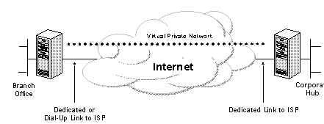

Common Uses of VPNs
SSW Clients have used VPN’s to:
- share files between remote offices via their local ISP – all within a secure environment across the Internet.
- use SQL Server replication for their databases
- connect their notebooks at when at home to the corporate LAN. By using the local connection to the ISP, the VPN software creates a virtual private network between the dial-up user and the corporate VPN server across the Internet.

Hardware
- If you want a fast reliable connection, SSW sets up a Cisco router with ISDN, or

- If you want an entry level solution with the standard analogue modems, then SSW sets up a Web Ramp (with the VPN kit)

ISP
Both solutions require the configuration of a VPN Server and a fixed IP address from your ISP.

The VPN Server (at the primary office) should be a dedicated connection as this VPN server must be listening 24 hours per day for incoming VPN traffic. The VPN server can be:
- Windows NT 4 or
- Windows 2000 Advanced Server (recommended)

I’m Sold. What do I do now?
Contact SSW on (02) 9953 3000 or email info@ssw.com.au and we will talk you though your options and give you a quote.

I’m Interested in Finding More Info

Virtual Private Networking: An Overview
http://msdn.microsoft.com/workshop/server/feature/vpnovw.asp

Virtual Private Networking Features
http://www.microsoft.com/ntserver/commserv/exec/feature/VPNFeatures.asp

Complete information on Windows Communication Solutions
http://www.microsoft.com/ntserver/commserv/exec/default.asp

Communication Services for NT Server
http://www.microsoft.com/ntserver/commserv/default.asp

