Exception Management

Version 1.1.2

G. Mustafa
Software Architect
Superior Software for Windows Pty Limited
www.ssw.com.au
Table of Contents
Overview 3
SSW.Framework.ExceptionManagement 3
SSW.Framework.ExceptionManagement.ReportingService.ExceptionReportingService 3
How to include Exception Manager in your project? 5

Overview
Exception Management is a part of SSW Tookkit. It is based on two main parts.
- SSW.Framework.ExceptionManagement
- SSW.Framework.ExceptionManagement.ReportingService.ExceptionReportingService

SSW.Framework.ExceptionManagement
- This part contains the Visual interface to the user. Where user can provide some additional information with runtime exception.  - Before appearing this screen. ExceptionManagement got the snapshot of the user desktop.  - In optional section “To” field is read only and display the receiver email address.  - WebServicePublisher.cs loads this form by initialising the configuration values as well as calls the web service to perform the exception tasks.  - The “To” field value is coming from App.config file of your application. | 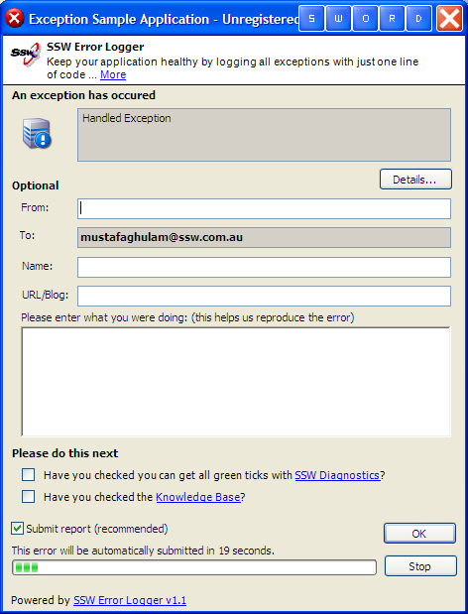

SSW.Framework.ExceptionManagement.ReportingService.ExceptionReportingService
- This part is a web service. The main file name is “ExceptionReportingService.asmx”. It contains only one public method which is called “ReportException”. This Method is done multiple tasks including inserting exception log into database as well as sending a notification to relevant developer and client.

Before insert new record in exception log it validates the client using private method “ValidateClientID”. After inserting record into Exception Log, it notifies the developer with runtime bug using “NotifyDeveloper” private method as well as an acknowledgement email to the client with the detail of bug using “NotifyClient” private method.

- This web service has two configuration files

- Email.Config
This configuration file contains all the SSW product names with responsible Project Managers/person email address. If you have new product and want to include in Exception Management then you have to add it here as given below.
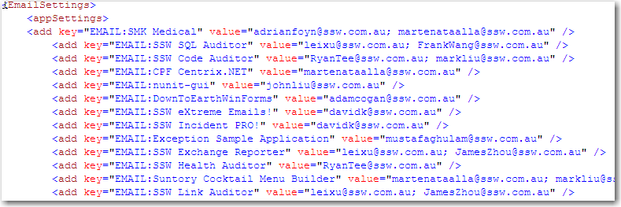

Moreover, you also add SMTP Server name and other stuff like “Client Email Body and Subject” and “Developer Email Body and Subject” as given below.
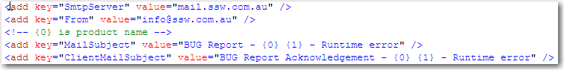

- Setting.Config
Database connectionstrings are defined in this file, which will be used all over the application. To see the detail of bug report on web, HttpServer name is also defined here. File format is given below.
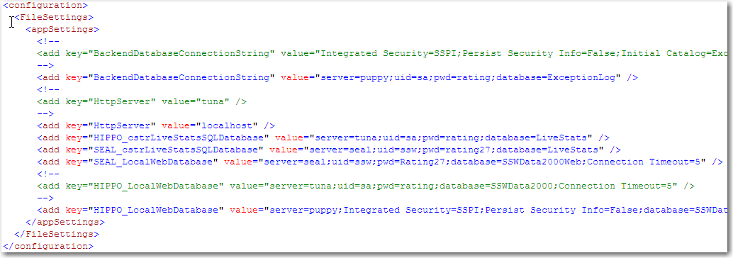

How to include Exception Manager in your project?

You need to add following lines in your project App.config file in <exceptionManagement></exceptionManagement> tags.
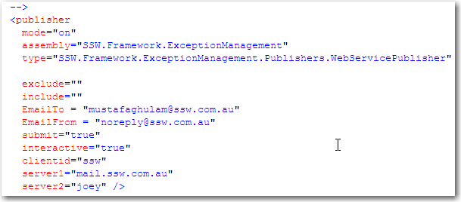
You also need to add following lines in your App.Config file. Don’t change these lines.
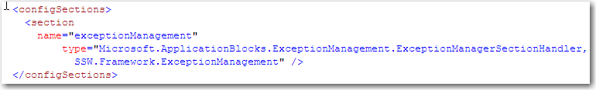

- To include Exception Manager in your project you have to add the reference of SSW.Framework.ExceptionManagement.

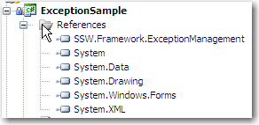
Figure: Reference to the Exception Management DLL

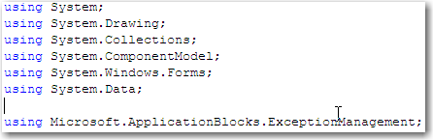
Figure: Including MS ApplicationBlocks Exception Management namespace in your file.

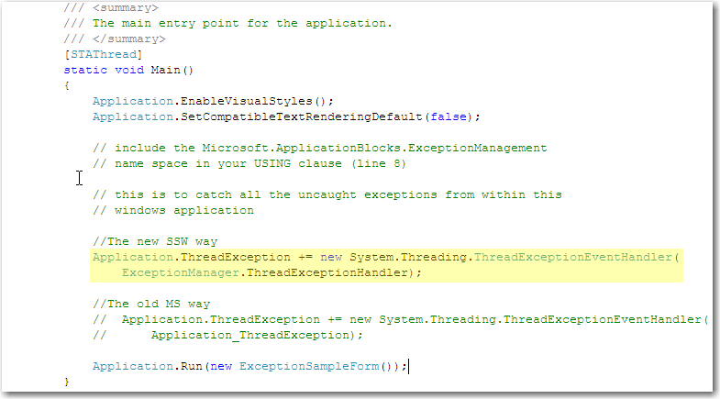
Figure: Include Event handler in your application entry point.

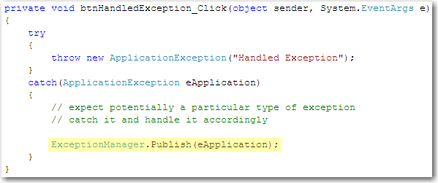
Figure: catch exception as given above.

After these steps, Exception will be thrown by SSW.Framework.ExceptionManagement namespace, and it will work for our application.

