http://roo/ssw/sqldatacompareforreplication/

Side bar

Install section - keep consistant with
http://roo/ssw/contactor/

>Stored Procedures and Linked Lists:
Stored Procedures and Linked Servers are automatically added

>SSW SQL Data Compare for Replication works by utilising four stored procedures that are executed to check for records missing, differences in the records and also a stored procedure that creates and updates an essential table called zs_TableSummary.
Too long

>When two databases are compared, the stored procedures that check for records missing and also check for records with differences in them.

>It then produces a list as shown below which can then be manipulate to update the records for synchronization using the sp_dummyupdate stored procedure.
Where is the image?

Move getting started to other page

>4) Compare the databases. After the Stored Procedures and Linked Servers have been created you will need to compare the two databases for the first time . This process may take some time depending on the size and quantity of tables in the databases. The tables with data not in sync will then be displayed as shown in the below screenshot.

Wrong font

>PLEASE NOTE: A '.' character is used to indicate a NULL value in SSW SQL Data Compare for Replication.

Move to form and delete from doco

>There are four options here that you can select:
- Options - configure the path and parameters for the Synchronize and Conflict Viewer tools.
- Synchronise - runs the Synchronize tool.
- Conflict Viewer - runs the Conflict Viewer tool.
- Close - closes the form.
Add to form if you want - kill from doco

>If you do not have these tools on your system, do not worry as the tools have been installed in the Install Directory of SSW SQL Data Compare for Replication. The default directory is C:\Program Files\SSW SQL Data Compare for Replication.

I think delete from doco and add this to the Conflict Viewer setting on the form - eg. say "wzcon??.exe is in your default .....
OR point to your copy by default.

Add this
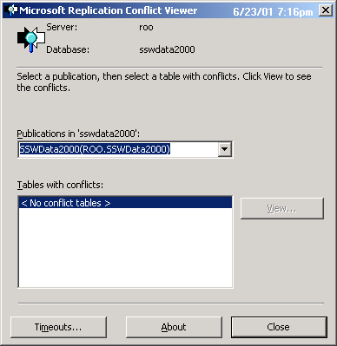

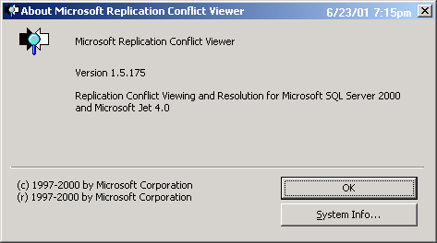
>http://roo/SSW/Products/frmProdCategory.asp
note any differences if the data is not in sync

See if your database has any differences in the data - you might be horrified - then use this tool to get your data back in sync.

Where is this?
Contact the team at 'SSW' - info@ssw.com.au
Make consistant with
http://roo/ssw/datapro/
What do I get if I register?
The unregistered product provides 70% functionality. Upon registration 100% functionality is activated.
Superior Software also provides free phone support to answer queries on registered products.
I'm sold. What now?
Click here NOW to Get a FREE version of Data PRO!.
Click here NOW to Purchase Full Registered version of Data PRO!.

Add this in side bar of all
User Guide
MS Access
SQL Server
Order NOW
Request More Information
Technical Support
Knowledge Base
Data PRO Links

Check the others

Please send us bug reports and feedback so that
Have this as one link - on all 3 new doco sites contact teamcalendar sqlcompare

