Can you make Access become disconnected gracefully against SQL Server?

Open Northwind.mdb connected to SQL Server
Hit Stop on SQL Server (to simulate a network problem)
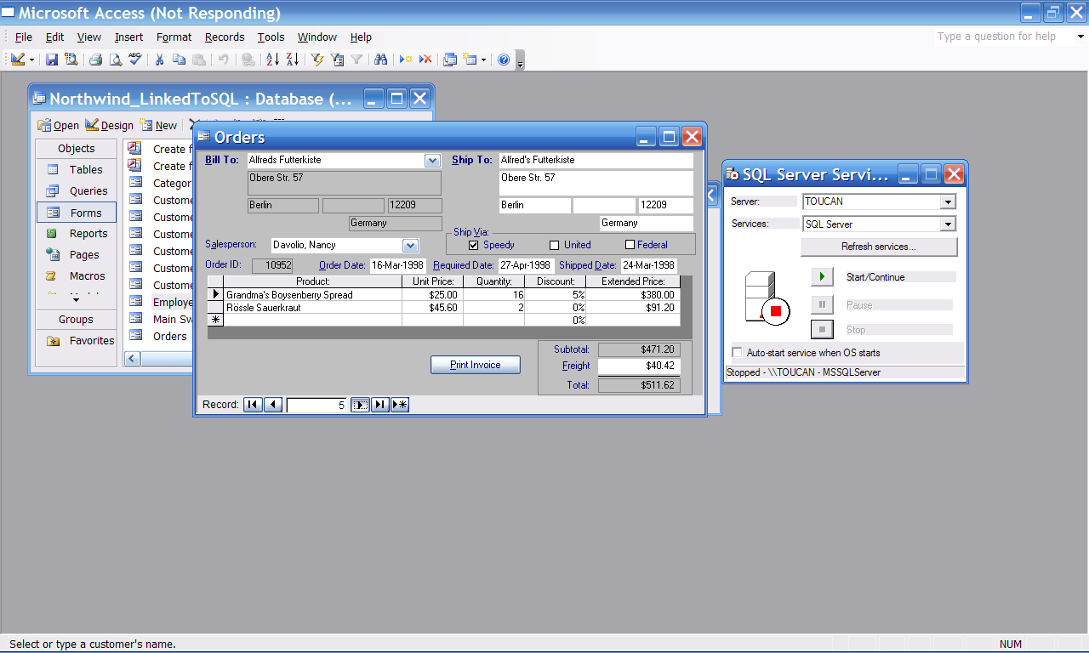

And you get all these errors



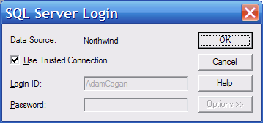





You can get 20 more message if you hit OK instead of Escape

Then you are forced to Close Access and reopen

