Packaging and deploying the Northwind .NET Solution
The Sample Northwind .NET Solution is kept under Sourcesafe in $\NorthwindNET
To package it properly:

- MAKE SURE YOU DO NOT HAVE ANY OF THE SOLUTION FILES CHECKED OUT – EVERYTHING MUST BE CHECKED IN BEFORE PACKAGING
- Get latest from sourcesafe into a folder your hard drive
- Make sure to set recursive, make writable and build tree:

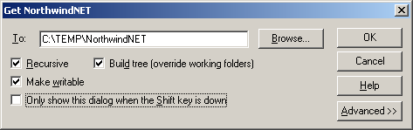

- Open the solution in VS.NET and show the Source Control toolbar
- Click Change Source Control:

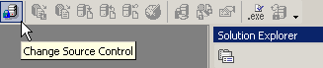

- Select al items and click Unbind and OK. Your solution is now unbound from SourceSafe.
- Zip up the solution and copy it to \\bee\ssw\Standards\DeveloperDotNet. increment the file version (NorthwindNET_vXX.zip)

Acknowledgements
Jatin Valabjee (jatinvalabjee@ssw.com.au)

