Proposal

For

Northwind Database
Development in Windows Forms
By Tim Fletcher
SSW
April 2004

Version 1

Mr Northwind
Suite 1, 1 Microsoft Ave
Sydney NSW 2000
02 9999 9999

Table of Contents
Table of Contents 2
Relevant Parties 4
Overview 4
Assumptions 4
Customer Stories 4
Business Rules and Test Cases 4
Technical Standards 5
Priorities & Estimates 5
Release 1 – Application Conversion to SQL Server & Win Forms 5
Prepaid Rates Conditions 7
Resources 7
Future Development 7
Support Agreement 7
Annual Maintenance 7
Support Bucket 7
Terms and Conditions 8
Development Agreement 8

Dear Mr Northwind,

Thank you for the opportunity to review your database development requirements.

This proposal outlines the development of your database with a SQL Server backend using a Windows Forms .NET solution.

The following estimate is based on our current understanding of your requirements based on the information you have given us. The work may vary from the estimated times based on the outcome of the investigation.

This estimate/quote is valid for 30 days from date of issue.

I look forward to your feedback.

Yours sincerely,

Tim Fletcher
Project Manager
Superior Software for Windows Pty Limited
www.ssw.com.au

Relevant Parties
Name | Company | Project Role | Contact
Mr Northwind | Microsoft | SSW Company Champion | northwind@microsoft.com  8220 8220
Adam Cogan | SSW | Chief Architect | AdamCogan@ssw.com.au  04 1985 1995
Tim Fletcher | SSW | Project Manager | TimFletcher@ssw.com.au  0422 861 606
Ross Donald | SSW | Senior Developer | ross@ssw.com.au  0405 093 813
Daniel Hyles | SSW | Senior Developer | DanielHyles@ssw.com.au  02 9953 3000

Overview
This project involves the conversion of your existing database (Northwind) to a SQL Server database with a Windows Forms .NET solution.

Assumptions
We assume we have a ‘Company Champion’ aka Mr Northwind available as we need quick client feedback. In order to minimize this risk, the client contact person should commit to a 4 hour response time.

Technical Standards
SSW follows a series of technical standards of best practices for application development and project management. These can be found at http://www.ssw.com.au/SSW/Standards/

Customer Stories
Customer Stories describe the functionality of the new system from the User’s point of view. They outline the way the system works and the process flow. They have been excluded from this document because the functionality of the application is in place.

#1 User Interface

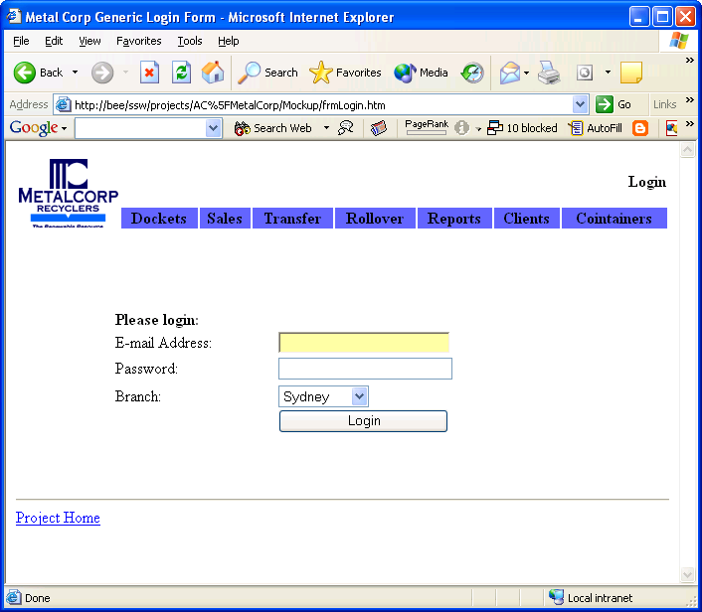

Please check all the screens at the following location.
Print each one and initial it in the bottom right hand corner. http://www.ssw.com.au/ssw/projects/AC%5FMetalCorp/Mockup/frmLogin.htm

#2 Data Schema

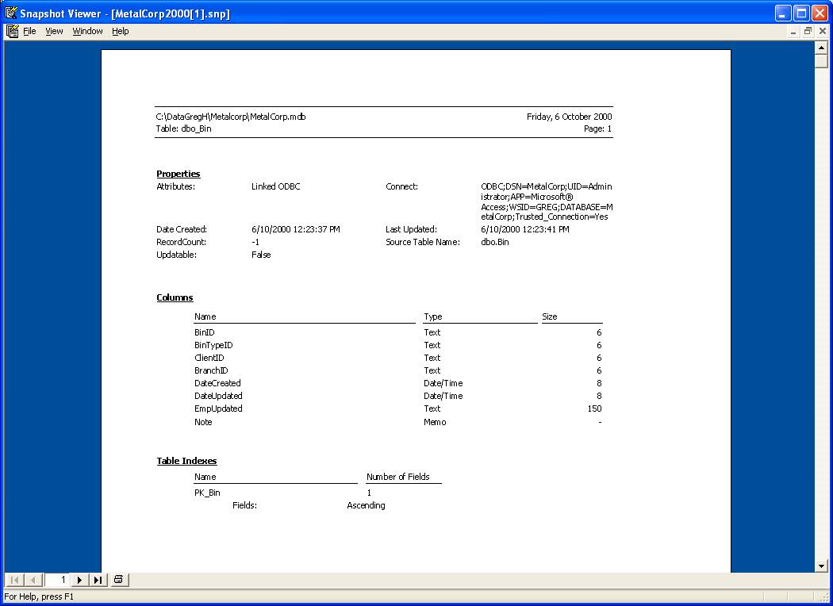

Please check the schema at the following location.
Print all pages and initial it in the bottom right hand corner. http://www.ssw.com.au/ssw/projects/AC%5FMetalCorp/Mockup/frmLogin.htm

#3 Business Rules and Test Cases
Customer Requirements
These are the rules as specified by the customer.

Customer Rule | Customer Description | Example | Comp-leted
OrderTotal | Totalling line items of an order. Each line item has a quantity, a unit cost and a discount percentage.  X = (qty) * (cost) – (% discount) | Qty Cost Discount  Example 1:  12 $14.00 0%  10 $9.80 0%  5 $34.80 0%  Grand total = $440.00  Example 2:  16 $7.70 25%  50 $15.60 0%  15 $39.40 25%  21 $12.00 25%  Grand total = $1504.65 | 
USDollar | All dollar amounts are to be stored in USD. Get the exchange rate from a web service at the time the order is saved. | Example 1:  AUD $135.00 = USD$100

Developer Questions
These are additional rules asked by the developer and specified by the customer

Developer Rule | Developer Question | Answer / Example | Comp-leted
Rounding | Rounding? Which rounding rules should be applied to the grand total? | (by customer)  $149.0282 rounds up to $149.03  $149.0232 rounds down to $149.02  $149.02 no need for rounding, return $149.02  $149.025 rounds down to $149.02 | 
WebServiceConn | What if the web service can’t be reached? | (by developer)  Use local cache

Priorities & Estimates
The following is an estimate of costs to complete the work. This is not a fixed-price contract. This estimate may be subject to review should the matter become more complex than originally anticipated by us.

Note: This list is in priority order.

Release 1 – Application Conversion to SQL Server & Win Forms
Description | Resources | Work Hrs | Man Hrs | Standard Rate  Total ex GST | Prepaid Rate Total ex GST
Forms Conversion (Access to SQL Server)
Menu Main (basic switchboard screen) | 2 | 3 | 6 | $990 | $900
frmBrokerDetail (basic calculations) | 2 | 5 | 10 | $1,650 | $1,500
frmBrokerOptions (no code) | 2 | 3 | 6 | $990 | $900
frmBrokerReport (~300 lines of code) (Uses control Local to select which reports to email) | 2 | 8 | 16 | $2,640 | $2,400
frmBrokerScheme (CalcScheme Function and Broker Logo Import function) | 2 | 12 | 24 | $3,960 | $3,600
frmControl (switchboard) and UpdateCreditCharge function | 2 | 6 | 12 | $1,980 | $1,800
frmCreditCharge (Basic Grid for Access to table) | 2 | 4 | 8 | $1,320 | $1,200
frmIntroduction (simple splash screen) | 2 | 2 | 4 | $660 | $600
frmLogon | 2 | 2 | 4 | $660 | $600
frmQuote (largest form - Calc function, search functionality) | 2 | 32 | 64 | $10,560 | $9,600
_basDataPRO - Use SSW SQL Deploy for deploying database changes, need call on open | 2 | 4 | 8 | $1,320 | $1,200
_New_Utilities (Update Local Data - could use Settings.XML | 2 | 6 | 12 | $1,980 | $1,800
basPrintEmailReport | 2 | 2 | 4 | $660 | $600
basSystemInfo | 2 | 3 | 6 | $990 | $900
Forms Extra Items
frmQuote (validators) | 2 | 2 | 4 | $660 | $600
Wise (check for update) | 2 | 5 | 10 | $1,650 | $1,500
Resolution Option In frmControl (remove and use anchoring) | 3 | 5 | 15 | $2,475 | $2,250
Web Services for all data (no caching) | 2 | 32 | 64 | $10,560 | $9,600
PDF option for reports | 2 | 32 | 64 | $10,560 | $9,600
Usage Report in Reporting Services (including the code to log the record) | 2 | 8 | 16 | $2,640 | $2,400
Usage Detail Report in Reporting Services (including the code to log the record) | 2 | 8 | 16 | $2,640 | $2,400
Conversion of CPF Reports 2000 to .NET
Send Email Functionality (Use Outlook if available then SMTP), with pdf attachments (NB NO snapshot format from Crystal) | 2 | 16 | 32 | $5,280 | $4,800
NECESSARY ADDITIONS | 2 | 0 | 0 | $0 | $0
Project Management (2 hours every 40 work hours) | 1 | 4 | 4 | $660 | $600
Testing (8 hours every 40) | 2 | 16 | 32 | $5,280 | $4,800
Fixes from User Acceptance Testing (10% of total work hours) | 2 | 16 | 32 | $5,280 | $4,800
Scheduling (8 hours per Release)) | 2 | 2 | 4 | $660 | $600
Total ex GST |  | 291 | 583 | $96,195.0 | $87,450.0
Total inc GST |  |  |  | $105,814.5 | $96,195.0

Prepaid Rates Conditions
SSW offers a competitive rate to those clients pre-paying time in blocks of 40 hours. Pre-paid rates take effect on day of payment.

Rates revert to standard if pre-payment is not maintained.

For continuing work a new invoice will be issued when more than half the hours of the previous invoice have been consumed. We recommend that you are able to process payment within 24 hours of receiving invoice to maintain pre-payment. Credit-Card and Direct Deposit only. See http://www.ssw.com.au/ssw/Company/AboutUs.aspx#Bank for SSW banking details.

Resources
- Ross Donald – Senior Developer - $175 +GST/hour
http://www.ssw.com.au/SSW/Employees/employeesprofile.aspx?EmpID=RD
- Daniel Hyles – Database Developer - $155 +GST/hour
http://www.ssw.com.au/SSW/Employees/employeesprofile.aspx?EmpID=DH

Future Development
- No future development is planned at this time.

Support Agreement
Support is defined as ensuring the application maintains its current functionality.
Telephone & Email support is provided through a designated "Company Champion" nominated by the client. Telephone support is available 9pm - 6pm weekdays. An emergency line is available 24 hours a day. You will be allocated primary and secondary account managers who will co-ordinate your support requirements. They will help to ensure that you are given the full attention of our staff, and your urgent problems are dealt with promptly.

Annual Maintenance
 Annual Maintenance Support is for Fixed Price contracts only. You may purchase Annual Maintenance Support at 15% of the total project cost. Alternatively you may purchase support at the agreed hourly rates. Onsite visits will be charged on an hourly basis, unless otherwise agreed upon.

Support Bucket
 The 40 hour Support Bucket is for Time & Materials OR Fixed Price contracts. A 40 hour Support Bucket must be pre-paid prior to the provision of support.

Clients are free to utilise support on an "as required" basis. Support can be provided on-site or off-site. When 40 hours is completed you can purchase a new Support Bucket. Fax, telephone & email support is provided through a designated "Company Champion" nominated by the client.

A 40 hour Support Bucket expires from 12 months of date of payment. Developer rates are charged on a prepaid basis. Rates are in accordance with the resources supplied.

Terms and Conditions
All work will be conducted according to our standard Terms & Conditions. These can be viewed at http://www.ssw.com.au/ssw/Company/ConsultingOrderTermsConditions.aspx. You are required to sign a copy of these prior to work commencing. This is not a fixed price contract. Work is conducted on a time & materials basis.

Development Agreement
Superior Software for Windows Pty Limited is to provide the services as stipulated in the Proposal. In doing this work unforseen circumstances may arise necessitating SSW to provide additional services; these services will provided on a time & materials basis subject to our standard Terms & Conditions. This Agreement shall become effective upon acceptance and can be terminated with 24 hours notice, in writing by either party.

Please select which payment option you prefer:
 Standard
 Prepaid* (Subject to Pre Paid Work conditions)

Superior Software for Windows Pty Limited  Gateway Court, Suite 10  81 – 91 Military Road  Neutral Bay NSW 2089  ABN 21 069 371 900 | Powerhouse Group
_______________________________________ | _______________________________________
Name | Name
_______________________________________ | _______________________________________
Signature | Signature
_______________________________________ | _______________________________________
Title | Title
_______________________________________ | _______________________________________
Date | Date
Please return fax entire document to (02) 9953 3105

This proposal has been prepared in good faith and diligence, and we have made every effort to ensure accuracy. Any recommendations are based on information supplied by you and our past experience, but your situation may differ from other clients. As such SSW makes no warranty, express or implied with respect to the correctness of this report or its recommendations. This contract is governed by the laws of NSW, Australia. The operation of the postal acceptance rule is expressly excluded.

