Lab 4: How to Migrate Access Forms to .NET Windows Forms
In this lab, you will migrate 3 forms from Microsoft Access to .NET Windows Forms using Visual Studio. The 3 forms are:
    - Main Switchboard
    - Orders
    - Orders Subform

You will be using the following programs during the migration process:
- Visual Studio .NET 2003

To access all course resources online visit: http://ssw.com.au/ssw/Events/2005AccessToSQLServerAndNET/resources.aspx

If you receive any security warnings from Access, click Open.
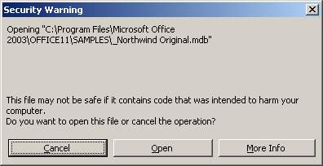

Exercise 1
Create the Solution
It is recommended that you print this document to make it easier to follow the steps.
- Open the supplementary whitepaper
    - Open the Microsoft whitepaper, How to Migrate Access Forms to .NET Windows Forms from http://www.ssw.com.au/ssw/standards/DeveloperDotNet/. You will be referring to this document throughout this lab.
    - Turn on the document map (View–>Document Map) in Word to make navigation easier.
- Create the solution
Follow the steps in the Create the Solution section of the whitepaper to do the following:
    - Create a new blank solution in Visual Studio .NET
    - Add the user interface project
    - Add the data access projects
    - Add the business project

Your solution structure should match that shown in Figure 1. You are now ready to begin migrating the forms.

Figure 1 – Your solution structure should now look like this
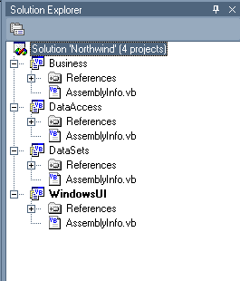

Exercise 2
Migrate the Main Switchboard Form
- Create the User Interface
See Step 1 of The 3 Steps to Migrate the Main Switchboard Form in the whitepaper for details on creating forms and which controls to use.
- Set the Control Properties
See Step 2 of The 3 Steps to Migrate the Main Switchboard Form in the whitepaper for details on naming controls and setting control properties.
- Add the Form Functionality
See Step 3 of The 3 Steps to Migrate the Main Switchboard Form in the whitepaper for details on using code to open forms and exit the application.

Exercise 3
Migrate the Orders and Orders Subform Forms
- Create the Data Access Components
Follow Step 1: Create the Data Access Components of the whitepaper to:
    - Create DataAdapters that store and retrieve data from the database
    - Modify the DataAdapters to produce calculated fields
    - Generate DataSets for each DataAdapter
- Create the User Interface
    - Refer to Step 2: Create the User Interface for steps to create the Orders Details form that is used to edit line items.

Step 2: Create the User Interface also provides steps to create the Orders form. A form has already been created with the necessary controls that can be imported into the WindowsUI project:
    - Right-click the WindowsUI project and select Add -> Add Exisiting Item….
    - Browse to OrdersForm.vb and click Open.
    - Click Yes to replace the existing Orders form.

The forms are now ready to be bound to your data
- Bind the Form Controls
There are 4 parts described in Step 3: Bind the Form Controls of the whitepaper:
    - Add references to the data access components
    - Create instances of the DataSets
    - Set the control properties
    - Add code to fill the DataSets

Follow each part in the whitepaper to bind the form controls to your data.

If you test the solution you will notice that it takes a long time for the Orders form to load. This is because our example reproduces the functionality of Access, which retrieves all records when the form loads. For a better approach, review the complete solution in available from http://www.ssw.com.au/ssw/Standards/DeveloperDotNet/Resources/Northwind/
- Add the Form Functionality
Your forms are now bound to the data source. You must now add code to:
    - Update the Bill To and Ship To details
    - Reproduce the functionality of the Access navigation panel
    - Format the Freight textbox
    - Calculate the subtotal and total
    - Add line items
    - Delete line items
    - Edit line items
    - Add records
    - Save changes

Follow Step 4: Add the Form Functionality to add this code to your solution.

Exercise 4
Maintaining the Application
- Change Your SQL Server
What happens if the location of your SQL Server database changes? Refer to Change Your SQL Server in the whitepaper for information and instructions that will allow you to change SQL Servers and rename databases without generating errors in your application.

