

What’s New and Different for the Access Developer Moving to SQL Reporting Services
SQL Server Technical Article

Writers: Adam Cogan
Technical Reviewers: Andrew Weaver, Jatin Valabjee
Project Editor: None
Designer: None

Published: [Insert Date:MM YYYY]
Updated: [Insert Date: MM YYYY]
Applies To: Access 2000/2002/2003, SQL Server 2000 SP3a

Summary: Microsoft® SQL Server™ Reporting Services is a powerful new tool allowing developers to move reporting solutions online for truly global access. This paper explains the key advantages, similarities and differences between Microsoft Access Reports and Reporting Services Reports for organizations considering migrating to Reporting Services.

Copyright
The information contained in this document represents the current view of Microsoft Corporation on the issues discussed as of the date of publication. Because Microsoft must respond to changing market conditions, it should not be interpreted to be a commitment on the part of Microsoft, and Microsoft cannot guarantee the accuracy of any information presented after the date of publication.

This White Paper is for informational purposes only. MICROSOFT MAKES NO WARRANTIES, EXPRESS, IMPLIED OR STATUTORY, AS TO THE INFORMATION IN THIS DOCUMENT.

Complying with all applicable copyright laws is the responsibility of the user. Without limiting the rights under copyright, no part of this document may be reproduced, stored in or introduced into a retrieval system, or transmitted in any form or by any means (electronic, mechanical, photocopying, recording, or otherwise), or for any purpose, without the express written permission of Microsoft Corporation.

Microsoft may have patents, patent applications, trademarks, copyrights, or other intellectual property rights covering subject matter in this document. Except as expressly provided in any written license agreement from Microsoft, the furnishing of this document does not give you any license to these patents, trademarks, copyrights, or other intellectual property.

Unless otherwise noted, the example companies, organizations, products, domain names, e-mail addresses, logos, people, places and events depicted herein are fictitious, and no association with any real company, organization, product, domain name, email address, logo, person, place or event is intended or should be inferred.

©2004 Microsoft Corporation. All rights reserved.

Microsoft, Microsoft Access, Microsoft Excel, Microsoft Office, Microsoft SQL Server Reporting Services, Microsoft Visual Studio .NET, and Microsoft Windows are either registered trademarks or trademarks of Microsoft Corporation in the United States and/or other countries.

The names of actual companies and products mentioned herein may be the trademarks of their respective owners.

Table of Contents

What’s New and Different for the Access Developer Moving to SQL Reporting Services
Introduction
About SSW and the Authors
What’s New/Different in Reporting Services if you are an Access Developer
Advantage – Your Reports Anywhere, Anytime
Advantage – A Shallow Learning Curve for Access Developers
Similarity – Designing and Specifying Data for Reports
Advantage – Export Reports to More Formats
Advantage – Scalability
Advantage – Consolidate and Control Your Reporting Investment
Advantage – Integrates with .NET
Difference – Expressions Are Used Instead of Access Code-behind
Advantage – Report Interactivity
Similarity – Parameters
Advantage – Integrated Security
Advantage – Extensible Open Architecture
Advantage – Scheduling of Reports
Difference – Cost Structure
Advantage – Multiple Data Sources in a Single Report
Advantage – Design Flexibility: No More Banded Reports
Advantage – Extensible to Other Devices
Similarity – Control Toolbox
Difference – Deploying Reports
Disadvantage – Making Reports Available Offline
Conclusion

What’s New and Different for the Access Developer Moving to SQL Reporting Services

Introduction
Microsoft® SQL Server™ Reporting Services is a new reporting platform that has even more functionality and flexibility than Microsoft Access and Crystal developers have become accustomed to. In addition, it combines the speed, scalability, and manageability of centrally managed reporting, as reporting has moved from the client model to the client-server model. This brings all the advantages of Web-based applications.

This paper explains the key advantages, similarities and differences between Access and Reporting Services.

The advantages of Reporting Services over Access that are covered are:

- Your Reports Anywhere, Anytime
- A Shallow Learning Curve for Access Developers
- Scalability
- Consolidate and Control Your Reporting Investment
- Integrates with .NET
- Report Interactivity
- Integrated Security
- Extensible Open Architecture
- Scheduling of Reports
- Cost Effective
- Multiple Data Sources in a Single Report
- Design Flexibility: No More Banded Reports

The similarities with the two platforms that are covered are:

- Designing and Specifying Data for Reports
- Control Toolbox
- Parameters

The differences between Reporting Services and Access that are covered are:
- Expressions are used instead of Access code-behind
- Deploying Reports

One disadvantage of Reporting Services compared to Access is that making reports and their associated data available offline is a somewhat more difficult task. This is also discussed.

About SSW and the Authors
This whitepaper is written by Adam Cogan (Chief Architect) and Jatin Valabjee (Senior Software Developer) of Superior Software for Windows (SSW). SSW is a Sydney based consulting company specializing in .NET solutions for progressive businesses since 1990. SSW offers custom software solutions in ASP.NET, VB.NET, C#, SQL Server, Exchange Server, Microsoft Access and Office 2003. Adam can be contacted at adamcogan@ssw.com.au.

Adam Cogan is one of two Australian Microsoft Regional Directors and has been developing custom solutions for businesses across a range of industries such as Government, banking, insurance and manufacturing since 1990 for clients such as Microsoft, Quicken, and the Fisheries Research and Development Corporation.

Jatin Valabjee has extensive industrial experience developing Microsoft solutions. He has an in-depth knowledge of the Microsoft suite of products, including Access, SQL Server 2000 and .NET Windows Forms and Web Forms.

Information in this whitepaper is based on our experiences and observations developing Windows software and databases. We welcome any feedback to info@ssw.com.au.

What’s New/Different in Reporting Services if you are an Access Developer
Reporting Services offers many advantages over Access, and is at once familiar to Access developers. These are presented in order of their importance to Access developers, although this may vary based on your company’s needs. There are also some differences in the way reports are designed and deployed which you should be aware of when migrating to Reporting Services.

Advantage – Your Reports Anywhere, Anytime
In Access, you must create and develop the reports then worry about deploying it to the appropriate users. Amongst other issues such as file versioning and deployment, users must have Microsoft Office or the Access runtime installed.

Reporting Services, on the other hand, permits more users to view reports with only a web browser, which is platform and system-independent.

Reports created with Reporting Services are web-based and reside on a centralized server or group of servers. This architecture enables any user with intranet or internet access to view their reports through a web browser, without requiring any extra software.

Accessing reports online is possible with both Reporting Services and Access, although the process to viewing and editing reports offline is somewhat more difficult with Reporting Services. See the Disadvantage – Making Reports Available Offline section for more information about offline reporting.

Advantage – A Shallow Learning Curve for Access Developers
As an Access developer, you will find the Reporting Services interface very familiar and will adapt very easily to the new features (see Figure 1 and Figure 2). Existing knowledge of Access is not lost when converting to Reporting Services, as many of the windows and layouts are similar to those of Access.

Figure 1 – Working with reports in Access…
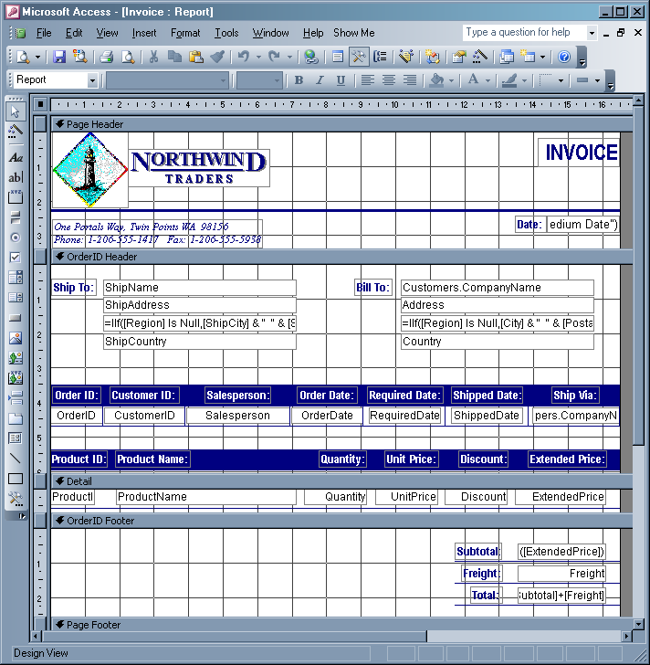

Figure 2 - … is very similar in Reporting Services
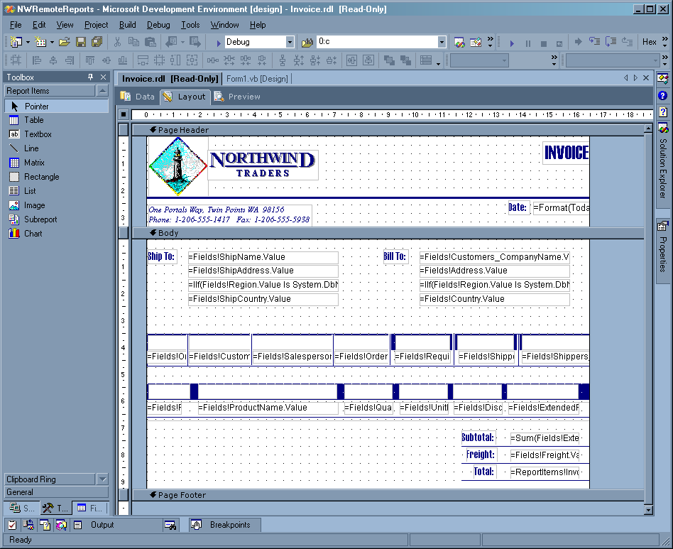

Similarity – Designing and Specifying Data for Reports
Access developers will find the Reporting Services Report Designer interface very familiar. Just like Access, Report Designer is split into data view, layout, and preview (see Figure 3, Figure 4, and Figure 5). As seen in Figure 3, when selecting the source of data to use for a report and specifying query parameters, you will find the process very familiar.

Figure 3 – Getting report data in Reporting Services is very similar to Access
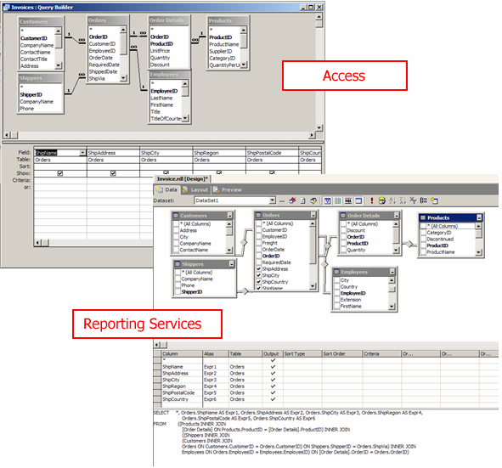

Figure 4 – Designing a report in Access is very similar to Reporting Services
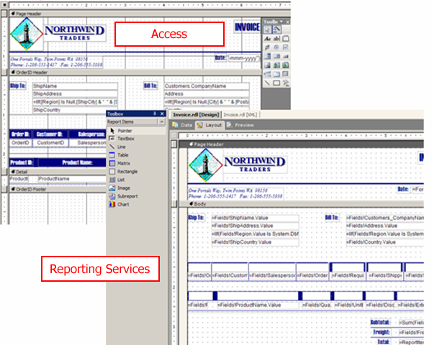

Figure 5 – Previewing a Report in Access is similar, but in Reporting Services you are previewing it in an Internet Browser Control
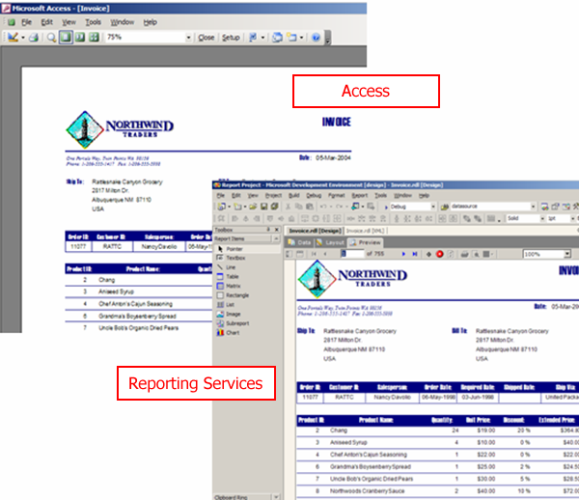

Advantage – Export Reports to More Formats
In Access, you can export reports to other formats, namely:

- Microsoft Word (.DOC)
- Microsoft Excel (.XLS)
- Access Snapshot (.SNP)

In Reporting Services, on the other hand, you can export to more file formats, which allow such features as report interactivity (see the Advantage – Report Interactivity section), easy printing (PDF), and use of report data in other applications (XML). You can export reports to:

- CSV (Comma-separated values)
- TIFF (Image)
- Acrobat (PDF)
- Web archive
- HTML with Office Web Components
- Excel
- XML file with Report Data

Advantage – Scalability
In Access, every time you run a report it queries the data source, potentially resulting in major performance bottlenecks.

Reporting Services, on the other hand, supports cached reports, which relieves the load on the database server. This, in turn, enables more users to view reports simultaneously (see Figure 6). Access databases are limited in their capacity to handle multiple simultaneous users viewing reports.

Figure 6 – Unlike in Access, you can cache reports in Reporting Services
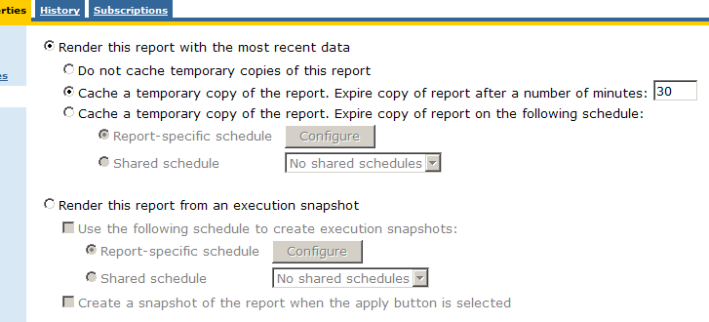

Advantage – Consolidate and Control Your Reporting Investment
In Access, one of the biggest issues for new versions (such as a new report) of an application is deployment. When a new version is ready for users, every user needs to get the new copy of the Access database (.mdb). File shares can be used, although many users attempting to connect to and perform actions on a database over a network connection can cause degradation of network performance.

Reporting Services, on the other hand, needs nothing installed on the client (note that the Adobe Acrobat Reader is required for the PDF format). Reporting Services is installed on a server which hosts all the reports (in a SQL database) as well as the Report Manager (shown in Figure 7). Report Manager is a web based application which enables viewing and administration of reports. All reports are web based and governed by role-based security so any user with the correct permissions and a web browser can view reports.

Figure 7 – Reporting Services provides a central interface for easy management of your reports
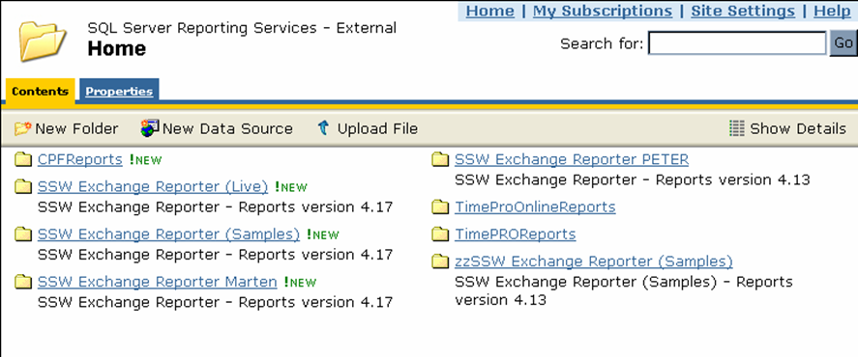

Advantage – Integrates with .NET
In Access, if you want to call a .NET assembly from your reports (i.e. a compiled set of business logic code) you must first create a wrapper to the assembly. Specifically, you need to create a type library for the .NET assembly, give it a strong name and put it in the Global Assembly Cache. The process is quite painful, and the performance is not great as it involves marshalling.

Reporting Services, on the other hand, is fully integrated with .NET. Developers can easily integrate any existing and new business logic with any report via expressions, which enable interaction with and manipulation of the report data. For example, currency conversions could be performed on an invoice based on current exchange rates.

Unlike earlier versions of Visual Basic, deploying a .NET assembly is as simple as copying the new version onto the reporting server along with the deployed reports (see the Difference – Deploying Reports section for more information on deploying Reporting Services reports). Once copied, the live reports on the server will automatically use the updated logic. This is a vast improvement as it does not require any server downtime to update business logic in DLLs, and can be done by anyone in the company.

Migrating your Access data to SQL Server, in conjunction with migrating your reports to Reporting Services, will ensure that your reporting server maintains a high uptime and is not affected by data updates or updates to business logic used by your reports. For more information on migrating to SQL Server from Access, see the white paper entitled How to Migrate from Access to SQL Server.

Difference – Expressions Are Used Instead of Access Code-behind
In Access, when you want to add custom business logic for a control, you select the page section (e.g. Group Header 1), then edit the event procedure for the control. Expressions can also be used in the source for an Access control.

Reporting Services, on the other hand, uses expressions for almost every property on any report item. Visual Basic .NET is used as the expression language in addition to some aggregate functions. Expressions in Report Designer can be accessed by selecting the control and choosing the <Expression…> option from the dropdown list for a property. For example, if the label of a textbox changes depending on a calculation or other expression, the expression can be changed by selecting the textbox, and selecting <Expression…> from the dropdown list for its label property (see ). The calculation can then be entered into the expression textbox.

Expressions can also make use of existing business logic in custom .NET DLL assemblies. To use .NET code with Reporting Services, you must compile the code into a .NET DLL, add a reference to it in the Reporting Services project, and then call it within an expression. For more details on creating custom assemblies and making them available to your Reporting Services project, please visit Microsoft’s Using Custom Assemblies with Reports at http://msdn.microsoft.com/library/en-us/rsprog/htm/rsp_prog_rdl_6d0i.asp.

Expressions should only be used for basic tasks such as text formatting. Any business logic and repeated processes should be moved to a custom .NET assembly and referenced from the expression. Information for developers wanting to develop and use custom .NET assemblies in Reporting Services can be found on Microsoft’s Writing Custom Code at http://msdn.microsoft.com/library/default.asp?url=/library/en-us/RSCREATE/htm/rcr_creating_expressions_v1_84f9.asp.

Expressions can potentially cause issues if the custom business logic is not kept out of the report and in custom .NET assemblies. This can be a disadvantage to Access developers as double-click event code editing functionality is lost, and code for a control can only be accessed via the expressions in its properties or via separate .NET code.

Figure 8 – Expressions are available for nearly all properties in Reporting Services. It is good practice to not put Business Logic in here. Business Logic should be in the middle tier (a .NET assembly).
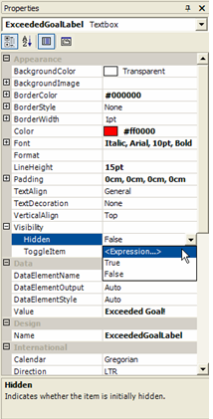

Advantage – Report Interactivity
In Access, all reports (not referring to DAPs) are rendered statically, that is, there is no interactivity within the report (see Figure 9).

Note that Data Access Pages (DAP) are a relatively new feature to Access and facilitate web-based data interaction. They do provide limited reporting functionality and interactivity, however they have been known to have performance issues and be somewhat inflexible in design. As such, a purpose-built reporting solution such as Reporting Services is recommended.

Figure 9 – A Report in Access has no interactivity – even text cannot be copied from the report.
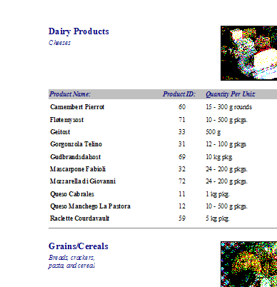

Reporting Services, on the other hand, offers a great level of interactivity which can be employed in reports, such as document maps, drill down and drill through.

A document map is a table of contents that is automatically generated when a report is rendered in an HTML, PDF or Excel format. The document map is generated based on labels that can be set in most report items, such as matrices and tables (see Figure 10 and Figure 11). Document map labels can also be expressions. Clicking items in the document map causes the report to refresh and display the area of the report corresponding to the item in the document map.

Figure 10 – Setting the Label property for a control so that it will appear on the document map
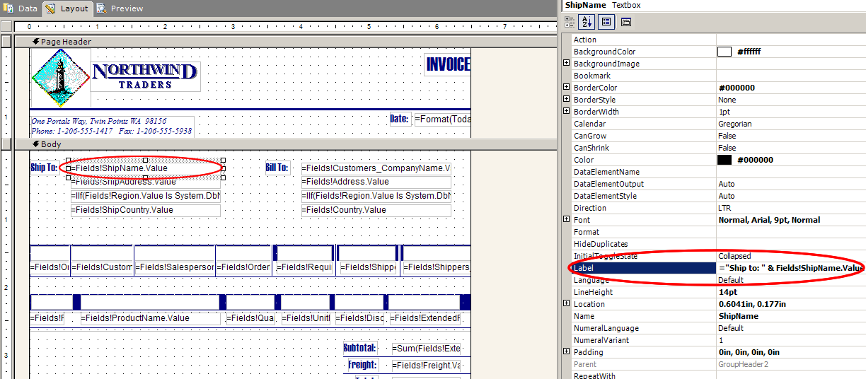

Figure 11 – A clickable document map is automatically generated based on the control's label
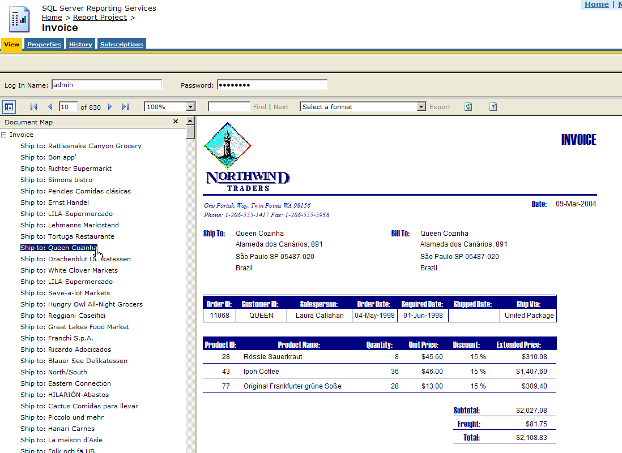

Drilldown is a feature which allows a user to selectively show or hide detail in a report. Drilldown would be useful in such a situation as in a report that shows sales by year. Users are able to expand any line by clicking the + sign, which shows sales by month for the selected year (see Figure 12).

Figure 12 – You can drill down to further levels of data in a Reporting Services report by clicking the + sign.
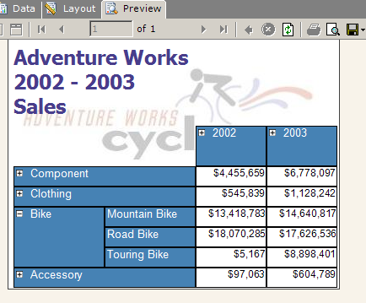

Drill through is a feature which lets you insert a hyperlink which links to another report to show additional details. An example would be providing a link from an order summary report (see Figure 13) to details on a specific order (see ).

Figure 13 – Note that when the Order Number link is clicked, you Drill Through to the Order Details report.
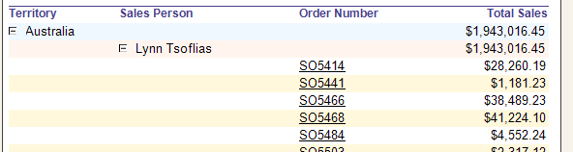

Figure 14 – This report was shown via the Reporting Services Drill Through feature
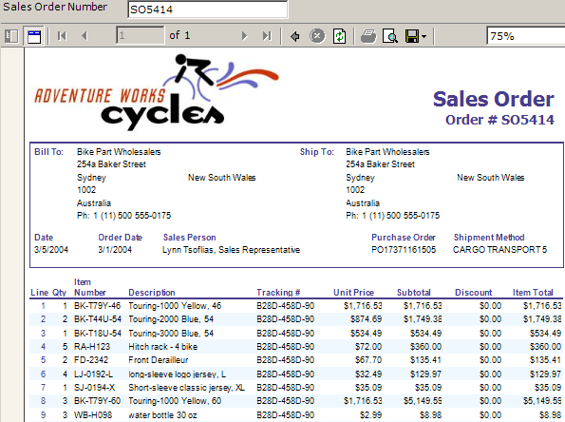

This document focuses on importing existing Access reports in Reporting Services. Taking advantages of these new features (document map, drilldown and drill through) is beyond the scope of this document. For instructions on using these, visit Microsoft’s Adding Interactive Features at http://msdn.microsoft.com/library/en-us/RSCREATE/htm/rcr_creating_interactive_v1_4vqr.asp

Similarity – Parameters
When viewing a report in Access, you are shown a popup prompt for any required parameter values. These parameters are used to determine report display information, such as a date filter to restrict the report to display data corresponding to the dates entered in the parameter boxes (see Figure 15).

When viewing a Reporting Services report, a bar in the report header is automatically generated that contains a textbox for each required parameter (see Figure 16). When the report is viewed these parameters can be entered and submitted, causing the report to refresh and display data based on the new parameters.

Figure 15 – Access: Entering Report Parameters
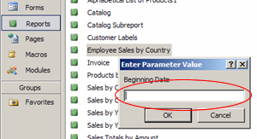

Figure 16 – Reporting Services: Entering Report Parameters
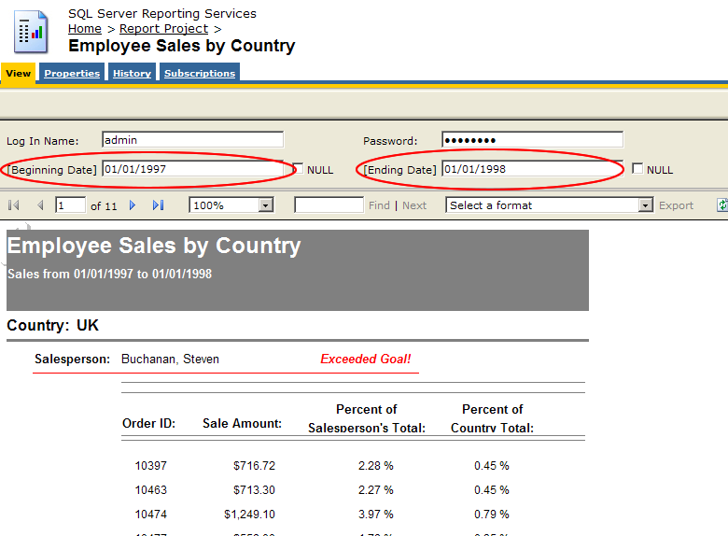

Advantage – Integrated Security
In Access, to make use of Windows integrated security you need to separately set up separate security policies stored in the system.mda file (see Figure 17). This can result in consistency and maintenance issues as separate policies need to be maintained for Active Directory users and Access users.

Figure 17 – Setting Security in Access usually involves re-entering users from Active Directory
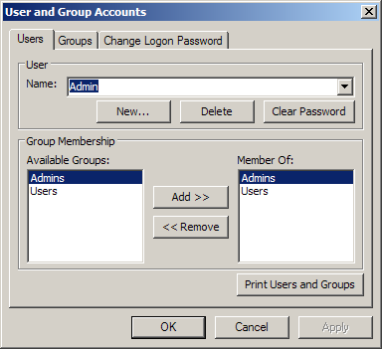

Figure 18 – Reporting Services is integrated with Active Directory, so there is no need to maintain two user lists
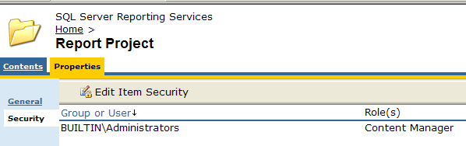

Reporting Services makes use of existing NT / Active Directory groups and user structure along with its own role-based security model to secure each report or report set (see Figure 18). Each user can manage their own set of private reports as well as view any publicly published reports. For information on configuring role-base security in Reporting Services, see Microsoft’s Understand Role-Based Security at http://msdn.microsoft.com/library/en-us/rswork/htm/rms_security_v1_488h.asp.

Advantage – Extensible Open Architecture
The Access report architecture has several major drawbacks:

- To view reports, Access (or the Snapshot Viewer) must be installed
- To programmatically call Access functions, Office automation COM libraries need to be used and Access needs to be installed
- Access reports are stored in binary format. They can become corrupted, leaving them unrecoverable

The Reporting Services architecture, on the other hand, offers several advantages over Access reports, including:

- To view reports, all that is required is a web browser. This also has the flexibility to output reports to any number of different formats, including Excel and XML
- To programmatically use Reporting Services functions, you call Web Services via the Reporting Services Application Programming Interface (API). Web Services are a viable and dependable solution because they are an industry standard – not just a Microsoft standard
- Reports in Reporting Services are stored entirely in plain-text XML (see Figure 19), so the reports can be easily accessed, backed up and recovered

Figure 19 – All reports in Reporting Services are stored in XML. Changes can be made manually, and will be reflected in the report layout
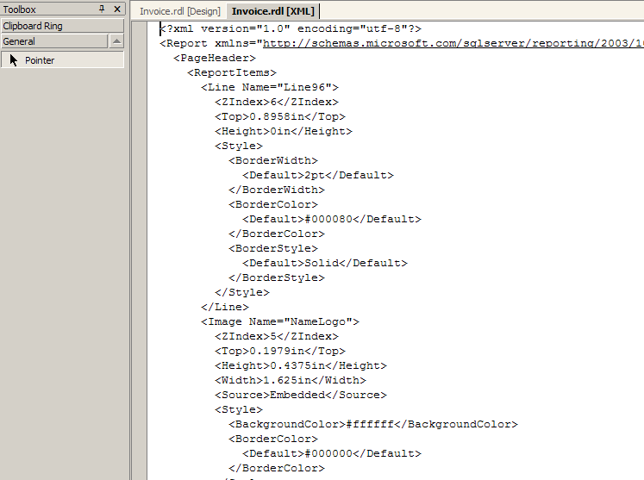

Advantage – Scheduling of Reports
Also included with Reporting Services is a convenient scheduling and delivery function which allows customized reports to be delivered to a set of users according to a schedule (as shown in Figure 20). For example, Reporting Services can automatically send sales reports to designated recipients via email at the beginning of each month.

Figure 20 – You can schedule your reports to be sent to you via email in a variety of different formats
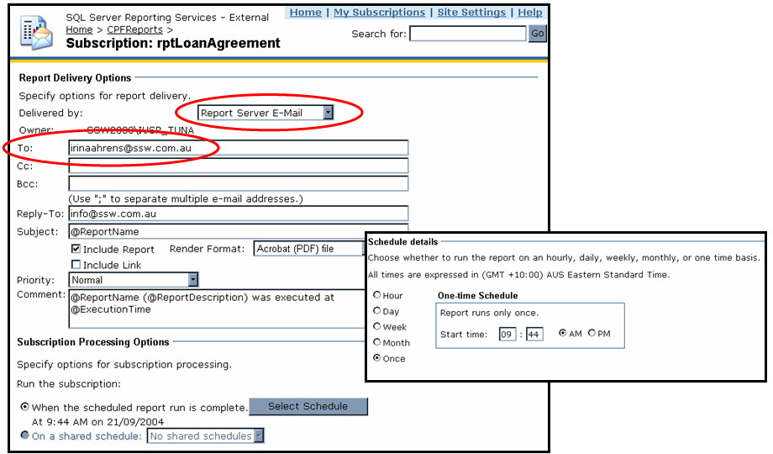

Difference – Cost Structure
Access requires that every user in an organization who needs to view and work with reports have a license for Access or Office. For medium to large organizations, this option is often economically unfeasible.

Reporting Services can potentially be a cheaper option, as it typically only requires one existing Microsoft SQL Server license to run (which most companies already have). Unlike with Access, users do not require any client software to be installed – they view reports simply by accessing the web-based report manager on the report server via a standard web browser.

In a typical company scenario (where Reporting Services and the SQL database are installed on the same single-processor PC), you can either purchase a processor license for SQL Server or some number of client access (per seat) licenses (CAL). Note that different licensing structures apply for other scenarios, such as SQL Server running on a separate machine to Reporting Services. More details about licensing can be found on Microsoft’s How to License Reporting Services at http://www.microsoft.com/sql/reporting/howtobuy/howtolicensers.asp.

Designing reports for Reporting Services also requires a report designer. You can use Visual Studio .NET, although several competitively priced third-party report design tools are available. See the Microsoft partners page at http://www.microsoft.com/sql/reporting/partners/softwareapps.asp for more information. The report designer does affect the cost of migrating to Reporting Services; however the total cost of using Reporting Services is potentially lower than the cost of licensing Access for each individual client machine.

Another possible scenario is running one full copy of Access on a server and installing run-time versions of Access on multiple machines. Although this would be a cheaper option than running Reporting Services with SQL Server, it is not a common practice as using the Access runtime is not as simple as copying and running an executable file. It requires a large installation and has some issues.

Advantage – Multiple Data Sources in a Single Report
In Access, you specify the query or table to use for a report record source via its RecordSource property. If a report requires data from multiple data sources, a subreport has to be created for each data source. This is not resource efficient. However, using subreports in instances where they are embedded in multiple reports, is efficient as it promotes report reuse.

Reporting Services, on the other hand, makes use of built-in data region controls such as tables and lists. Reporting Services enables multiple data sources to be accessed from a single report, which encapsulates all the features of multiple subreports into one report. This vastly improves the manageability and can improve the performance of the report (as shown in Figure 21).

Figure 21 – Reporting Services lets you specify a data source for every control
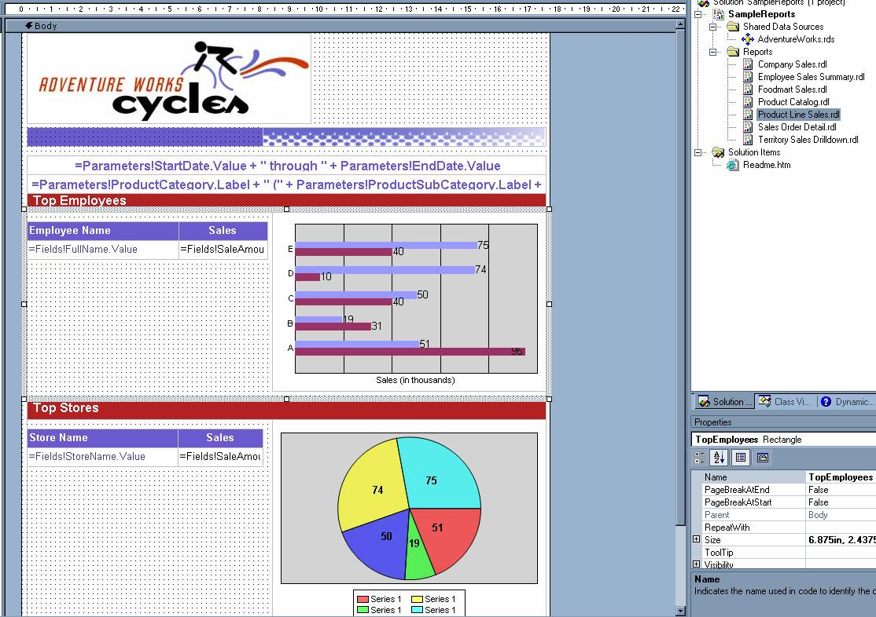

Reporting Services also supports subreports, although it is advised that data region controls are used where possible. Data region controls perform better than subreports.

Advantage – Design Flexibility: No More Banded Reports
In Access, the report layout requires arrangement of items on the report using bands, that is, horizontal sections on the report. These sections may include report header, report footer, page header, page footer, groups, and detail (see Figure 22).

Reporting Services, on the other hand, provides a more flexible layout – data regions provide grouping and detail, and multiple data regions can be placed anywhere in the body of the report, even side-by-side (see Figure 23). Examples of data region controls are the list, table, matrix, chart, and subreport controls. Each can be bound to a separate dataset and each has its own grouping, filtering, and sorting properties.

Figure 22 – In Access, tabular data is limited by report bands
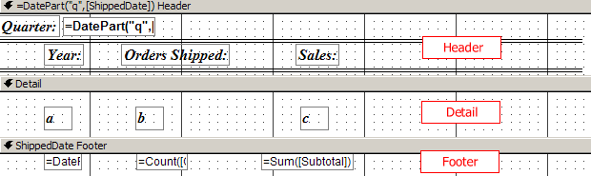

Figure 23 – However, in Reporting Services, group headers, detail and footers can be placed anywhere in the report layout
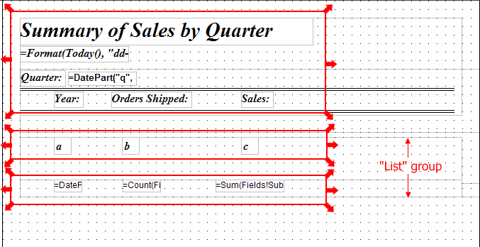

Advantage – Extensible to Other Devices
Access reports can only be viewed by users with Office, Access or the Access Snapshot viewer installed. This limits their availability to a Microsoft Windows environment with one of the applications installed.

Reporting Services reports, on the other hand, are web based and have an open architecture. This enables them to be accessed from a virtually unlimited set of applications and devices, such as:

- Pocket PCs
- Windows .NET forms
- ASP .NET pages
- Mobile phones
- Legacy devices

Any device that can view web pages can view Reporting Services reports – reports can be customized to deliver data in the best format to information consumers. Moreover, the Reporting Services programming model enables you to integrate and customize Reporting Services reports in your .NET applications.

Similarity – Control Toolbox
Table 1 compares design controls available in Access and design controls available in Reporting Services.

Table 1 - Differences between Access and Reporting Services report design controls
Access Control | Reporting Services Equivalent
Control Wizard | Not supported – wizards pop up where appropriate e.g. the image control, however they cannot be turned on or off.
Label
Textbox
Option Group | Not supported
Toggle Button | Not supported (this was an unnecessary control for a report)
Option Button | Not supported
Check Box | Not supported
Combo Box | Not supported
List Box | Not supported
Command Button | Not supported
Image
Unbound Object Frame | Not supported (for example embedded Excel spreadsheets).
Bound Object Frame
Page Break | PageBreakAtEnd or PageBreakAtStart property for the report item (rectangle, table, matrix, list, chart, or group)
Tab Control | Not supported
Subform / SubReport
Line
Rectangle
More Controls… | Not supported
[New Control] | - used for normal report data
[New Control] | - used for crosstab data
[New Feature] | - used for simple lists

Note that the form controls (Option Box, Group Box, Check Box etc.) are non-interactive in Access and provide no additional functionality. As such, they were not included in Reporting Services.

Difference – Deploying Reports
The main difference in deployment of reports between Access and Reporting Services is that Access databases run on the client machine, whereas Reporting Services reports run on a server.

Access reports are deployed simply by copying or uploading the Access database to the target machine, or accessing via a network share. The database can then be opened on the target machine and reports can be run.

Reporting Services reports need to be deployed before being available for viewing. The deployment process is essentially building the project (checking for syntax problems) and then calling a Web Service to upload the report description to the specified report server’s database. This is all done automatically – deploying reports is as straightforward as selecting the report project from the Solution Explorer in Visual Studio and clicking the Deploy Report Project menu option (see ). If you are using any custom .NET assemblies with your reports, they must be manually copied to the reporting server with the reports.

Figure 24 – For others to view your reports you need to select Deploy Report Project
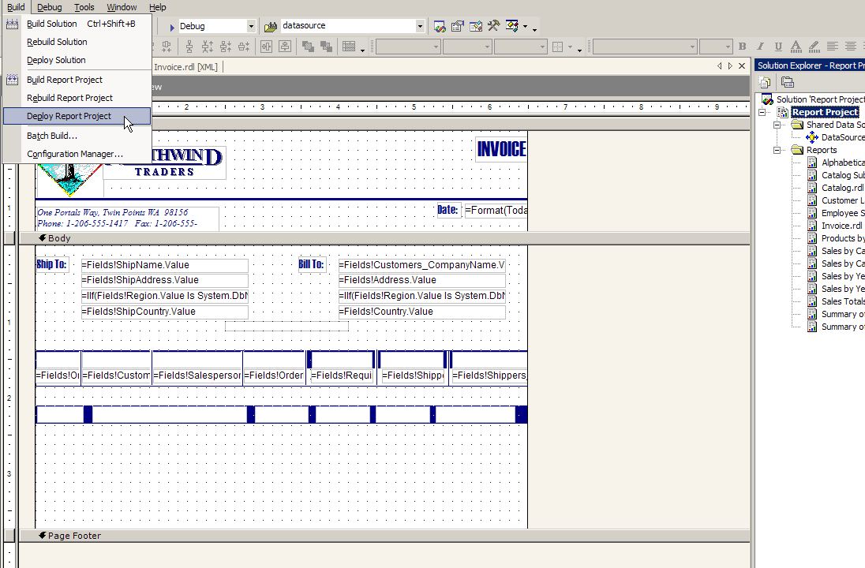

Disadvantage – Making Reports Available Offline
In Access, when you want to use reports offline (i.e. not on the server), you need the following components (assuming your data has been moved to SQL Server and you are using Access reports):

- A copy of SQL Server installed on the local machine
- SQL Server Replication set up with a copy of the report data
- A setup executable that copies the Report .mdb file locally to your PC

To view and modify reports offline in Access all that is required is a copy of the Report .mdb file on the local PC.

Reporting Services, on the other hand, requires:

- A copy of SQL Server installed on the local machine
- SQL Server Replication set up with a copy of the report data
- Reporting Services installed (including IIS)
- A setup executable that copies the Reports from the development PC to the local PC and runs a custom deployment script

This last step is much more complicated than merely copying files from one PC to another. The report (RDL) files must be copied to the local PC, and then the RS.exe application must be called along with a deployment script. The deployment script contains code to send the reports to the local machine via a web service, and must be written and debugged manually, which is potentially time-consuming.

Conclusion
Microsoft® SQL Server™ Reporting Services is a powerful reporting solution that provides centralized management, an open architecture for robust extensibility, and seamless integration into existing business environments.

There are several advantages, similarities and differences between Microsoft Access and Reporting Services which should be noted when considering migrating to Reporting Services from Access.

For more information:
http://www.microsoft.com/sql/!href()

Did this paper help you? Please give us your feedback. On a scale of 1 (poor) to 5 (excellent), how would you rate this paper?!href(mailto: sqlfback@microsoft.com?subject=Feedback: [What’s New and Different for the Access Developer Moving to SQL Reporting Services])

