Lab 2: Migrating from Access to SQL Server
In this lab, you will migrate your Access 2003 database to SQL Server 2000.
You will use the following programs during the upsizing process:
- SSW Upsizing PRO!
- SSW Performance PRO!
- SQL Server Enterprise Manager
- SQL Server Query Analyzer

To access all course resources online visit: http://ssw.com.au/ssw/Events/2004AccessToSQLServerAndNET/resources.aspx

If you receive any security warnings from Access, click Open.
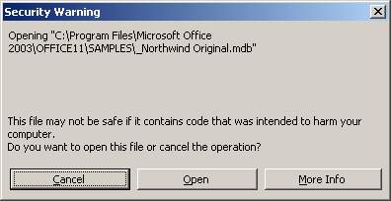

Exercise 1
Set up a copy of your live Access database for testing
It is recommended that you print this document to make it easier to follow the steps.
- Open the supplementary whitepaper
    - Open the Microsoft whitepaper, How to Migrate Your Backend from Access to SQL Server 2000 from http://www.ssw.com.au/ssw/standards/DeveloperSQLServer/. You will be referring to this document throughout this lab.
    - Turn on the document map (View–>Document Map) in Word to make navigation easier.
- Set up a copy of your live database
The first step in upsizing is to make an “offline” copy of your live database. This is so that you can perform a test migration and iron out any deployment issues before upsizing the live database.
    - Download NorthwindApp_2003.mdb and NorthwindData_2003.mdb from http://www.ssw.com.au/ssw/Standards/DeveloperSQLServer/Resources/NorthwindMDB
    - Save them to a temporary location, e.g. C:\temp
- Re-link the temp databases
The front-end database has the location of the backend hard-coded. So when you copied the two databases to the temp folder, the links became incorrect. You need to re-link the front-end to the backend in the temp folder.
    - Open NorthwindApp_2003.mdb in the temp folder.
    - Select Tools –> Database Utilities –> Linked Table Manager
    - Click Select All and check Always prompt for new location
    - Click OK, and locate NorthwindData_2003.mdb in the temp folder. Click Open. Click Close in the Linked Table Manager once the tables have been refreshed.

Exercise 2
Migrate a test copy of your live Access database
- (Optional) Check the Performance of Your Forms
Going through this section is optional.
    - Download and run SSW Performance PRO! from www.ssw.com.au/PerformancePRO
    - Click Next then browse to NorthwindApp_2003.mdb in the temp folder then click Finish. Performance PRO! tests the performance of your forms and generates two reports.
    - Click Publish It with Microsoft Word for each report and save to your hard drive
    - Close the reports and Performance PRO!. You do not have to fix any of the forms reported by Performance PRO! – as you will see, there are no poorly performing forms. In a real system you may need to fix up any slow forms.
- Change Your DAO Code to Use ADODB
    - Refer to step 5 in Part B of the whitepaper (Page 19) for how to convert your DAO code to ADO. Open the DAO to ADODB Example form in NorthwindApp_2003.mdb. This form simply populates 3 fields from the first record in the Employees table when you click Show Record.
    - Read through and uncomment the ADO code. If you cannot see the uncomment and comment toolbar buttons, unhide the Edit toolbar.
    - Delete or comment the original DAO code
    - Close the Visual Basic window and re-open the form to see that the data appears in the text fields when you click Show Record.
- Remove Access Permissions
    - Open the front-end database (NorthwindApp_2003.mdb)
There is a group called Receptionists in the front-end database that has read-only permissions to all database objects. There is a user named StaceyJones who is part of this group.
    - Delete the Receptionists group and the StaceyJones user from the front-end database in Tools –> Security –> User and Group Accounts…. This is to ensure the upsizing wizard has full access to all database objects.
- Identify Database Problems
    - Run SSW Upsizing PRO!
    - Click Next and select Step 1: Before Upsizing.
    - Continue clicking Next until you see the QueryTimeout box. Enter a value of zero (0) and click Set QueryTimeout.
    - Continue clicking Next until you see a prompt to specify the path of your backend database. Locate the test copy of NorthwindData_2003.mdb in the temp folder and click Finish to begin the scan.
    - Select Show Errors Only and click View Results. This report shows all errors found in the database that will prevent upsizing to SQL Server.
    - Click Publish It with Microsoft Word
- Fix Database Problems
    - Fix the errors detailed in the SSW Upsizing PRO! report using the suggested actions
    - Once the 3 errors are fixed, run SSW Upsizing PRO! again using Step 1: Before Upsizing to ensure there will be no upsizing errors
- Run the Upsizing Wizard
Once SSW Upsizing PRO! reports no errors, you can run the Microsoft Upsizing Wizard.
    - Follow step 10 in Part B (Page 31) of the whitepaper for steps to running the wizard. Ensure that you are running the wizard on the backend database (NorthwindData_2003.mdb). Use the name (local) as the SQL Server name (or the name of your SQL Server computer if it you are not connecting to the one on your computer). Use NorthwindSQL as the database name, as shown below.

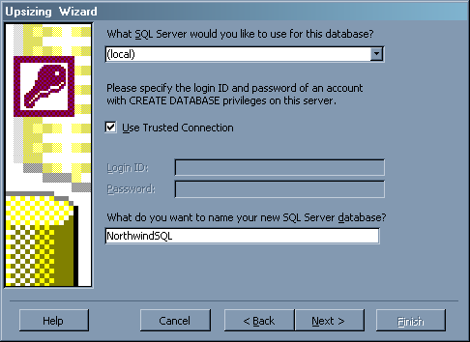

    - Open SQL Server Enterprise Manager, and expand the Microsoft SQL Servers –> SQL Server Group –> (LOCAL) –> Databases node. Ensure that your upsized database, NorthwindSQL, is in the database list.
- Fix Issues in the Upsized Database
The first thing to do once your test database is upsized is to ensure all relationships and tables were successfully upsized.
    - Download and run SSW Upsizing PRO! from www.ssw.com.au/SSW/UpsizingPRO
    - Select Step 3: After Upsizing
    - Continue clicking Next until you see the screen to specify the Access and SQL Server database connection strings
    - Browse for the Access backend database (NorthwindData_2003.mdb) and the SQL Server database (NorthwindSQL).
    - Fix any errors reported by SSW Upsizing PRO! using the actions suggested in the report.
- Re-link the front-end
You now need to change the links in the front-end (NorthwindApp_2003.mdb) to point to the new SQL Server backend (NorthwindSQL).
    - Open NorthwindApp_2003.mdb. Follow the steps in Step iii: Re-Link the Access Front-end to the SQL Server Backend in Part B-11 of the whitepaper (Page 37).
Now that your front-end is linked to your SQL Server backend, you need to update any code references to point to SQL Server.
- Fix connection strings to point to the SQL Server database
    - Follow Step iv: Use Find & Replace to Update Connection Strings in Part B-11 of the whitepaper (Page 42). Select Current Project to ensure all of your code is searched.

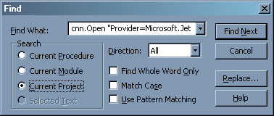
- Re-create the Access queries and VBA functions as SQL Server Views and User-defined Functions

bleh Step iv: Use Find & Replace to Update Connection Strings
Now that your code is updated to work properly with the SQL Server backend, you should manually convert any Access queries and custom VBA functions used by those queries. In a real system, this will provide a significant boost in application performance, as all the work will be done on the database server.
    - Follow Step vi: Convert Access Queries and Custom VBA Functions to SQL Server Views and User-Defined Functions in Part B-11 of the whitepaper (Page 43) to convert the IsWestCoast VBA function and WestCoastCustomers query to a SQL Server user-defined function and a view, respectively. Then follow the steps to link the view in Access.
Note: You can use the electronic version of this document to copy/paste the SQL, to save typing.
    - Make sure you save the SQL script as changes.sql in a Scripts folder.
- Recreate Permissions in the SQL Server Database
Now that the live database has been upsized and final changes made, you can reconfigure security. In this step, you will recreate the Receptionists group in Windows Active Directory and see how you can use Windows security in SQL Server.
    - Right-click My Computer. Click Manage.
    - Expand the System Tools –> Local Users and Groups –> Groups node as shown below.
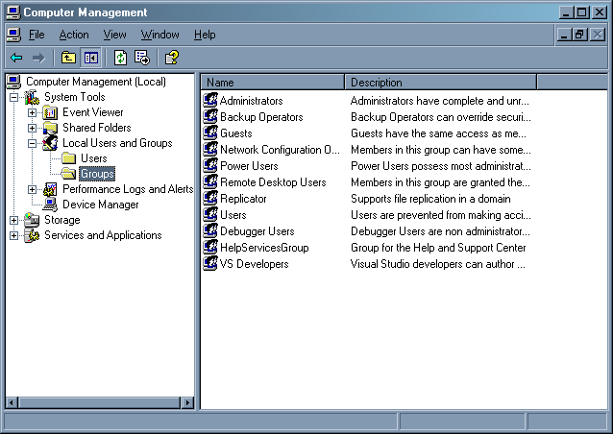
    - Create a new group called Receptionists
    - Open Enterprise Manager
    - Expand the (LOCAL) –> Security –> Logins Node
    - Right-click –> New Login…
    - Click the ellipsis button
    - Select the Receptionists group and click Add and OK.
    - Set the default database to NorthwindSQL as shown below. Use (LOCAL) (or your server name) instead of VPC-ROADSHOW.

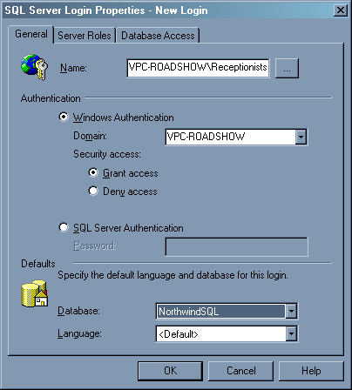
    - Select the Database Access tab and check the box next to NorthwindSQL as shown below. Under database roles, tick db_datareader. This gives the group read-only access to the NorthwindSQL database and its objects (tables and views). Click OK.
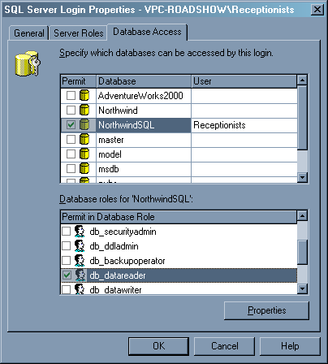
A Receptionists user with the specified permissions is automatically created in the NorthwindSQL database.

