Import reports

Delete unused reports
Keep
- Employee Sales by Country
- Sales by Category Subreport
- Sales by Category
- Invoice

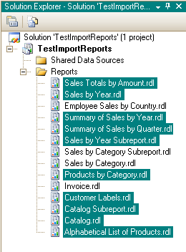

Create shared data source
C:\Program Files\Microsoft SQL Server\MSSQL.1\MSSQL\Data
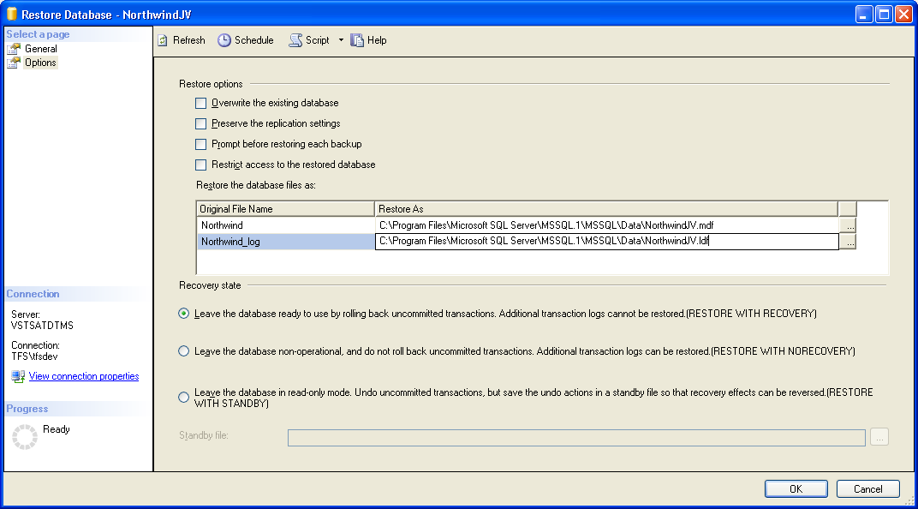

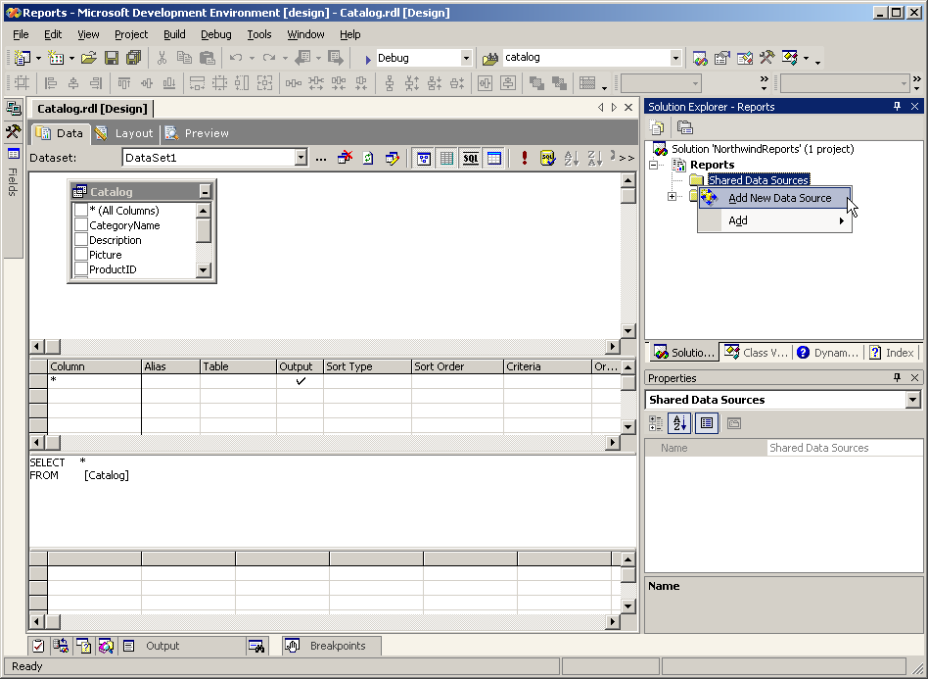

Change data source of all reports
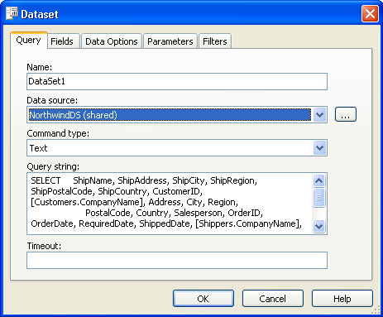

#1 Invoice report

Preview to see the 2 problems
- It is pointing at access
- 830 pages (no parameter)
- 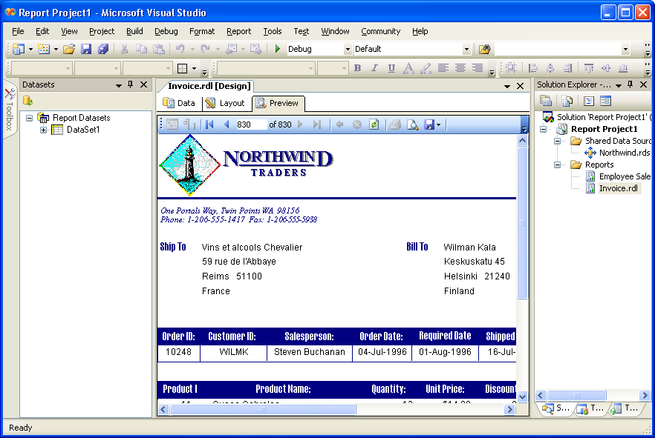

Modify Invoices view in Northwind

From dbo.Customers.CompanyName AS CustomerName
To dbo.Customers.CompanyName AS Customers_CompanyName

From dbo.Shippers.CompanyName AS ShipperName
To dbo.Shippers.CompanyName AS Shippers_CompanyName

Change to * so the field names refresh

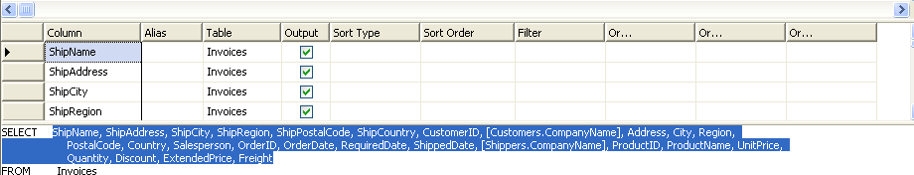

Add parameter – add where clause and it all happens automatically
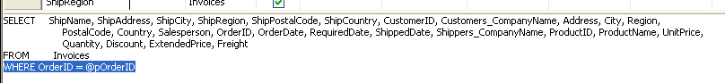
WHERE OrderID = @pOrderID

Test
with OrderID 10643

Show
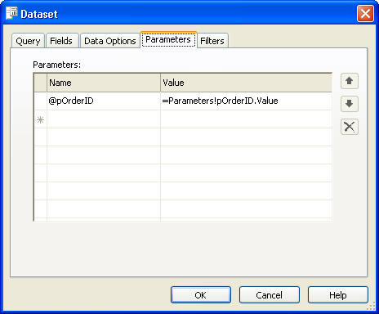

See (+ change to Integer)
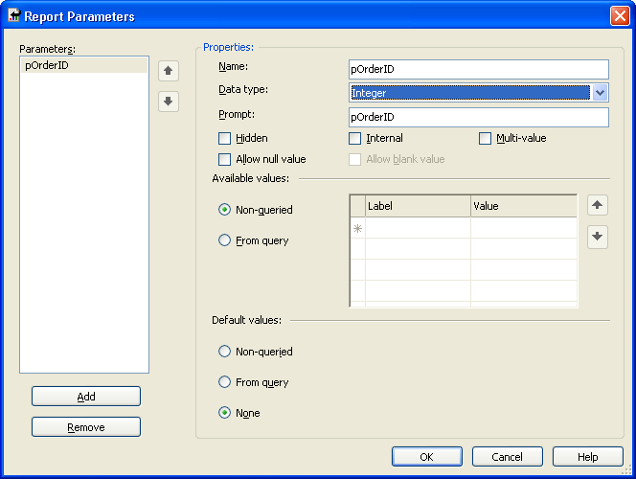

Show multi-value
- Create new dataset with SELECT OrderID FROM Orders
- Change report parameter to multi-value
- Change value list

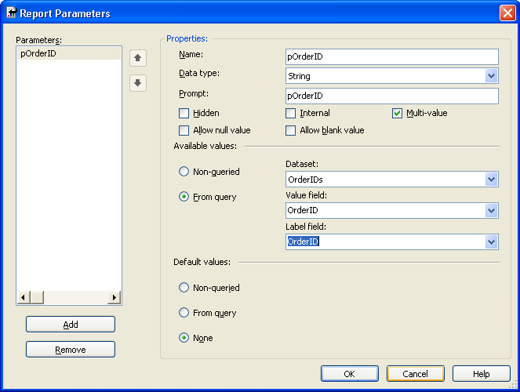

- Change query to use IN

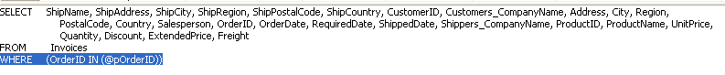

Pick dataset again in designer
BUG: Because I put in a 2nd dataset – I lost the dataset of the mainlist

If you preview you will get this error.

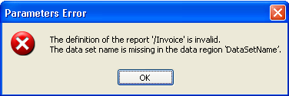
re-pick the dataset in the designer for control GroupLevel0

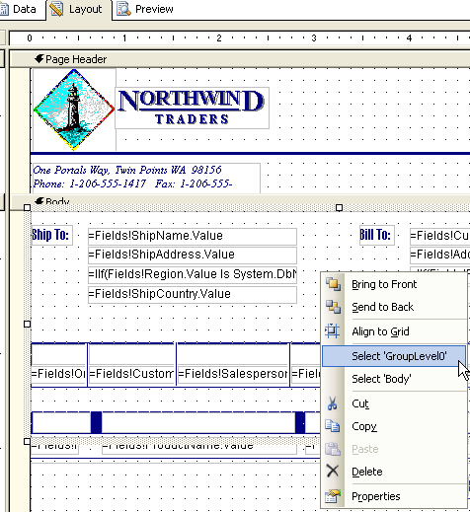

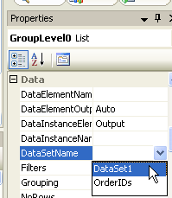

#2 Employee sales by country report
Make sure dataset is pointing to SQL Server

Create Order Subtotals as view – same as the Access query
SELECT OrderID, SUM(CONVERT(money, (UnitPrice * Quantity) * (1 - Discount) / 100) * 100) AS Subtotal
FROM dbo.[Order Details]
GROUP BY OrderID

Call it [Order Subtotals]

Create Employee Sales by Country view – same as in Access

SELECT DISTINCT Employees.Country, Employees.LastName, Employees.FirstName, Orders.ShippedDate, Orders.OrderID, [Order Subtotals].Subtotal AS SaleAmount
FROM Employees INNER JOIN (Orders INNER JOIN [Order Subtotals] ON Orders.OrderID = [Order Subtotals].OrderID) ON Employees.EmployeeID = Orders.EmployeeID

Call it [Employee Sales by Country]

Add in WHERE clause
SELECT *
FROM EmployeeSalesByCountry
WHERE (ShippedDate BETWEEN @ID_Beginning_Date_ AND @ID_Ending_Date_)

Set Parameter to Date Time and uncheck Null
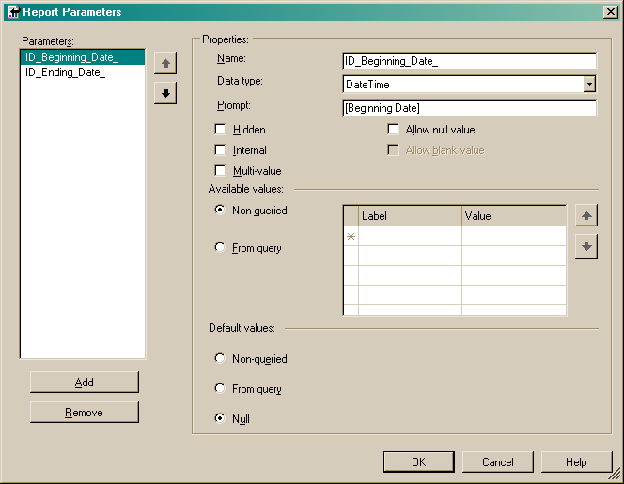
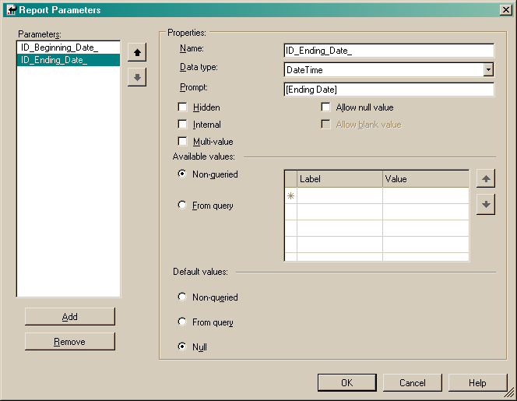

Preview with dates
1/1/1996 and 31/12/1996

Add conditional formatting expression in “Visibility” property for “Exceeded Goal!” textbox
=iif(Sum(Fields!SaleAmount.Value) > 15000, False, True)

#3 Sales by Category Report

Create chart
- Drop in Chart
- Drop Product Sales in data fields
- Drop Product Name in category fields

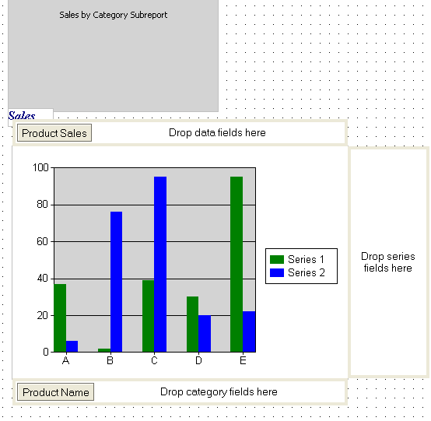

Link reports #1: Modify query in Sales by Category Subreport – add WHERE clause
SELECT CategoryID, CategoryName, ProductName, ProductSales
FROM [Sales by Category]
WHERE (CategoryID = @pCategoryID)

Link reports #2: Link master / child
Go to properties of subreport in main report, parameters tab

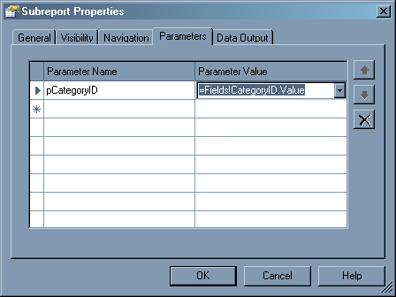

Run

