Lab 3: How to Migrate Access Reports to Reporting Services
In this lab, you will migrate 4 reports from Microsoft Access to Microsoft SQL Server Reporting Services. The 4 reports are:
    - Invoice
    - Catalog and Catalog Subreport (the subreport will be created as part of the main report in the .NET conversion)
    - Employee Sales by Country
    - Sales by Category (the Sales by Category Subreport does not require any extra work to import)

You will be using the following programs during the migration process:
- Visual Studio .NET 2003
- Microsoft SQL Server 2000 Enterprise Manager
- Microsoft Access 2003

To access all course resources online visit: http://ssw.com.au/ssw/Events/2005AccessToSQLServerAndNET/resources.aspx
If you receive any security warnings from Access, click Open.
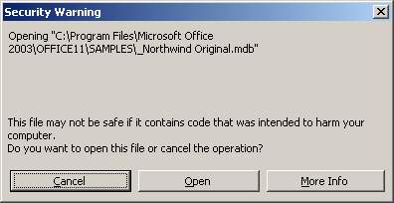

Exercise 1
The First Steps for Migration
It is recommended that you print this document to make it easier to follow the steps.
- Open the supplementary whitepaper
    - Open the Microsoft whitepaper, How to Migrate Access Reports to SQL Server Reporting Services from http://www.ssw.com.au/ssw/standards/DeveloperSQLReportingServices/. You will be referring to this document throughout this lab.
    - Turn on the document map (View–>Document Map) in Word to make navigation easier.
- Create a new Report Project in Visual Studio .NET
    - See step 1 of The First Steps for Migration in the whitepaper (Page 5) for details on creating a Report Project.
- Import the reports into the Report Project
    - Download the NorthwindApp_2003.mdb database from http://www.ssw.com.au/ssw/Standards/DeveloperSQLServer/Resources/NorthwindMDB. NOTE: Do not use the Access databases you were using in Session 2 for this step.
    - Link the tables in the front end Access database (NorthwindApp_2003.mdb) to the Northwind database in SQL Server. If you’re not sure how to do this, see Re-link the temp databases in the Access to SQL hands-on lab (http://www.ssw.com.au/ssw/Standards/DeveloperSQLServer/).
    - See step 2 of The First Steps for Migration in the whitepaper (Page 5) for how to import reports. In this lab you will only retain the four reports listed at the top of this document.
- Create a Shared Data Source
    - See Create a Shared Data Source in the whitepaper (Page 10) for how to create a shared data source which is linked to your SQL Server backend. NOTE: Use Northwind (the one that is installed with SQL Server 2000) as the data source, NOT your upsized database (in case there were errors upsizing in the previous session). Your data link properties window should look like this:

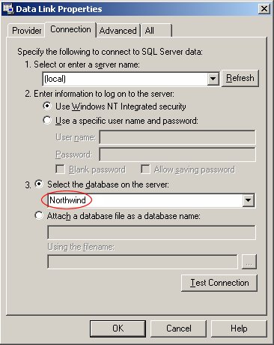
    - Make sure all of your reports are linked to this shared data source so that they all use the SQL Server data and not the Access data. See step 7 of Create a Shared Data Source in the whitepaper (Page 13) for how to do this.
- Delete any build errors that do not relate to the four reports
    - Note the build errors related to the report you want to delete
    - Tick all the build errors related to that report (using the tick box next to the task description). Repeat for all reports that you will not be fixing.
    - Hide all the Checked tasks by right clicking the Tasks and Show Tasks –> Unchecked Tasks
    - Delete the reports that you are not using for this exercise (shown below)
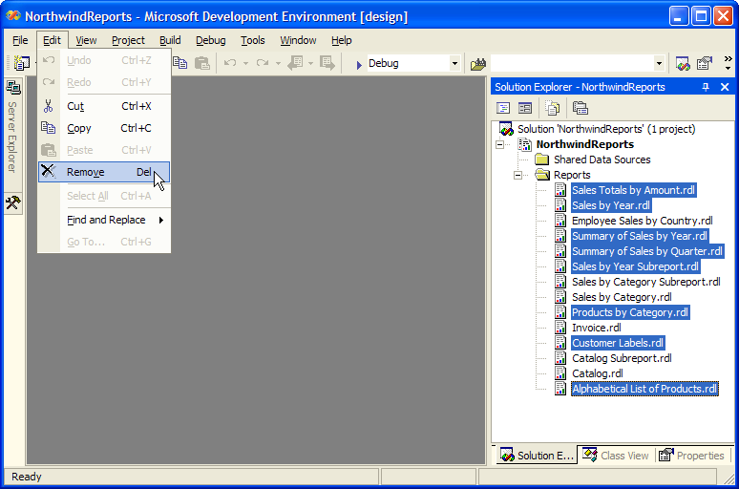
Refer to steps 3 and 4 of The First Steps for Migration in the whitepaper (Page 6) for details.
You are now ready to fix any conversion issues in the .NET Report Project.

Exercise 2
Correcting Report Conversion Issues
The next step is to correct any issues encountered by the Import Wizard when importing your Access reports. In this exercise you will:
    - Fix any warnings shown in the Visual Studio .NET Task List
    - Recreate any queries as SQL Server views and parameterise the reports
    - Fix any other issues
    - Deploy the reports

Follow these 4 sections in the whitepaper:
    - The Steps to Successfully Migrate the Invoice Report (Page 13)
    - The Steps to Successfully Migrate the Catalog and Catalog Subreport Reports (Page 17)
    - The Steps to Successfully Migrate the Employee Sales by Country Report (Page 24)
    - The Steps to Successfully Migrate the Sales by Category Report (Page 34)

