Dear XXX,

Thanks for the meeting last XXX. It was great to meet and discuss your requirements. Our current understanding is that you would like to:

- XXX
- XXX

As per our conversation, here is a little more about our company, and a description of what is required to allow SSW to help you achieve your goals. If you’re interested in how we run projects at SSW please check our Rules to Better Project Management: http://www.ssw.com.au/SSW/Standards/Rules/RulestoBetterProjectManagement.aspx

I'm very happy to discuss any part of this brief proposal will you so feel free to give me a call.

Specification Review
SSW always enters into a specification process with clients before beginning work on a project. Just like you would never build a house with getting an architect to create a plan; SSW always creates detailed plans for the project before starting work.

As you might appreciate, it is not realistic to understand the complexity of your system and give you a realistic estimate after a brief meeting. Our experience tells us we will need to spend a few days to obtain and document the requirements from your project’s stakeholders. This will help you turn your ideas into a more detailed roadmap.

For most projects the specification process is broken up into a number of stages, the first being a specification review, and then further specification work as and when required. For smaller projects, say less than a month in duration, only a specification review may be conducted. It really depends on how complex your project is. At the completion of the specification review it’s likely we will be able to provide you with a ballpark of how big (or small) the project is.

We hope to obtain a broad understanding of the following items during the course of the specification review:

- Ballpark estimates
  - The number of releases
  - The number of ‘man-months’ of work to complete the project
- Requirement Analysis
  - Infrastructure – A summary of your current infrastructure, and technology configuration and limitations.
  - System Overview – An overview the new system requirements.
  - System Integration – An outline of integration required with different data sources. SSW developers will investigate all these systems and create a roadmap for the integration. You will have a confirmation that all sources can be integrated and the method of integration.

- Architectural Design
  - Database Schema – A basic schema of your new database to be designed according to your requirements. The schema will demonstrate the table design and relationships in the back-end.
  - Page Descriptions – A general description of the pages based on the System Overview above, including controls and general business rules which provide the foundation for detailed business logic and implementation.
  - Sitemap – A diagram illustrating the application navigation, and the connection between pages.

- Summary Release Plan – A list of tasks will be broken down based on the Requirements Analysis and the Architectural Design. These tasks will then be estimated and moved into release plans for two week implementations.

Where to from here?
SSW offers both fixed price and time and materials contracts although all specification work, including the specification work is done on a time and materials basis.

- Time & Materials: We work to your specification, billing for the number of hours we accrue. The benefit of this type of development is flexibility – you are able to add, remove and reprioritise development tasks during development.

- Prepaid Time & Materials: Time and Materials clients have the option of a prepaid discount – buying blocks of 40 hours per resource in advance entitles you to a $15 per hour discount on the hourly rate of each developer. You should see the specific terms on our Terms & Conditions.

- Fixed Price: Fixed price contracts necessitate having a specification signed off before work commences. This spec can’t be altered, so additional items must wait until the fixed price contract is completed. The benefit of this type of development is that your expenditure is fixed. Fixed price projects are charged at a 20% premium to the project cost based on the standard hourly rates.

Terms and Conditions
Should this work be accepted, it will be conducted according to our standard Terms & Conditions. These can be viewed at http://www.ssw.com.au/SSW/Standards/Forms/ConsultingOrderTermsConditions.aspx. I will need you to sign a copy and fax it to me on +61 2 9953 3105 prior to work commencing.

Resources
SSW employees are Microsoft Certified, and constantly training in the latest technologies.

OBTAIN CURRENT RATES FROM
http://www.ssw.com.au/ssw/Standards/Forms/ConsultingOrderTermsConditions.aspx

Adam Cogan
Profile: http://www.ssw.com.au/SSW/Employees/employeesprofile.aspx?EmpID=XXX
Standard Hourly Rate=$XXX+GST
Prepaid Hourly Rate=$XXX+GST (minimum 40 hours per resource, subject to prepaid terms)

Gordon Hartley
Profile: http://www.ssw.com.au/SSW/Employees/employeesprofile.aspx?EmpID=XXX
Standard Hourly Rate=$XXX+GST
Prepaid Hourly Rate=$XXX+GST (minimum 40 hours per resource, subject to prepaid terms)

Tim Kremer
Profile: http://www.ssw.com.au/SSW/Employees/employeesprofile.aspx?EmpID=XXX
Standard Hourly Rate=$XXX+GST
Prepaid Hourly Rate=$XXX+GST (minimum 40 hours per resource, subject to prepaid terms)

Estimate
The estimated cost for your specification review is $XXX+GST, based on two developers each working for XXX 8 hour days.

Let’s get started!
Our developers are very comfortable working in other companies’ environments, are all fast learning and will be able to get up to speed quickly and seamlessly to help you.

XXX, I look forward to chatting with you in the next couple of days so we can get cracking and build you some fantastic software.

Kind regards,

Account Manager
www.ssw.com.au

About us
SSW is a Sydney-based consulting company specializing in custom Microsoft based solutions. We have the knowledge, expertise and resources to complete your project within your planned target dates.

SSW can help you with custom software solutions, utilizing the latest Microsoft technologies including ASP.NET, VB.NET, C#, SQL Server, XML, Exchange Server and SharePoint Portal Server. We have been around since 1990, and our developers also have extensive experience with legacy platforms such as VB6, C++, Access, and ASP.
SSW clientele include a variety of domestic and international clients, from medium sized companies (Westbus), government organizations (Australian Fisheries), to large accounting & financial companies (Cap Gemini Ernst Young & Commonwealth Bank), all of which have glowing testimonials.

The Industry Leader in Custom Software Solutions
Our Chief Architect, Adam Cogan, is one of only two Regional Directors in Australia and we are Microsoft Gold Partners, placing us among the top 1.5% of solution providers in Microsoft technologies.


More About Us

Industry Best Practices
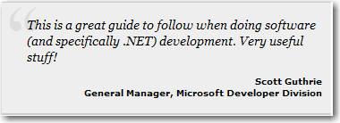
We publish a well known set of industry best practices called the SSW Rules: http://www.ssw.com.au/SSW/Standards/Default.aspx
All our developers are very familiar with these practices, which mean that you can be assured of consistently high standards in the work our developers produce.

Scott Guthrie, the general manager at Microsoft for the entire .NET platform made a reference to the SSW standards recently on his blog:
http://weblogs.asp.net/scottgu/archive/2006/07/27/Rules-to-Better-Software-Development.aspx

Testimonials

 | SSW developed an intranet based ASP.NET solution to help them better manage their staffing timesheets and allow HR to better track employee performance and work expectations.  This solution was nominated for the Microsoft Software Solution of the Year Award. You can read a case study here: http://www.ssw.com.au/ssw/Projects/ML_CommTrack/Documentation/ANZAward_final.pdf  The project was written in .NET with a MS SQL Server backend. It was written in a combination of both VB.NET (for the front-end plus security) and C# (for data access and business logic). The website needed to be very rich in terms of the client interaction, it was originally slated as a Windows Forms project but for various reasons it ended up being web based. This meant that large effort was put into developing and using rich controls with considerable client-side functionality.  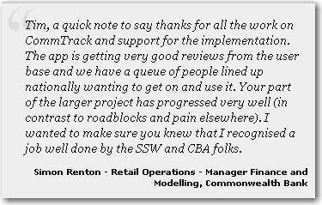  Simon Renton Contact Details:  rentons@cba.com.au  9312 8207
 | Sportstec is a leading provider of sporting technology designed to maximise individual and team performance.  Our focus is on helping their clients by using all the benefits of leading-edge technology. That means working closely with individual athletes, coaches, teams, sports agents and sporting organisations to develop products that are useful and relevant to their sport and their ambitions.  Coda is Sportstec’s 7th unique Software development for Sporting Game or Coaching analysis.  The concept for this development was to create a portable solution for the coding of sporting performance. A PDA was chosen as the ideal platform.  The majority of our development is done in-house, however our developers were fully committed at the time we needed to bring Coda to market.  Sportstec Website  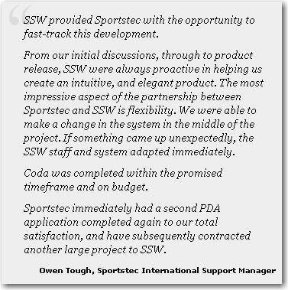  Owen Tough – Contact Details  9979 1700
 | Westbus is Sydney's largest private bus company serving the communities of Western Sydney and the Hills District by providing local, city, school and charter bus services.  SSW developed Westbus' Charter Booking system to serve multiple concurrent users based at the various Westbus depots which service the Western Sydney region. The objective was to replace an existing DOS system, to automate quote calculation and to integrate with Microsoft Great Plains Accounting for invoicing.  View the Case Study  The application was developed as an ASP.NET intranet application using a 4 tier design. The .NET Framework 1.1 was used in conjunction with SQL Server. The system generates reports powered by Crystal Reports whilst being exportable to Adobe Acrobat PDF.  Daniela Fontana, Westbus Business Development Manager says “SSW’s simple and efficient design has ensured the application has been quickly accepted by the depot users?  Our work for Westbus was recognised by Computer World in their article "NET helps wheels go round at bus company" and Microsoft also commissioned a .NET Snapshot.  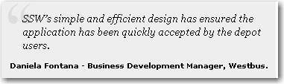  Daniela Fontana  02 9890 0031

More Testimonials

