Formatting a Floppy Disk
Formatting a floppy disk deletes any existing files and prepares the disk for new files

First we format the disk
- Put Floppy disk in A: drive
- Left Double click on My Computer (icon on desktop)
- Right click on 3.5 floppy ( A: ) A menu will appear
- Left click on Format
- The screen shown below will appear: Ensure your screen looks the same.
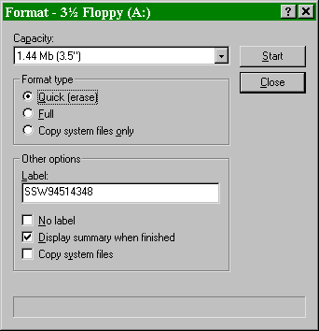

- Click on Start Allow the disk to format
- Click on Close
- Click on Close again

Second we scan the disk for errors
- Right click on 3.5 floppy ( A: ) A menu will appear
- Click on Properties, then click on Tools
- Click on Check Now
- Make sure your screen looks like the one below i.e. Thorough and Automatically fix errors are selected.
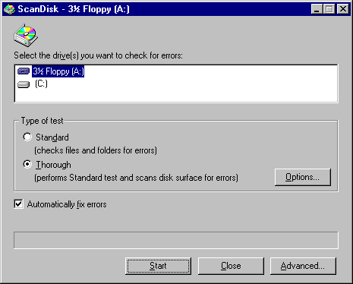

- Click on Start and allow the disk to scan
- The screen shown below will appear. Check the 2nd line for “0 bytes in bad sectors.” If it is more than 0, then put a ‘B’ on the disk next to the date.
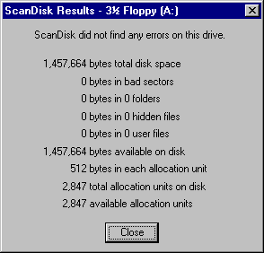
- Click on Close
8. Put a label on the disk carefully and put the date in bottom left of label.

Third, we return to ‘My Computer’
- Click on Close
- Click on the X in the top right corner of active box (ie Blue title bar)

