Live Stats
- This document describes how to access and use Live Stats to get a detailed report on the internet activity on www.ssw.com.au

Description
Accessing and reading statistics from Live Stats is a fairly straightforward process.

- Browse to http://bee/ssw/stats.asp
- Click on “Stats on Seal”
- Hover the mouse on "Referrals Report" on the Left Hand Side and select "Referrals by Search Engine" from the slide out dialog

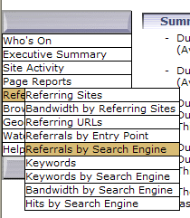

- Click on “Month” on the main page to view the current report for the current month

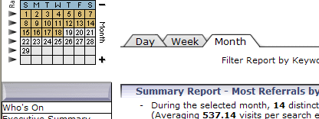

- A list of reports is displayed as shown below.

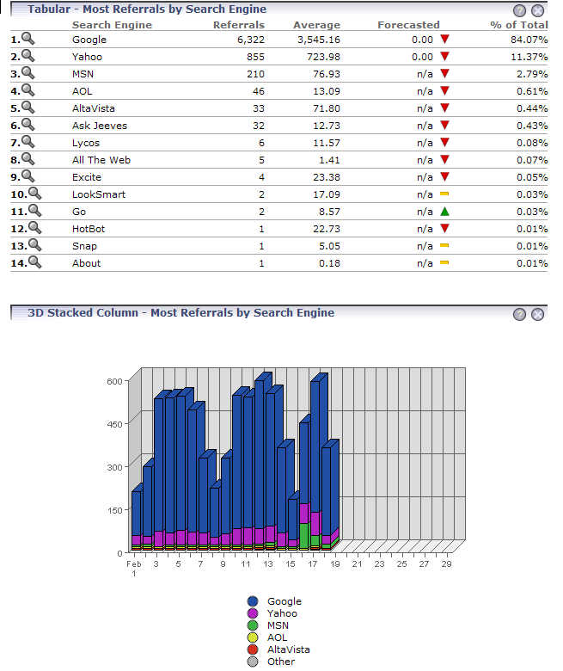

6. To view the statistics for different months, we need select from the calendar on the Left Hand Side the month we require with the +/- and select activate report for that selected month
Click to activate
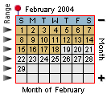
Select Month

