Standard Using Version Table
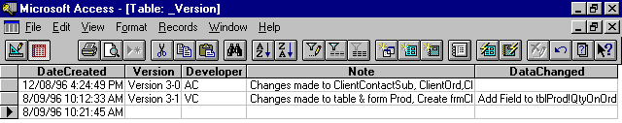
If your Database does not consist of the table “ _Version”, you must import it:

You then need to put the expression = Dmax(“Version”,”_Version”) on the Main Menu
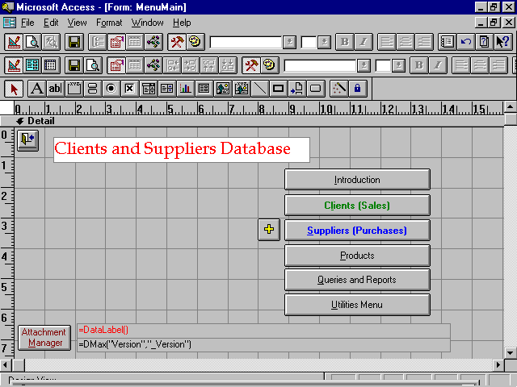
Every time you work on a database, you need to enter a new record in table “_Version”. Following are the description of each field in the table:
- DateCreated Date you work on the database
- Version Version of the database ie. Version 3-01
(you must increase the version every time you work on the database)
- Developer Your initials ie. VC
- Note Description of what you have changed exclude changes made to tables

_VersionData
- Your database should also have a _VersionData table. This is for any changes made to tables in ....Data.mdb
ie. Add table Client
Add Prod!QtyOnOrd (means add field)
Rename Prod!QtyOnOrd to Prod!QtyOrd (means rename field)
Rename Product to Prod (means rename table)
Delete Prod!QtyOnOrd (means delete field)
Change Prod! Qty.Text to Prod!Qty.Number(single) (means change field properties)

