Version numbers in Microsoft Word and Excel

We always like having the version number in the footer of our document. Ie.

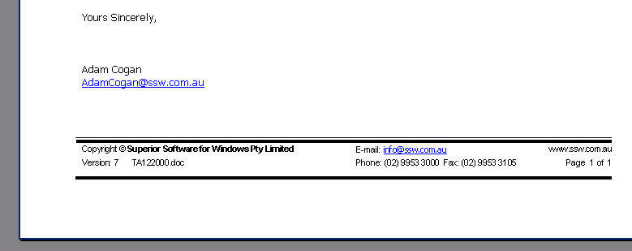

How do you do it in Word?
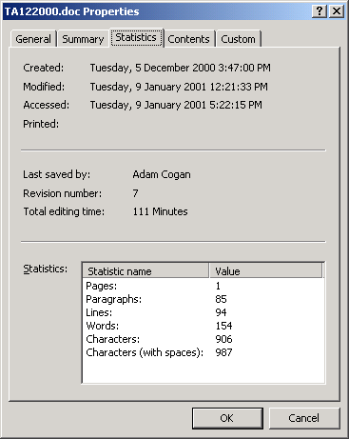

Go to the footer and type (the curly braces are a word field and you need to type CTRL+F9)
Version: { DOCPROPERTY "RevisionNumber" \* MERGEFORMAT }

This gives you Version: 2

How do you do it in Excel?

Well you have the same properties
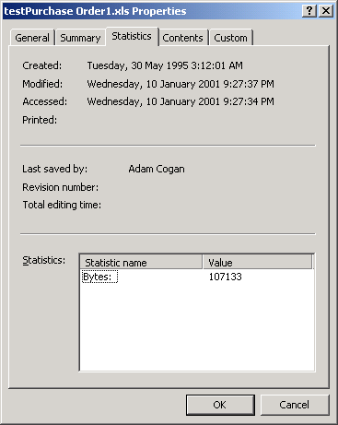

But where is the revision number. Well Microsoft left it out. (See knowledge base article Q214393 for more info).

OK but you can add the code in to do it.
Open Code Alt+F11
Create a New Module

Option Explicit

Public Function SSWRevisionNumber()

Dim objWorkbook As Excel.Workbook
Set objWorkbook = Excel.ActiveWorkbook

SSWRevisionNumber = objWorkbook.BuiltinDocumentProperties("Revision Number")

Set objWorkbook = Nothing

End Function

Public Sub SSWIncreaseRevisionNumber()

Dim objWorkbook As Excel.Workbook
Set objWorkbook = Excel.ActiveWorkbook

objWorkbook.BuiltinDocumentProperties("Revision Number") = Val(objWorkbook.BuiltinDocumentProperties("Revision Number")) + 1

Set objWorkbook = Nothing

End Sub

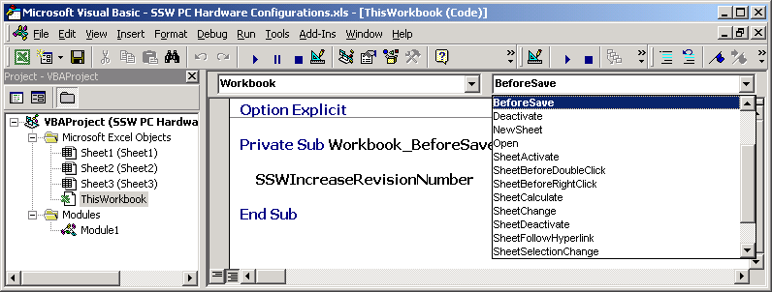

Then you need to call the function

Option Explicit

Private Sub Workbook_BeforeSave(ByVal SaveAsUI As Boolean, Cancel As Boolean)

SSWIncreaseRevisionNumber

End Sub

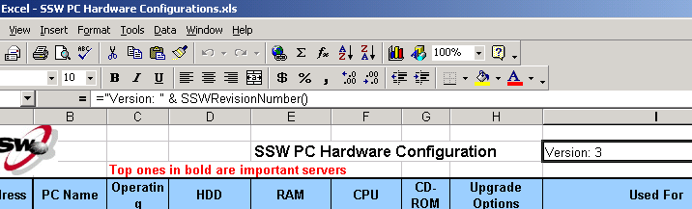

Then you can put in a cell

="Version: " & SSWRevisionNumber()

Note: Can’t put a value from a cell in a footer in Excel

Warning: When you open this xls in the future you will get this

