This is a description of the steps to add a new mockup page or site.

Go to
https://us.ssw.com.au:8443/
Login: Admin
Password: R@t1ng

- Click on Domains

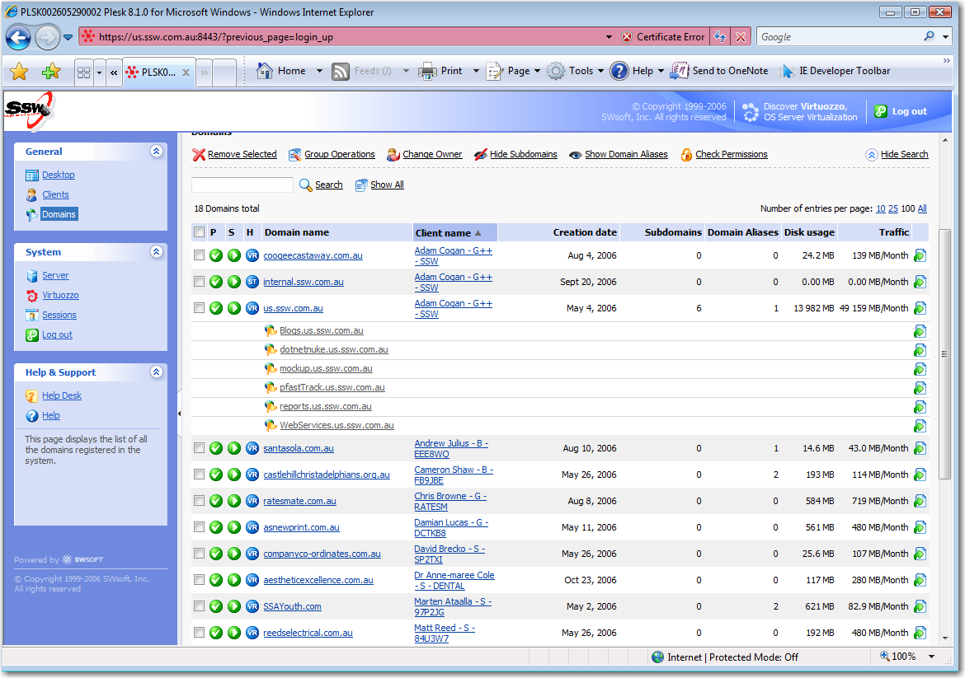
- Click on mockup.us.ssw.com.au
- Click on web directories
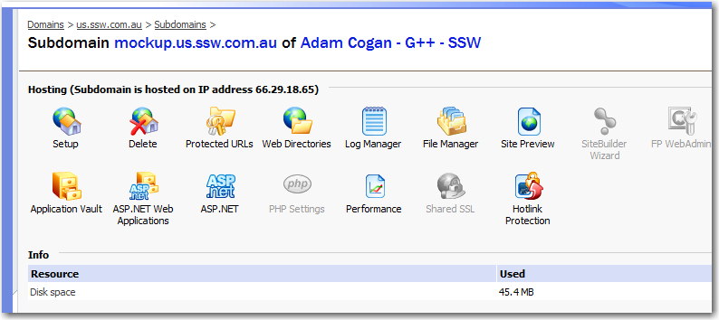
- In the web directory screen, Click add new virtual directory
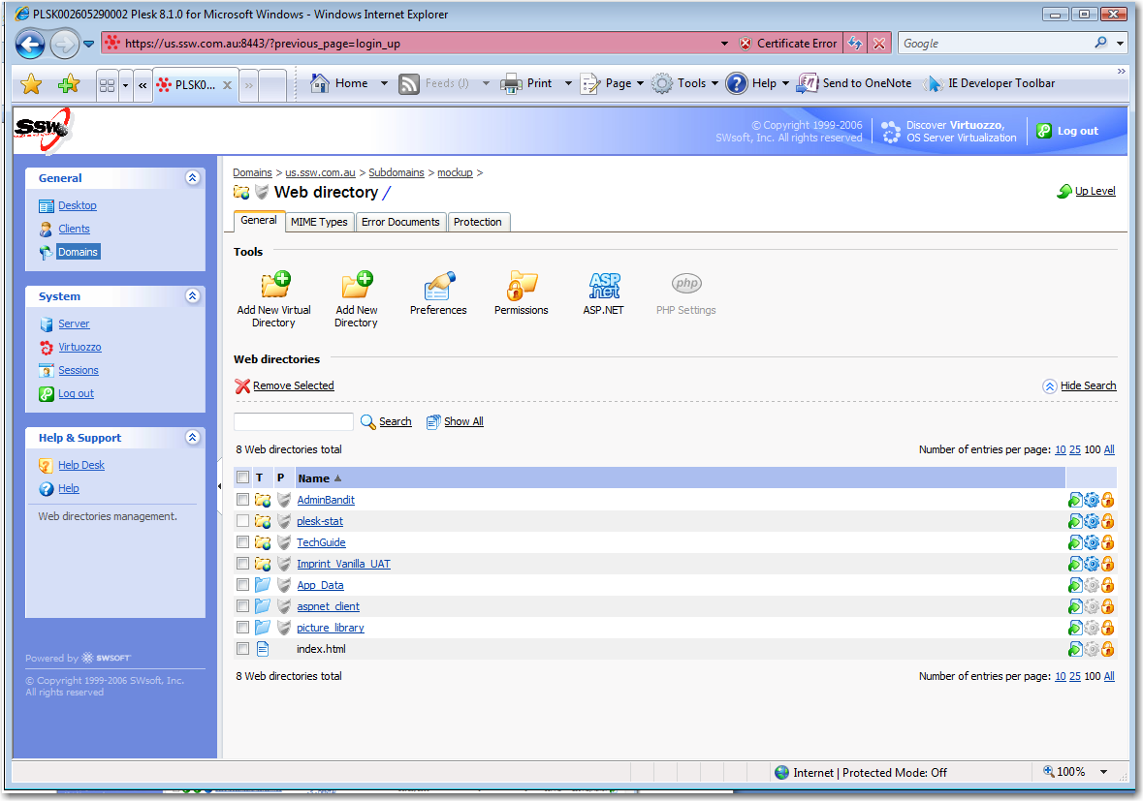
- You should now have a virtual directory to FTP To.
