Setting up Hosted Email Accounts

SSW offers hosting and in addition we offer email accounts (currently $9 per mailbox) as per http://www.ssw.com.au/ssw/hosting/

This standard describes how to setup up email accounts for our hosted customers. This is can be separated into two steps:

- Setting up the hosted environment (the companies info store)
Setting up Exchange 2000 to have multiple companies on the same server requires a partitioned Active Directory, separate mail stores, segregated administrative rights, and special security measures.
- Setting the user(s)
See Steps 4, 5 and 8 for setting up the Users and adding the Users to the Groups.

Setting up Hosted Email Accounts 1
Setting the hosted environment 2
Add the users 8

Setting the hosted environment

Step 1: Create the Organizational Unit

Open up Active Directory Users and Computers by going Start -> Administrative Tools -> Active Directory Users and Computers.

Now Right-click on the ‘Hosted’ node and select New -> Organizational Unit.

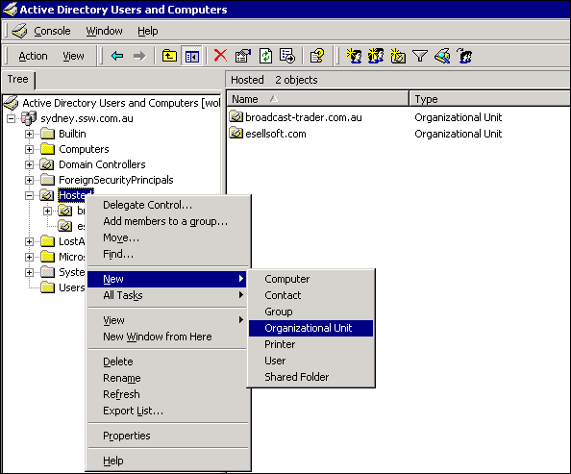

Next specify the name of the organizational unit. This should be the suffix for the email address. E.g. for info@esellsoft.com the Organizational Unit would be called esellsoft.com

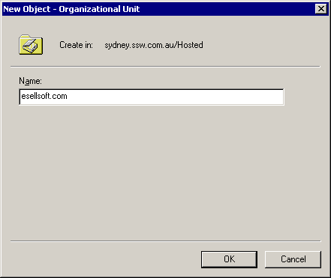

Click OK to create the Organizational Unit.

Step 2: Create the User Principle Name Suffixes

User Principle Name (UPN) Suffixes enable users to log on using a "friendly
name," such as info@ssw.com.au, instead of logging on using the
traditional logon name and the hosting company's domain (such as info in
domain SSW2000). You need to create UPN Suffixes for each company.

To do this, select Start | Programs | Administrative Tools | Active Directory
Domains and Trusts, and highlight Active Directory Domains and Trusts at the
Top of the hierarchy. Right-click and select Properties.

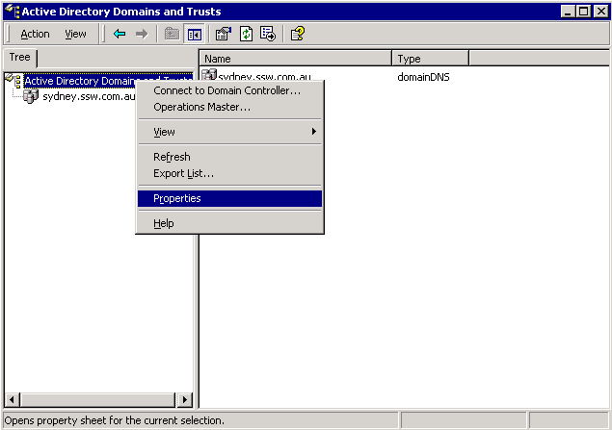

Now specify the name of the organizational unit as an alternative UPN suffix and click on Add. Now, you can close the Active Directory Domains and Trusts console.

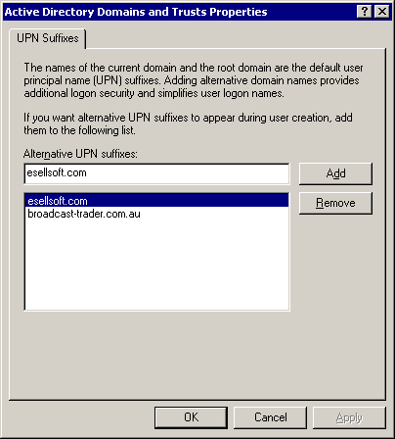

Click OK to confirm the alternative UPN Suffix.

Now when you create a new user, you can specify the alternative UPN Suffix as part of the Account Name.

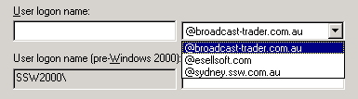
Step 3: Create a Mailbox Store

We want to place each company that hosts mail with us on a separate mailbox store. This allows us to keep the address lists separate between the different companies and it also makes administration less of a problem.

To create a Mailbox Store, select Start -> Programs -> Microsoft Exchange -> System Manager and navigate to the Servers container. Expand the ‘WOLF’ node, select the ‘Hosting’ node and right-click, and then choose New -> Mailbox Store.

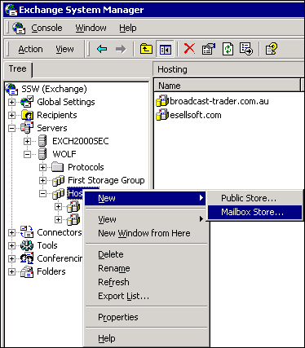

Specify the name of the Mailbox Store to be the Organizational Unit name. E.g. esellsoft.com

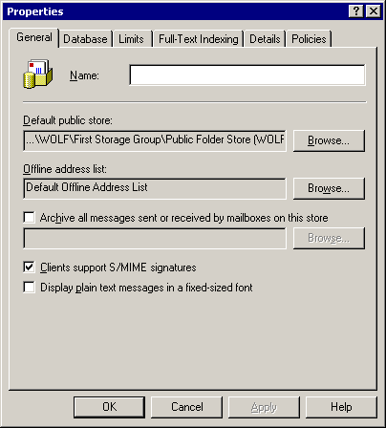

Go to the Limits tab and set the warning and prohibit sizes.
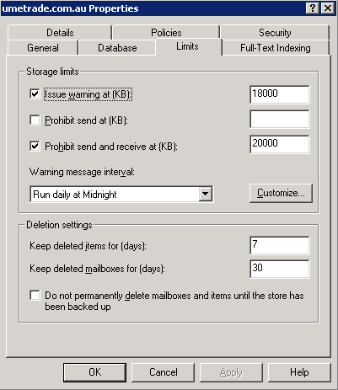

Click OK to confirm the new Mailbox Store.

Add the users
Step 4: Populate the Organizational Units

Now we will create the users for the new Organizational Unit. One user will be required for each email account.

To do this, go back to Active Directory Users and Computers and right-click on the Organizational Unit you created in step 1 and select New -> User.

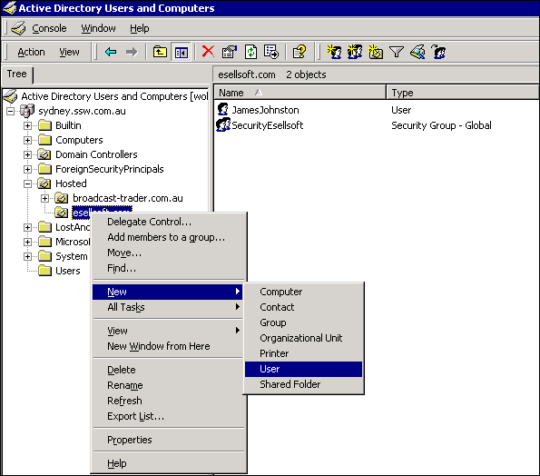

Specify the user name. Remember that the name must be unique across all mailbox stores which means that you cannot choose the name info for a new hosting customer because it is already being used by info@ssw.com.au
Try to incorporate the domain name in the Name e.g. EsellsoftJohn

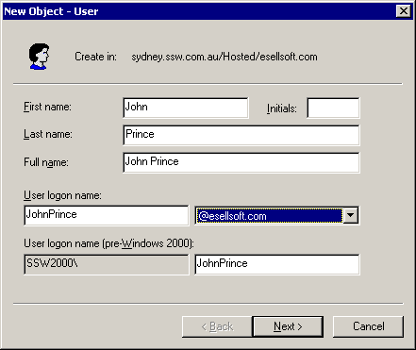

Specify the password. Also mark the ‘Password Never expires’ checkbox.

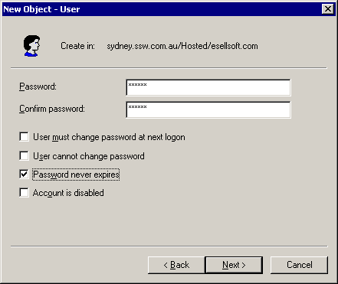

Make sure the ‘Create an Exchange mailbox’ checkbox is checked. Select SSW/First Administrative Group/WOLF as the Server and the Mailbox Store you want to use. E.g. Hosting/esellsoft.com which was created earlier in Step 3.

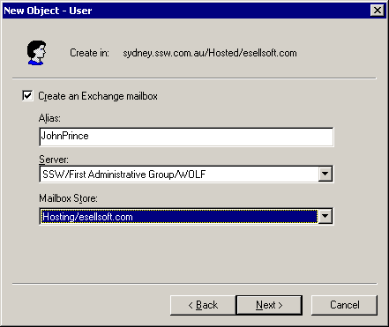

Now Click on Next and then on Finish to create the User.

Step 5: Add Groups

We now want to create a group for the users to belong to. This will allow us to give all the users appropriate permissions consistently.

To create a new group, select the new Organizational Unit in Active Directory Users and Computers, Right-click and choose New -> Group.

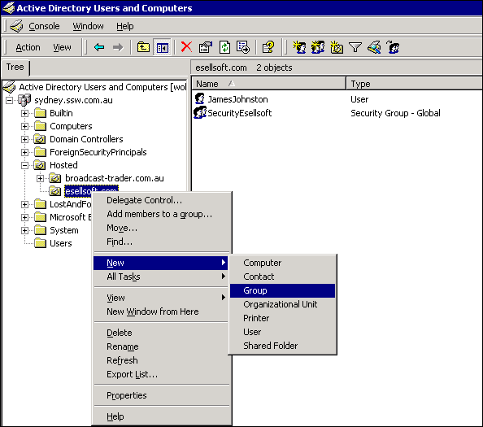

Specify the Group Name. Leave the defaults as is and choose Next.

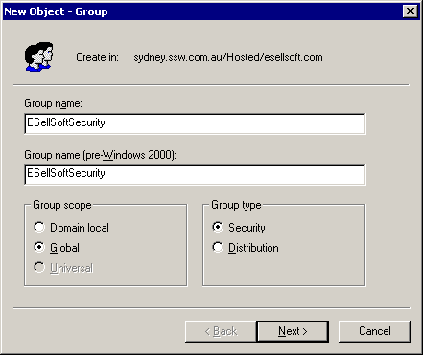

Uncheck the ‘Create an Exchange e-mail address’. Then click Next and Finish to create the Group.

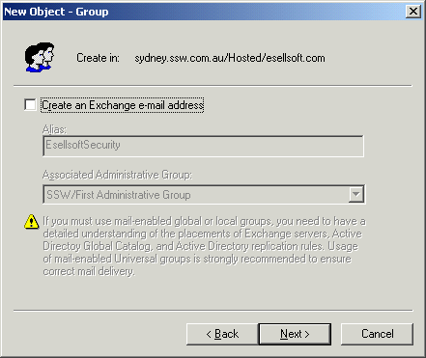

Right-click on the new Group and choose Properties. Go to the Members tab and add the user(s) you created to the Members tab.

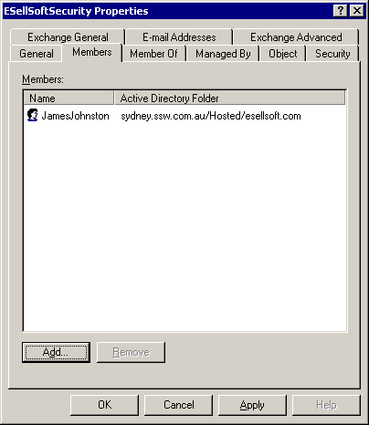

Step 6: Apply Directory Security

Now we need to isolate the new company from other companies in our Active Directory. We need to modify the settings on the Organizational Unit. Otherwise, users in each Organizational Unit will be able to access directory objects from other Organizational Units. That means that two different hosting customers could have access to each others’ email addresses.

To modify the Security information, select View -> Advanced Features from within Active Directory Users and Computers.

Now select the Organizational Unit created previously and right-click and select Properties. Then select the Security tab.

Uncheck the checkbox at the bottom of the screen that says "Allow inheritable
permissions from parent to propagate to this object" and choose Apply.

While still in the Security Tab, scroll through the list of users and groups and find ‘Authenticated Users’, then select Remove. Also remove the ‘Everyone’ group.

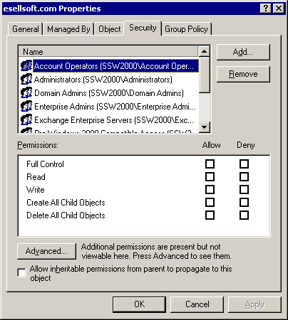

Now click on Add and add the group you created in the previous step. The steps you have gone through have blocked other Active Directory users and groups from viewing the Organizational Units’ contents. Only group members and default Windows 2000 security group members can access this Organizational Unit’s information.

Step 7: Set up Address Lists

Part of hosting multiple organizations includes providing separate Global
Address Lists for each company.

To do this, open Exchange System Manager and expand All Global Address Lists under the Recipients container.

Now right-click on the All Global Address Lists container and select the New ->
Global Address List.

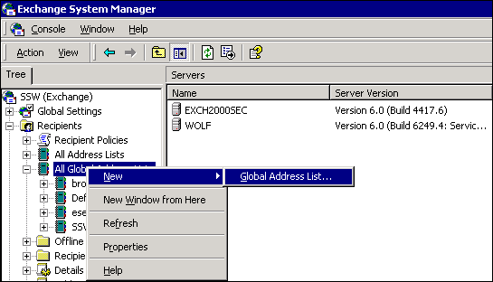
Call it the Organizational Name (e.g. esellsoft.com).

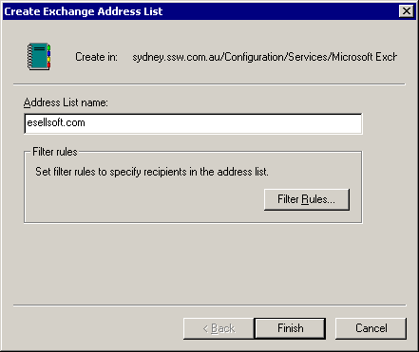

Click on Filter Rules and select Custom Search in the Find dropdown menu and switch to the Advanced tab.

Enter the following query:

(&(&(&(&(|(&(objectCategory=user)(userPrincipalName=*@franchise.signwave.com.au))(&(objectCategory=group)(description=Signwave)))))))

Where ‘esellsoft.com’ is the Organizational Unit.

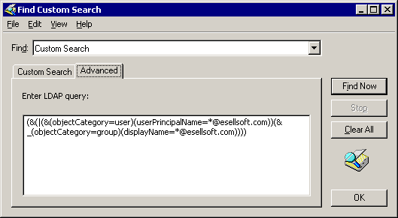

The query above will return all users and groups within the Organizational Unit.

Now click on OK once to return to the property page. Switch to the Security tab and uncheck "Allow inheritable permissions from parent to propagate to the client."

Remove administrator, anonymous Logon, authenticated Users, and the Everyone groups and then add the new Security group you made.

Uncheck all of the Permissions, and then select Read (which automatically selects four other permissions), List Object, and Open Address List. Click on OK to save the Address List.

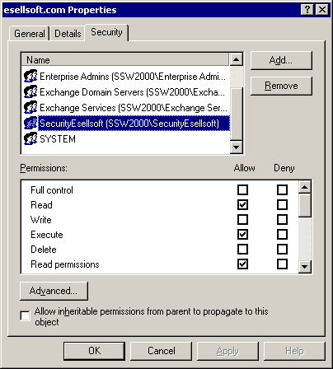

Delete the “Default Global Address List” list if it exists.

If you delete any Address Lists then you have to remove the link in ADSI edit. (don’t know why)
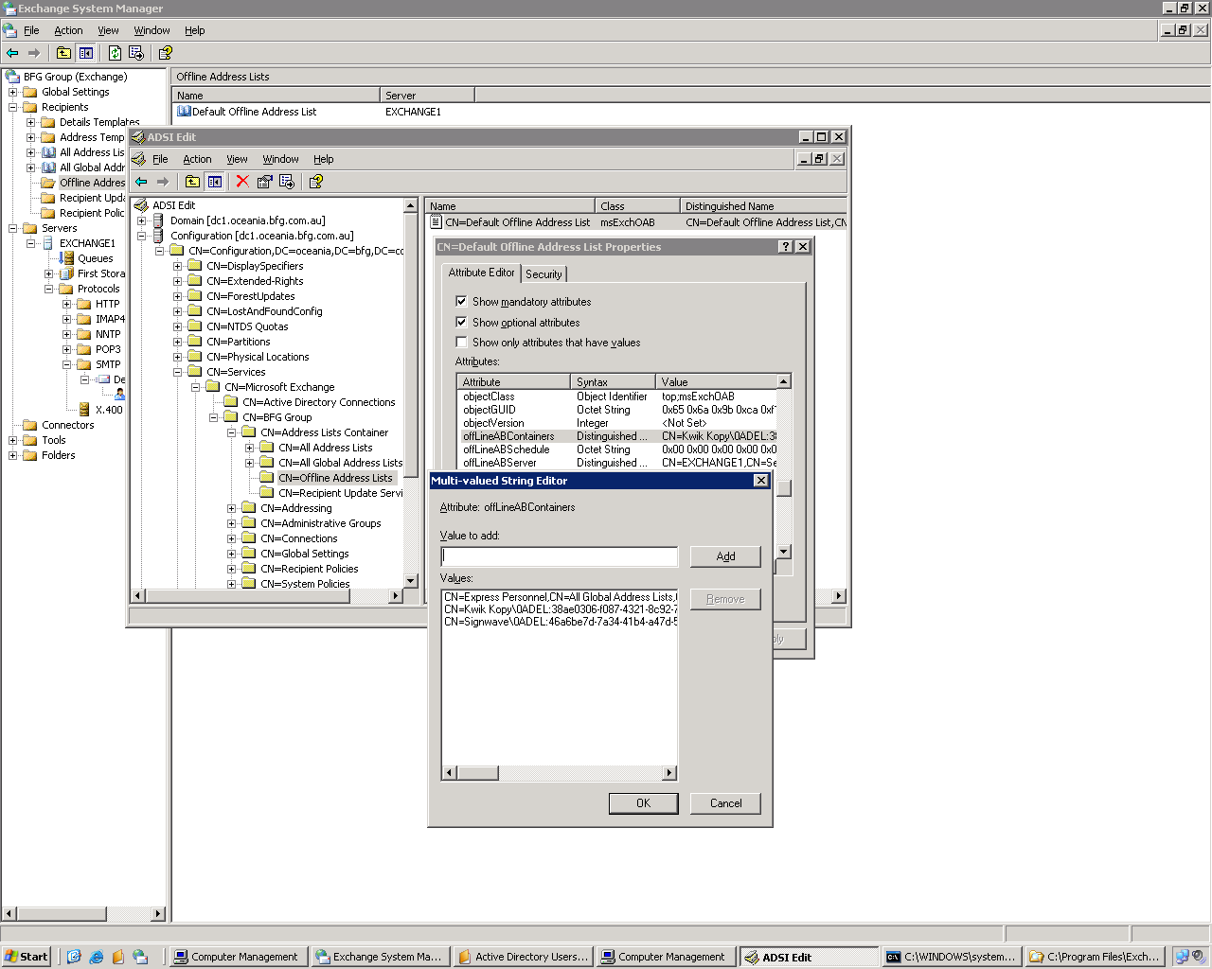
Step 8: Set msExchQueryBaseDN

Outlook Web Access (OWA) performs LDAP queries under the security context of the
Server’s System account instead of impersonating the logged-in user. This means that users logged into OWA who click on the Address Book icon and use the Find dialogue will be able to access information in other Organizational Units and Containers in the Active Directory, despite the directory security settings you made in Step 6.

To get around this, you can redirect the query root for a user to his or her company's Organizational Unit. Select Start -> Programs -> Windows 2000 Support Tools -> Tools -> ADSI Edit.

WARNING: Using ADSI Edit incorrectly can cause serious or irrevocable damage to your Active Directory, so use it with caution.

Expand the Domain Naming Context, Domain NC, OU=Hosted and navigate to OU=[OrganizationalUnit].

Where [OrganizationalUnit] is the Organizational Unit you created previously.

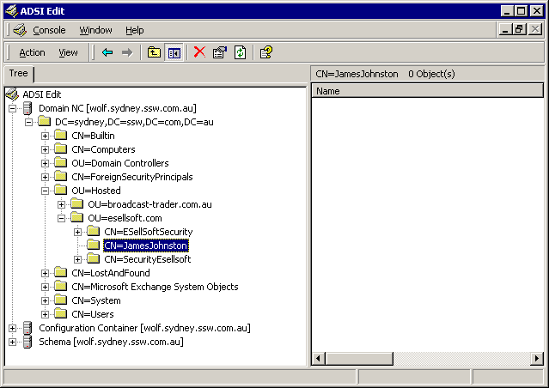

Right-click on CN=[User] and choose properties.

Where [User] is the user you created previously.

This shows you many properties that aren't exposed through MMC. Select Optional and find the msExchQueryBaseDN property. Type the following text in the Edit Attribute field:

OU=esellsoft.com,OU=Hosted,DC=sydney,DC=ssw,DC=com,DC=au

Where OU is the Organizational Unit you created.

You will need to replace the bold with the Organizational Unit you created.

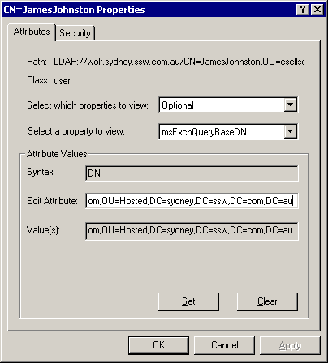

Now click on Set and OK, and then exit ADSI Edit.

[Repeat above for each user]
Step 9: Create Recipient Policies for User and Group Addressing

You should have noticed the addresses on the Property page E-mail Addresses
Tab for the users and groups you've created still reflect the parent domain.

You want the addresses to reflect the company's domain name and not that of the hosting company. Recipient policies enable you to change this. You define a recipient policy within Exchange 2000's System Manager for users, and another policy for groups within each Organizational Unit.

To create a policy, launch System Manager and navigate to the Recipients
container's Recipient Policies sub-container. Right-click on the Recipient
Policies container and choose New -> Recipient Policy.

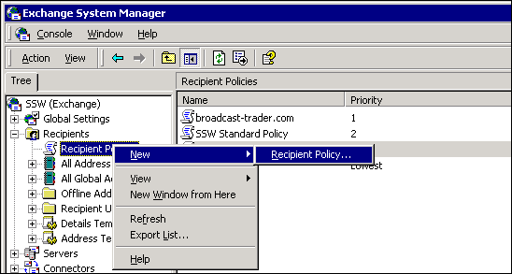

Specify the Recipient Policy name. It is usually the same as the Organizational Unit.

Choose Modify. In the following screen, click on the Find dropdown menu and choose Users, Contacts, and Groups. Then select the Advanced tab and choose User -> Logon Name and Ends With "@[OrganizationalUnit]." Click on Add and then Find Now to see what your recipient policy's membership will be. If everything seems to be working fine, click on OK.

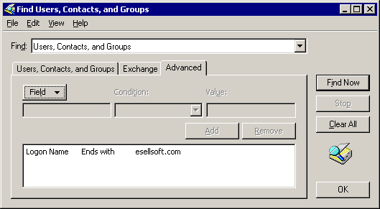

Now that you've defined the membership of this recipient policy, you need to define the policy itself.

Make sure you click on Apply, and then switch to the E-mail Addresses tab and click on New (if New is grayed out, you probably didn't click Apply).

Select SMTP Address and type "@[OrganizationalUnit]" as the address. Click on OK, and then choose Set as Primary to force this address suffix to be added to all your users instead of the hosted company's address.

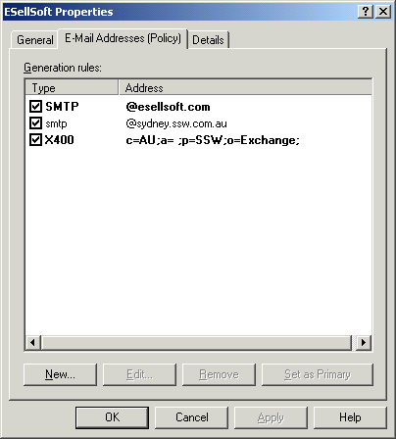

You can then make any other address modifications that fit your business practices and requirements. Now click on OK, answer Yes to save changes, and apply the policy to all existing and new accounts.

You'll need to repeat Step 11 for groups within the Organizational Unit. Each step is the same, except for when you come to advanced criteria. Here, you'll choose Group -> Display Name and Ends With "@[OrganizationalUnit]."
Step 10: Create Custom Public Folder Virtual Roots (optional)

The final thing you need to do is to set up a Public Folder root visible
only to each company. Launch System Manager and navigate to the Public
Folders container at the console's bottom.

Right-click and select New -> Public Folder. Give the folder a name and click on OK. Now right-click on the public folder, and select Properties -> Permissions -> Client Permissions.

Highlight each user in turn and set the Role to None with the Folder Visible checkbox cleared. Click on Add, and find the group you created and add it.

When you're done with setting up permissions, click on OK, then select the Directory Rights button.

Uncheck the "Allow Inheritable Rights from parent to propagate to this object" checkbox and choose Copy. Next, remove the Authenticated Users group from the Directory Rights list and click on OK.

Try viewing the Public Folder hierarchy from within Outlook 2000. You should only see the Organizational Unit Public Folders and default Internet Newsgroups Public Folders.

