How to create a scheduled task to synchronize a SQL Server database every day
- Open the Start menu, Select Programs, Accessories, Synchronize
- Press the Setup button
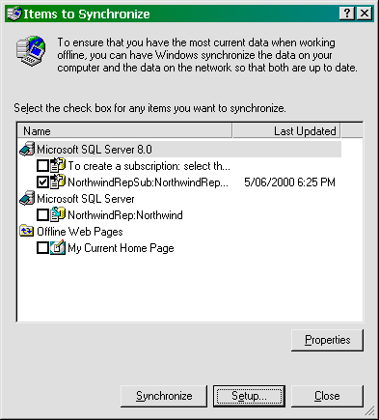

- Press the ‘Scheduled’ Tab
- Press the Add Button
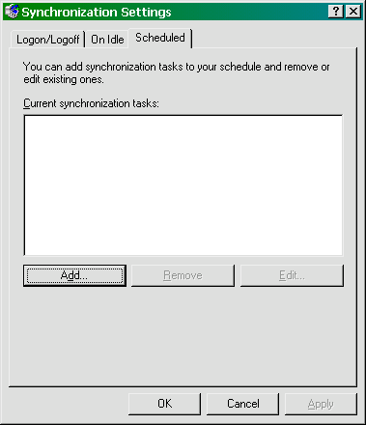

- Press the Next button when the Wizard appears
- Select the connection for your VPN from the list at the top of the screen
- Make sure the box next to SSWData:SSWData is ticked
- Tick the box at the bottom that says ‘If my computer is not connected when this scheduled synchronization begins, automatically connect for me’
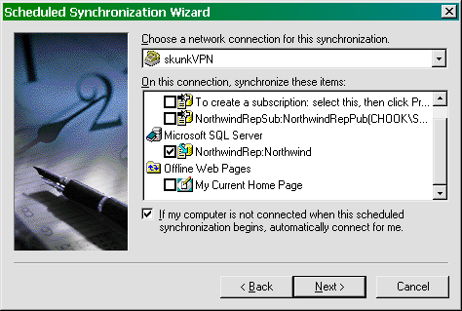

- Press the Next button to continue
- Set the Time to synchronize to 4 AM
- Set the the task to be performed Every Day
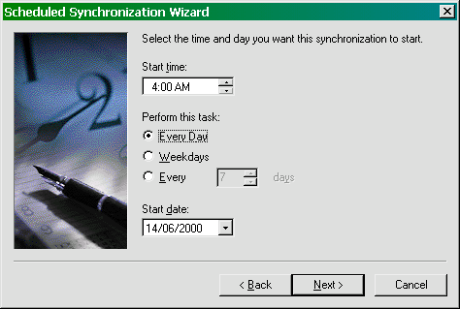

- Press Next to continue
- Enter ‘SSWData’ as the name for the task
- Press Finish to save the task

