Replication of Time PRO! database procedure

Purpose
The purpose of this procedure is to reconcile the records in Time PRO! on local computers (workstations, laptops) with the master copy of the database on the SSW server.

Hint
Although this procedure can be initiated from either the local machine or the server, it is best to initiate it from the server.

Step-by-Step procedure
- Make certain the laptop you are replicating SHOULD be replicated. Currently, only "Tiger" is replicated against the master.
- Connect your local computer to the network. You are successfully connected if you detect the "I:" drive on the Explorer application.
- Open the copy of Time PRO! on your local computer. This application can be found on your "C:" drive, whether you are using your local computer or the server.
- If you are not using the server, open the copy of Time PRO! on the server. MAKE CERTAIN THAT NO ONE ELSE IS USING THE MASTER COPY or errors may result. This can be found as "I:\_DBCurr\Ssw\SswData2000.mdb". If you are using the server, open the copy of Time PRO! on the computer with which you want to replicate files.
- Now you should have two copies of Time PRO! (backend) running on your computer.
- Open the Database window of the local copy and click on the TABLES tab. You should now see a list of tables for that local copy of Time PRO! Select the ClientContact table, click on the Open button and it will be displayed. Select the ContactID field. Sort it in descending order so that the highest ContactID is listed on top. Do the same for the master copy of Time PRO! Manipulate the windows to place the two tables side by side so they can be visually compared.
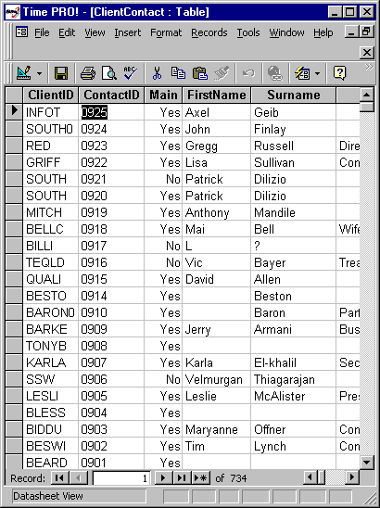

- By inspecting the latest records (those with the highest ContactID values) find any records which have the same ContactID but different data. Alter the ContactID values so that each value refers to a different set of data. For example, if you find ContactID 0925 in the local database referring to "Axel Geib" and ContactID 0925 in the master database referring to "Charles Manson", alter the ContactID of the local database to 0926, so that 0926 refers only to "Axel Geib" and 0925 refers only to "Charles Manson".
- Do the same for the ClientDiary table.
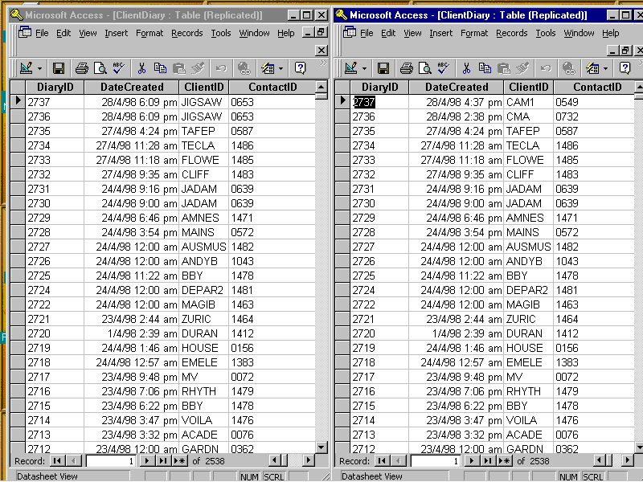
- Keep the local copy of Time PRO! open (if you are on the server, this means the master copy) and close the remote copy.
- From the Tools menu, select Replication/Synchronize Now. Follow the prompts to select the other database, with which you want to synchronize.
- It may give you a list of records which are in conflict; that is, two versions of the same record which may vary by one or more fields. Select the correct field to be retained in the master database on the basis of currency or by consulting with the person who prepared the record. Where there is doubt, retain the existing record and note the value of the alternative in order to consult with the person who prepared the record at a later time.
- After resolving conflicts repeat Step 10.
- If you resolved all conflicts in Step 11 there should be no more conflicts to resolve.

