SQL Replication – Check it is working

* Scheduled to syncronise
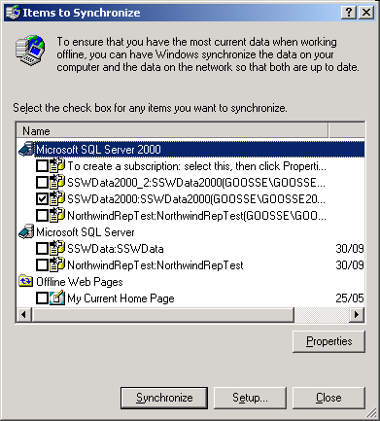

* Adam is on Idle

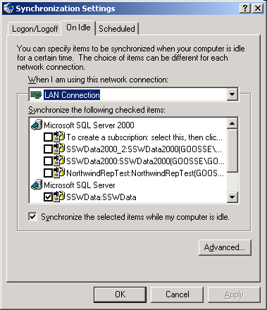

* SGW is on Scheduled (Ross to Check)
As per
I:\InetPub\wwwroot\SSW\TimePROOnline\SSWStandards\General-Computer\How to create a scheduled task to synchronize a database every day.doc

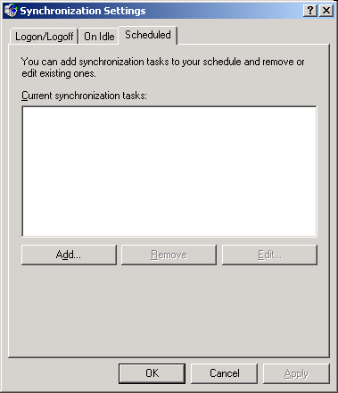

3) SQL Agent sends email if no replication for 5 days (Ross to do)

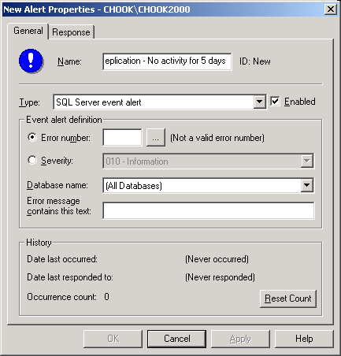

Check the Structure of all 3 databases is the same (Sergei)

Using SQL Compare

Check the data of all 3 databases is the same (Ross)

Using SQL Data Compare or the Merge Agent Profiles - Rowcount and Check Sum

