SSW Standard for Setting up FTP Replication

SSW Standard for Setting up FTP Replication 1
Make sure that the servers can see each other first 1
Setup of Publisher 3
Setup of FTP on Publisher 15
Setup of Subscriber 18
Acknowledgements 24

Note: Please remember that Joey has been Replaced by Tuna, so in all the screenshots, where it refers to Joey, it means Tuna, or whichever machine is our SQL Server at the time.

Make sure that the servers can see each other first
One thing to get straight from the start, FTP replication does not mean that the subscriber server only needs to have FTP access to the publisher. SQL will only use the FTP for a common place to download the files from when the physical unc is not available (like though the web). This means that the SQL port (1433) as well as the FTP port (21) must be exposed externally to the internet.
You may want to change these ports from the default as not to allow external hackers that the ports are SQL and FTP.

Enterprise manager has to be setup so that there are both servers listed on the tree. So if we are syncing joey (publisher) and seal (subscriber) then the servers seal and joey are listed on the enterprise managers of both servers. The (local) connection is not good enough; you will have to connect to the local server again but with the computer name.

Go to the client network utility on both computers and make an alias for the other server which maps to the external IP and port of the other server.
- 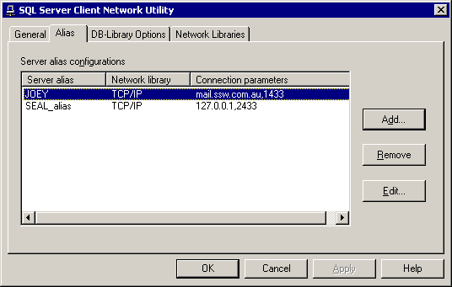

- It should be set like this:
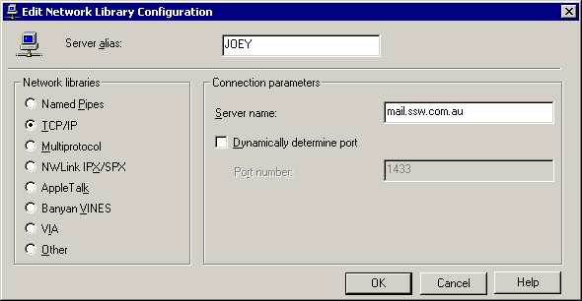

Setup of Publisher
Create a new publication by Right clicking on Enterprise Manager->Server->Replication->Publications, New Publication.
- 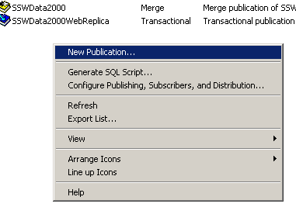
- 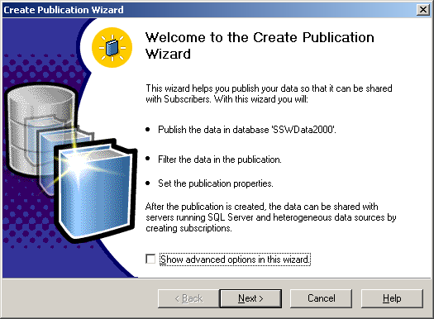
- 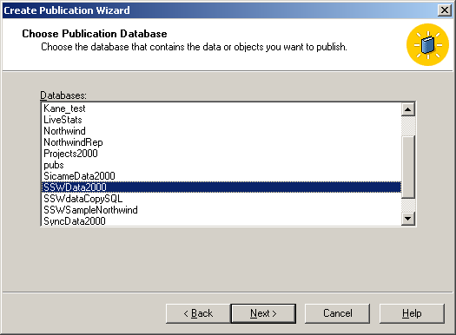
- 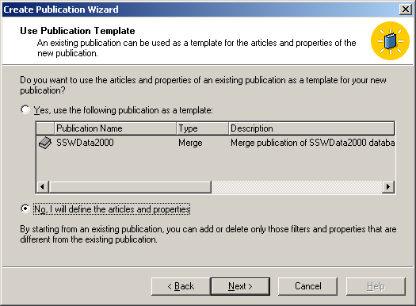
- 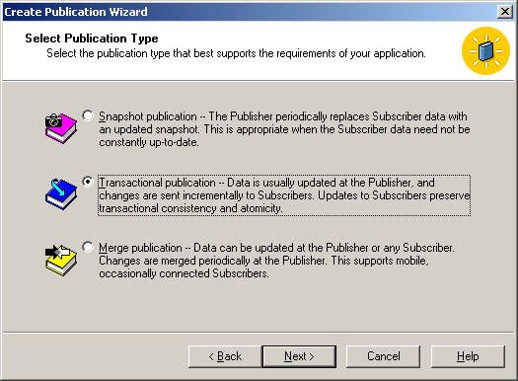
- 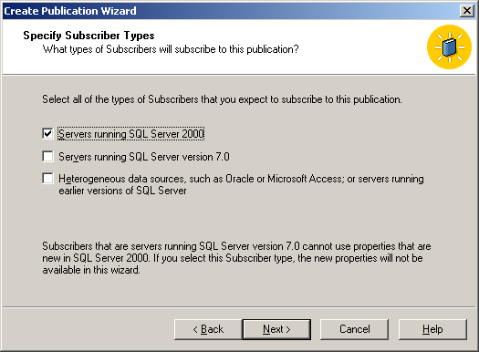
- 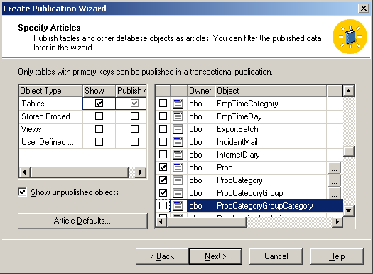
- 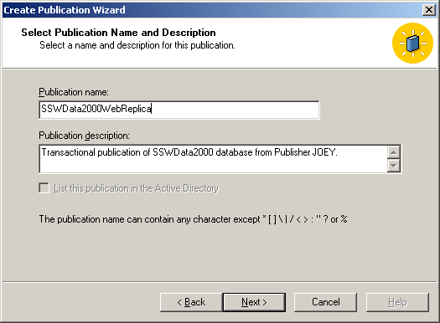
- 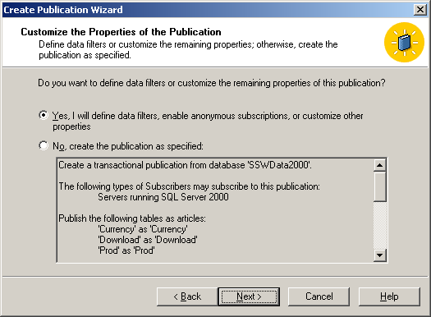
- 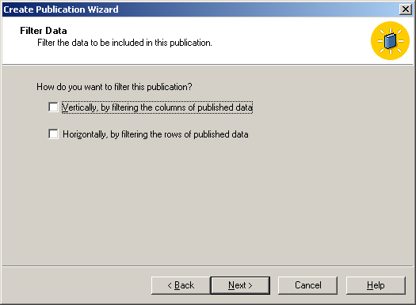
- 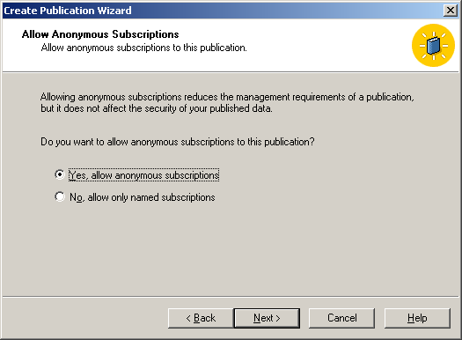
- Set the schedule for the snapshot agent. You will want to manually trigger this off the first time.
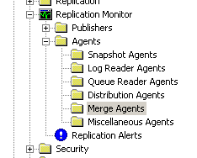
- 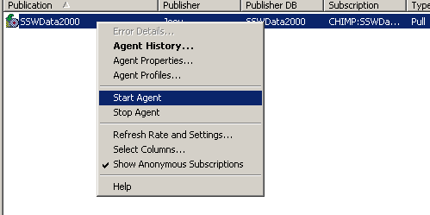
- 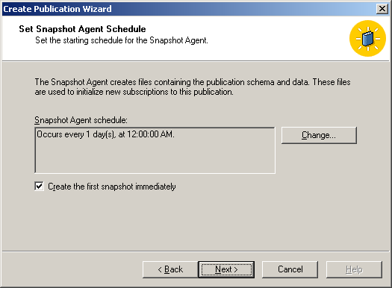

- In the properties of the publication:
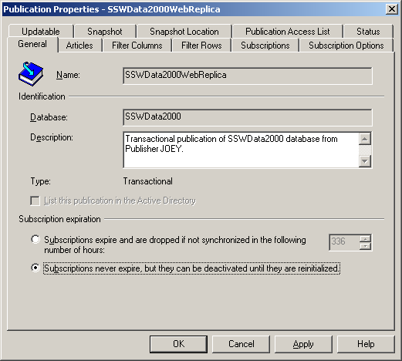

- 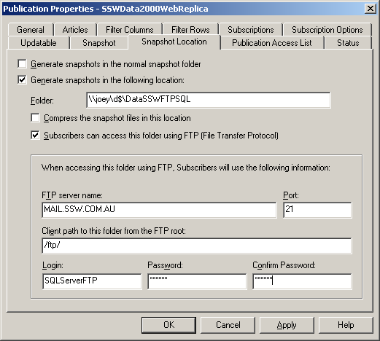

Setup of FTP on Publisher
You have to make the ftp account that you have entered data for in the step above. Set the home directory to be the same folder as entered on the previous screen (don’t worry about that there are sub directories under this folder).
Give full permissions on this ftp user as the subscriber will need to read/write/create/delete files.

In IIS, setup a ftp site.
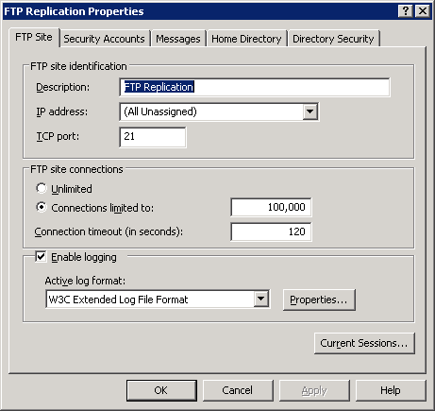

Make sure that you set the home directory as the repldata directory. Also ensure that the user has Read and Write permissions.
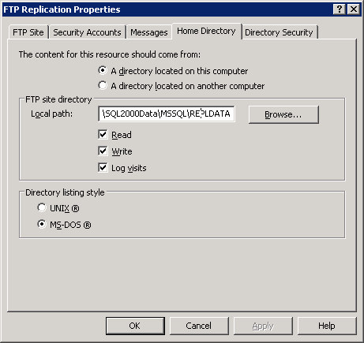

Also make sure that there are no Anonymous connections allowed.

Setup of Subscriber
- Create a new Pull Subscription
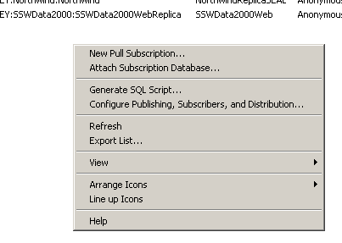
- 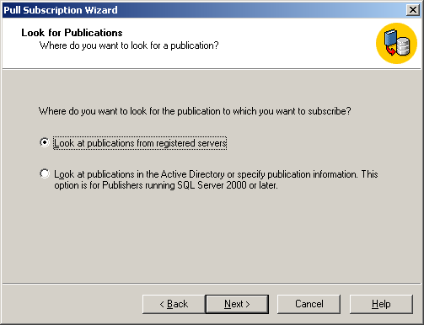
- 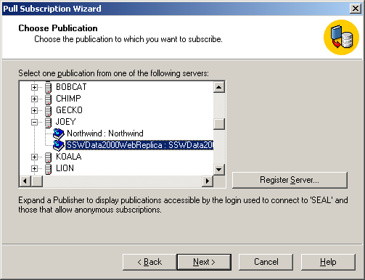
- 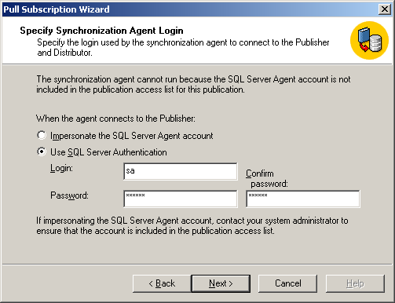
- 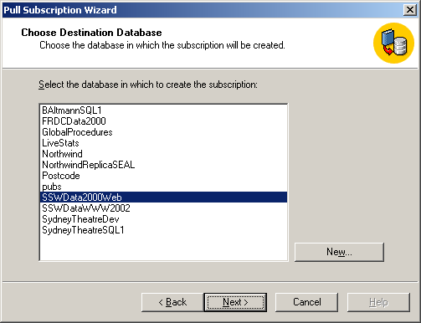

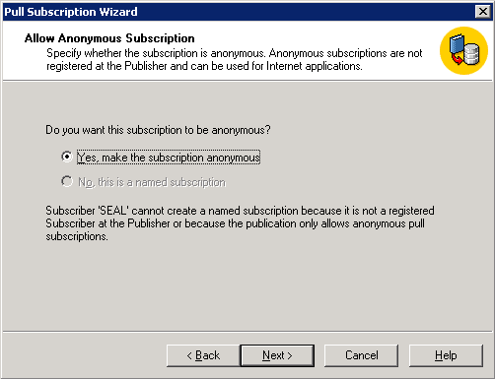

- 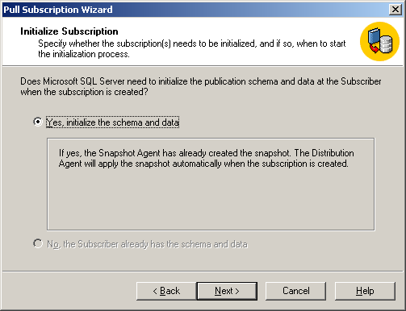
- 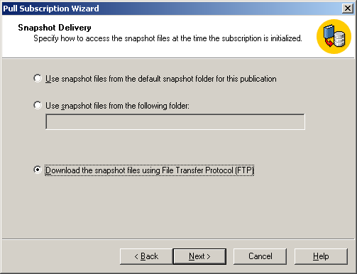
- 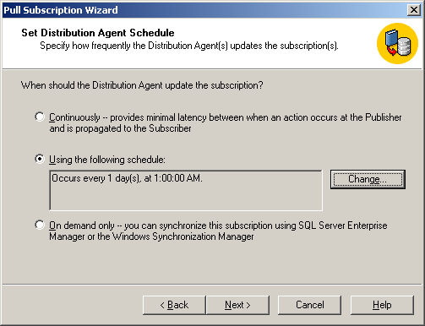

Acknowledgements
David Klein 1/5/2002
Daniel Hyles 9/9/2003

