Standard Security for SSW Databases

Goal is to give ‘Public’ role the minimum permissions for data access that they need

Create the following 2 groups in NT, then add them in SQL Server under Security – Logins

Then check their roles

- NTDomain\SSWDevelopers – ‘System Administrator’ on a Server Role
- NTDomain\SSWUsers – nothing on a Server Role
But at a database level they get ‘Data Reader’, ‘Data Writer’ + exec on all stored procs

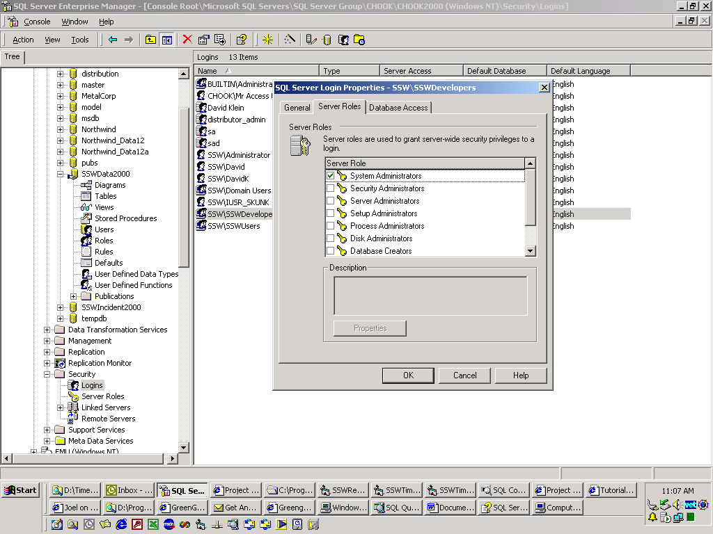

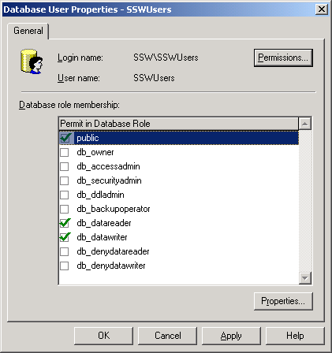

Now everything is OK except SSWUsers can’t execute Stored Procs

(Now need to grant access to all you can run this)
select 'grant all on [' + name + '] to public' + char(13) + 'go'
from sysobjects
where type = 'p'
order by type, name

This generates the script that we run

Finally you can check that Public has exec permissions on stored procs

