SQL and Exchange Server Backup

This standard shows how to back up SQL Server and how to install and use the tool “Backup Exec” for the Exchange Server Backup.

I. SQL Server Backup
- Open enterprise manager. Point to the server you want backed up. 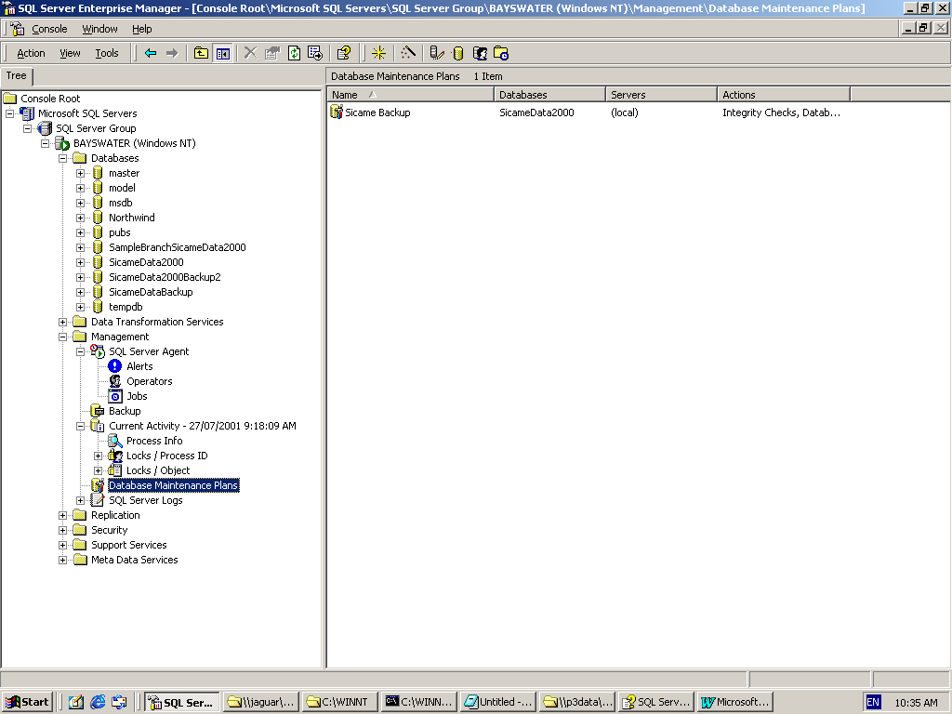

- Go to Database Maintenance Plans. Right click on database maintenance plans, click “New Maintenance Plan”

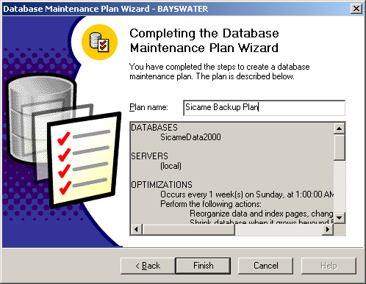

- Select the databases you want OR Select “All databases” 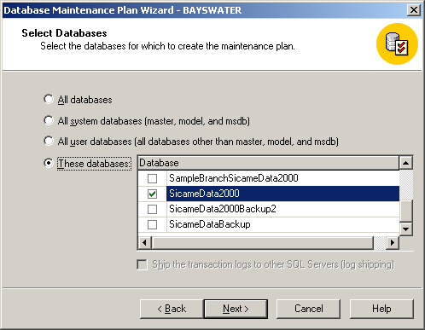

- Database Optimisation:
- enable “recognise data and index pages”
- enable “Remove unused space from database files”
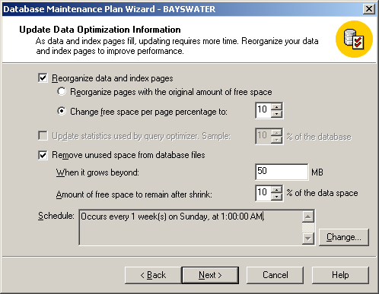

- Data Integrity check:
- Enable “Check database integrity”
- Enable “Perform these checks before doing backups”

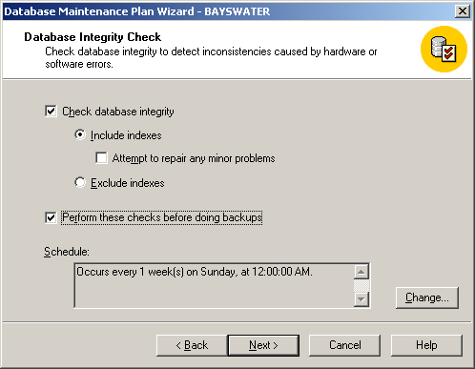

- Database Backup Plan
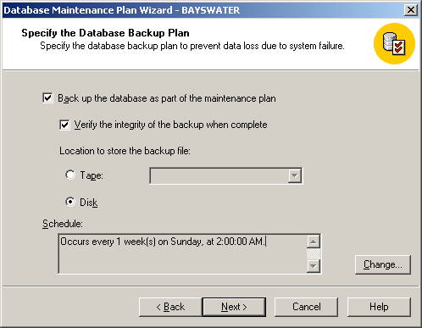

- Backup disk recovery
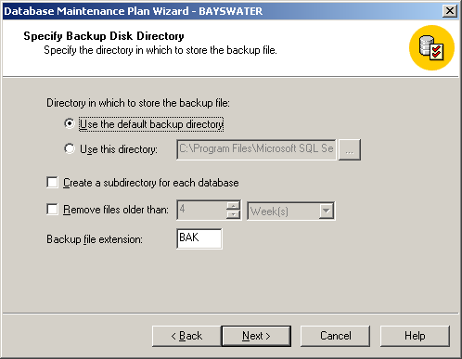

- Modify the transaction Log Backup Job (Management -> Jobs) for the current server.
- Enable “Back up the transaction log as part of the maintenance plan”

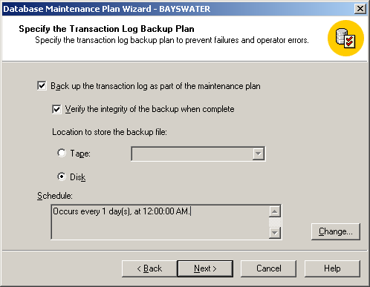

- Specify transaction log backup disk directory:
- Check “Use this directory”
- Enable “Remove files older than” and change to 1 week
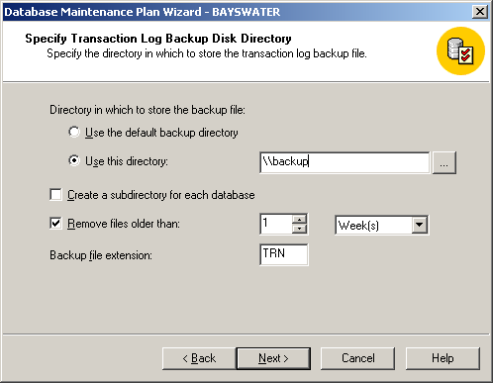

- Reports to Generate:
- You have to make an assistant that has an email address first
- Then enable “Send e-mail report to operator”
Note: Don’t set up emails so that they just send on failure. We want them to be sent on success so they can act as a kind of “heartbeat”. Otherwise, when the network goes down, we will not be aware of a problem because no failure messages will be sent through.
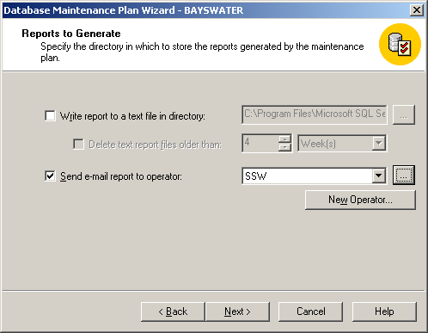

- Maintenance History
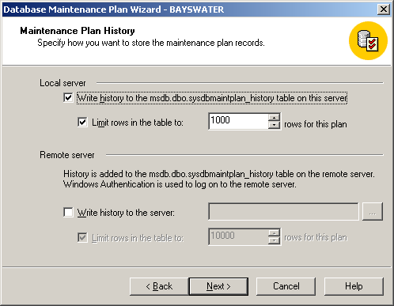

- Complete the wizard and give your maintenance plan a name.

II. Exchange Server Backup
1a. Install “VERITAS Backup Exec”. We use this tool as it provides more control over the backup and uses a more advanced method of backing up exchange then Windows Backup. An other excellent feature of this tool is the E-mail notification function.

A) Installation of Backup Exec

1. Choose "Install Backup Exec software or options on this computer"

2. Enter the Serial Number

3.Select these Components:

Backup Exec
Enable Robotic Library Support
Agent for Microsoft Exchange Server
Open File Option
SAN Shared Storage Option

and click "Next".

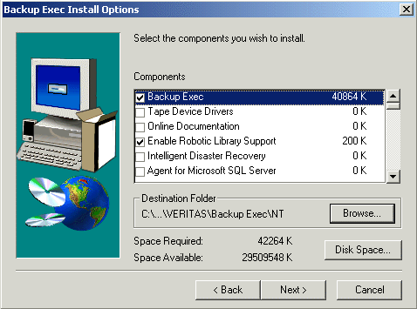

4. Leave the default option in the page "Device and Media Manager" as we don't have a robotic library. Click "Next" and finish the installation wizard.

5. Follow the steps of the next wizards straight forward. Always use the default options.

6. After the installation, start Backup Exec. The "First Time Startup Wizard" will be shown.

7.In the Media Overwrite Introduction page click the button "Select Overwrite Protection Level".

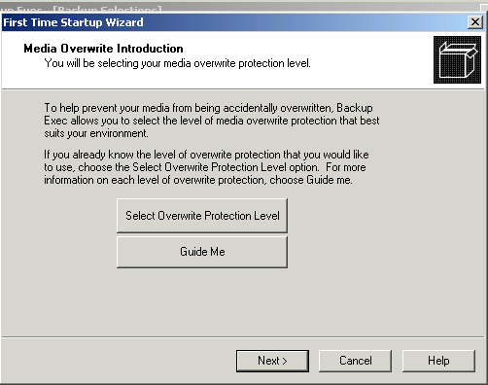

8. Select "None" und uncheck all checkboxes.

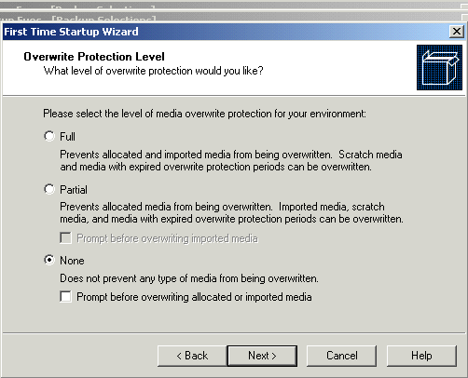

9. Follow the wizard using the default options and Finish.

10. Now the "Device Configuration Wizard" will appear. You can cancel this one.

11. Also cancel the "Backup Exec Assistant" wizard.

12. Select the tab "Devices" on the Backup Exec main page. Right click "Backup-to-Disk Folders" from the tree ("All Devices" -> "EXCHANGE2000" -> "Backup-to-Disk Folders") and select "New Folder".

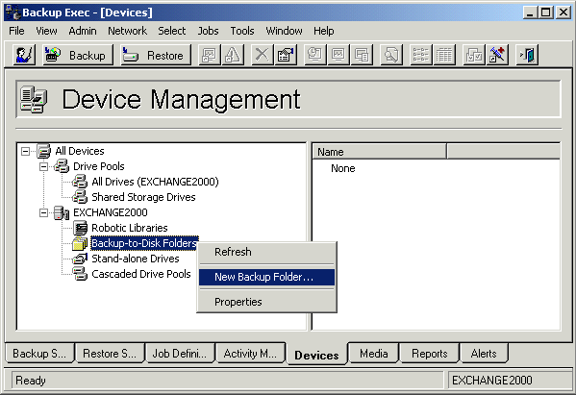

13. Select a Backup name and the folder you want to use.

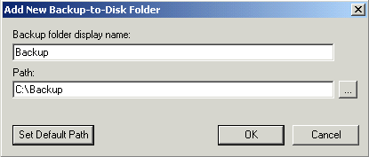

14. Select "Notification Setup..." from the menu "Tools" to open the Notification Setup page.

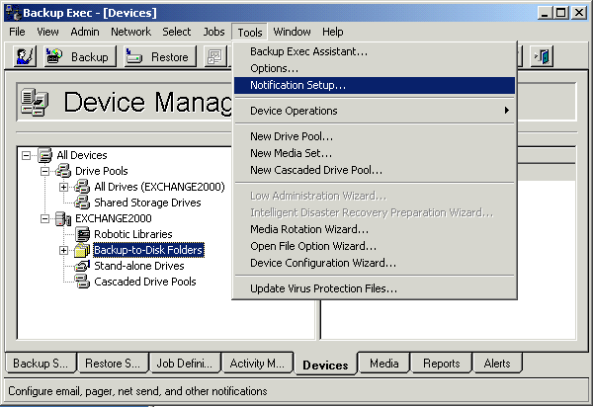

15. Select "Job Failed" from the tab "Notifications", click "Add Notification...". In the following page select "Send E-mail (SMTP)" and click "Add...".

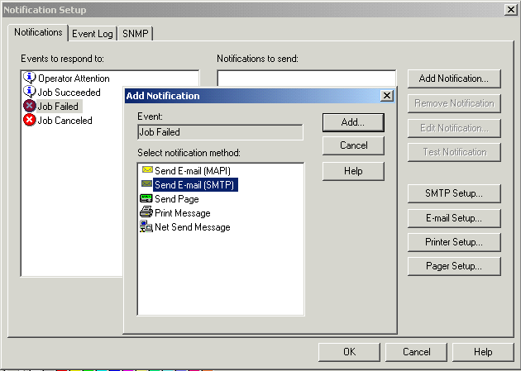

16. Enter the E-mail address "info@ssw.com.au" and enter some Message text. Then click the OK button and close the Email Notification page by clicking OK again.

17. Run the "Backup Exec Assistant.

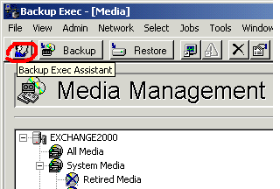

B) Creating a Backup Job

1. Select “Create a new Backup Job” from the wizard

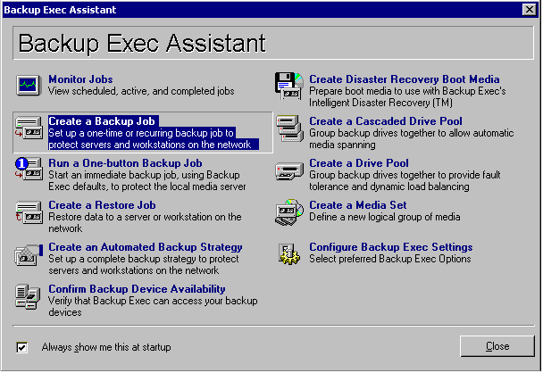

2. Click “Next” until you can select the items you want to back up. Select “Microsoft Information Store” and “System State” here, then click “Next”.

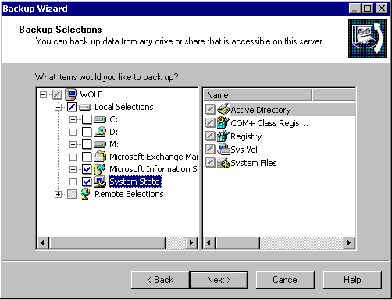

3. Enter a name “Exchange Backup” for the backup job, then click “Next”.

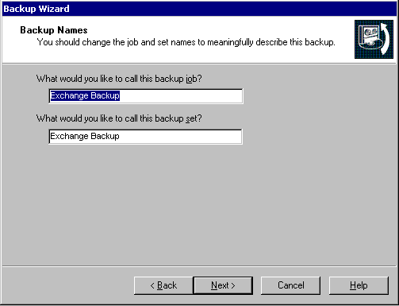

4. Select the device “C:\BackupExchange:1” and the media “Media Set 1”, then click “Next”.

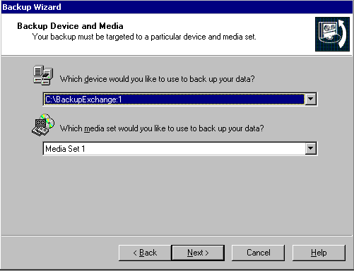

5. Select the overwrite method “Overwrite Media”, then select “Next”.

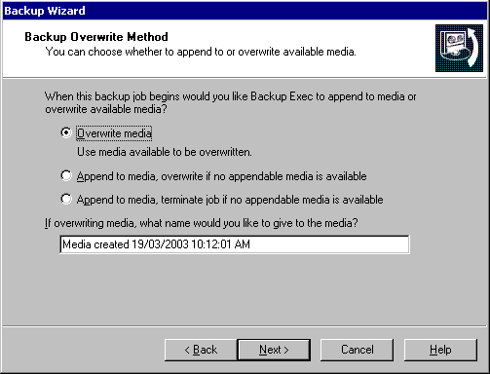

6. Select the backup method “FULL”, then click next.

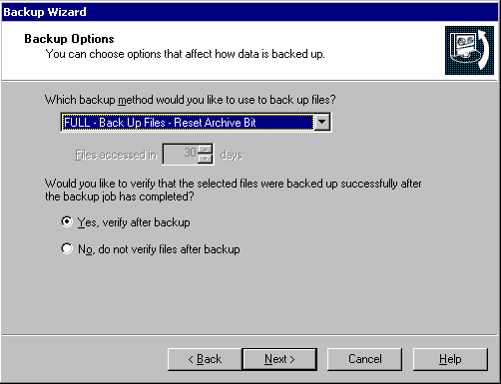

7. Select the exchange option “FULL”, then click next.

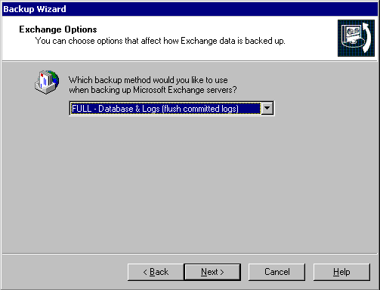

8. Select “No, schedule the job to run later”, an then click “Finish”.

9. Enter the option “Day of the week”, and check the checkboxes for Monday, Tuesday, Wednesday, Thursday and Friday. Enter a start time of 10:00 pm.

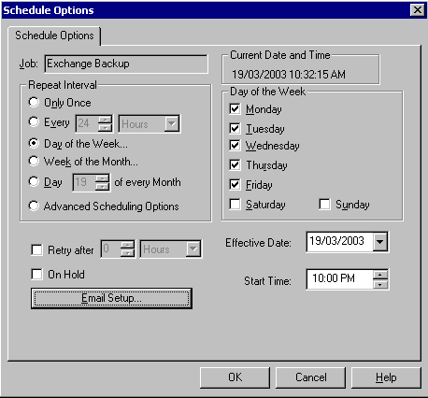

10. Close the wizard.

11. In the “Backup Exec” main page, select the tab “Activity Monitor”. Here you can see your scheduled job. Double click a job to get the Job Options as described in 10).
Right click a job and select “Edit Job” to view and change all the properties.

11. On the tab “General” change the Backup method to “Daily”.

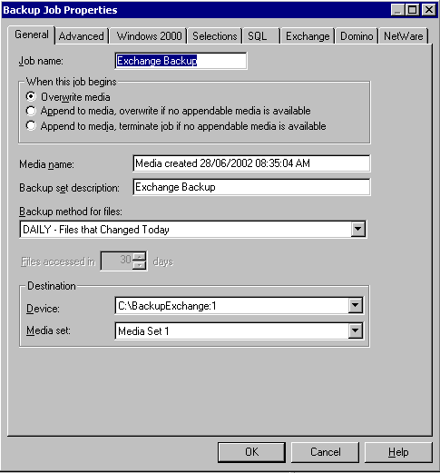

12. On the tab “Advanced” set compression type to “Software”. Choose “Never” in the section “Open file backup”.

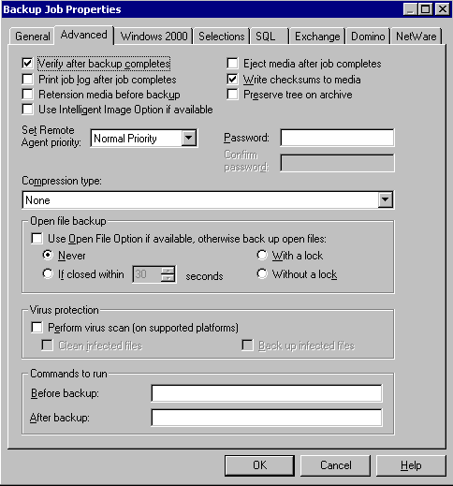

That’s it. Now you can close Backup Exec.

