http://www.ssw.com.au/SSW/Shop/Basket.aspx

Mockup of the new shopping basket page

When the user has a promotional code they will enter it in at the shopping basket stage. If the code qualifies them for a free product then they will not have to pay at the checkout. If the code qualifies them for a discount then they will only have to pay the difference at the checkout.

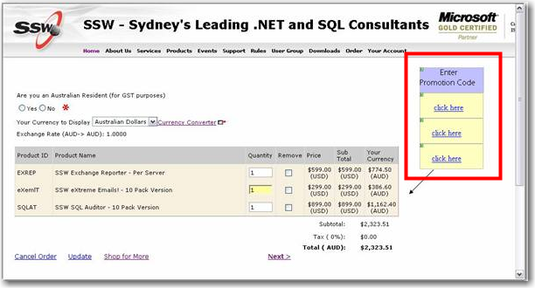

The user will click on the “Click Here” link and the popup window will be shown:

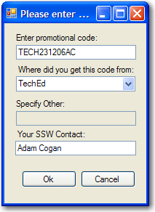

If the client chooses “Other” in the “Where did you get this code from” then the “specify other” textbox will be enabled so the user can enter in where they received the code.
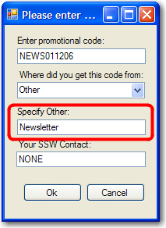

When the user clicks okay they will be taken back to the Shopping basket so they can continue the purchase.

Once the user clicks OK then a message will be in the table under the product name explaining the discount applied. The updated price of the product will also be shown in the Shopping Basket

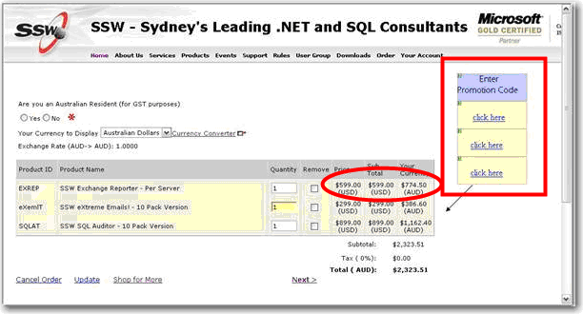

If the user enters an incorrect code then a message will be shown, “Promotional Code is invalid.”

Add link to to explain how to get a promotional code

