SSW Registration (COM Version Control, COM Interop)
John Liu
John Prince

Superior Software for Windows
22 November 2002

Applies to:
Visual Basic 6
COM Components
.NET COM Interop

Current Problem:

SSW Registration (VB6 COM Component) is currently compiled with no version compatibility.

Each product (except Diagnostics) uses SSW Registration and the dll is installed into the System 32 directory (always override the previous file).

For most of our products, there were no issues because they all use the same registration DLL for a long time.

Recently Incident PRO was packaged with an updated version of the Registration DLL, this caused a few problems:

The older registration DLL was overwritten.

The VB6 apps were not affected, because they look up the ProgID (i.e., SSWTest.Test), which points to the (new) GUID, and they were able to load registration dll.

The .NET apps were affected, because COM Interop found the dll, but could not match the GUID with that which is in the file.

VB6 Compatibility

VB6 projects can be configured to use the following compatibility modes

(No compatibility)
Each version of the DLL does not need to support the previous interface, they also have a different GUID (class id) each time it is compiled.
New clsid and new interface IDs. No relationship between versions of a component, programs compiled to use one version can not use subsequent versions.

In .NET with COM Interop, if you have a .NET application compiled to use an earlier version of the dll, you will get an error similar to this one:

System.Runtime.InteropServices.COMException (0x80040154): COM object with CLSID {C2D0C1C8-5F4A-4920-A819-F7C11C465652} is either not valid or not registered.

*This may manifest itself in different forms of error messages…

Project Compatibility
The dll version is updated as can be seen in the picture below
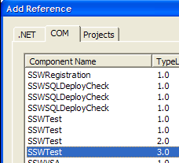

But if a registered version is updated .NET still can not load the dll properly. Type library identifier is kept, so that your test projects can maintain their references to the component project. Different Interface ID is created if it fails binary compatibility with an earlier version.

In .NET with COM Interop, if you have a .NET application compiled to use an earlier version of the dll, you will get an error similar to this one:

System.InvalidCastException: No such interface supported at System.Runtime.InteropServices.UCOMIConnectionPointContainer.FindConnectionPoint(Guid& riid, UCOMIConnectionPoint& ppCP)

Binary Compatibility
In Visual Basic 6.0, the Binary Compatibility option allows you to automatically retain class and interface identifiers from a previous version of a component when you compile a new version. The new version contains both the old identifiers and the new identifiers, and client applications can continue using the old interface to your component without having to be updated.

In VB6, if you changed your interface, you will get a warning like this:
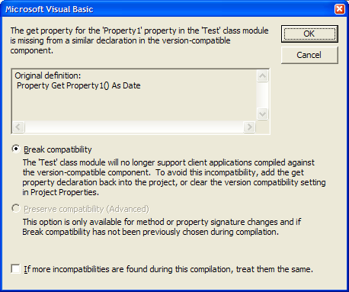

In practice, if you are updating a component that has already been released, you shouldn’t be changing the interface anyway – old programs will be broken if they happen to use the interfaces that you have now changed.

Both VB6/.NET applications have no trouble with components compiled with Binary Compatibility, no recompilation is required. COM Interop for .NET applications does not need to be replaced.

Final Solution

Any COM Components must have Binary compatibility turned on. This has the side effect that program interfaces can not be changed after it has been released.

The SSWRegistration dll component will be installed in the System32 directory as a shared dll, overriding only after version comparison (i.e., only override with a later version is allowed)

SSWRegistration dll will be uninstalled when all SSW products are uninstalled (a registry counter is updated/reduced and when it reaches zero the dll will be removed).

While it is possible to install separate versions of SSW Registration dll in separate folders, with separate COM Interops pointing to them, this is not desirable, because when this version is uninstalled in one directory, the system unregisters the dll before removing it, and all other existing products fails to load the component.

Example
Test Examples are available; this includes a simple VB6 component and a VB.NET application: \\hippo\ssw\StandardsInternal\DeveloperProducts\COMInterop.zip (Temporarily)

