**ASK NICO MAK (winzip) what he thinks**
**MAKE THIS A PUBLIC RULE**

How to cripple software effectively?

It is important to be able to disable or cripple your software so that there is an incentive for users to purchase your software. If you release your software without adequate restrictions for unregistered version then you are never going to make money off the software.

Let us consider the various methods for crippling software:

- No timeout or crippling of features = problem – only honest users will register; there is no incentive to register.
- No timeout, but crippling of some features = problem – only users that need the extra features will register. Others may like the base product and never get an incentive to register.
- Timeout after 30 days = problem – this one is flawed. If I install the application and don’t use the software for 30 days it has already expired without having used it. We want users to use our software.
- Timeout after 50 uses = problem – The user who only needs it now will have ALL the functionality for the time they need and will have no incentive to register.
- Combination of methods 2 and 4 is the best option in our opinion.

Unregistered Products vs Registered Products

Each of our products has functionality that is available in the unregistered version and additional functionality that is available in the registered version.

For the most part, each product is a fully functional product that is limited to a certain number of uses – usually 60.

Here is a listing of the products and the functionality that is available in the unregistered version.

SSW SQL Auditor
Number of uses = 50
Process all rules
Process 70% of tables – exclude the 30% of tables with the most records
Report will list the tables that have been skipped and a note ‘30% of tables have not been checked as this is an unregistered version’
NOTE: This will be indicated to the user as per the following screenshot.
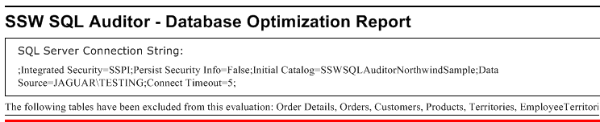
SSW Code Auditor
Process all rules
Process 70% of files in folders (process 7 files then skip 3 files)
Report will say ‘30% of files have not been checked as this is an unregistered version’
SSW SQL Deploy

Access to full functionality for 60 uses.

SSW SQL Total Compare

Access to full functionality for 60 uses.

SSW Upsizing PRO!

Access to full functionality for 60 uses.

Report will say ’30% of tables have not been checked as this is an unregistered version’.

SSW Performance PRO!

Access to full functionality for 60 uses.

Report will say ’30% of forms have not been checked as this is an unregistered version’.

SSW Data PRO!

Access to full functionality for 60 uses.

Report will say ’30% of tables have not been checked as this is an unregistered version’.

SSW Data Renovator

Access to full functionality for 60 uses.

Report will say ’30% of tables have not been checked as this is an unregistered version’.
SSW Property and Event PRO!

Access to full functionality for 60 uses.

SSW Access Reporter .NET For IIS

Access to full functionality for 60 uses.

SSW Team Calendar

Access to full functionality for 100 uses.

Only scans 50% of the users in the Exchange Mail Store.

SSW Contactor for Outlook

Access to full functionality for 60 uses.

SSW Incident PRO!

Access to full functionality for 60 uses.

SSW Time PRO! Smart Tags

Access to full functionality for 100 uses.

