DTS Problem: Horror stories getting Access Time data into SQL Server via DTS
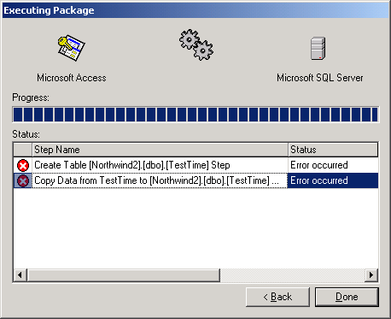

I came across the problem when attempting to perform the apparently simple task of transferring a table (which happened to include dates) from an Access 2000 database to an SQL Server 7.0 database. You may see the included Access 2000 .mdb file (SSWHorrorStoriesGettingAccessTimeDataIntoSQLServerViaDTS2000.mdb) so that you can duplicate the problem yourself. The same problem occurred when transferring from Access 97 to SQL Server 7.0. DTS errors occur when using DTS to import time format data from an Access 2000 database, to a SQL server 7.0 databases. I have confirmed this on SQL Server 7.0 (SP1 and SP2), and the SQL 2000 final version. The Upsizing Wizard does not encounter the same problem.

My problem occurred when trying to export Date/Time fields with a time format (short, medium, long encounter the same problem). DTS seems to recognise these times all as a data type of smalldatetime, and tries to copy them as timestamps. This obviously causes an error, as seen in the screen shots, Figure 1 and Figure 2. The solution is to change them to datetime via a DTS transform, which seems to work correctly.

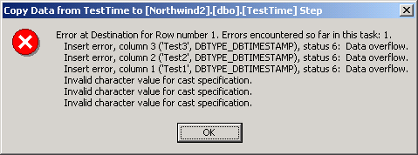
Figure 1

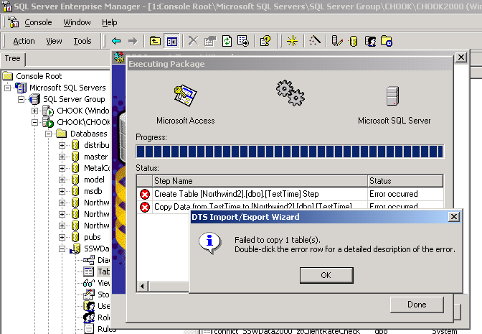
Figure 2

Conclusion
One more reason to use the upsizing wizard.

