Upsizing – Does DTS do the job?

Introduction
This article refers to one of several problems I came across when attempting to upsize from Access 2000 to SQL Server. Hopefully, you will pick up a few tips that will save you heaps of time. We will talk about 3 different utilities:
- Microsoft Access 2000 Upsizing Wizard
- SQL Server 7 and 2000 DTS (Data Transformation Services)
- SSW Upsizing PRO!

When transferring data from Access to SQL Server, most people use and recommend using SQL Server DTS. By the end of this article, you will see that the Microsoft Upsizing Wizard has a place equal or greater than DTS in this transfer process.

Access and SQL Server talk the same language most of the time.
Most of the common field types can are translated fine. For example, a “Memo” field in Access would be a “Text” field in SQL Server. Most relationships translate 1:1 from Access to SQL Server. However, there are subtle differences between the two. The “Text” fields in Access can only be 255 characters long, whereas the equivalent data types of “Varchar” and “Nvarchar” can store 8000 and 4000 characters respectively. Another element of difference is that Access and SQL Server have different default behaviours. For example, by default, Microsoft Access disallows fields with blank strings i.e. “Allow Zero Length” = No. However, SQL Server allows such fields by default. Differences like these have to be kept in mind on the winding road to upsizing heaven.

Let the bugs fly!
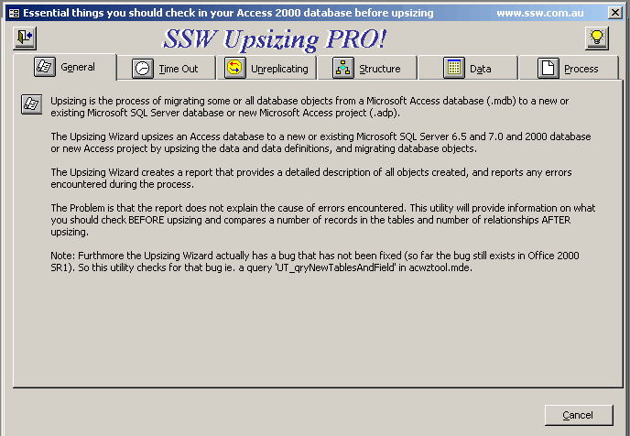
As much as we love the Microsoft Access 2000 Upsizing Wizard, it still has deficiencies. These range from missing constraints to complete tables being skipped without any significant warnings. SSW Upsizing PRO! highlights these problems, so you can be prepared for such issues. These problems include (but are not limited to):
- The Upsizing Wizard allows tables without unique constraints. Tables with this problem cannot be modified.
- SQL Server and the upsizing wizard allow spaces in table and field names (e.g. “Order Details”), but this is not a good idea.
- Validation rules are not upsized.
- If a unique index is set on a field, and the required property is set to “No” in Access, the Upsizing Wizard will fail.
- If you have created a table and then reordered the fields after you have saved it (everybody does this), the Upsizing Wizard will often fall over.
- Multiple Key Foreign Key Relationships on tables that map to fields of a different name will fail. (As below)
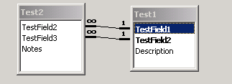
Figure 1

- Tables with invalid dates will be skipped without warning (SQL Server smalldatetime can only store from the years 1900 to 2079. Dates outside this range will fail.) For example, Access will allow data entry errors such as ‘1/1/199’.
- Fields with multiple-key indexes cannot be upsized if the total size of the fields adds to more than 450 characters.

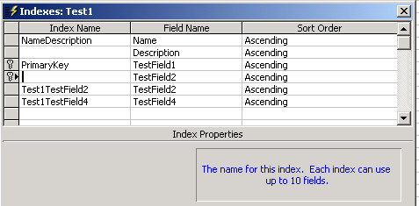
Figure 2

It is the manual intervention necessary (as described in the problem description document) is the bane of a smooth upsizing. Sometimes you may wish you had the time to build the database schema from scratch! This is not practical in the majority of cases, and this is why SSW created the SSW Upsizing PRO! – to make your upsizing experience as smooth as possible.

In a similar way, there are still major problems in the DTS, which is the other vital instrument in the Upsizer’s toolkit.

See www.ssw.com.au/SSW/UpsizingPRO/DTSDateTimeProblem.doc for more detailed information on the example problem.

Conclusion

For a seamless transition from Access to SQL Server, the Developer has to use many tools to:
- Isolate bad data
- Find structural problems (the source of most errors)
- Counter problems in the official Upsizing tools provided by Microsoft.

These tools include:
  - Microsoft SQL Server DTS
  - Cutting and Pasting in Microsoft Access
  - SSW Upsizing PRO!

With the deficiencies of DTS in mind, the Upsizing Wizard is your best overall solution to upsizing. I recommend using the Upsizing Wizard as your primary tool, with DTS as an ancillary tool for troubleshooting minor problems. In sum, use Upsizing PRO! in conjunction with the upsizing wizard for a relatively hassle-free upsizing process.
Without these tools, there is a steep hill to climb, particularly when you are faced with the upsize of a large and/or complicated legacy Access database.

