Sample Stories – Northwind Application
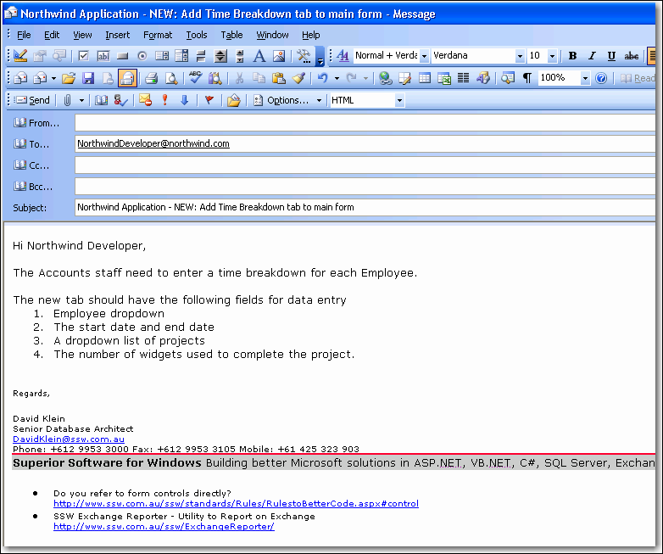

Figure 1 - Sample Story – New feature for the Northwind application

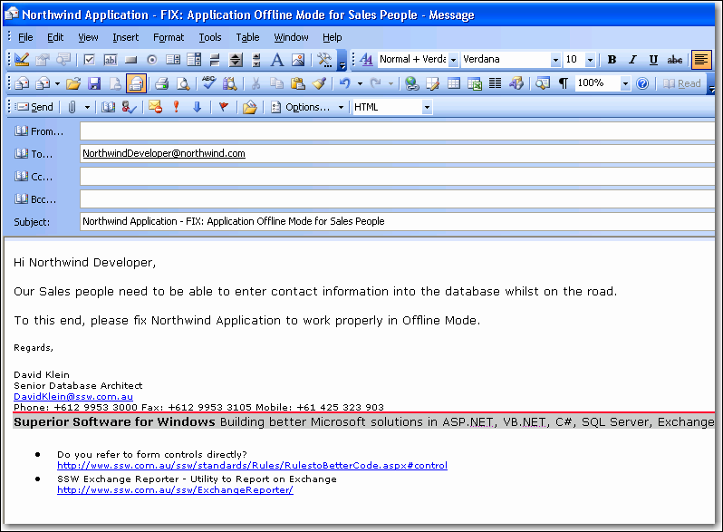
Figure 2 - Sample Story – Outlines fix to Offline mode for the Northwind application

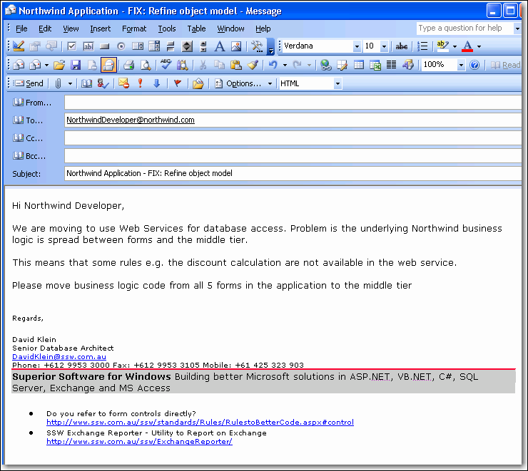
Figure 3 - Sample Story – Outlines code Improvements required for Web Service Implementation

