

What’s New and Different when Moving Your Backend from Access to SQL Server 2000
SQL Server Technical Article

Writers: Adam Cogan, Jatin Valabjee
Technical Reviewer: David Klein, Ross Donald
Project Editor: None
Designer: None

Published: 09 2004
Updated:
Applies To: Access 2000/2002/2003, SQL Server 2000 SP3a

Summary: This document compares the features of Microsoft™ Access® 2000 and above with the features of Microsoft™ SQL Server® 2000. New features in Microsoft™ SQL Server® 2000 are also discussed.

Copyright
The information contained in this document represents the current view of Microsoft Corporation on the issues discussed as of the date of publication. Because Microsoft must respond to changing market conditions, it should not be interpreted to be a commitment on the part of Microsoft, and Microsoft cannot guarantee the accuracy of any information presented after the date of publication.

This White Paper is for informational purposes only. MICROSOFT MAKES NO WARRANTIES, EXPRESS, IMPLIED OR STATUTORY, AS TO THE INFORMATION IN THIS DOCUMENT.

Complying with all applicable copyright laws is the responsibility of the user. Without limiting the rights under copyright, no part of this document may be reproduced, stored in or introduced into a retrieval system, or transmitted in any form or by any means (electronic, mechanical, photocopying, recording, or otherwise), or for any purpose, without the express written permission of Microsoft Corporation.

Microsoft may have patents, patent applications, trademarks, copyrights, or other intellectual property rights covering subject matter in this document. Except as expressly provided in any written license agreement from Microsoft, the furnishing of this document does not give you any license to these patents, trademarks, copyrights, or other intellectual property.

Unless otherwise noted, the example companies, organizations, products, domain names, e-mail addresses, logos, people, places and events depicted herein are fictitious, and no association with any real company, organization, product, domain name, email address, logo, person, place or event is intended or should be inferred.

©2004 Microsoft Corporation. All rights reserved.

Microsoft, Microsoft Access, Microsoft Excel, Microsoft JET, Microsoft SQL Server, Microsoft Visual Studio .NET, and Microsoft Windows are either registered trademarks or trademarks of Microsoft Corporation in the United States and/or other countries.

The names of actual companies and products mentioned herein may be the trademarks of their respective owners.

Table of Contents
Assumptions 1
Who Should Read This 2
Introduction 3
About SSW and the Authors 4
SQL Server Tools 5
Difference – The SQL Server Tools to Design Databases, Queries and Browse Data 5
Difference – The SQL Server Tools to Import and Export Data 11
New Feature – SQL Server Profiler 14
Architecture 16
Advantage – Less Chance of Data Corruption 16
Advantage – Database Log Files Enable Data Recovery 17
Difference – System Requirements 18
SQL Server Versions 19
Difference – Data Types 19
New Feature – User-Defined Data Types 20
Difference – Identity Values Are Generated After an Insert 22
Similarity – Table Design 24
Similarity – Relationships 25
Difference – Data Validation 26
Disadvantage – Cascading Update Circular References are Not Supported 28
Advantage – Improvements to Indexing 29
Similarity – Access Queries / SQL Views 31
Similarity – Access Queries / SQL Stored Procedures 34
New Feature – Access Queries / SQL User-Defined Functions 35
New Feature – Triggers on Tables and Views 36
Scalability and Performance 38
Advantage – Support for More Concurrent Users 38
Advantage – Support for a Larger Database 38
Difference – File Extensions 38
Advantage – Database and Log Files Can Be Split Across Multiple Devices 39
Advantage – More Robust Queries 40
Working with Data 41
Difference – Querying Data 41
Advantage – T-SQL Provides Powerful Functionality 45
Advantage – Ability to Script Objects 46
Advantage – Table Variables: Useful for Complex Queries 46
Advantage – Recovering from System Failure 48
Advantage – Backups Can Be Done While the Database is Running 49
Difference – Comparing Databases 50
Conclusion 54
Glossary – New Terms for Access Developers 55

Assumptions
All comparisons in this paper are made under the assumption that the following software is used:

- Microsoft Access 2000/2002/2003
- Microsoft SQL Server 2000 Standard Edition or Enterprise Edition

This paper is relevant for all versions of Access. However, you will notice more differences between older versions of Access and SQL Server than between Access 2003 and SQL Server. Therefore it is strongly advised that you upgrade your database to Access 2003.

It is assumed that your data is currently stored in an Access database (.mdb) file, and not in SQL Server. Also, it is assumed that you are not using an Access Data Project (ADP), which does support many of the SQL Server features described in this paper.

Who Should Read This
This paper has been written for Access developers who are familiar with the features of Access and are considering moving their back-end infrastructure (data and queries) to Microsoft SQL Server. This paper is for anyone who uses an Access backend. The typical audience is Access, Visual Basic and .NET developers.

Readers should be familiar with the features of Access, such as:

- Basic SQL
- Importing and exporting data from and to various formats
- Backing up and restoring data
- Implementing security


Or the Visual Basic 6 Developer
Or the .NET Developer
Using an Access Backend
e.g. Data.mdb
The Access Developer
The Goal
Microsoft Access developers generally consider a move to SQL Server for performance, security and stability reasons. This process is known as upsizing and developers will find a number of key differences while migrating from Access to SQL Server. The goal is to:
- Find out what’s new and different when moving your backend from Access to SQL Server 2000 (covered in this white paper)
- Successfully migrate your Access database to SQL Server 2000 with no problems (covered in the Microsoft white paper, How to Migrate Your Backend from Access to SQL Server 2000)

Introduction
Microsoft Access developers generally consider a move to SQL Server for performance, security and stability reasons. This process is known as upsizing and developers will find a number of key differences while migrating from Access to SQL Server. It is crucial that these differences are noted and appropriate action is taken to ensure a seamless and incident-free migration from Access to SQL Server.

Microsoft SQL Server is an enterprise-level data management system. It encapsulates industry-standard security, scalability and manageability. In addition there is support for Extensible Markup Language (XML) and Internet queries.

This paper assists the new SQL Server developer by comparing Access and SQL Server features. The following topics are covered:

- SQL Server Tools
- Architecture
- Scalability and Performance
- Working with Data

This paper does not cover the process of migration from Access to SQL Server.
More information on migration can be found in the Microsoft white paper, How to Migrate from Microsoft Access to Microsoft SQL Server.

This paper does not cover the differences between data replication and database security.
More information on replication can be found in the Implementing Replication page of Microsoft’s MSDN Library at http://msdn.microsoft.com/library/default.asp?url=/library/en-us/replsql/replimpl_88j2.asp.
More information on security in SQL Server can be found under Managing Security Accounts in Microsoft’s MSDN Library at http://msdn.microsoft.com/library/default.asp?url=/library/en-us/adminsql/ad_security_41yr.asp.

About SSW and the Authors
This whitepaper is written by Adam Cogan (Chief Architect) and Jatin Valabjee (Senior Software Developer) of Superior Software for Windows (SSW). SSW is a Sydney based consulting company specializing in .NET solutions for progressive businesses since 1990. SSW offers custom software solutions in ASP.NET, VB.NET, C#, Windows Workflow, SQL Server, Exchange Server, Microsoft CRM, Microsoft Access and Office 2003. Adam can be contacted at adamcogan@ssw.com.au.

Adam Cogan is one of two Australian Microsoft Regional Directors and has been developing custom solutions for businesses across a range of industries such as Government, banking, insurance and manufacturing since 1990 for clients such as Microsoft, Quicken, and the Fisheries Research and Development Corporation.

Jatin Valabjee has extensive industrial experience developing Microsoft solutions. He has an in-depth knowledge of the Microsoft suite of products, including Access, SQL Server 2000 and .NET Windows Forms and Web Forms.

Information in this whitepaper is based on our experiences and observations developing Windows software and databases. We welcome any feedback to info@ssw.com.au.

SQL Server Tools
In Access, to create a query, design a database, or browse through data you use one tool:

- Access

From the database window you can select the function from the main menu (tables, queries, forms, reports, and modules). To export or import data to and from your database, you use the File –> Export… option and the File –> Get External Data –> Import menu option respectively.

SQL Server, on the other hand, provides a suite of powerful tools for browsing, querying, importing and exporting data. They are:

- SQL Server Enterprise Manager
- SQL Server Query Analyzer
- Visual Studio .NET
- Data Transformation Services (DTS)
- SQL Server Profiler

Difference – The SQL Server Tools to Design Databases, Queries and Browse Data
When using SQL Server, you will be using two new tools to perform database maintenance tasks and browse through and edit data. These are SQL Server Enterprise Manager and SQL Server Query Analyzer. Access forms developers planning to move their forms to .NET will also find Microsoft Visual Studio .NET very useful. It provides in integrated way of creating and managing your SQL Server database along with your data access forms – all within the same development environment.

SQL Server Enterprise Manager
SQL Server Enterprise Manager is the application bundled with SQL Server to design and manage your database (as shown in Figure 1) and browse through data (as shown in Figure 2). Enterprise Manager also provides functionality to:

- Manage tables, fields and data, table relationships, stored procedures, views, triggers, functions, and user defined data types
- Create database diagrams
- Create backups of databases and restore data
- Manage database logins and object permissions
- Import and export data from/to a variety of formats (which uses Data Transformation Services)

Figure 1 – SQL Server Enterprise Manager replaces the main Access dialog for designing and managing your database
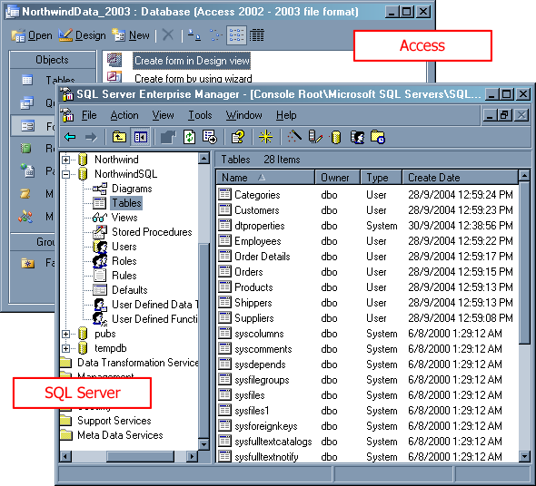

Figure 2 – Enterprise Manager lets you browse and edit data in much the same way as Access
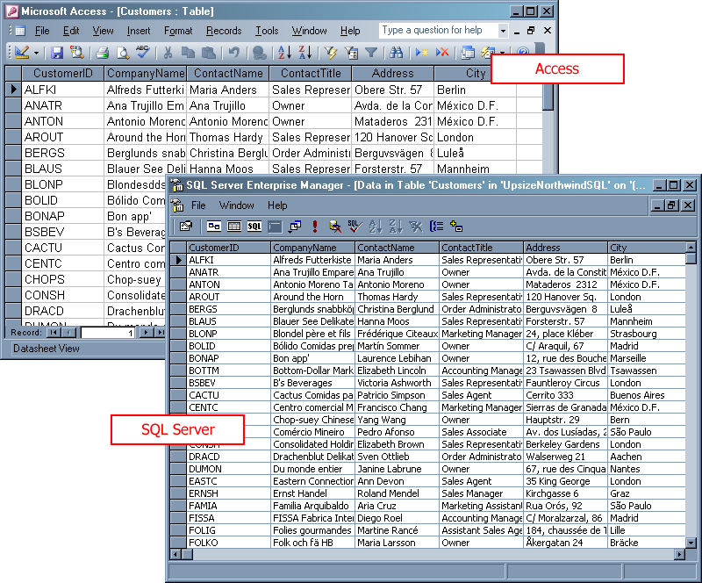

SQL Server Query Analyzer
SQL Server Query Analyzer is a fully-featured graphical query tool which replaces the main Access query designer. It allows you to:

- Create and debug queries
- Run multiple simultaneous queries
- View data
- Export data (via Query –> Results to File)
- Optimize queries (Query –> Show Execution Plan)
- Debug advanced queries (via Tools -> Object Browser –> Debug…)

Figure 3 – Query Analyzer replaces Access' Query Designer and adds features like syntax highlighting and query debugging
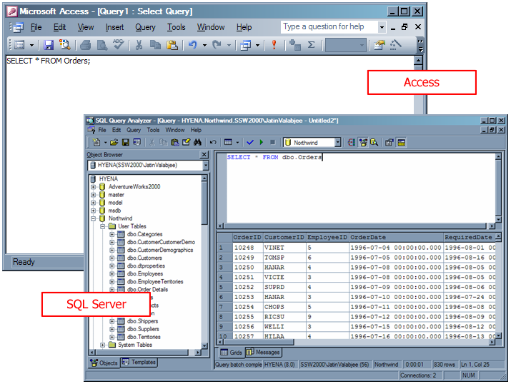

Tip: Although you can write stored procedures inside Enterprise Manager (as shown in Figure 4), Access developers will find Query Analyzer more feature rich as it supports the above features and syntax highlighting for easy viewing and debugging of queries, as shown in Figure 3.

Figure 4 – Writing advanced stored procedures inside Enterprise Manager is not as easy as in Query Analyzer
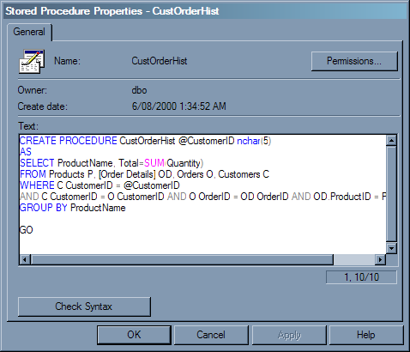

Note that the Query By Example (QBE) designer does not exist in Query Analyzer. You have two options to design queries visually in SQL Server:

- Use the designer in Enterprise Manager (only for views)
- Create an ADP in Access 2000/2002/2003, which has a QBE designer for simple stored procedures and views
Also note that the Create query by using Wizard in Access has no equivalent in SQL Server; you will have to create queries using the query designer or SQL Server statements.

Visual Studio .NET
Visual Studio .NET allows you to manage your database and database objects in much the same way as Enterprise Manager and Access (as shown in Figure 5 and Figure 6). Depending on your version of Visual Studio .NET, you can create a database project that allows you to:

- Design and execute stored procedures, views, triggers and functions
- Browse tables
- View data

This feature is useful for .NET developers as it offers an integrated method of database management; developers can develop applications and manage their database within one application.

Figure 5 – Visual Studio .NET provides an integrated way to manage your data and database objects
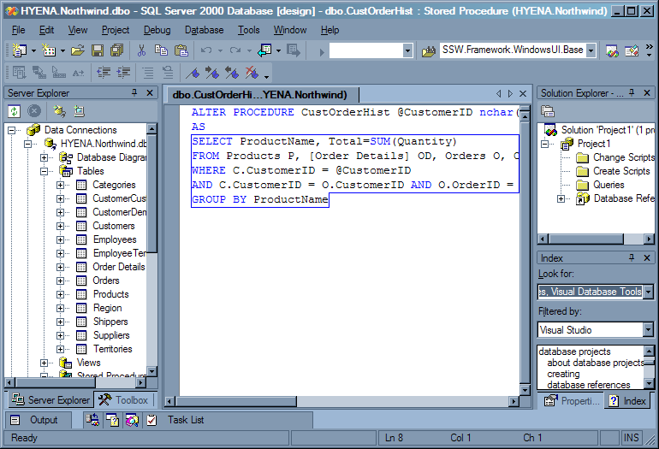

Figure 6 – Access developers will find the Visual Studio .NET view designer very familiar
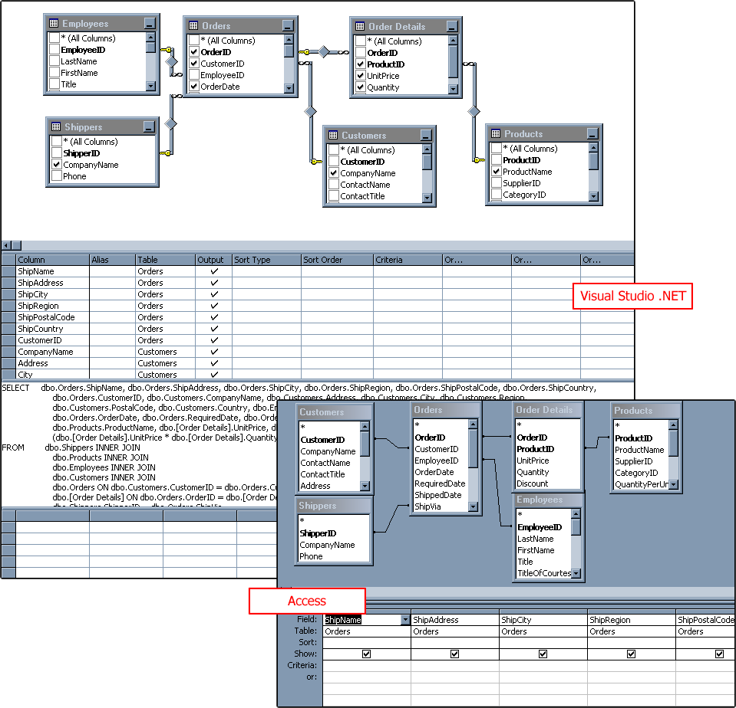

For more information on which versions of Visual Studio .NET support which database management features, please see http://msdn.microsoft.com/library/default.asp?url=/library/en-us/vdbt7/html/dvconVisualDatabaseToolsEditions.asp.

Difference – The SQL Server Tools to Import and Export Data

Data Transformation Services (DTS)
Data Transformation Services (DTS) allows you to import and export data from and to various data sources (such as Microsoft Excel) that use an OLE DB provider. DTS replaces the Access import and export functions (as shown in Figure 8), and also provides functions to:

- Export and import data to and from another SQL Server
- Export and import data to and from various formats such as Excel (XLS), Comma-Separated Values (CSV), and Microsoft Access (see Figure 7)
- Perform transformations on data

Figure 7 – DTS lets you import and export data from and to a variety of formats
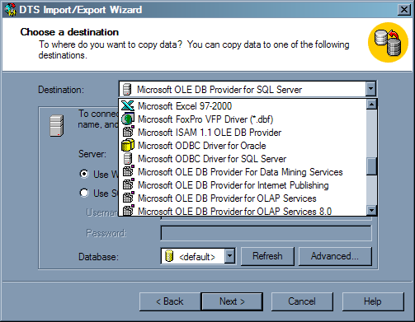

DTS is much more powerful than the Access import and export commands. Many tasks that are performed in an Access import process are done in multiple steps (for example, populating temporary tables and running multiple queries to perform the transformation). This can be performed in one step in DTS. You can perform data transformations, such as copying data from one table to another using a SQL query, or even execute VB Script code to transform parts of the data before insertion into the destination table as shown in Figure 9.

Figure 8 – SQL Server DTS replaces the Access import and export wizards
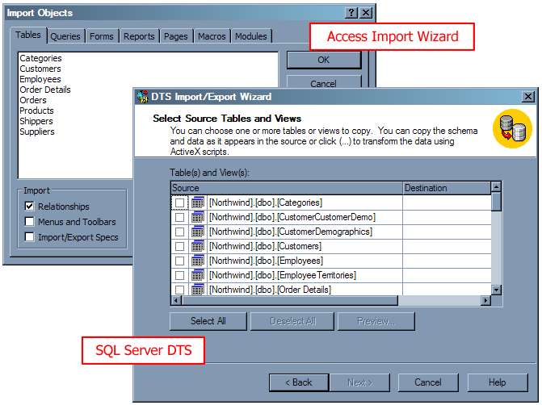

Figure 9 – DTS lets you perform powerful transformations on data that would take much longer in Access
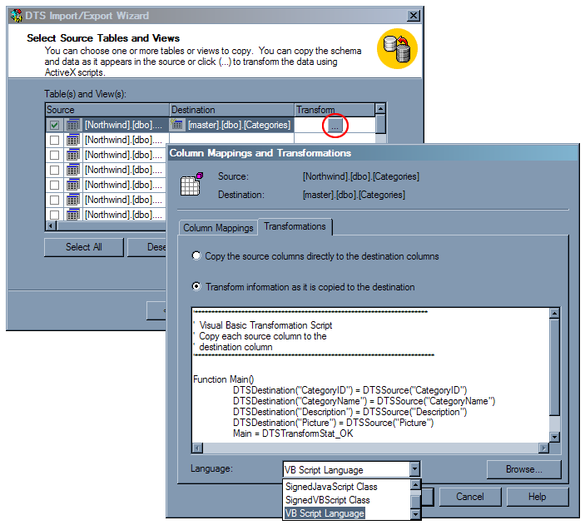

New Feature – SQL Server Profiler
SQL Server Profiler is an essential tool in optimizing the performance of your database. It is especially useful after a migration from a client-only system such as Access. It shows all commands executed on the server, such as connections opened and closed and database transactions (as shown in Figure 10). This helps identify any transactions that are particularly lengthy or resource-intensive.

Figure 10 – SQL Server Profiler monitors database activity to aid in performance optimization
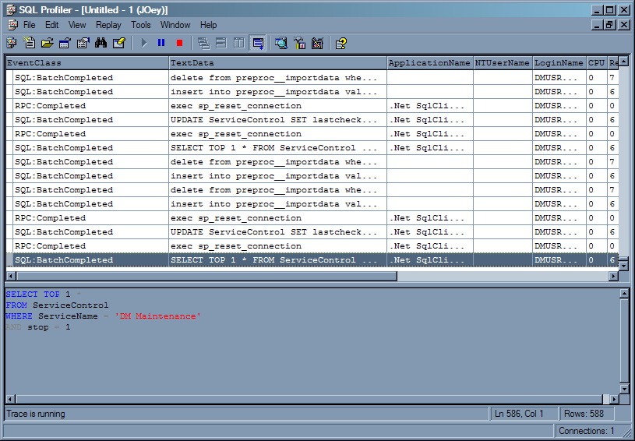

For more information on using these SQL Server tools, see the Microsoft whitepaper, How to Migrate from Microsoft Access to Microsoft SQL Server.

Architecture
There are several differences, similarities, advantages and disadvantages between the architecture of Access and SQL Server. Access developers need to know differences with:

- System requirements
- SQL Server versions
- Data types
- Identity values
- Table design
- Relationships
- Indexing
- Access queries

SQL Server also introduces some powerful new features to optimize and simplify data manipulation, including:

- User-defined data types
- User-defined functions
- Triggers

Advantage – Less Chance of Data Corruption
In Access, you open the MDB file directly. If, for example, the network connection is unexpectedly broken or a client or server machine shuts off without properly shutting down the application, there is a good chance your data will be corrupted. You may receive an error similar to that in Figure 11.

Figure 11 – You will receive an error when attempting to open a corrupted Access database
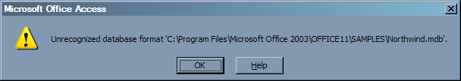

SQL Server, on the other hand, runs as a service – you do not have direct access to the file. Requests for data are managed by the SQL Server service, so if the server shuts down unexpectedly or the network connection is broken, the next request for data will not be fulfilled. Therefore the integrity of the data is maintained.

Advantage – Database Log Files Enable Data Recovery
SQL Server has a distinct advantage over Access in that all transactions (database updates, insertions and deletions) are kept in a log file. This log records the changes to the data and enough information to undo the modifications (if necessary later) made during each transaction. These logs can also be used to recover your data in the event of system failure. See the Advantage – Recovering from System Failure section for more information about data recovery.

Tools such as Lumigent Log Explorer allows you to look into a SQL Server transaction log and undo transactions manually (see Figure 12). Please visit http://www.lumigent.com for more information on this product.

Figure 12 – Lumigent Log Explorer gives takes advantage of your SQL Server log files, allowing the viewing of past transactions
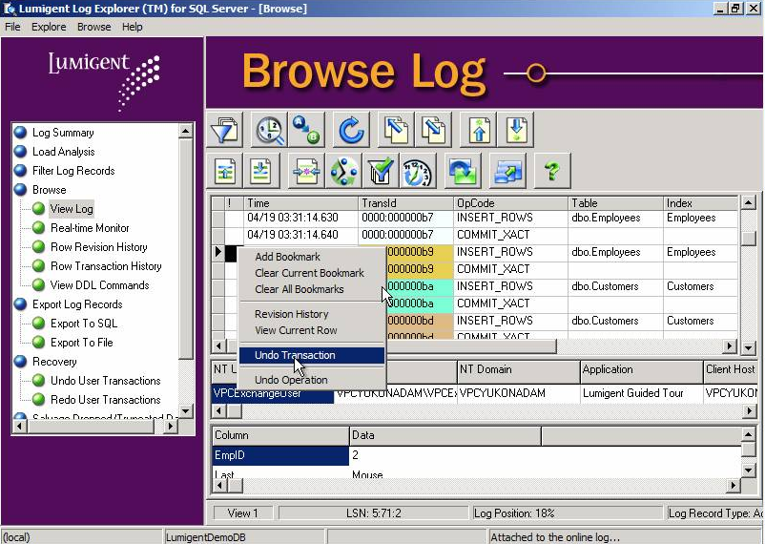

Difference – System Requirements

Minimum System Requirements
As SQL Server has more features and is more scalable than Access, it has slightly more demanding system requirements. Table 1 compares the minimum system requirements between the two systems.

Table 1 - SQL Server has slightly more demanding minimum system requirements than Access
 | Access | SQL Server
Processor | Pentium 75 MHz | Pentium 166 MHz
Memory | 8MB + 4MB for each application running simultaneously + 128MB for Windows XP | 128 MB RAM or more recommended
Hard disk space | 30 MB | 270 MB (full installation)
Operating system | Windows 98, Windows 98 Second Edition, Windows Millennium Edition (Windows Me), Windows NT 4.0 with Service Pack 6 (SP6), Windows 2000, or Windows XP or later | Windows 9x, Windows NT, Windows CE and Windows 2000 and above

Clearly, if you perform a high volume of transactions on your Access database, your processing requirements for SQL Server will be higher.

Realistic System Requirements
The above minimum requirements are unrealistic in a typical operational environment. The realistic system requirements depend on many factors, mainly:

- The quantity of data
- The number of concurrent users

In a scenario of 10 concurrent users and a 1 GB database, the system specified in Table 2 is recommended for running Access or SQL Server in a real world environment.

Table 2 - Realistic system requirements to run Access or SQL Server
 | Recommended
Processor | Pentium III 650MHz
Memory | 512MB
Hard disk space | 2 GB
Operating system | Microsoft Windows 2003 or later

SQL Server Versions
SQL Server 2000 is available in six editions:

- Enterprise
- Standard
- Personal
- Developer
- Desktop Engine (MSDE)
- SQL Server CE (a compatible version for Windows CE)

Table 3 shows the operating system requirements for the different SQL Server Editions.

Table 3 - System requirements for different SQL Server editions
Operating System | SQL Server CE | Desktop Engine (MSDE) | Personal Edition | Developer Edition | Standard Edition | Enterprise Edition
Windows CE
Windows 9x
Windows XP Professional
Windows Server 2003 Standard |  |  |  |  | (most common)
Windows 2003 Server Enterprise
Windows 2003 Server Datacenter

Difference – Data Types
Access data types are automatically converted when upsizing to SQL Server. Table 4 shows all Access data types and what they are converted to when using the Upsizing Wizard.

Table 4 – The Upsizing Wizard automatically converts your Access data types to their SQL Server equivalents
Access (Jet) | SQL Server
Text | nvarchar
Memo | text
Number | int
Date/Time | datetime
Currency | Money
AutoNumber | int (with identity)
Yes/No | bit
OLE Object | image
Hyperlink | text

New Feature – User-Defined Data Types
In Access, you specify the Field Size property for all text fields. For example, you have an email address field defined in three tables of type text and varying field sizes (as shown in Figure 13). You now realize that you need to increase the field size to 100. In Access you would have to manually go through and change each table definition.

Figure 13 – In Access there is no way to ensure consistency across matching fields
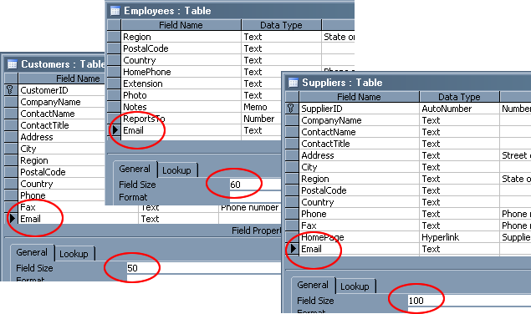

SQL Server allows you to define custom data types via Enterprise Manager, called user-defined data types (UDDT). UDDTs are based on existing SQL Server data types; also, constraints can be added directly to the types to:

- specify a default value (i.e. a value that will be entered automatically into a field if no value has been specified for that record)
- set the maximum field size
- set whether or not the field can be null

UDDTs become invaluable when specifying fields in tables whose properties may change in the future. Using the above email address example, if you defined an email address in multiple tables with data type varchar(100) (i.e. a string of length 100 characters) and defined all related stored procedures to accept a parameter of type varchar(100), changing the length or data type of the field would become a major maintenance issue. All stored procedures and tables would need to be changed to reflect the changes to the data type.

A better solution would be to create a UDDT called Email and define the length and base data type in there (as shown in ). All stored procedures and the table definitions would use this UDDT (instead of varchar(100)), so if the field size increased, it would simply be a matter of changing the definition of the UDDT. This is also a great advantage as you can ensure your field types and lengths are consistent across the database.

Figure 14 – SQL Server lets you specify User-Defined Data Types for use in your database objects
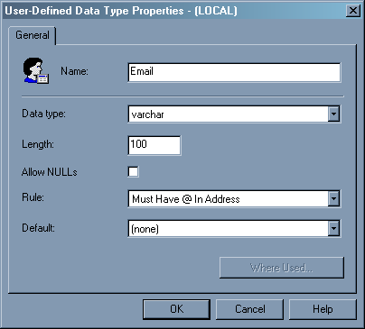

Difference – Identity Values Are Generated After an Insert
In Access, values in autonumber columns are automatically incremented as soon as the user starts editing a new record, before it is inserted into the table. In SQL Server, the identity value is only generated when the record is saved. It is important to be aware of the behavior of functions which make use of the autonumber / identity fields.
For example, you may have a function that adds a new record to the Employees table and displays the autonumber field EmployeeID of the new record:

Private Sub btnCreateRecord_Click()
' Add a new record to the Employees table, show the autonumber value

' Connect to the database
Dim cnn As ADODB.Connection
Set cnn = New ADODB.Connection
cnn.Open "Provider=Microsoft.Jet.OLEDB.4.0;Data Source=C:\Northwind.mdb;"

' Create a recordset for the Employees table
Dim rst As ADODB.Recordset
Set rst = New ADODB.Recordset
rst.Open "Employees", cnn, adOpenDynamic, adLockOptimistic

' Create a new Employee record in the RecordSet and commit to the table
Dim strEmployeeID As String
rst.AddNew
rst("FirstName") = "John"
rst("LastName") = "Stevenson"
rst.Update

' Get the EmployeeID from the RecordSet
strEmployeeID = rst("EmployeeID")
rst.Close
cnn.Close
Set rst = Nothing
Set cnn = Nothing

MsgBox (strEmployeeID)
End Sub

When run on the Employees table in Access, this shows a message box with the EmployeeID of the record that was just created. However, when this function is run on an upsized SQL Server table, the EmployeeID will be a null value. As previously mentioned, this occurs because the ID is generated after a record is inserted.

SQL Server stores a variable called @@IDENTITY which contains the identity value of the most recently inserted record. To make the above function return the latest EmployeeID correctly, you must add code to select this value once the record is inserted. Modify your function to retrieve the value:

Private Sub btnCreateRecord_Click()
' Add a new record to the Employees table, show the autonumber value

' Connect to the database
Dim cnn As ADODB.Connection
Set cnn = New ADODB.Connection
cnn.Open "Provider=SQLOLEDB.1;Integrated Security=SSPI;Initial Catalog=Northwind;Data Source=(local)"

' Create a recordset for the Employees table
Dim rst As ADODB.Recordset
Set rst = New ADODB.Recordset
rst.Open "Employees", cnn, adOpenDynamic, adLockOptimistic

' Create a new record in the recordset and show the Employee ID of the current record
Dim strEmployeeID As String
rst.AddNew
rst("FirstName") = "John"
rst("LastName") = "Stevenson"

rst.Update
rst.Close

' Retrieve the EmployeeID for the record that was just added
rst.Open ("SELECT @@IDENTITY AS EmployeeID")
strEmployeeID = rst("EmployeeID")

rst.Close
cnn.Close
Set rst = Nothing
Set cnn = Nothing

MsgBox (strEmployeeID)
End Sub

When run on a SQL Server table from Access, this correctly returns the generated identity value.

Similarity – Table Design
Tables are represented similarly in both Access and SQL Server. Both DBMSs are relational, that is, related data is stored in logical tables linked by unique identifiers. The table design interface is very similar in Access and SQL Server, as shown in Figure 15.

Figure 15 – Designing Tables is similar in Access and SQL Server
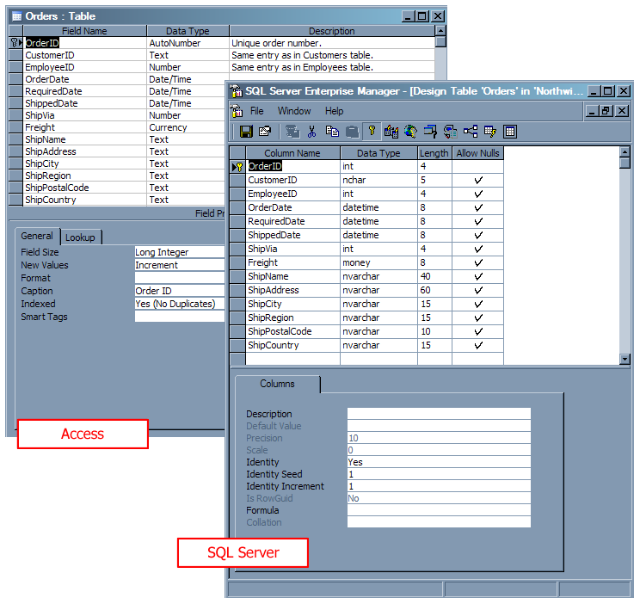

Similarity – Relationships
In Access, you can specify rules on fields in tables, to ensure that data in related tables is consistent.

SQL Server on the other hand, lets you create the same rules via the diagram designer in Enterprise Manager (as shown in Figure 16).

Figure 16 – SQL Server supports similar relationships to Access
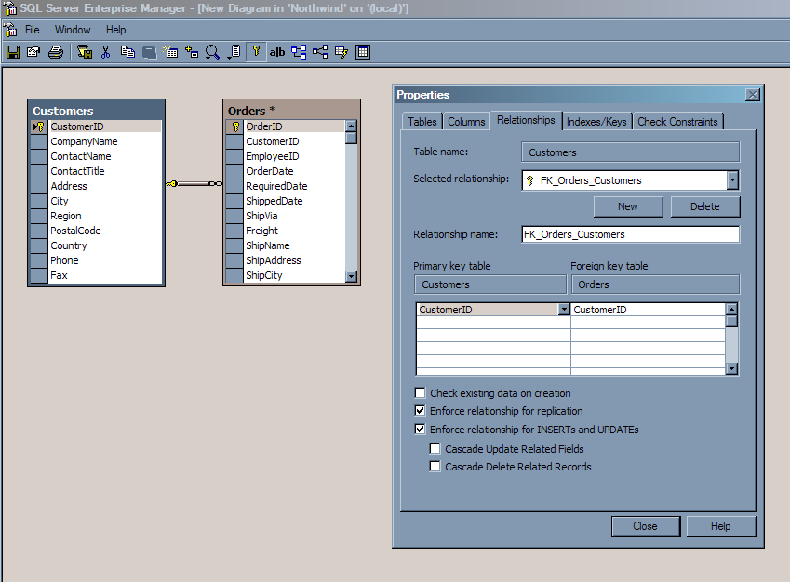

Difference – Data Validation
In Access, you can add 4 types of validation rules on your data:

- Input Mask
- Validation Rule
- Validation Text
- Indexed

SQL Server supports five classes of constraints:

- NOT NULL – specifies that the column cannot contain a NULL value
- CHECK – restricts the values that can be entered into a column. The following SQL creates an Employee table which adds a CHECK constraint to the Salary field so that the value is between 10,000 and 1,000,000.

CREATE TABLE Employee
(
EmployeeID int PRIMARY KEY,
Name char(50),
Address char(50),
Salary money,
CONSTRAINT chk_Salary CHECK (Salary BETWEEN 10000 and 1000000)
)

- UNIQUE – ensures all values in a column for a table are unique. This is commonly used for ID columns.
- PRIMARY KEY – identifies the column or set of columns whose value(s) uniquely identify a row in a table
- FOREIGN KEY – sets the relationships between tables. The following SQL creates an EmployeePosition table which references the EmployeeID in the previously created Employee table.
CREATE TABLE EmployeePosition
(
EmployeePositionID int PRIMARY KEY,
EmployeeID int FOREIGN KEY
REFERENCES Employee(EmployeeID)
ON DELETE CASCADE
Position char(50)
)

The ON DELETE clause has two options:

- CASCADE – specifies that if an employee’s record is deleted from the Employee table, any record with a matching EmployeeID in the EmployeePosition table will also be deleted.
- NO ACTION – specifies that the EmployeePosition record will not be affected if its referenced parent record in the Employee table is deleted.

SQL Server also supports the ON UPDATE clause, which specifies the action to be taken if a parent record is updated. It also supports the CASCADE and NO ACTION options.

Note that relationships in SQL Server are not flexible as they are in Access.
In Access:

- You can cascade update and/or delete update from a table to itself
- You can cascade update and/or delete update foreign keys in a table where the Required property is set to Yes
- You can have a relationship between fields that have different field lengths, for example a CustomerID primary key of length 10 linked to a CustomerID foreign key in another table of length 15.
Note that you should not use this feature as problems may arise when attempting to enforce referential integrity.

These options are not supported by SQL Server.

Disadvantage – Cascading Update Circular References are Not Supported
Unlike Access, SQL Server does not permit circular referential integrity. For example, in your company there is an employee who is in the sales department and is a manager. In the database, his Employee Type is Manager, whose Category is Sales (as shown in Figure 17). However, in the database the Employee Type Manager is in the Sales Category.

Figure 17 – Circular cascading update constraints are permitted in Access; however they will cause errors in SQL Server
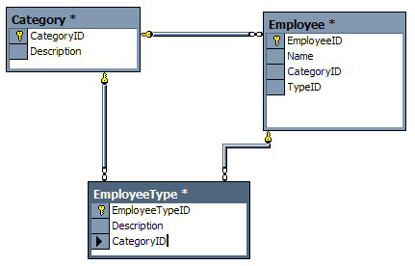

In SQL Server, this structure creates a circular reference, and SQL Server does not allow it. You will receive something similar to the following error if you attempt to create circular update constraints:

Unable to create relationship 'FK_EmployeeType_Employee'.
ODBC error: [Microsoft][ODBC SQL Server Driver][SQL Server]Introducing FOREIGN KEY constraint 'FK_EmployeeType_Employee' on table 'EmployeeType' may cause cycles or multiple cascade paths. Specify ON DELETE NO ACTION or ON UPDATE NO ACTION, or modify other FOREIGN KEY constraints.
[Microsoft][ODBC SQL Server Driver][SQL Server]Could not create constraint. See previous errors.

This is because there is the potential to cause an infinite loop if one field is updated in any one of the tables; in this example, updating one CategoryID field would cause the next CategoryID field to be updated (due to Cascading Update referential integrity), which would cause the next CategoryID field to update, and so on.

To circumvent this issue in SQL Server, you will need to remove the referential integrity constraints from the tables, and create a trigger on each table to perform the updates. For more information on using triggers, please see Microsoft’s MSDN Library page Enforcing Business Rules with Triggers at http://msdn.microsoft.com/library/default.asp?url=/library/en-us/createdb/cm_8_des_08_116g.asp.

Advantage – Improvements to Indexing
In both Access and SQL Server, indexes can be built on one field in a table, or many fields which is known as a composite key. Indexes speed up searches on data by pre-sorting the indexed column values.

SQL Server provides a special type of index known as a clustered index. If a table has a clustered index defined, the rows are stored on the hard disk in sorted order. Clustered indexes are best used on columns that contain frequently searched ranges of values.

For example, you have an application whose database has an Invoice table with a CustomerID foreign key that links to a Customer table. When a customer record is displayed, the application retrieves all invoices for the selected customer from the Invoice table. Adding a clustered index to the CustomerID column in the Invoice table (as shown in Figure 18) would improve performance as all invoices for a customer would be grouped together on disk (as shown in Figure 19). Note that a table can have only one clustered index; however the index can comprise multiple columns.

Figure 18 – Setting a table index to use clustering in SQL Server can provide major performance benefits
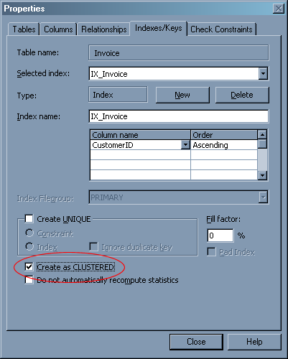

Figure 19 – Clustered Indexes can vastly improve the performance of table lookups as data is grouped physically on the hard disk
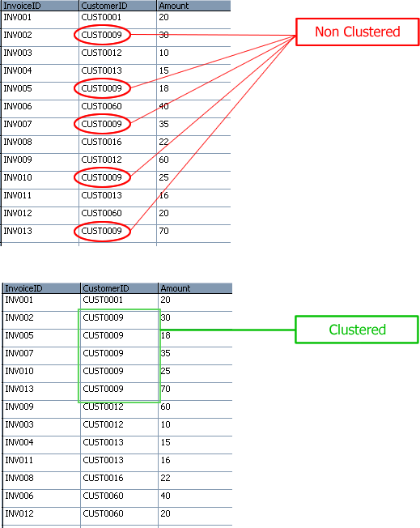

There are third-party tools available to highlight table that are missing clustered indexes and recommend appropriate fields. One tool that does this is SSW SQL Auditor (http://www.ssw.com.au/SQLAuditor).

Similarity – Access Queries / SQL Views
In Access, you design queries by opening a query in design view. Queries allow you to specify a filtered set of data, potentially collated from multiple tables and other queries.

SQL Server has views, which are similar to queries in Access, as can be seen in Figure 20 and Figure 21. Nested queries are supported in both; however you cannot use parameters in views. Stored procedures should be used in this case.

The Access query designer is similar to the view designer in SQL Server, as can be seen in Figure 22.

Figure 20 – Queries in Access are essentially the same as…
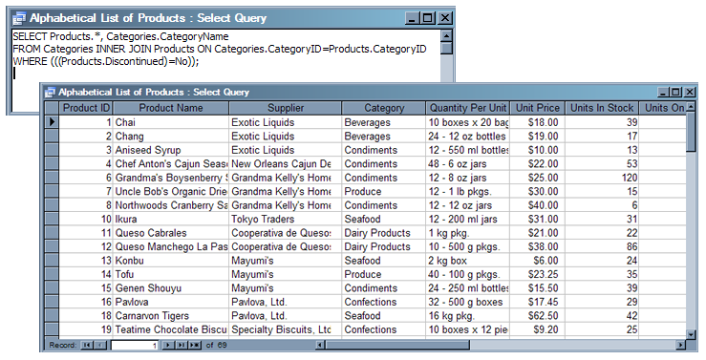

Figure 21 – …Views in SQL Server
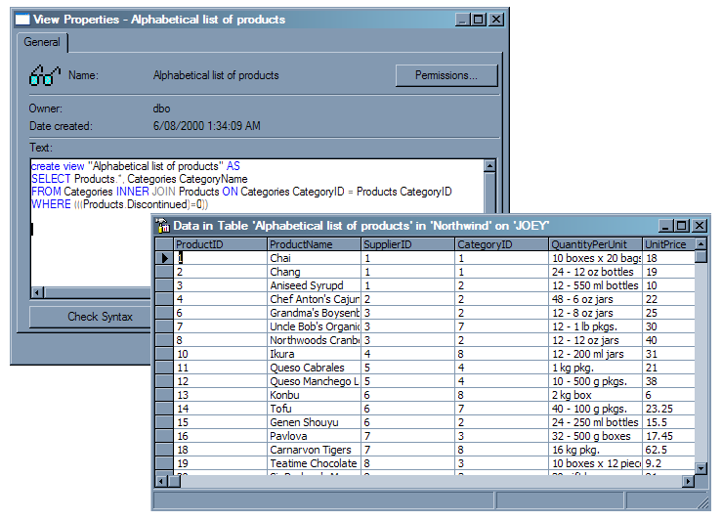

Figure 22 – Designing queries in Access is similar to designing views in SQL Server
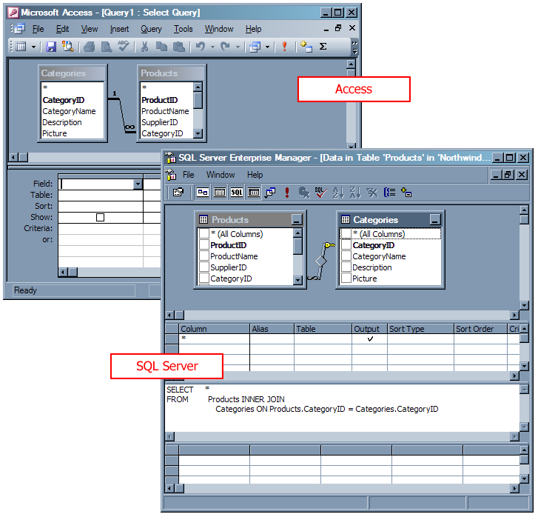

Views are useful for handling security related issues. For example, if you want a certain group of users to be able to view information about a customer, but not their stored credit card details, you would:

- Create a view that only retrieves the non-sensitive fields from the customers table
- Deny access to the table by the group of users
- Allow access to the view by the group of users
- Modify your application to query customer information from the view instead of the table

Similarity – Access Queries / SQL Stored Procedures
SQL Server uses stored procedures to query and perform calculations on data. The main advantage of stored procedures is that they are compiled the first time they are run. This means that SQL Server will calculate the most optimal way to execute the stored procedure and store this execution plan in memory. Subsequent execution of the stored procedure will be much faster, as SQL Server has already worked out the best path to take to run the query. Both Access queries and SQL Server stored procedures support use of parameterized queries. SQL Server views also take advantage of execution plans.

Stored procedures are created and modified within Query Analyzer. Stored procedures are similar to Access queries in that they accept input parameters.

As stored procedures are written in Transact SQL (T-SQL), they offer an advantage over Access queries in that conditional logic and calculations can be used to modify or return data and/or perform some other function. For example, you could write a stored procedure that accepts a bit value of 1 (true) or 0 (false). Based on the value passed, it returns customers with country USA (1) or all other countries (0):

CREATE PROCEDURE procCustomersLocal_Select
@IsLocal bit
AS
IF (@IsLocal = 1) --True - only US customers
SELECT * FROM Customers WHERE Country = 'USA'
ELSE
SELECT * FROM Customers WHERE Country <> 'USA'
GO

SQL Server also lets you debug your stored procedures, which can be invaluable when working with stored procedures that contain complex business logic. The debugger supports setting breakpoints, defining watch expressions, and step-by-step procedures (as shown in Figure 23).

Figure 23 – SQL Server provides advanced query debugging – here you can see the value of the @CustomerID parameter is 123
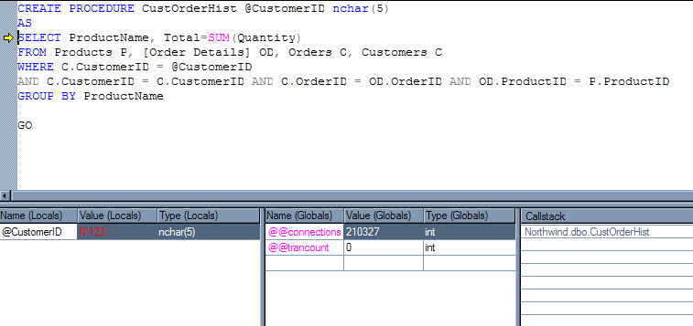

New Feature – Access Queries / SQL User-Defined Functions
Along with built-in functions in SQL Server, you are also able to specify custom blocks of T-SQL statements. These are known as user-defined functions (UDFs). Implemented in much the same way as functions in programming languages, UDFs are a powerful feature that allow code re-use and encapsulation of business logic. UDFs can return a single (scalar) value, or return a table.

Scalar UDFs
For example, you could write a UDF to accept a money value and a state, perform tax calculations, and return the tax-inclusive price. This function could then be called from any stored procedure that required a tax calculation.

Table UDFs
SQL Server 2000 introduced a new table data type, which lets you return a data table from a function. Using table data types in your UDFs is much more efficient than creating and dropping physical tables to perform queries on subsets of data. They are stored and manipulated in memory and do not require any disk access.

For more information on user-defined functions, please see Microsoft’s MSDN Library page User-Defined Functions at http://msdn.microsoft.com/library/default.asp?url=/library/en-us/createdb/cm_8_des_08_460j.asp.

New Feature – Triggers on Tables and Views
In Access, when a record is changed in a table, there is no event raised which can be handled.

SQL Server, on the other hand, has support for triggers. Triggers are simply stored procedures which execute when data in a table is updated, deleted or inserted. Triggers can be set to run when a specific row or field is updated. Note that triggers can be used to enforce referential integrity much like referential constraints; however, referential constraints are more efficient than triggers and should be used where possible.

Triggers should be used to perform custom actions when records are updated. For example, you could set up a trigger to compare the inserted or updated data to data in another field in another table, and update that data accordingly or display a custom error message.

The following example updates a custom field in the Customers table called SumOfOrders. When a record is inserted into the Customers table, the SumOfOrders is updated with the new order total.

CREATE TRIGGER tri_SumOfOrders
ON dbo.Orders
FOR INSERT
AS
DECLARE @CustomerID varchar (5)
SELECT @CustomerID = CustomerID FROM inserted

-- Update the "SumOfOrders" field in the Customer table with the sum of all orders for that customer
UPDATE Customers
SET Customers.SumOfOrders = Customers.SumOfOrders +
(SELECT IsNull(SUM(Freight),0) FROM inserted, Customers WHERE inserted.CustomerID = Customers.CustomerID)
WHERE Customers.CustomerID = @CustomerID

Triggers can be created via SQL Server Enterprise Manager and in a Visual Studio .NET database project, as shown in Figure 24.

Figure 24 – Triggers can also be created in a Visual Studio .NET database project
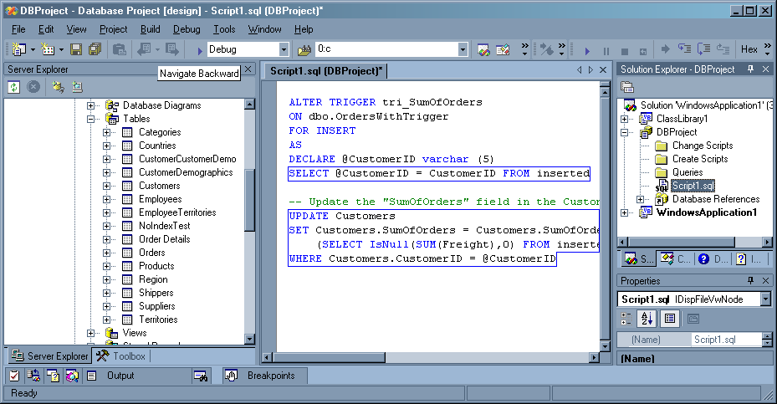

For more information on using triggers to enforce business rules, please see Microsoft’s MSDN Library page Enforcing Business Rules with Triggers at http://msdn.microsoft.com/library/default.asp?url=/library/en-us/createdb/cm_8_des_08_116g.asp.

Scalability and Performance
SQL Server offers significant improvements over Access for scaling your database solution to meet increased business demands. Also, with an improved client / server architecture, the processing load is distributed and usually results in faster performance.

Advantage – Support for More Concurrent Users
Access supports a maximum of 255 concurrent users, and as such is not a feasible enterprise-level data storage solution. In a real world environment it is common to experience major performance issues with as few as 20 users attempting to use the Access database simultaneously over a network.

SQL Server, on the other hand, supports a concurrent user base that is limited only by available system memory, and because of its optimized query processing engine and ability to simultaneously utilize multiple computers, processors and hard drives, it can scale to meet any enterprise requirements.

Advantage – Support for a Larger Database
Access supports a maximum database size of 2GB plus linked tables. Although use of linked tables theoretically enables you to store much more data, it is common to experience performance issues due to the amount of data being processed. Generally you should consider upsizing your Access database(s) if the size of any one of them reaches 100MB.

SQL Server, on the other hand, has vastly improved storage capabilities, allowing for 1,048,516 TB of data to be stored efficiently across multiple devices. It also has self-repairing and self-compacting features, making it a very robust database solution.

Difference – File Extensions
In Access, your whole database is stored as a single .MDB file. When the MDB is opened, a file with extension .LDB is created, which contains information on which users currently have the database open.

SQL Server databases, on the other hand, are simply a group of physical files that are managed by SQL Server. These files comprise, as a bare minimum, a primary data file (.MDF), and a transaction log file (with extension .LDF). Note that the Access LDB and SQL Server LDF are completely different; the former simply stores locking information and the latter contains a complete log of all transactions occurring in the SQL Server database.

SQL Server databases can also have one or more secondary data files (.NDF). The primary data file is used as the starting point for the database and contains data as well as references to the secondary data files.

Advantage – Database and Log Files Can Be Split Across Multiple Devices
Access databases are stored as a single .MDB file. As such, they can only be stored and run on a single machine. This can cause issues when the database and user base grow, as the processing power and storage space become constrained by the hardware on the single database server.

SQL Server, on the other hand, lets you split data and transaction logs across multiple computers (as shown in Figure 25).

Figure 25 – in SQL Server you can specify multiple devices for your database files and transaction logs
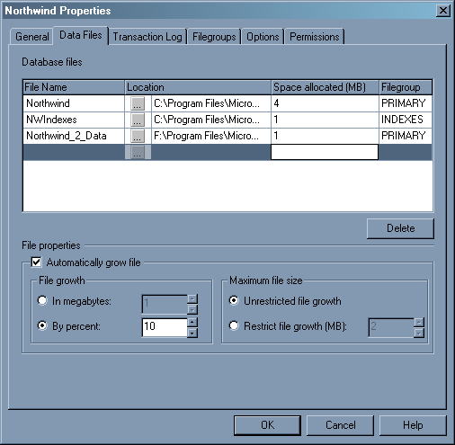

When working with a large database, storing the transaction log and multiple data files on separate computers enables you to harness the processing power of multiple computers. It also helps you utilize storage space across multiple computers or hard disks.

Advantage – More Robust Queries
Access developers may have encountered an Out of Memory or Query too Complex error when attempting to run a query, a form, or a report based on a query. This usually occurs because the query you are attempting to execute contains more table joins than Access can handle. To circumvent this issue, Access developers often are forced to waste resources in redesigning queries and restructuring tables.

It is also important to note that you can do much more complicated nesting in SQL even though the product’s specification indicates otherwise. Technically Access supports up to 50 nested sub-queries, whereas SQL Server supports a maximum of only 32.

SQL Server, on the other hand, has been re-architected to support much more flexible queries. Inside a single query, you can use up to:

- 256 tables in the SELECT statement
- Approximately 256KB of query text
- 4096 columns in the SELECT statement

Working with Data
Creating queries in Access is different to creating queries in SQL Server; there are differences in the query language (T-SQL) and the query designer. SQL Server developers use views, stored procedures and user-defined functions, which facilitate reuse of business logic.

Difference – Querying Data

Always Use a WHERE Clause for the Form’s Record Source
Many Access forms have a whole table or query set as their Record Source property. In an upsized SQL Server database, Jet selects a batch of records at a time from the table. When you navigate past the last record that was retrieved, Jet selects the next batch, and so on.

To allow more granular control over exactly which records are retrieved from the SQL Server database, change the form’s record source to use a WHERE filtering clause.

For example, a query behind an Access form would be:

SELECT * FROM Customers

This query retrieves potentially thousands of records. In SQL Server, on the other hand, this should be optimized to only return the current record. The SQL query would be in the form:

SELECT * FROM Customers WHERE CustomerID = ‘BOLID’

This returns just one row / record. Every time the user navigated to the next or previous record in the form, the CustomerID would change, and the database would need to be re-queried to retrieve the current record.

Query Types
Access provides several methods to let you view and design queries for your data. Table 5 explains the possible options when migrating built-in Access query types to SQL Server.

Table 5 - There are several options when converting your queries from Access to SQL Server
Access query type | SQL Server migration options
Select | A SELECT statement can be used in a T-SQL file, a stored procedure or a view. SELECT statements can also be designed using the built-in SQL Server query designer, which is very similar to the Access query designer.
Crosstab | A Crosstab can be implemented as a T-SQL file, a stored procedure or a view. Temporary tables can be used to query the data sets required for the crosstab in memory. The temporary tables can be joined and queried to retrieve the required crosstab data.  Converting Access crosstab data to work in SQL Server can become quite a lengthy task. You can use a third-party utility such as The Relational Application Companion (http://www.rac4sql.net/), or you can convert them manually. The best technique is to manually convert crosstabs is the Rozenshtein Method, blogged by Stephen Forte at http://www.stephenforte.net/owdasblog/default.aspx?date=2003-08-07.  A more flexible, efficient and extensible solution for crosstab queries is SQL Server Analysis Services. Analysis Services lets you build online analytical processing (OLAP) data cubes to enable generation of complex, dynamic reports. For a detailed explanation of using SQL Server Analysis Services on your data visit Microsoft’s SQL Server: Analysis Services page at http://www.microsoft.com/sql/evaluation/bi/bianalysis.asp.
Make table | A make table can be implemented as a T-SQL statement which uses the SELECT INTO clause to copy data from one table to another.
Update | An update statement can be stored as a T-SQL statement or a stored procedure which uses the UPDATE clause.
Append | An append statement can be stored as a T-SQL statement or a stored procedure which uses the INSERT INTO clause.
Delete | A delete statement can be stored as a T-SQL statement or a stored procedure which uses the DELETE FROM clause.

Query Language Features
Table 6 summarizes the main differences in query language features supported in Access and SQL Server.

Table 6 - Access and SQL Server have differences in data queries
Feature | Supported by Access SQL with Jet 4 SQL-92 Extensions | Supported by SQL Server 2000 T-SQL
Security (GRANT, REVOKE etc.)
Transaction support (COMMIT, ROLLBACK etc.)
Views (CREATE VIEW)
Temporary tables
Joins in FROM clause
Joins in UPDATE and DELETE statements
Support for FULL OUTER JOIN and UNION JOIN
Support for subqueries in the SET clause of UPDATE statements
Support for multiple tables in DELETE statements
SELECT DISTINCTROW
SELECT TOP
Cursors (DECLARE CURSOR, FETCH, etc.)
Domain support (CREATE DOMAIN, ALTER DOMAIN, etc.)
Support for check constraints
Assertions (CREATE ASSERTION, DROP ASSERTION etc.)
Row value constructors
CASE expressions
Full referential integrity support in CREATE TABLE statement
Standardized system tables and error codes
Standard data types
Standard string operators
Standard wildcard characters
Support for VBA functions
Additional aggregate functions
TRANSFORM statement
Parameters in queries or stored procedures
SELECT INTO statement

For more information on designing your Access queries in SQL Server, please see the Microsoft white paper, How to Migrate from Microsoft Access to Microsoft SQL Server, or see the Microsoft whitepaper, Migrating Your Access Database to Microsoft SQL Server 7.0 at http://msdn.microsoft.com/archive/default.asp?url=/archive/en-us/dnarsql7/html/access2sql.asp. Be aware that the paper is still relevant but written for SQL Server 7.0; Microsoft has never updated it to SQL Server 2000.

Advantage – T-SQL Provides Powerful Functionality
Structured Query Language (SQL) is the language used by Access and SQL Server for data access and manipulation. The latest revision as defined by the American National Standards Institute (ANSI) to the SQL language is called SQL-92, named for the year it was completed. Microsoft has added some of its own extensions to SQL-92, which vary between the two DBMS solutions.

Access supports SQL-92 as well as custom extensions which add support for managing transactions using SQL. These extensions also add support for easy management of database security; however some features, such as setting and changing database object ownership, are not supported.

In SQL Server 2000, on the other hand, Microsoft has added custom extensions to the base SQL-92 language. These extensions add script support for some important features, such as:

- stored procedures
- distributed transactions
- operating system functions
- more flexible sub-queries
- aliases in queries
- backup and restoration of data

Microsoft’s T-SQL language is a very powerful extension to the standard SQL set of commands. Like SQL-92 it provides all the functionality necessary to:

- retrieve, modify, delete and add data to database tables
- accept and return parameters
- perform calculations
- run built-in and user-defined functions

T-SQL is like a cross between Access queries and VBA, in that data queries can be combined with conditional logic and calculations.

SQL Server completely supports the SQL-92 standard – use of the extensions is optional.

Advantage – Ability to Script Objects
To make changes to a database structure in Access, you would typically have to manually record the changes, which must then be manually done in all copies of the Access database. When many changes are made to the database structure, keeping track of these becomes tedious and prone to error.

SQL Server, on the other hand, provides database object scripting to simplify this process. A script is a series of T-SQL statements stored in a file. Scripts are extremely powerful – they can be used to store commands to recreate an entire database and its data, which can later be run on a different computer to create an exact replica of a database. They can also be used as a backup mechanism, so that in case of system failure, backed up scripts can be run to recreate the database and its data. SQL Server Enterprise Manager provides a Generate SQL Script function to automatically create scripts for objects in your database such as tables (see Figure 26). The included osql utility can then be used to run the scripts on a separate computer.

Figure 26 – Enterprise Manager can automatically generate SQL scripts for your database objects so that they can be recreated on other computers
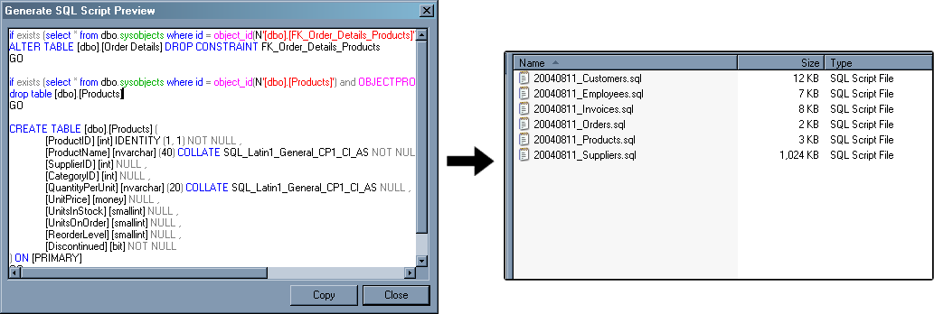

Advantage – Table Variables: Useful for Complex Queries
In Access, if you wanted to perform calculations on a set of joined tables, you would create a query defining the joins. In an application using that data, every time this query was used in a SQL SELECT statement, all of the tables would need to be rejoined, which is potentially an extremely resource-intensive operation (particularly in a multiple user environment).

For example, if you wanted to delete all Customers whose first name starts with “A”, and delete all the customer’s related orders and order history, in Access you would need to:

- Create a SELECT query that gets all the required Customer ID’s:

SELECT Customers.CustomerID
FROM Customers
WHERE Customers.ContactName LIKE "A*"

- Wrap the above SELECT query into two DELETE queries that will delete all required Customers, Orders and Order History:

Query 1:

DELETE FROM Orders WHERE Orders.CustomerID IN
(
SELECT Customers.CustomerID
FROM Customers
WHERE Customers.ContactName LIKE "A*"
)

Query 2:

DELETE FROM Customers
WHERE Customers.ContactName LIKE "A*"

This is clearly a very inefficient way to perform this operation, as a resource-hungry LIKE filter would have to be run on the Customers table for every delete operation. Performing such wildcard WHERE filters would present major performance issues should the Customers table grow to millions of records.

A much more efficient way to perform this operation would be to use table variables, a new feature available in SQL Server. Table variables are used exactly like regular tables in SQL syntax. However, they differ from regular tables in that they are stored temporarily in memory, not on the hard disk (similarly to other variables). As memory access is significantly faster than hard disk access, table variables become useful when performing multiple operations on the same set of filtered or joined data.

To implement the above example using a table variable, you would:

- Declare the table:

DECLARE @tmpCustomerIDs TABLE (CustomerID nvarchar(50))

- Get the filtered set of records and store them in the table variable:

INSERT INTO @tmpCustomerIDs (CustomerID)
(SELECT CustomerID FROM Customers WHERE Customers.ContactName LIKE 'A%')

- Perform all delete operations on Customers and Orders using values from the table variable:

-- Delete all order records matching the CustomerIDs in the temp table
DELETE FROM Orders
WHERE Orders.CustomerID IN
(
SELECT CustomerID
FROM @tmpCustomerIDs
)

-- Delete all customer records matching the CustomerIDs in the temp table
DELETE FROM Customers
WHERE Customers.CustomerID IN
(
SELECT CustomerID
FROM @tmpCustomerIDs
)

Temporary tables are another mechanism offered by SQL Server to efficiently perform operations on a dynamic set of data. Unlike table variables, they stay in memory longer and so can require more locks on data and logging resources.

Advantage – Recovering from System Failure
Most Access developers would have encountered an Unrecognized database format error when attempting to open a corrupt database (as shown in Figure 27). When a system crash occurs (such as an operating system crash or power outage), your options are:

- Attempt to recover data from the corrupt .mdb file using the Access compact and repair utility, then import the recovered data into a blank database to minimize the number of corrupt records. This is not a failsafe process, and data can be lost.
- Restore from a recent backup, which would result in wasted resources used to re-enter lost data.
- Run the Jet compact utility, JETCOMP.exe. This is often more effective than running the compact and repair utility, however there is still no guarantee that all data will not be corrupted.
- Submit your corrupted database to a third party database recovery specialist, who will use proprietary methods to extract data from the database. This is potentially a costly process, and can have security implications as external parties will be handling your data.

Figure 27 – You will receive an error when attempting to open a corrupted Access database

SQL Server offers much more control over data recovery. You can select one of three recovery models for each SQL Server database to determine how your data is backed up and what your exposure to data loss is. The three recovery models are:

- Simple recovery – allows the most recent backup to be recovered.
- Full recovery – allows the database to be recovered to the point of failure. This model requires the most system resources and disk space (for logging).
- Bulk-logged recovery – allows the database to be recovered to the point of the last log backup. This requires less system resources and disk space than the full recovery model, although there is a higher chance of having to re-enter data manually.

These recovery models give you the flexibility to select the best way to recover from system failure balanced with availability of system resources.

Advantage – Backups Can Be Done While the Database is Running
The major advantage SQL Server data backups offer over Access backups is that they can be done while the database is running, without requiring users to log-off. This vastly improves the availability of the database to users and allows a much higher uptime.

Difference – Comparing Databases
In Access, keeping your live production database up to date with the latest structural changes is an ongoing problem. The database needs to be taken offline quickly to make structural changes and convert data but this can be difficult when people are relying on the system. The data conversion can also take time as new fields and relationships might have been added.

To make structural changes to an Access database, typically:

- The developers work on the Application Database and make structural changes to the database containing the data while the database is closed
- Changes to the database containing the data are tracked and either Update Queries or DAO code are written to make the update
- After development is complete, the databases need to be taken offline while updates are made manually

Third party applications such as SSW Data Renovator (http://www.ssw.com.au/DataRenovator/) help minimize system downtime and reduce the likelihood of mistakes by automating part of this process. SSW Data Renovator compares the new database with the production database, generates reports on all the differences between the two, and provides a wizard-style interface to automatically move data into the new structure (see Figure 28).

Figure 28 – SSW Data Renovator helps minimize system downtime by providing easy to follow reports on the differences between two databases
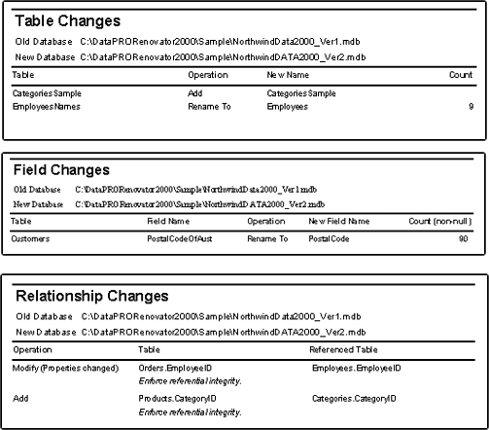

Although SQL Server has the benefit of not requiring the database to be taken offline to make structural updates, database administrators still must:

- Analyze all database schemas and change logs for structural changes
- Manually create migration scripts to use on the target database

Third-party utilities, such as Red-Gate SQL Compare (http://www.red-gate.com/SQL_Compare.htm) or SSW SQL Deploy (http://www.ssw.com.au/SQLDeploy) help automate this task by:

- Comparing all objects in both databases, including stored procedures, relationships, tables, views and user-defined functions
- Reporting on all differences (see Figure 29 and Figure 30)
- Generating migration scripts which can then be run directly on the target database

Figure 29 – Red-Gate SQL Compare provides a simple way to compare and synchronize SQL Server database structures
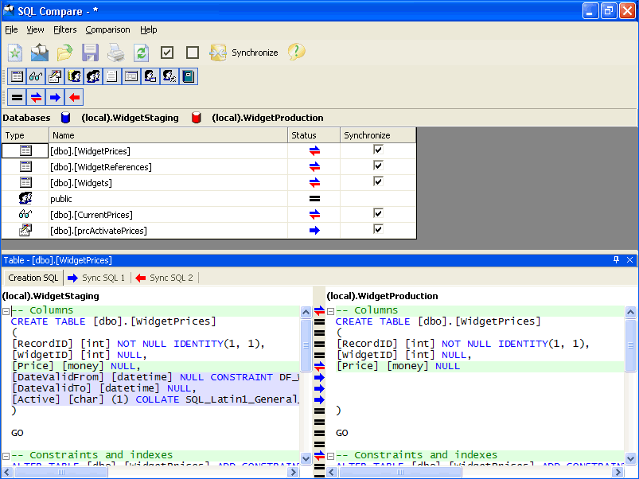

Figure 30 – SSW SQL Deploy automatically runs SQL scripts to synchronize multiple schemas
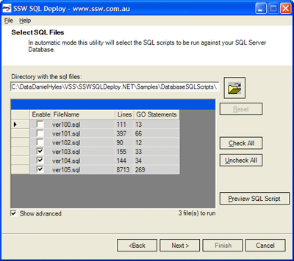

Conclusion
Microsoft SQL Server is an enterprise-level database solution with vastly improved scalability, maintenance and database recovery features in comparison with Access. As it is based on a client / server architecture, SQL Server is quite different to Access in the way it processes and sends data over a remote connection. SQL Server also offers many new features to make the task of querying data, reusing business logic, and backing up data much more simple and flexible.

Access developers looking to migrate their database backend to SQL Server should take note of these differences and similarities, and refer to the Microsoft white paper, How to Migrate from Microsoft Access to Microsoft SQL Server, to assist in the migration process.

Glossary – New Terms for Access Developers
ADO.NET
A new data access model provided with the Microsoft .NET framework. It is designed specifically for the web with scalability, statelessness, and XML in mind.
Client / Server Architecture
A software architecture that promotes scalability by allowing multiple clients to make requests and receive results from a central server or group of servers. The processing load is shared between the client/s and the server/s.
Clustering
A method of indexing and sorting data directly on the hard disk, to enable extremely fast querying of data.
OLAP
Online Analytical Processing. A powerful data storage model that lets you analyze your business data from limitless different points of view. For example, you can use OLAP to view all products sold in a certain region above a certain price during a certain time period.
UDDT
User-defined data types. A new feature in SQL Server which lets you create your own data types based on existing SQL Server base data types. UDDTs promote more strict business rules on data.
UDFs
User-Defined Functions. Custom blocks of T-SQL statements that facilitate re-use of business logic throughout your database application.
SQL Server Enterprise Manager
A utility supplied with SQL Server to provide easy management of database objects, users, backups and database permissions.
SQL Server Query Analyzer
A utility supplied with SQL Server to enable writing and debugging of database queries.
SQL Server Profiler
A utility supplied with SQL Server to help you optimize queries by identifying any database transactions that are particularly lengthy or resource-intensive.
SQL Server Data Transformation Services
A utility supplied with SQL Server that allows you to import and export data from and to various data sources that use an OLE DB-based architecture, such as Microsoft Excel.
T-SQL
Transact-SQL. An extension of the SQL-92 query language standard, providing extended features in SQL Server, such as stored procedures, backup and restoration of data, and distributed transactions.
Visual Studio .NET
An integrated development environment (IDE) that lets developers visually build a broad range of Microsoft .NET-connected applications. It provides powerful tools for designing, building, testing and deploying .NET-enabled web and windows applications.
XML
eXtensible Markup Language. A widely adopted standard way of representing text and data in a format that can be processed without much human or machine intelligence.

For more information:
http://www.microsoft.com/sql/!href()

Did this paper help you? Please give us your feedback. On a scale of 1 (poor) to 5 (excellent), how would you rate this paper?!href(mailto: sqlfback@microsoft.com?subject=Feedback: [What’s New and Different when Moving Your Backend from Access to SQL Server 2000])

Access 2002 Desktop – Developer’s Handbook, Litwin / Getz / Gunderloy, ©2001 SYBEX, Inc.

