How to Migrate Access Forms to .NET Windows Forms
.NET Technical Article

Writers: Adam Cogan, Jatin Valabjee
Technical Reviewers: Marten Ataalla
Project Editor: None
Designer: None

Published: [Insert Date:MM YYYY]
Updated: [Insert Date: MM YYYY]
Applies To: SQL Server 2000 SP3a

Summary: This document details the manual conversion process from a Microsoft™ Access® front-end application to Microsoft™ .NET® Windows Forms. As part of this walkthrough, three forms are converted from the sample Access Northwind Traders application into .NET. It is aimed at making the conversion process as straightforward and intuitive as possible.
New features in Microsoft™ .NET® Windows Forms are also discussed.

Copyright
The information contained in this document represents the current view of Microsoft Corporation on the issues discussed as of the date of publication. Because Microsoft must respond to changing market conditions, it should not be interpreted to be a commitment on the part of Microsoft, and Microsoft cannot guarantee the accuracy of any information presented after the date of publication.

This White Paper is for informational purposes only. MICROSOFT MAKES NO WARRANTIES, EXPRESS, IMPLIED OR STATUTORY, AS TO THE INFORMATION IN THIS DOCUMENT.

Complying with all applicable copyright laws is the responsibility of the user. Without limiting the rights under copyright, no part of this document may be reproduced, stored in or introduced into a retrieval system, or transmitted in any form or by any means (electronic, mechanical, photocopying, recording, or otherwise), or for any purpose, without the express written permission of Microsoft Corporation.

Microsoft may have patents, patent applications, trademarks, copyrights, or other intellectual property rights covering subject matter in this document. Except as expressly provided in any written license agreement from Microsoft, the furnishing of this document does not give you any license to these patents, trademarks, copyrights, or other intellectual property.

Unless otherwise noted, the example companies, organizations, products, domain names, e-mail addresses, logos, people, places and events depicted herein are fictitious, and no association with any real company, organization, product, domain name, email address, logo, person, place or event is intended or should be inferred.

©2004 Microsoft Corporation. All rights reserved.

Microsoft, Microsoft Access, Microsoft Excel, Microsoft Office, Microsoft SQL Server Reporting Services, Microsoft Visual Studio .NET, and Microsoft Windows are either registered trademarks or trademarks of Microsoft Corporation in the United States and/or other countries.

The names of actual companies and products mentioned herein may be the trademarks of their respective owners.

Table of Contents

Assumptions
Who Should Read This
Introduction
About SSW and the Authors
What Will Be Migrated
Create the Solution
The 3 Steps to Migrate the Main Switchboard Form
Step 1: Create the User Interface
Step 2: Set the Control Properties
Step 3: Add the Form Functionality
The 4 Steps to Migrate the Orders and Orders Subform Forms
Step 1: Create the Data Access Components
Step 2: Create the User Interface
Step 3: Bind the Form Controls
Step 4: Add the Form Functionality
Maintaining the Application
Change Your SQL Server
Conclusion

How to Migrate Access Form to .NET Windows Forms

Assumptions
The information and steps provided in this paper are based on the following assumptions:

- Your data is stored in a SQL Server database
- Enterprise Manager is being used to manage your backend
- You are using Microsoft Access 2000/2002/2003
- Visual Studio .NET 2003 will be used as the development environment

Who Should Read This
This paper has been written for Access developers who are familiar with the features of Access and are considering moving their front-end application to .NET Windows Forms. Other readers may include Visual Basic and .NET developers.
Readers should have an understanding of:

- The features of Access
- Access form design and data binding
- VBA (events, variables, subroutines, functions)
- The Visual Studio 6 or Visual Basic for Applications (VBA) development environment
- The benefits of separating your application into presentation and logic, and n-tier architectures

It is recommended that, prior to migrating your Access forms, you read the Microsoft whitepaper What’s New and Different for the Access Developer Moving to .NET. It will help to gain a better understanding of what to expect in .NET.



Or the Visual Basic 6 Developer
Or the .NET Developer
The Access Developer

With understanding of Access Database concepts e.g. ADO.

Introduction
Microsoft Access developers generally consider a move to a .NET front-end for performance, extensibility, security and stability reasons. This process is known as application conversion and developers will find a number of key differences while migrating from Access to the .NET environment. It is crucial that these differences are noted and appropriate action is taken to ensure a seamless and incident-free migration from Access to .NET Windows Forms.

This paper assists the new .NET developer on the migration from Access forms to .NET Windows Forms. The following topics are covered in the process of converting the sample Access application:

- Move data access and ADO code to ADO.NET and a Data Access Layer (DAL)
- Utilizing new .NET controls
- Recreating Access forms in .NET
- Moving logic from Northwind forms to a business logic layer in .NET
This paper does not cover the process of migration of the database backend from Access to SQL Server. More information on migration can be found in the Microsoft whitepaper How to Migrate Your Backend from Access to SQL Server 2000.

About SSW and the Authors
This whitepaper is written by Adam Cogan (Chief Architect), Drew Walker (Software Developer) and Jatin Valabjee (Senior Software Developer) of Superior Software for Windows (SSW). SSW is a Sydney based consulting company specializing in .NET solutions for progressive businesses since 1990. SSW offers custom software solutions in ASP.NET, VB.NET, C#, SQL Server, Exchange Server, Microsoft Access and Office 2003. Adam can be contacted at adamcogan@ssw.com.au.

Adam Cogan is one of two Australian Microsoft Regional Directors and has been developing custom solutions for businesses across a range of industries such as Government, banking, insurance and manufacturing since 1990 for clients such as Microsoft, Quicken, and the Fisheries Research and Development Corporation.

Jatin Valabjee has extensive industrial experience developing Microsoft solutions. He has an in-depth knowledge of the Microsoft suite of products, including Access, SQL Server 2000 and .NET Windows Forms and Web Forms.

Information in this whitepaper is based on our experiences and observations developing Windows software and databases. We welcome any feedback to info@ssw.com.au.

What Will Be Migrated
In this whitepaper, three forms from the Northwind database will be migrated from Access to .NET.

- Main Switchboard (shown in Figure 1)

Figure 1 – The Northwind Main Switchboard form
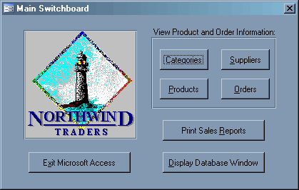

- Orders (shown in Figure 2)

Figure 2 – The Northwind Orders form
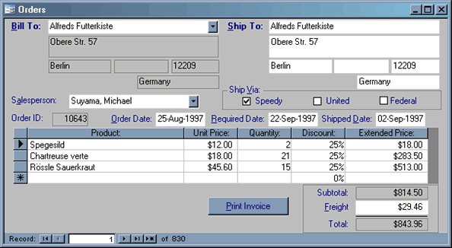

- Orders Subform (shown in Figure 3)

Figure 3 – The Northwind Orders Subform form
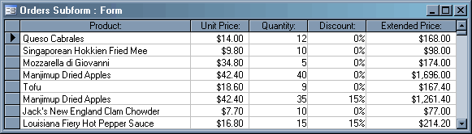

The Northwind database is shipped with Access and can be found in the Samples subdirectory of the Access installation directory. Alternatively it can be downloaded from Microsoft’s Download Center at http://www.microsoft.com/downloads/.

Create the Solution
The first step to prepare for migration of Access forms is to create a Visual Studio .NET solution and add projects that represent the separate layers of the application. Table 1 lists each project in the solution and its purpose. Figure 4 demonstrates the relationship between the projects and layers.

Table 1 – The projects used in the solution and their purpose
Project Name | Purpose
WindowsUI | Contains forms and form controls that will comprise the application’s user interface
DataAccess | Handles connections and interactions with the database
DataSets | Stores and defines an in-memory copy of data from the database
Business | Defines specific business logic and rules separate from data access code

Figure 4 – The relationships between the projects and layers of the application
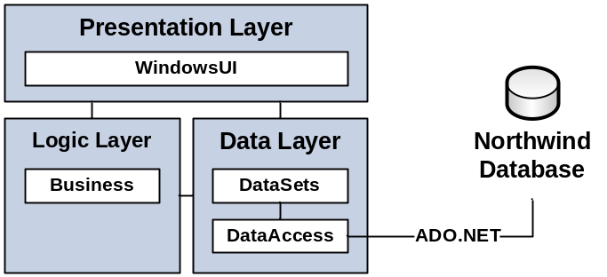

To create the solution and projects in Visual Studio .NET, complete the following steps:

- Select File –> New –> Blank Solution (as shown in Figure 5) and name the solution Northwind (as shown in Figure 6)

Figure 5 – Create a new blank solution
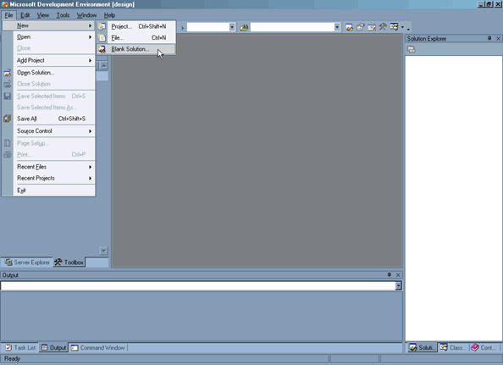

Figure 6 – Name the solution Northwind
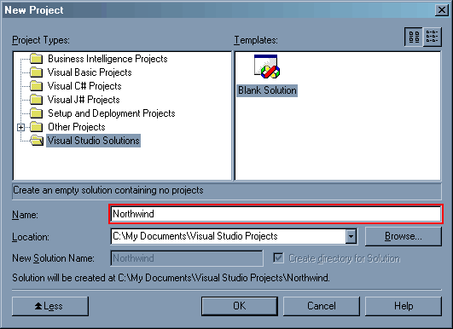

- Right-click the solution and select Add -> New Project… (as shown in Figure 7). Select Windows Application from Visual Basic Projects and name the project WindowsUI (as shown in Figure 8).

Figure 7 – Add a new project to the solution
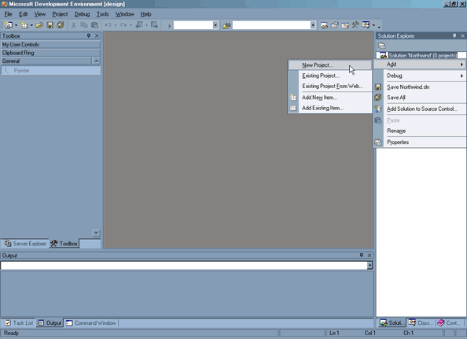

Figure 8 – Use the Visual Basic Windows Application template to create a new project named WindowsUI
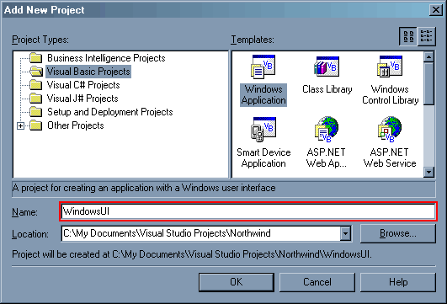

- Add three Visual Basic Class Library projects to the solution named Business, DataAccess and DataSets.

When a project is created, Visual Studio .NET adds a file based on the project type. These files do not need to be used in the solution:

- Delete Form1.vb from the WindowsUI project and Class1.vb from each class library project.

The project is named WindowsUI based on SSW’s Rules to Better .NET Projects at: http://www.ssw.com.au/ssw/standards/Rules/RulesToBetterdotNETProjects.aspx#SolutionStructure.

The solution now has the structure shown in Figure 9.

Figure 9 – This is how the solution looks once all the projects have been added
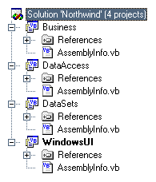

The 3 Steps to Migrate the Main Switchboard Form
In Access, creating the Northwind Main Switchboard form involves:

- Creating the user interface - Forms are added to the database, and controls to the form.
- Setting the control properties – Buttons are given names and control captions are set.
- Adding the form functionality – Code is added to each button that executes when the button is clicked. For example, DoCmd.OpenForm(“Categories”).

In Visual Studio .NET, the process to create the Main Switchboard form is the same. However, the steps within each process differ slightly. For example, instead off calling the DoCmd.OpenForm(“Categories”) function, the following code could be used:

Dim categoriesForm As New Categories
categoriesForm.Show()

Follow the three steps below to create the Main Switchboard form in Visual Studio .NET.

Step 1: Create the User Interface
When creating applications it is crucial to give objects meaningful names to produce simple and maintainable code. The conversion example in this whitepaper follows the naming standards described on SSW’s page, .NET Object Naming Standard, at http://www.ssw.com.au/ssw/standards/DeveloperDotNet/DotNetStandard_ObjectNaming.aspx. Using this standard, the form that shows orders would be named OrdersForm.

In Access, a new form can be added to a database by clicking the New button on the Forms page of the database window. In Visual Studio .NET, a form is added by right-clicking a project and selecting Add -> Add Windows Form… (as shown in Figure 10).

To create the Main Switchboard form in Visual Studio .NET, complete the follow step:

- Select Add -> Add Windows Form… (as shown in Figure 10) and name the form MainSwitchboardForm.

Figure 10 – Add a new Windows Form to the project
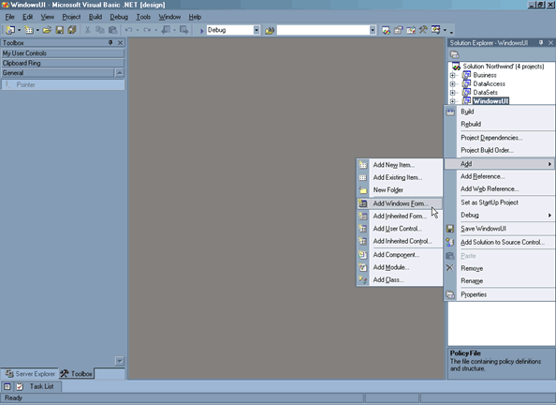

In Access, the properties of forms and controls are set via the properties window. The same is true in Visual Studio .NET. However, in Visual Studio .NET text cannot be entered directly onto a control; control text is set via the Text property. The properties window is shown in Figure 11.

Figure 11 – The properties of the form are set via the Properties window
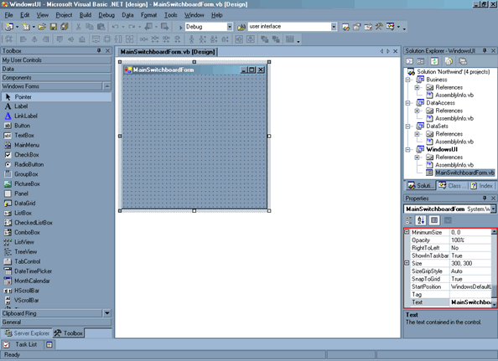

- Set the GridSize property to 4, 4.

Changing to a smaller grid size gives greater control over the placement of form controls.

- Set the Text property to Main Switchboard.

- Add a second form named OrdersForm and set the Text property to Orders.

The Orders form is created now to test the functionality of the Main Switchboard form in the proceeding steps.

- Go back to the Main Switchboard form and add the eight controls as shown in Figure 12. The Display Database Window button is not needed in this example as it is no longer applicable. Controls used on the .NET Main Switchboard form (and their Access equivalents) are given in Table 2.
Figure 12 – Size and position the form and controls on the Main Switchboard form
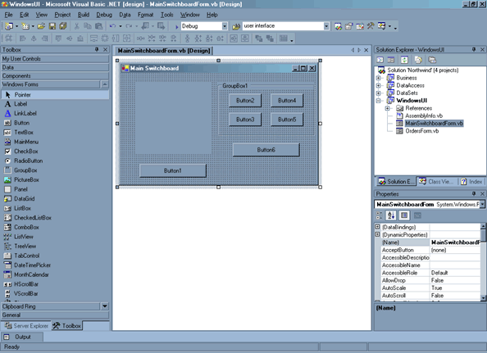

Table 2 – .NET controls and their access equivalents
.NET Control/s | Access Equivalent | Important Property
Button | Button | Text – Sets the control text (caption)
PictureBox | Image | Image – Sets the image source by clicking the ellipsis button and browsing to the image
GroupBox | Rectangle | Text – Sets the GroupBox heading

For an extensive comparison of Access and .NET form controls refer to the Microsoft whitepaper What’s New and Different for the Access Developer Moving to .NET.

Step 2: Set the Control Properties
- Set the Image property of the PictureBox by clicking the ellipsis button and browsing to Northwind.gif.

Northwind.gif is included as part of the Northwind .NET solution files in NorthwindNET_vXX.zip located at: http://www.ssw.com.au/ssw/standards/DeveloperDotNet/Resources/

- Set the Text property of each control until the form resembles Figure 13.

Figure 13 – Set the Text property of the controls
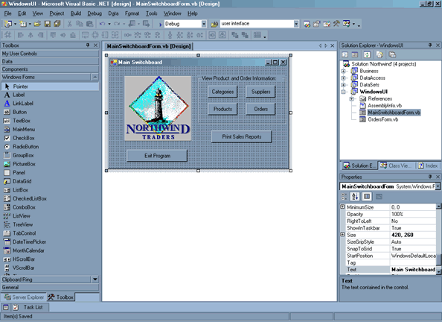

- Set the Name property of the Orders button to btnOrders.

- Set the Name property of the Exit Program button to btnExitProgram.

- Set the BackColor property of any unused buttons to Red. The color indicates to the user that the control is not in use.

The completed interface for the Main Switchboard form is shown in Figure 14.

Figure 14 – The completed user interface for the Main Switchboard form
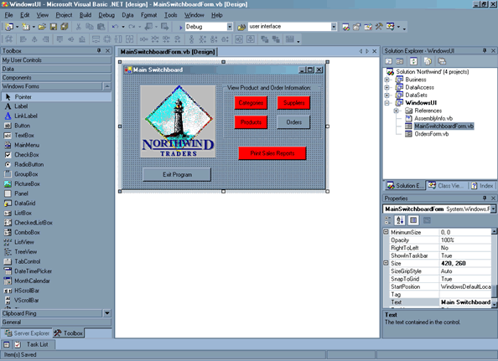

Step 3: Add the Form Functionality
In Visual Studio .NET, there is no expression builder or macro support: all form event code is written in functions behind the form. This is similar to the code builder option in Access.

Double-clicking a control in the Visual Studio .NET form designer will cause a new sub to be created in the form’s code that responds to the default event for the control. In the case a button, the default event is a mouse click. That is: the Click event.

As in VBA, Visual Studio .NET generates a signature that contains the name of the sub based on the control name and the name of the event. In .NET, the signature also contains an event handler that tells the application which events to handle for which controls.

Now add code that will run when the Orders button is clicked. The code will open the Orders form and display an hourglass while it is loading:

- Double-click the Orders button to create a sub with the following signature:

Private Sub btnOrders_Click(ByVal sender As System.Object, ByVal e As System.EventArgs) Handles Orders.Click

- Add the following code to the sub:

Me.Cursor.Current = Cursors.WaitCursor

Dim OrdersForm As New OrdersForm
OrdersForm.Show()

' TIP: Since none of the form's properties or methods
' are used, the following code could be used:
' Call New OrdersForm().Show()

Me.Cursor.Current = Cursors.Default

Before the solution can be tested, a startup object must be specified for the WindowsUI project. The startup object indicates which form is first loaded when the application is run:

- Open the properties window of the WindowsUI project and set MainSwitchboardForm as the Startup object (as shown in Figure 15).

Figure 15 – Set MainSwitchboardForm as the startup object for the WindowsUI project
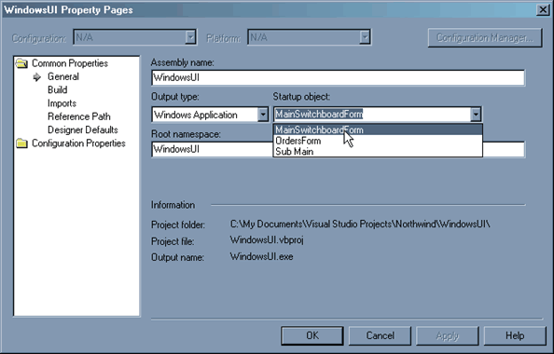

- Test the solution by pressing F5 or clicking the Play button to build and run the solution. The form is now running in debug mode.

- Click the Orders button to test that the Orders form shows.

- Close all forms or press the Stop button to exit debug mode and return to the designer.

When an application is built in Visual Studio .NET, an .EXE file is created in the bin directory of the solution. This executable is run while debugging and can also be run as a Windows executable.

- Create a sub to handle the Exit Program button’s Click event by double-clicking the button in the form designer.

- Paste the following code into the sub:

Application.Exit()

- Press F5 and test that the Exit Program button works correctly.

As this paper only discusses the Northwind Orders, Orders Subform and Main Switchboard forms, code for the other buttons does not need to be added to the solution. As such, the Main Switchboard form is now complete and the migration of the Orders and Orders Subform forms can begin.

The 4 Steps to Migrate the Orders and Orders Subform Forms
In the Northwind database there are two forms used to display order information: Orders and Orders Subform. Migrating these forms to .NET involves four steps:

- Creating the data access components – The first step is to create the components that perform all database interaction – selecting, updating, inserting and deleting records. These components are called from the user interface whenever any data interaction needs to take place between the forms and the database. You will learn basic SQL syntax and how to work with ADO.NET SqlConnections, SqlDataAdapters and DataSets.
- Creating the user interface – The user interface comprises two forms – Orders and Order Details. While creating the two forms you will learn about working with new .NET controls, adding controls and setting control properties.
- Binding the form controls – In this step you will reference projects in the solution that allow you to store and interact with data. You will also learn how to data bind form controls using the Visual Studio .NET designer.
- Adding functionality to the forms – The last step in migrating Northwind to .NET is to add functionality to the two forms. You will learn how to reproduce the functionality of the access navigation buttons using a binding manager as well as reproducing other functionality from the form.

Step 1: Create the Data Access Components
In Access, binding controls to the database is as straightforward as setting the form’s RecordSource property to a query or table and then setting the ControlSource for any control to a field in the specified query or table.

In .NET, forms are disconnected from the database. To bind controls to the database, projects are created that contain classes and objects to specifically handle database operations. Four types of objects will be used:

- SqlConnection – creates a unique session to your SQL Server database
- SqlDataAdapter – retrieves (SELECT) and commits (UPDATE) data from and to the database
- DataSet – stores an in-memory copy of the data for use in the application
- DataRelation – maintains a relationship between two tables in a dataset, much like relationships in a relational database

From Figure 16, it can be seen that these object types are closely related.

Figure 16 – The data access project uses several ADO.NET objects for all database operations; an example using Northwind is shown on the right
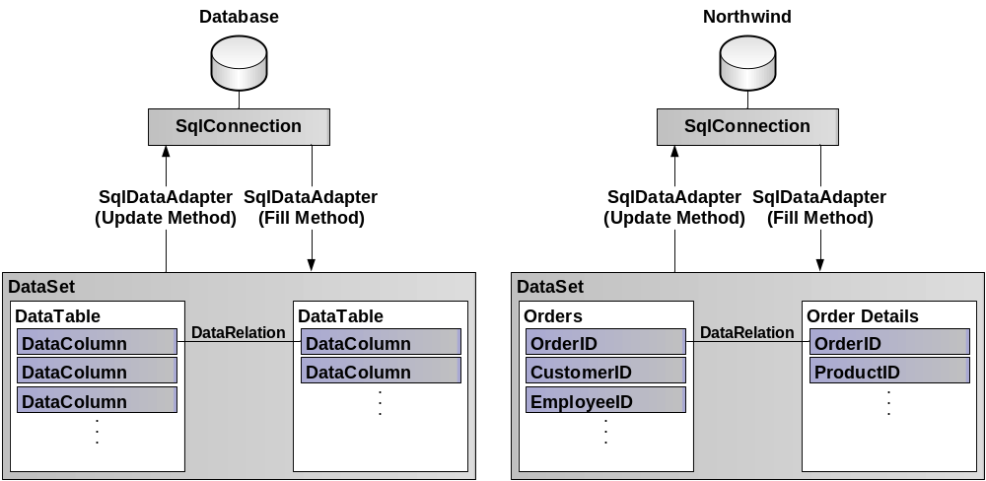

In the following example, SqlConnection, SqlDataAdapter and DataSet objects are created for each table used in the solution. There will not be a DataSet created for the Order Details table as it will be added to the DataSet for the Orders table and related using a DataRelation object. This ensures that only the appropriate line items are displayed for the selected order when data is bound to the form controls.

The SQL Server Query Builder will be used to relate the Order Details and Products tables so that the ProductName field can be displayed in the migration of the Orders Subform form. The Query Builder is almost identical to the Design View for Access queries.

a: Create the Data Access Components
Follow these steps to create the data access components:

- Add a new Component to DataAccess (as shown in Figure 17) with the name CustomersDataAdapter.

Figure 17 – Add a new component to the DataAccess project
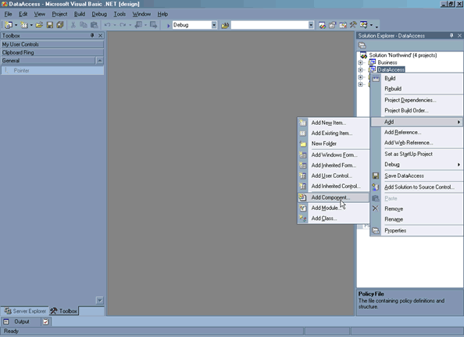

- Drag the Customers table onto the Component Designer from the Server Explorer as shown in Figure 18.

Figure 18 – Drag the Customers table onto the Component Designer
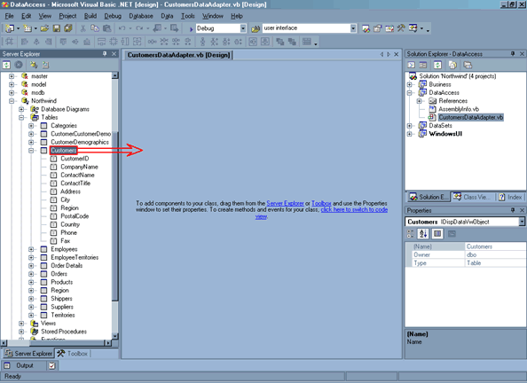

Visual Studio .NET automatically creates SqlConnection and SqlDataAdapter objects.

- Select SqlConnection1 in the Component Designer and click the ellipsis button for its DynamicProperties -> ConnectionString property. Tick Map property to a key in configuration file (as shown in Figure 19) then click OK.

Figure 19 – Map the connection string property to a key in the app.config file
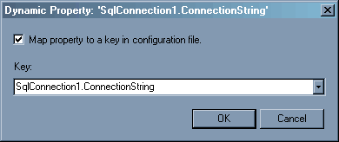

Ticking this box creates a file called app.config in the DataAccess project. If you open it you will see that it is simply an XML file with a key that contains the connection string to the database. Because you will be creating more of these DataAdapters in following steps, it makes sense to let them use a shared connection string; if the location of your database changes, you can simply change the value in app.config and your application will use the new connection string.

- Select SqlDataAdapter1 in the Component Designer and set the following properties:

- Name = Adapter
- Modifiers = Public

Setting the name to Adapter allows for easier access to the object in code. Setting the Modifiers property to Public allows the object’s methods to be accessed from the WindowsUI (user interface) project.

- Repeat steps 1-4 to add a new component to the DataAccess project for each table that is used in the solution:

- Customers (CustomersDataAdapter.vb – already done)
- Employees (EmployeesDataAdapter.vb)
- Order Details (OrderDetailsDataAdapter.vb)
- Orders (OrdersDataAdapter.vb)
- Products (ProductsDataAdapter.vb)
- Shippers (ShippersDataAdapter.vb)

The solution is now structured as shown in Figure 20.

Figure 20 – The Visual Studio .NET solution containing all the necessary DataAccess components
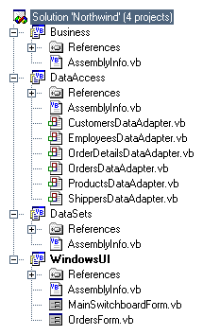

b: Add Calculated Fields to the DataAdapters
In the Access Orders form there are calculated fields for Salesperson and Extended Price that are displayed in the Salesperson dropdown list and in Orders Subform (as shown in Figure 21).

Figure 21 – In Access, there are calculated fields for Salesperson and Extended Price
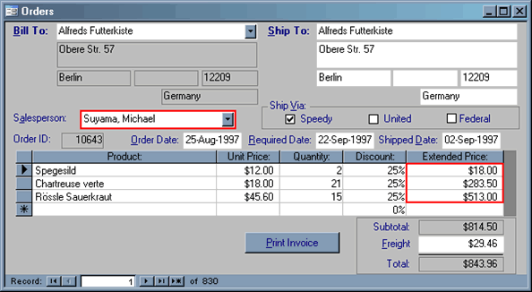

To generate these fields in Visual Studio .NET, the SqlDataAdapter object in OrderDetailsDataAdapter must be modified using the Query Builder.

- Open OrderDetailsDataAdapter and select Adapter in the Component Designer.

- Expand SelectCommand in the Properties window and click the ellipsis button next to the CommandText property.

- Enter a new expression UnitPrice * Quantity * (1 - Discount) with the Alias ExtendedPrice (as shown in Figure 22).

Figure 22 – Enter the expression for ExtendedPrice into the Query Builder
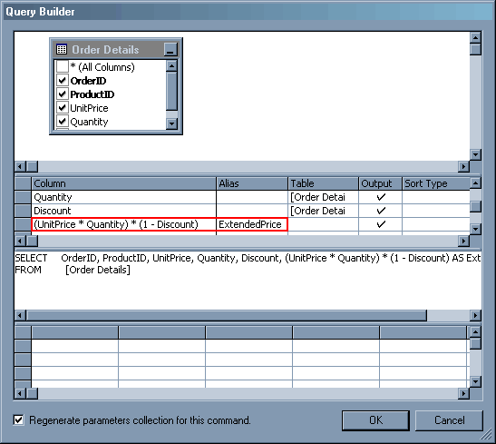

- Right-click in the white space surrounding the Order Details table in the Query Builder and click Add Table….

- Select Products from the Tables list and click Add and then click Close.

The Query Builder automatically recognizes a relationship between the two tables and modifies the SQL statement accordingly.

- Tick the ProductName field of the Products table in the Designer.

- Click OK to close the Query Builder and return to the Component Designer.

- Add a calculated field to EmployeesDataAdapter with the expression LastName + ', ' + FirstName and the alias FullName.

c: Generate the DataSets
Now that the data access components have been created and configured, DataSets must be generated so that forms can read and make changes to the data:

- Right-click the SqlDataAdapter in CustomersDataAdapter and select Generate Dataset… (as shown in Figure 23).

Figure 23 – Generate a DataSet for CustomersDataAdapter
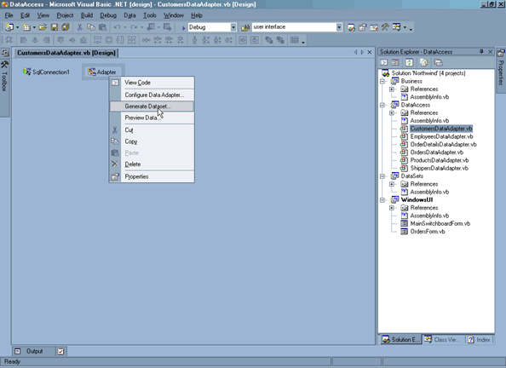

- Select New and name the DataSet CustomersDataSet (as shown in Figure 24) then click OK.

Figure 24 – Name the new DataSet CustomersDataSet
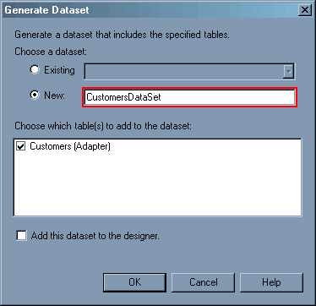

- Generate a DataSet for each table that is used in the solution:

- Customers (CustomersDataSet – already done)
- Employees (EmployeesDataSet)
- Order Details (do not generate this DataSet yet)
- Orders (OrdersDataSet)
- Products (ProductsDataSet)
- Shippers (ShippersDataSet)

To properly relate the Orders and Order Details tables, a DataSet must be generated containing the two tables. A Relation must then be used to relate the OrderID (Primary Key) in the Orders table to OrderID (Foreign Key) in the Order Details table. Complete the following steps to relate the tables:

- Generate a DataSet from the SqlDataAdapter in OrderDetailsDataAdapter in the existing DataSet DataAccess.OrdersDataSet.
- Open OrdersDataSet and drag a Relation from the Toolbox onto the Order Details table to show the Edit Relation window. Change the Name of the relation to OrdersOrder_Details and click OK.

A relationship has now been created between the two tables based on OrderID. There is one more property that needs to be set in the DataSets in order for the forms to function correctly:

- Set the ReadOnly property for the ExtendedPrice field in the Order Details table to False.

- Move each DataSet to the DataSets project.

Now that each DataSet has been generated and moved to the DataSets project, the next step of migration can be performed; Step 2: Create the User Interface.

Figure 25 – The Visual Studio .NET solution containing the necessary elements to begin Step 2: Create the User Interface
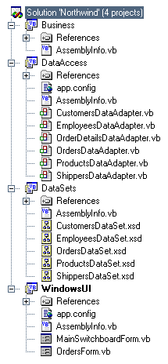

Step 2: Create the User Interface
In the Access Northwind database the Orders Subform form is part of the Orders form. The Orders Subform form shows all line items for the current order and allows editing of individual line items. The Access Northwind Orders and Orders Subform forms are shown in Figure 26.

Figure 26 – The Northwind Orders Subform form shows details for the current order in the Orders form
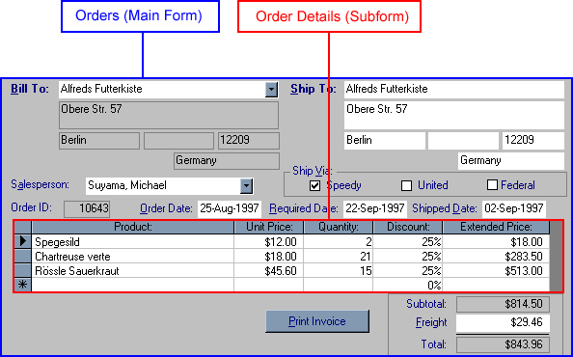

The Orders Subform form is a datasheet linked to the Order Details table; when embedded in the Orders form, linkages can be specified between the two forms so that only related records are shown in the Orders Subform form. This has the same effect as specifying the relation in the Orders DataSet.

As there is no support for subforms in .NET, there are three main options:

- A third party control. For example, Infragistics’ NetAdvantage (www.infragistics.com) provides a customizable DataGrid control that supports features such as ComboBoxes (see Figure 27). 3rd-party controls are not recommended because they force the purchase of a 3rd-party component.

Figure 27 –In Access, there is a ComboBox on the product column. To implement this, 3rd-party controls can be used. One like Infragistics’ NetAdvantage allows easy customization and extension of the .NET DataGrid
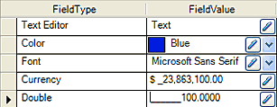

- A ListView control. Can be used to display summary information. When an item in the list is double-clicked, a form pops up with details for the item that can be edited. The ListView does look better than the built-in DataGrid and can sort columns by default. However, the main reason the ListView is not used in this example is because it cannot be bound to a data source.

- The built-in DataGrid control (recommended). Can be used in place of the Orders Subform form and although it has some limitations in design flexibility, it is much easier to display data from a data source in a DataGrid than other controls. This is the best option for this example, and will be used to perform the migration of the Orders Subform form in this solution.

The built-in .NET DataGrid will be used in this example for the Orders Subform form. It does lack some functionality, such as a ComboBox for the list of products. Implementing these features in a DataGrid requires extensive customization through code; the simplest option is to have a read-only DataGrid that displays order details, and an editable Order Details form which opens when the user selects a row and clicks an edit button.

a: Create the Order Details Form
In .NET, new controls are used to make data entry easier. One such control is used in the creation of the Order Details form: NumericUpDown. The NumericUpDown only allows numeric input in the range specified in the Minimum and Maximum properties for the control.

Follow these steps to create the Order Details form:

- Add a Windows Form to the WindowsUI project called OrderDetailsPopupForm.

- Set the following properties for the form:

- GridSize – 4, 4
- Text – Order Details

- Add the controls shown in Figure 28 to the form.

Figure 28 – Place the .NET controls on the Order Details form. Use the new NumericUpDown control to ease data entry
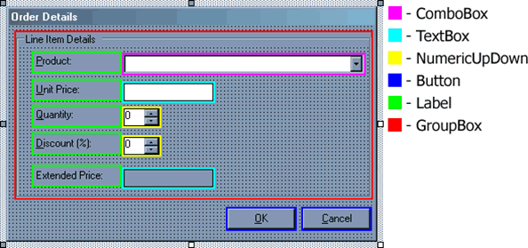

Some controls (such as the Product ComboBox) have a fixed set of values (in this case, the names of all the products). A new feature of .NET can be used to prevent users from entering text into the ComboBox:

- Set the DropDownStyle property of the Product ComboBox to DropDownList.

As the extended price is based on other user input, the user should not be able to change its value directly:

- Set the ReadOnly property of the Extended Price TextBox to True.

In order to return the result to the Orders form, we must track whether the user clicks OK or Cancel:

- Set the DialogResult property of the OK Button to OK and the Cancel Button to Cancel.

b: Recreate the Orders Form
Once again new .NET controls are used to ease the data entry process. For example, instead of using a TextBox for the Order Date field on the Orders form, use a DateTimePicker control. Figure 29 shows where updated .NET controls can be used on the Orders form.
Figure 29 – Use new controls (such as the DateTimePicker) to make data entry easier in .NET
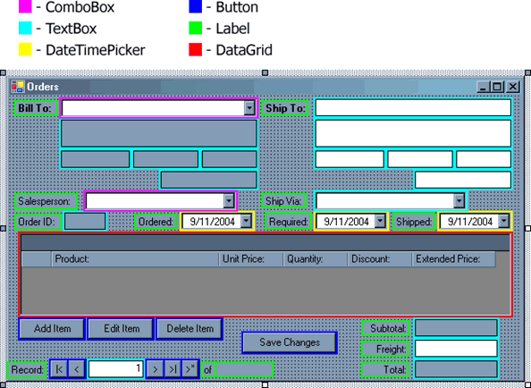

Once these controls are added, set the following properties:

- ComboBoxes - Set the DropDownStyle property to DropDownList.
- shipAddress / billAddress TextBoxes - Set the Multiline property to True.
- Gray TextBoxes - Set the ReadOnly property to True
- DateTimePickers - Set the Format property to Short.

To print the Northwind Invoice report from the Orders form, convert the report to a SQL Server Reporting Services report. For steps on migrating the invoice report, see the Microsoft whitepaper How to Migrate Access Reports to SQL Server Reporting Services.

Step 3: Bind the Form Controls
In Access, binding a form control is achieved by setting the Record Source property of a form to a query or table and setting the Control Source and/or Row Source of the control to a field of the form’s record source.

To bind the controls in the .NET Orders form to the DataSets:

- Add references to the data access components
- Create instances of the DataSets
- Bind the form controls
- Add code to fill the DataSets

a: Add References to the Data Access Components
Before data can be bound to form controls, references must be added to the data access components that were created in Step 1: Create the Data Access Components.

It is necessary to explain how Visual Studio .NET builds a solution before the data access projects can be referenced. When a solution is built in Visual Studio .NET each project is built individually. The two data access projects are compiled into DLL files and the WindowsUI project into an EXE. In order for the user interface to access the functionality of the two data access projects, references must be added to each DLL:

- Right-click on References in the WindowsUI project and select Add Reference.

- Click on the Projects tab, and then double-click each project to add the reference as shown in Figure 30.

Figure 30 – Reference each projects from the user interface
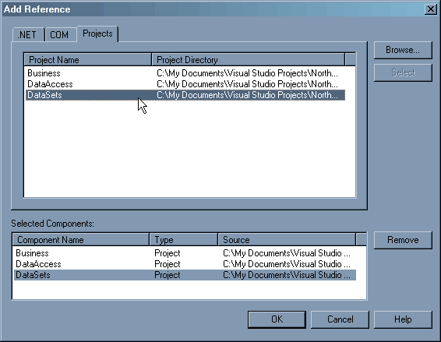

b: Create Instances of the DataSets
For each DataSet that the form uses information from, an instance of that DataSet must be declared.

The Orders form uses data from every DataSet that was created in Step 1: Create the Data Access Components. The Order Details form only uses data from ProductsDataSet.

- Drag a DataSet object from the Toolbox to the Orders form.

- Select Referenced DataSets… as shown in Figure 31.

Figure 31 – Select Referenced Datasets… in the Add Dataset wizard
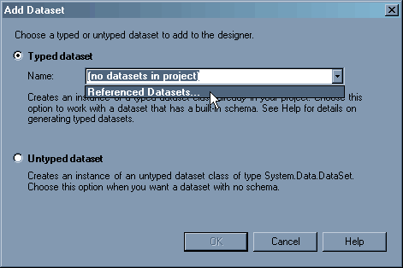

- Select DataSets.CustomersDataSet as shown in Figure 32.

Figure 32 – Select DataSets.CustomersDataSet from the list of referenced datasets
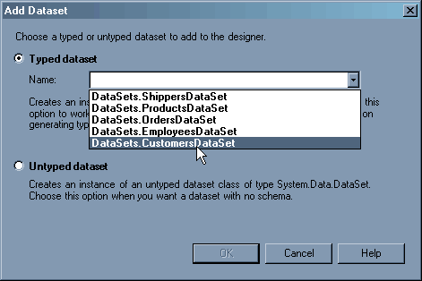

- Set the Name property of the DataSet to CustomersList.

- Repeat the steps for each of the following DataSets:

- EmployeesDataSet (EmployeesList)
- OrdersDataSet (OrdersList)
- ProductsDataSet (ProductsList)
- ShippersDataSet (ShippersList)

- Create an instance of the ProductsDataSet in the Order Details form by opening the form and following the same procedure.

c: Set the Control Properties
In .NET, the property used to set the bound field changes depending on the type of control, but generally the controls will use the DataBindings -> Text property.

In Access, basic controls such as text boxes are bound to the query or table specified in the form’s Record Source by setting their Control Source property. In Visual Studio .NET, these controls are bound by setting their DataBindings –> Text property. A comparison of databinding text boxes in Access and Visual Studio .NET can be seen in Figure 33.

Figure 33 – As with Access, databinding in Visual Studio .NET occurs through properties of the control
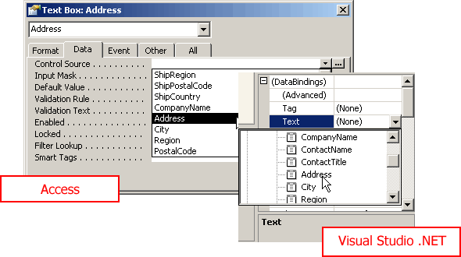

In Access, data bound ComboBoxes have a Control Source, which usually defines the internal ID for each list item (such as CustomerID). They also have a Row Source, which is a SQL SELECT clause defining the text to display for each list item. In .NET, you specify the ValueMember and DisplayMember properties for a ComboBox.

Other controls (such as DataGrids and DateTimePickers) are bound in a similar fashion. The procedure to do this is shown below.

In .NET, data binding usually occurs by setting one of the following properties for the control:

- DataSource – for ComboBoxes and DataGrids.
- DataBindings -> Text – for TextBoxes and Labels.
- DisplayMember – for ComboBoxes.
- ValueMember – for ComboBoxes.
- DataBindings -> SelectedValue – for ComboBoxes.

- Set the data binding properties of the ComboBoxes on the Orders form as shown in Table 3.
Table 3 – Set the data binding properties for ComboBoxes
Control | DataSource | DisplayMember | ValueMember | DataBindings -> SelectedValue
Bill To ComboBox | CustomersList.Customers | CompanyName | CustomerID | OrdersList - Orders.CustomerID
Salesperson ComboBox | EmployeesList.Employees | FullName | EmployeeID | OrdersList - Orders.EmployeeID
Ship Via ComboBox | ShippersList.Shippers | CompanyName | ShipperID | OrdersList - Orders.ShipVia

- Set the data binding properties for other controls on the Orders form as shown in Table 4.

Table 4 – Data binding properties for other controls
Control | DataBindings -> Text
Ship To Name TextBox | OrdersList – Orders.ShipName
Ship To Address TextBox | OrdersList – Orders.ShipAddress
Ship To City TextBox | OrdersList – Orders.ShipCity
Ship To Region TextBox | OrdersList – Orders.ShipRegion
Ship To Postal Code TextBox | OrdersList – Orders.ShipPostalCode
Ship To Country TextBox | OrdersList – Orders.ShipCountry
Order ID TextBox | OrdersList – Orders.OrderID
Ordered DateTimePicker | OrdersList – Orders.OrderDate
Required DateTimePicker | OrdersList – Orders.RequiredDate
Shipped DateTimePicker | OrdersList – Orders.ShippedDate
Freight TextBox | OrdersList – Orders.Freight

- Select the DataGrid that was created during the migration of the Orders form and set the following properties:

- DataSource - OrdersList
- DataMember - Orders -> Orders.OrdersOrder_Details
- ReadOnly - True

By setting the DataMember property to the relation created in OrdersDataSet, only the line items for the current order will be displayed.

- Pressing F5 to build and run the solution. If you go to the Orders form you will notice that no data is displayed in the form. This is because the DataSets have not been filled with data from the database. In the following section we will add code behind our forms to fill the DataSets. However, before we do, we will format the DataGrid on the Orders form.

By default, all columns in a DataGrid are formatted as plain text – custom formatting (such as percentages and currencies) must be specified. Formatting is achieved by applying a TableStyle to the DataGrid.

- Select the TableStyles property of the DataGrid and click the ellipsis button to open the DataGridTableStyle Collection Editor.

- Click Add to add a new DataGrid Table Style and set the following properties:

- AllowSorting – False
- Mapping Name – Order Details

By creating a new TableStyle, custom GridColumnStyles can be added that allow customization of the DataGrid columns, including formatting.

- Select the GridColumnStyles property and click the ellipsis button to open the DataGridColumnStyle Collection Editor.

- Click Add to add a new DataGridColumnStyle. Set the Mapping Name property to Order Details -> OrderID.

- Create the remainder of the DataGrid columns, setting their properties as shown in Table 5.

Table 5 – Set the formatting properties for each column in the Orders Subform DataGrid
Name | HeaderText | NullText | Format | MappingName
ProductID |  | (null) |  | Order Details -> ProductID
ProductName | Product: | (null) |  | Order Details -> ProductName
UnitPrice | Unit Price: | $0.00 | C | Order Details -> UnitPrice
Quantity | Quantity: | 0 |  | Order Details -> Quantity
Discount | Discount: | 0.00 % | P | Order Details -> Discount
ExtendedPrice | Extended Price: | $0.00 | C | Order Details -> ExtendedPrice

You may notice that some column styles are given a Format character. This is the equivalent of setting the Format property of a text box in Access. The formatting characters you need to be familiar with for migrating the Orders Subform form are C (for currency) and P (for percentages).

- Hide the OrderID and ProductID column by setting the Width property to 0.

Before we can edit line items we must produce a list of available products in the Order Details form. To do this we must change the properties of the ComboBox on the form:

- Open the Order Details form and set the following properties for the Product ComboBox:

- DataSource – ProductsList.Products
- DisplayMember – ProductName
- ValueMember – ProductID

d: Add Code to Fill the DataSets
At this point all the necessary DataSets have been created in the forms, and the form controls have been bound. However, the controls will not yet display information, as the DataSets have not been filled with data from the database. In the following steps SqlDataAdapters from the DataAccess project will be instantiated then used to fill the corresponding DataSets.

When creating the instances of the SqlDataAdapters the variable names are prefixed with an underscore. This is a convention used to indicate that the SqlDataAdapter is a member variable. A member variable is a variable that is available to all methods in the class.

- Insert the following code on the first line in Code View for both the Orders and Order Details forms:

Imports DataSets
Imports DataAccess

By inserting these two lines of code the SqlDataAdapter objects from the DataAccess class can be referred to as SqlDataAdapterName rather than DataAccess.SqlDataAdapterName.

To view the code for a Windows Form, right-click the form in the Solution Explorer and select View Code. You can also use the same method to return to the designer window after editing code by selecting View Designer.

- Insert the following code below Windows Form Designer generated code in OrdersForm.vb:

Private _customersDA As New CustomersDataAdapter
Private _employeesDA As New EmployeesDataAdapter
Private _ordersDA As New OrdersDataAdapter
Private _shippersDA As New ShippersDataAdapter
Private _orderDetailsDA As New OrderDetailsDataAdapter

- Double-click the Orders form in the Designer and insert the following code into the OrdersForm_Load sub:

_customersDA.Adapter.Fill(customersList)
_employeesDA.Adapter.Fill(employeesList)
_shippersDA.Adapter.Fill(shippersList)
_ordersDA.Adapter.Fill(ordersList)
_orderDetailsDA.Adapter.Fill(ordersList)

- Double-click the Order Details form in Design view and insert the following code into the OrderDetailsPopupForm_Load sub:

Dim productsDA As New ProductsDataAdapter
productsDA.Adapter.Fill(productsList)

- Press F5 to test the solution. You will receive the following error:

The key 'SqlConnection1.ConnectionString' does not exist in the appSettings configuration section.

This error is due to an issue in Visual Studio .NET. To avoid this error, a copy of the app.config file must be placed in the WindowsUI project:

- Right-click the app.config file and click Copy.
- Right-click the WindowsUI project and click Paste.

The two app.config files must be manually synchronized whenever changes are made. This is not the ideal situation, but is required for the solution to function properly.

- Re-test the application to ensure that all controls are now properly bound.

Step 4: Add the Form Functionality

Update the Bill To and Ship To Details
In Access, the Northwind Orders form displays the Ship To details for the current record. However, if a different customer is selected from the Bill To ComboBox, the Bill To details for the selected customer are displayed and the Ship To details are updated with the selected customer’s details. In Access, this is achieved by setting the values of the controls to the values from the database using the AfterUpdate event of the ComboBox. In .NET, the SelectedIndexChanged event for the Bill To ComboBox is used. However, because this event is also fired when navigating records, a variable must be used to track whether the user is moving between records or whether they selected a new Bill To customer. For this reason, the _movingRecords variable is created.

Whenever an event is fired that changes the current record, the _movingRecords variable is set to True, the record position is changed, then the _movingRecords variable is set to False. An If statement can then be used to test whether the user is moving between records. If the user is not moving records, the Ship To details are updated.

- Add the following declaration to OrderDetailsPopupForm.vb below the Windows Form Designer generated code:

Private _movingRecords As Boolean

- Add the following sub to OrdersForm.vb:

Private Sub billName_SelectedIndexChanged(ByVal sender As System.Object, ByVal e As System.EventArgs) Handles billName.SelectedIndexChanged
' Updates the "Bill To" details.
If Not Me.billName.SelectedValue Is Nothing Then
Dim customerItem As CustomersDataSet.CustomersRow = customersList.Customers.FindByCustomerID(billName.SelectedValue.ToString)
If Not customerItem.IsAddressNull Then Me.billAddress.Text = customerItem.Address
If Not customerItem.IsCityNull Then Me.billCity.Text = customerItem.City
If Not customerItem.Is_RegionNull Then Me.billRegion.Text = customerItem._Region
If Not customerItem.IsPostalCodeNull Then Me.billPostalCode.Text = customerItem.PostalCode
If Not customerItem.IsCountryNull Then Me.billCountry.Text = customerItem.Country
End If

' Updates the "Ship To" details.
If Not _movingRecords Then
Me.shipName.Text = Me.billName.Text
Me.shipAddress.Text = Me.billAddress.Text
Me.shipCity.Text = Me.billCity.Text
Me.shipRegion.Text = Me.billRegion.Text
Me.shipPostalCode.Text = Me.billPostalCode.Text
Me.shipCountry.Text = Me.billCountry.Text
End If
End Sub

- Test the solution by pressing F5 and changing the Bill To ComboBox

Reproduce the Functionality of the Access Navigation Panel
Unlike Access, Windows forms do not have built in controls to handle record navigation. It is for this reason that controls have been added to the form to create the same functionality that would be seen in Access.

In Access, when the Navigation Buttons property for a form is set to Yes a panel is displayed at the bottom of the form that handles the following behaviours:

- Displaying the total number of records
- Navigating records by clicking one of four buttons that will move to either the first, previous, next or last record
- Navigating records by tracking user input in the text box that displays the current record
- Displaying the current record
- Adding new records

In order for the record navigation to work an instance of the BindingManagerBase must be created. The BindingManagerBase enables the synchronization of controls that are bound to the same data source. This means that whenever the position property of the BindingManagerBase is changed, each bound control is updated to display the current record. This feature can be used to reproduce record navigation functionality.

- Add the following declaration to OrdersForm.vb below the Windows Form Designer generated code:

Private WithEvents _ordersManager As BindingManagerBase

- To associate the binding manager with the Orders DataSet, add the red line of code to the OrdersForm_Load sub:

_ordersDA.Adapter.Fill(ordersList)
_orderDetailsDA.Adapter.Fill(ordersList)
_ordersManager = BindingContext(ordersList, ordersList.Orders.TableName)

- To display the total number of records, add the red line of code to the OrdersForm_Load sub:

_orderDetailsDA.Adapter.Fill(ordersList)
_ordersManager = BindingContext(ordersList, ordersList.Orders.TableName)

Me.totalRecords.Text = _ordersManager.Count.ToString()

- Test the solution and confirm that the total number of records is displayed.

It is now easy to add functionality to the buttons for record navigation. By incrementing or decrementing the Position property of the binding manager, all controls that contain information from a field in the Orders DataSet will be updated to reflect the current record.

- Double-click the button to move to the first record and insert the following code:

' Check that the user isn't on the first record.
If Not Me._ordersManager.Position = 0 Then
_movingRecords = True
Me._ordersManager.Position = 0
_movingRecords = False
End If

- Double-click the button to move to the previous record and insert the following code:

' Check that the user isn't on the first record.
If Not Me._ordersManager.Position = 0 Then
_movingRecords = True
Me._ordersManager.Position -= 1
_movingRecords = False
End If

- Double-click button to move to the next record and insert the following code:

' Check that the user isn't on the last record.
If Not Me._ordersManager.Position = Me._ordersManager.Count - 1 Then
_movingRecords = True
Me._ordersManager.Position += 1
_movingRecords = False
End If

- Double-click the button to move to the last record and insert the following code:

' Check that the user isn't on the last record.
If Not Me._ordersManager.Position = Me._ordersManager.Count - 1 Then
_movingRecords = True
Me._ordersManager.Position = Me._ordersManager.Count
_movingRecords = False
End If

Another way to navigate records in Access is to enter the record number directly into the input box. The following sub tracks user input in the recordNumber TextBox. When the Enter key is pressed the form moves to the record entered by the user.

- Add the following sub to OrdersForm.vb:

'
' Checks to see if enter key is pressed and then moves to the
' appropriate order by changing the binding manager position.
'
Private Sub recordNumber_KeyPress(ByVal sender As System.Object, ByVal e As System.Windows.Forms.KeyPressEventArgs) Handles recordNumber.KeyPress
If Char.IsWhiteSpace(e.KeyChar) Then
_movingRecords = True
Me._ordersManager.Position = CInt(Me.recordNumber.Text) - 1
_movingRecords = False
End If
End Sub

- Press F5 to test that the form now handles navigation of records.

However, the form does not yet show which record is currently being displayed. In this situation the PositionChanged event of the binding manager can be used to update the record number so that current position of the binding manager is shown.

- Add the following sub to OrderForm.vb:

Private Sub _ordersManager_PositionChanged(ByVal sender As System.Object, ByVal e As System.EventArgs) Handles _ordersManager.PositionChanged
Me.recordNumber.Text = (Me._ordersManager.Position + 1).ToString
End Sub

Note that one is added to the position of the binding manager. This is because the first position of the binding manager is zero.

- Test the solution to ensure the current record number is displayed when moving records.

The final functionality of the Access navigation buttons is the ability to add new records. This function will be added in a later step.

Format the Freight TextBox
When testing the solution in the previous step you may have noticed that the Freight TextBox displays a decimal value (for example, 12.0000). In Access, the Freight textbox is formatted as a currency by specifying the Format property. To reproduce this functionality in .NET, two handlers must be added to the TextBox that will format the data to a currency (when the TextBox is bound) and convert the inputted data to a decimal (when the DataSet is updated).

Before handlers can be added to the TextBox two generic subs must be created that will handle the formatting to currency and conversion to decimal:

- Add the following sub to OrdersForm.vb that formats a decimal as a currency:

Private Sub FormatCurrency(ByVal sender As Object, ByVal e As ConvertEventArgs)
If TypeOf e.Value Is Decimal Then
e.Value = CType(e.Value, Decimal).ToString("c")
End If
End Sub

- Add the following sub to OrdersForm.vb that converts a currency to a decimal:

Private Sub ParseCurrency(ByVal sender As Object, ByVal e As ConvertEventArgs)
If e.DesiredType Is GetType(Decimal) Then
e.Value = Decimal.Parse(e.Value.ToString(), Globalization.NumberStyles.Currency)
End If
End Sub

- Add the red lines of code to the OrderForm_Load sub:

AddHandler Me.freight.DataBindings("Text").Format, AddressOf Me.FormatCurrency
AddHandler Me.freight.DataBindings("Text").Parse, AddressOf Me.ParseCurrency
_customersDA.Adapter.Fill(customersList)
_employeesDA.Adapter.Fill(employeesList)
_shippersDA.Adapter.Fill(shippersList)
_ordersDA.Adapter.Fill(ordersList)
_orderDetailsDA.Adapter.Fill(ordersList)

- Run the solution and confirm that the Freight TextBox is being properly formatted. Also, notice that the Subtotal and Total for the order are not currently displayed.

Calculate the Subtotal and Total
In Access, the subtotal is calculated by using the Sum function in the Control Source property for a control. This function tallies each value in a specified field to return the total. The Sum function is used in the Orders Subform form to calculate the order subtotal based on the ExtendedPrice.

In .NET, the subtotal can be calculated by creating a function that accepts an array of line items as an argument. The array is then looped whilst totaling the extended price. The result is then returned to the code that called the function.

Before the functions can be added, a new class must be added to the Business project and the DataSets project must be referenced:

- Right-click the Business project and select Add -> Add Class… and name the class Orders.

- Right-click References in the Business project and select Add References… then add a reference to the DataSet project.

- Add the following line of code to the first line of the Orders class:

Imports DataSets

- Add the following function to the Orders class that calculates the subtotal:

Function CalculateSubtotal(ByVal OrderLineItems As Array) As Decimal
Dim Subtotal As Decimal

Dim LineItem As OrdersDataSet.Order_DetailsRow
For Each LineItem In OrderLineItems
Subtotal += Convert.ToDecimal(LineItem.ExtendedPrice)
Next

Return Subtotal
End Function

In Access, the total is calculated by writing an expression to add the fields in the Control Source property. For Example: =[Subtotal]+[Freight].

In .NET, this functionality is reproduced by creating a function that accepts and adds two arguments: the subtotal and freight.

- Add the following function to the Orders class that calculates the total:

Function CalculateTotal(ByVal Subtotal As Decimal, ByVal Freight As Decimal) As Decimal
Dim Total As Decimal

Total = Subtotal + Freight

Return Total
End Function

The two functions in the Orders class will be called from a function in OrdersForm.vb. The function calculates the subtotal value by passing the line items for the current order to the CalculateSubtotal function. The value for freight is then retrieved from the form and the two values (subtotal and freight) are passed to the CalculateTotal function.

- Add a reference to the Business project in WindowUI.

- Add the following declaration to OrdersForm.vb below the Windows Form Designer generated code:

Private _business As New Business.Orders

- Add the following function to OrdersForm.vb:

Private Sub CalculateTotals()
Dim orderItem As OrdersDataSet.OrdersRow = CType(CType(_ordersManager.Current, DataRowView).Row, OrdersDataSet.OrdersRow)

Dim subtotal As Decimal = _business.CalculateSubtotal(orderItem.GetOrder_DetailsRows())
Dim freight As Decimal = 0

If Not Me.freight.Text = "" Then
freight = Decimal.Parse(Me.freight.Text, Globalization.NumberStyles.Currency)
End If

Dim total As Decimal = _business.CalculateTotal(subtotal, freight)

Me.subtotal.Text = subtotal.ToString("c")
Me.total.Text = total.ToString("c")
End Sub

Now that the CalculateTotals sub has been created, the sub can be called whenever the totals need to be calculated. The totals currently need to be calculated during three events:

- The Load event for the Orders form – when the form loads
- The PositionChanged event for _ordersManager – when the user changes orders
- The LostFocus event for the Freight TextBox – when the user leaves the freight textbox

- Add the red line of code to the OrderForm_Load sub:

Me.totalRecords.Text = _ordersManager.Count.ToString()
CalculateTotals()

- Add the red line of code to the _ordersManager_PositionChanged sub:

Me.recordNumber.Text = (Me._ordersManager.Position + 1).ToString
CalculateTotals()

- Add the following sub to OrdersForm.vb:

Private Sub freight_LostFocus(ByVal sender As Object, ByVal e As System.EventArgs) Handles freight.LostFocus
CalculateTotals()
End Sub

- Test the solution to ensure that the totals are calculated when the form loads and when the record or freight is changed.

Add Line Items
In Access, line items are added by entering data in a new row of the Orders Subform form. In .NET, the add functionality will be reproduced by passing the selected line item to the Order Details form when the Add Item button is clicked. The form will then be populated from the values in the passed row.

Before the row can be passed to the Order Details form, a sub must be created that accepts the row, and code must be added to the Click event for the OK button that stores the values entered on the form into the row.

- Add the following declaration to OrdersDetailsPopupForm.vb below the Windows Form Designer generated code:

Private _orderItem As OrdersDataSet.Order_DetailsRow

- Add the following sub to OrderDetailsPopupForm.vb that allows a row to be passed to the form:

Public Sub New(ByVal orderItem As OrdersDataSet.Order_DetailsRow)
Me.New()
_orderItem = orderItem
End Sub

Now that the Order Details form can accept a row, a sub will be added to the Orders form that:

- Creates a new row
- Passes the row to the Order Details form
- Shows the Order Details form and waits for the result

- Add the following sub to OrdersForm.vb:

'
' Opens the Order Details form and passes a new row so that
' it can be edited and then added to the Order Details.
'
Private Sub addItem_Click(ByVal sender As System.Object, ByVal e As System.EventArgs) Handles addItem.Click
' Create a new row.
Dim orderItem As OrdersDataSet.Order_DetailsRow = ordersList.Order_Details.NewOrder_DetailsRow()

' Pass the new row to the Order Details form.
Dim orderDetailsForm As New OrderDetailsPopupForm(orderItem)

' Show the Order Details form and return the result.
Dim result As DialogResult = orderDetailsForm.ShowDialog()
End Sub

- Test the solution. When you click Add Item, you will notice that the first item in the Product ComboBox is selected.

- Add the red line of code to the OrderDetailsPopupForm_Load sub that clears the Product combobox so that no product is selected:

Dim productsDA As New ProductsDataAdapter
productsDA.Adapter.Fill(productsList)
Me.productName.SelectedIndex = -1

Before we can properly add a line item we must add the following functionality to the Order Details form:

- When the user changes the product, the unit price textbox is populated with the value for the corresponding product and the extended price is calculated.
- When the unit price is changed by the user, the input is validated. If the input is valid, it is formatted as a currency and then the extended price is recalculated. If the input is not valid, the user is notified and the focus is placed on the Unit Price field.

- Add the following function to OrderDetailsPopupForm.vb that gets the value of the UnitPrice field for the selected product and formats the value as a currency:

Function GetUnitPrice() As String
Dim productItem As ProductsDataSet.ProductsRow = productsList.Products.FindByProductID(Convert.ToInt32(Me.productName.SelectedValue))
Return productItem.UnitPrice.ToString("c")
End Function

- Add the following function to OrderDetailsPopupForm.vb that calculates the extended price and formats the value as a currency:

Function CalculateExtendedPrice() As String
Dim unitPrice As Decimal
If Not Me.productUnitPrice.Text = "" Then
unitPrice = Decimal.Parse(Me.productUnitPrice.Text, Globalization.NumberStyles.Currency)
Else
unitPrice = 0
End If
Dim quantity As Decimal = Me.productQuantity.Value
Dim discount As Decimal = Me.productDiscount.Value
Dim extendedPrice As Decimal = unitPrice * quantity * (1 - (discount / 100))
Return extendedPrice.ToString("c")
End Function

- Add the following sub to OrderDetailsPopupForm.vb that gets the unit price and calculates the extended price when the product is changed:

Private Sub productName_SelectedIndexChanged(ByVal sender As System.Object, ByVal e As System.EventArgs) Handles productName.SelectedIndexChanged
If Not Me.productName.SelectedIndex = -1 Then
Me.productUnitPrice.Text = GetUnitPrice()
Me.productExtendedPrice.Text = CalculateExtendedPrice()
End If
End Sub

- Test the solution. Notice that text entered into the unit price textbox is not validated. To validate the user input a regular expression is used.

Regular expressions allow the developer to define a custom format for a string. For example, a regular expression could be used to validate that a user has entered a string that contains three letters followed by three numbers.

The IsMatch method is used to compare the user input to the regular expression. If the input matches the regular expression, the value is then formatted as a currency. If not, the user is notified and the focus is returned to the unit price field.

- Firstly, add the following generic function to OrderDetailsPopupForm.vb that formats a value as a currency:

Function FormatCurrency(ByVal value As String) As String
Dim currencyValue As Decimal = Decimal.Parse(value, Globalization.NumberStyles.Currency)
Return currencyValue.ToString("c")
End Function

- Now add the function to OrderDetailsPopupForm.vb that validates and reacts to the user input in the unit price field:

Private Sub productUnitPrice_Leave(ByVal sender As Object, ByVal e As System.EventArgs) Handles productUnitPrice.Leave
If System.Text.RegularExpressions.Regex.IsMatch(Me.productUnitPrice.Text, "^\$?([0-9]{1,3},([0-9]{3},)*[0-9]{3}|[0-9]+)(.[0-9]{1,2})?$") Then
Me.productUnitPrice.Text = FormatCurrency(Me.productUnitPrice.Text)
Me.productExtendedPrice.Text = CalculateExtendedPrice()
Else
MsgBox("The value you entered isn't valid for this field." + Environment.NewLine + Environment.NewLine + "For example, you may have entered text in a numeric field or a number than is larger than the field permits.", MsgBoxStyle.Information, "Error")
productUnitPrice.Focus()
End If
End Sub

- Test the solution. Notice that the extended price is not recalculated when the quantity or discount are changed.

- Add the following sub to OrderDetailsPopupForm.vb that calculates the extended price when the quantity is changed:

Private Sub productQuantity_ValueChanged(ByVal sender As Object, ByVal e As System.EventArgs) Handles productQuantity.ValueChanged, productQuantity.Leave
Me.productExtendedPrice.Text = CalculateExtendedPrice()
End Sub

- Add the following sub to OrderDetailsPopupForm.vb that calculates the extended price when the discount is changed:

Private Sub productDiscount_ValueChanged(ByVal sender As Object, ByVal e As System.EventArgs) Handles productDiscount.ValueChanged, productDiscount.Leave
Me.productExtendedPrice.Text = CalculateExtendedPrice()
End Sub

- Test the solution.

Code must now be added to the addItem_Click sub that responds to the user input in the Order Details form. If the user clicks OK, the row is added to the DataSet. If the user clicks Cancel, the row is deleted.

- Add the red lines of code to the addItem_Click sub:

' Show the Order Details form and return the result.
Dim result As DialogResult = orderDetailsForm.ShowDialog()

If result = DialogResult.OK Then
orderItem.OrderID = CType(CType(Me._ordersManager.Current, DataRowView).Item("OrderID"), Integer)
' Add the new row to the DataSet.
ordersList.Order_Details.AddOrder_DetailsRow(orderItem)
CalculateTotals()
ElseIf result = DialogResult.Cancel Then
' Delete the new row.
orderItem.Delete()
End If

- Add the following sub to OrderDetailsPopupForm.vb that stores the values from the form in the row:

Private Sub ok_Click(ByVal sender As System.Object, ByVal e As System.EventArgs) Handles ok.Click
' Set the values in the row to the values entered by the user
_orderItem.ProductName = Me.productName.Text
_orderItem.ProductID = Convert.ToInt32(Me.productName.SelectedValue)
_orderItem.UnitPrice = Decimal.Parse(Me.productUnitPrice.Text, Globalization.NumberStyles.Currency)
_orderItem.Quantity = Convert.ToInt16(Me.productQuantity.Value)
_orderItem.Discount = Me.productDiscount.Value / 100
_orderItem.ExtendedPrice = Decimal.Parse(Me.productExtendedPrice.Text, Globalization.NumberStyles.Currency)
End Sub

- Run the solution and test the Add Item functionality.

Delete Line Items
In Access, line items can be deleted by selecting the row and clicking the Delete Record button. The user is then asked to confirm if they would like to delete the record. In .NET, the user will once again be asked to confirm if they would like to delete the record. If the user clicks Yes, the row will be deleted and the totals recalculated.

- Add the following sub to OrderForm.vb:

'
' Deletes selected line item.
'
Private Sub deleteItem_Click(ByVal sender As System.Object, ByVal e As System.EventArgs) Handles deleteItem.Click
If MsgBox("Are you sure you want to delete this record?", MsgBoxStyle.YesNo, Application.ProductName) = MsgBoxResult.Yes Then
' Check that there is a row selected to delete.
If Not Me.orderItems.CurrentRowIndex = -1 Then
Dim cm As CurrencyManager = CType(BindingContext(ordersList, "Orders.OrdersOrder_Details"), CurrencyManager)

' Get the current row.
Dim orderItem As OrdersDataSet.Order_DetailsRow = CType(CType(cm.Current, DataRowView).Row, OrdersDataSet.Order_DetailsRow)

' Delete the current row from the DataSet.
orderItem.Delete()

CalculateTotals()
End If
End If
End Sub

- Test the solution and ensure that the Delete Item button works.

Edit Line Items
The same form can be used to edit line items as is used to add line items. A function must be created in the Orders form to pass the selected row (as opposed to a new row) to the Order Details form. If the user clicks OK the totals are recalculated:

- Add the following sub to OrdersForm.vb:

'
' Opens the Order Details form and passes the selected row so that
' it can be edited and then returned to the Order Details.
'
Private Sub editItem_Click(ByVal sender As System.Object, ByVal e As System.EventArgs) Handles editItem.Click
' Check that there is a row to edit.
If Not BindingContext(ordersList, "Orders.OrdersOrder_Details").Position = -1 Then
Dim cm As CurrencyManager = CType(BindingContext(ordersList, "Orders.OrdersOrder_Details"), CurrencyManager)

' Get the current row.
Dim orderItem As OrdersDataSet.Order_DetailsRow = CType(CType(cm.Current, DataRowView).Row, OrdersDataSet.Order_DetailsRow)

' Pass the current row to the Order Details form.
Dim orderDetailsForm As New OrderDetailsPopupForm(orderItem)

' Show the Order Details form and return the result.
Dim result As DialogResult = orderDetailsForm.ShowDialog()

' Check if the user clicked "OK".
If result = DialogResult.OK Then
CalculateTotals()
End If
End If
End Sub

- Test the solution. Line items can now be edited. However, when the Order Details form loads it does not show the current values for the selected line item.

In order to show the current values we must check whether a line item is being added or edited from the Order Details form. If the RowState property of the row is Detached, it means we are adding a new line item. If not, it means we are editing an existing line item and need to populate the form fields with values from the row. Once the fields have been populated we must format the unit price as a currency and calculate the extended price.

- Add the red lines of code to the OrderDetailsPopupForm_Load sub:

Dim productsDA As New ProductsDataAdapter
productsDA.Adapter.Fill(productsList)

' Before a new row is added to a dataset, its state is "detached".
' If the state is NOT detached, then it is an existing row and
' is being edited.
' The next block checks the state, and if not detached, then the
' form is populated with the contents of the current row.
If Not _orderItem.RowState = DataRowState.Detached Then
Me.productName.SelectedIndex = Me.productName.FindString(_orderItem.ProductName)
Me.productUnitPrice.Text = Convert.ToDecimal(_orderItem.UnitPrice).ToString
Me.productQuantity.Value = _orderItem.Quantity
Me.productDiscount.Value = Convert.ToDecimal(_orderItem.Discount * 100)
Me.productExtendedPrice.Text = _orderItem.ExtendedPrice.ToString("c")
Me.productUnitPrice.Text = FormatCurrency(Me.productUnitPrice.Text)
Me.productExtendedPrice.Text = CalculateExtendedPrice()
Else
Me.productName.SelectedIndex = -1
End If

Add Records
The following sub adds a new record (using the binding manager), increments the total number of records, empties unbound controls and clears any ComboBox selections.

- Add the following sub to OrdersForm.vb:

'
' Adds a new Order.
'
Private Sub newRecord_Click(ByVal sender As System.Object, ByVal e As System.EventArgs) Handles newRecord.Click
_movingRecords = True
Me._ordersManager.EndCurrentEdit()
Me._ordersManager.AddNew()
_movingRecords = False

Dim recordCount As Integer = Convert.ToInt32(Me.totalRecords.Text)
Me.totalRecords.Text = (recordCount + 1).ToString()

Me.billAddress.Text = String.Empty
Me.billCity.Text = String.Empty
Me.billRegion.Text = String.Empty
Me.billPostalCode.Text = String.Empty
Me.billCountry.Text = String.Empty
Me.subtotal.Text = String.Empty
Me.total.Text = String.Empty
Me.billName.SelectedIndex = -1
Me.orderSalesperson.SelectedIndex = -1
Me.orderShipVia.SelectedIndex = -1
End Sub

Save Changes
In Access, it is not necessary to add functionality to save changes. This is because form data is bound directly to a control by setting the Record Source for the container form, and the Control Source for the control.

Although steps have been covered to bind data to controls in a .NET Windows Form, these controls are not bound directly to a database; they are bound to a DataSet. Any changes that are made to the DataSet need to be committed back to the database. One way to commit changes back to the database is to add a button to the form that saves the changes to the database. In this sub, simple error handling is also shown.

- Double-click the Save Changes button that was created in Step 2: Create the User Interface and add the following code:

Me._ordersManager.EndCurrentEdit()
' Check if changes were made
If ordersList.HasChanges Then
Try
' Update the Orders table
_ordersDA.Adapter.Update(ordersList)
' Update the Order Details table
_orderDetailsDA.Adapter.Update(ordersList)
Catch ex As System.Data.SqlClient.SqlException
' Handle errors
Select Case ex.Number
Case 2627
MsgBox("The changes could not be saved because they would create duplicate values. Change the data in the field or fields that contain duplicate data.", MsgBoxStyle.Information, Application.ProductName)
Case Else
MsgBox("An error has occurred: " + ex.Message, MsgBoxStyle.Information, Application.ProductName)
End Select
End Try
End If

Maintaining the Application

Change Your SQL Server
What changes can I make to my SQL Server that will break the database connections from my .NET application? And how do I go about fixing them?

Database connections will cease to function when:

- the database is moved to a new machine
- the database is renamed

To fix issues relating to these two situations, the connection string in the app.config file (in the user interface project) must be changed:

- When a database is moved, the data source must be changed
- When a database is renamed, the initial catalog must be changed

To continue working with the data in Visual Studio .NET, the same changes must be made to the app.config file in the data project.

Conclusion
.NET is the latest software development technology from Microsoft. As it has been built from the ground up, Access developers will notice several major differences between Visual Basic / VBA and .NET.

Access developers should be aware of differences in application design, form design and the programming model. Despite these differences, you will gain many benefits by migrating your Access applications to .NET; you will be moving your applications to a powerful and scalable industry standard object-oriented architecture.

For more information:
http://msdn.microsoft.com/smartclient/windowsforms/default.aspx

Did this paper help you? Please give us your feedback. On a scale of 1 (poor) to 5 (excellent), how would you rate this paper?!href(mailto: sqlfback@microsoft.com?subject=Feedback: [What’s New and Different for the Access Developer Moving to .NET])

