Proposal for
Client Champion - CHANGE IN FILE > INFO > PROPERTIES > ADVANCED > CUSTOM
Client Company - CHANGE IN FILE > INFO > PROPERTIES > ADVANCED > CUSTOM
Client CEO - CHANGE IN FILE > INFO > PROPERTIES > ADVANCED > CUSTOM

Specification Review Document Title (This Should Be Used for Most Spec Reviews)
  - 12/02/2015
Dear Client Champion - CHANGE IN FILE > INFO > PROPERTIES > ADVANCED > CUSTOM,
Thank you for the opportunity to review your development requirements.
As per our conversation this document outlines our proposal to build the Specification Review Document Title (This Should Be Used for Most Spec Reviews) system.
The following estimate is based on our current understanding of your requirements based on the information you have given us. Actual work may vary from the estimated times.
These estimates are valid for 30 days from date of issue. After this the rates and estimates are subject to change.
The resources allocated to your project depend on availability. All efforts will be made to allocate the original resources used on the Spec Review, but that cannot be guaranteed.
I look forward to your feedback.

Yours sincerely,
[Author]
Project Manager
www.ssw.com.au

Relevant Parties
Name | Company | Project Role | Contact
Client Champion - CHANGE IN FILE > INFO > PROPERTIES > ADVANCED > CUSTOM | Client Company - CHANGE IN FILE > INFO > PROPERTIES > ADVANCED > CUSTOM | Product Owner | Client Champion - CHANGE IN FILE > INFO > PROPERTIES > ADVANCED > CUSTOM
Marlon Marescia | SSW | Sales Manager | Marlon@ssw.com.au  +61 2 9953 3000

Overview
The project aims to...

SSW Agile Tools
SSW will engage in the following process to develop the system in 1 or 2 week Sprints.

SSW Scrum Master
An SSW Scrum master’s job is to ensure that the Scrum process is being followed well and to help remove any impediments that might slow down development
- Ensure Daily Scrums happen and are effective
- Facilitate Review, Retrospective, and Planning meetings
- Liaise with the Product Owner (normally the client) to ensure the developer team is working from their priority list.

Sprint Backlog
A Sprint Backlog details all the tasks to be completed over a fixed period, normally 2 weeks. At the end of every Sprint, the aim is to provide useful functionality to users for an internal UAT or rollout to production.
The items added to the current Sprint are based on the priority given to tasks by the Product Owner, and the Sprint plan is approved by the client before work on the Sprint begins.

Product Backlog
Tasks that are not in the current release due to lower priority or because of dependencies with features that are not yet implemented are listed in the Product Backlog. This list of tasks allows the client to review items left to do, and the order of the Product Backlog should reflect the Product Owners priorities.
Tasks are added to the Product Backlog as soon as they are raised by either the client or SSW during a Sprint, and the Product Owner will order them according to priority level.

Product Backlog Items (PBIs)
PBIs can be expressed as User Stories. These describe the functionality of the new system from the User’s point of view. They outline the way the system works and the process flow. They will be listed in the TFS Product Backlog.

Review and Retrospective
The Review and Retrospective occur at the end of each Sprint. The outcomes of this meeting are:
- Each PBI is demonstrated and either marked as Done or returned to the Product Backlog to be re-prioritised.
- All team members give feedback on what is and isn’t working, and changes to the process are agreed for the next release.
- Discussions around the business’s commitment and resource allocation to the project
- Assessment of the estimated time left to complete the project

User Acceptance
User acceptance is integrated into the whole process. Testing should run concurrently to development.

During development
Once the development process begins, the Scrum Master will hold Daily Scrum (phone) meetings and regular in person meetings with the Software Architects to confirm the specification is on track with the business expectations.

Users involved at each step in the process
At the end of each Sprint during the project, the system is sent to stakeholders (or the Product Owner) for testing and signoff.

Scope

Configuration
Configuration and demonstration of the system to suit the discussed requirements is in scope.

Deliverables
- System development

Out of Scope

Training
End User Training and preparing training procedures are out of scope of this project

System Integration
Any integration requirements between the system and external systems are out of scope of this project.

Data Migration
Any planning associated with data migration is out of scope of this project. Users will be trained and migrate data and documents to the new system.

Assumptions

Key Assumptions
Client Champion - CHANGE IN FILE > INFO > PROPERTIES > ADVANCED > CUSTOM will take responsibility for facilitating user feedback and managing user expectations
Reports are developed internally by Client Champion - CHANGE IN FILE > INFO > PROPERTIES > ADVANCED > CUSTOM
Required Microsoft Licenses are provided internally

Development Location
Subject to acceptance, SSW will perform the specification at our SSW offices.

Risks
The following items are a risk to the successful implementation of these releases:
No Project Manager available – This could influence quick client feedback. In order to minimize this risk, the client contact person should commit to a 4 hour response time.
The process of capturing the correct requirements is very difficult. Mistakes and omissions will be made, but the more time SSW has with your key employees the greater the chance these issues will be reduced.

Client Champion - CHANGE IN FILE > INFO > PROPERTIES > ADVANCED > CUSTOM Commitments
To deliver the specification on time and at the highest level of quality, SSW will require the following from Client Champion - CHANGE IN FILE > INFO > PROPERTIES > ADVANCED > CUSTOM:
- Access to the stakeholders during the project
- A Product Owner that:
  - Has an understanding of the requirements and business case of the project
  - Should also be well connected and have the ability to organise all meetings.
  - Be able to make decisions and have authority to control the budget for the project or have direct access to the decision makers so decisions can be made on a timely basis

Technology & Architecture

Roles & User Stories

Roles
Name | Notes
Admin | Client Company - CHANGE IN FILE > INFO > PROPERTIES > ADVANCED > CUSTOM users can change global system settings and have access to manage all user data
Manager | These internal employees manage other employees, and the data those employees enter
Employee | These are the internal users of the system who can add and manage data
Client | These external users access the system and can only access data that is read-only and must be related to themselves

User Stories
As a Manager I would like to come into system, create a new client, merge client details (name, address, etc.) into an approved template document and save it in the client document library and identify the document against the job number.
As an Employee I would like to prepare custom documents for a client from set of base template documents, be able to search and browse the templates, and know when the template used to prepare a customised version is changed
As a Client I would like to navigate to a section of my documents, e.g. “Collective Agreements”, open a document to review it, see a history during the review through multiple versions of the document, communicate changes to the Employee who created the document, and give my approval of the document so that a Manager is notified to give final approval

Priorities & Estimates
This is a list of priorities as agreed at our meeting and an estimate of costs to complete the work. This is not a fixed-price contract. This estimate may be subject to review should the matter become more complex than originally anticipated by us.
Note: This list is in priority order.

Sprint 01 – UX and Mock-ups

Sprint 02 – Basic System

Sprint 03 – Advanced System

Costing Summary
The following section details the costing options

Scrum Master | Developers | Designers
1 day per sprint | 2 devs for X sprints | 1 designer for X sprints

Project Cost
Product | Man Hours | Standard Rates Total (ex GST) | Prepaid Rates Total (ex GST)
Release 1 – UX and Mockups |  | $ | $
Release 2 – Basic System |  | $ | $
Release 3 – Advanced System |  | $ | $
Net Total |  | $ | $
GST 10% |  | $ | $
Total including GST |  | $ | $

Prepaid Rates Conditions
SSW offers a competitive rate to those clients pre-paying time in blocks of 40 hours per Project Team Member. Pre-paid rates take effect on day of payment.
Rates revert to standard if pre-payment is not maintained.
For continuing work a new invoice will be issued when more than half the hours of the previous invoice have been consumed. We recommend that you are able to process payment within 24 hours of receiving invoice to maintain pre-payment. Credit-Card and Direct Deposit only. See http://www.ssw.com.au/ssw/Company/AboutUs.aspx#Bank for SSW banking details.

Terms and Conditions
All work will be conducted according to our standard Terms & Conditions. These can be viewed at http://www.ssw.com.au/ssw/Company/ConsultingOrderTermsConditions.aspx. You are required to sign a copy of these prior to work commencing.

Resources
The estimates above are based on the following resources being allocated to your project, although this may change:
 | Eric Phan  Solution Architect | Standard Hourly Rate | Prepaid Hourly Rate
 | Eric Phan  Solution Architect | $245 + GST | $230 + GST
 | http://sharepoint.ssw.com.au/AboutUs/Employees/Pages/Eric.aspx
 | Damian Brady  Solution Architect | Standard Hourly Rate | Prepaid Hourly Rate
 | Damian Brady  Solution Architect | $245 + GST | $230 + GST
 | http://sharepoint.ssw.com.au/AboutUs/Employees/Pages/Damian.aspx
 | Brendan Richards  Senior Software Architect | Standard Hourly Rate | Prepaid Hourly Rate
 | Brendan Richards  Senior Software Architect | $205 + GST | $190 + GST
 | http://sharepoint.ssw.com.au/AboutUs/Employees/Pages/Brendan.aspx
 | Tiago Araujo  Web Designer | Standard Hourly Rate | Prepaid Hourly Rate
 | Tiago Araujo  Web Designer | $155 + GST | $140 + GST
 | http://sharepoint.ssw.com.au/AboutUs/Employees/Pages/Tiago.aspx

APPENDIXES

SSW Design

UX - User Experience
The term "user experience" refers to a concept that places the end-user at the focal point of design and development efforts, as opposed to the system, its applications or its aesthetic value alone. It's based on the general concept of user-centered design.
True user experience goes far beyond giving customers what they say they want, or providing checklist features. In order to achieve high-quality user experience in a company's offerings there must be a seamless merging of the services of multiple disciplines, including software engineering, marketing, graphical and interface design.
The skillset of a user experience consultant combines the knowledge of a strong design principles and technical understanding to produce an engaging experience for the user unattainable by either a designer or developer.

Design Process
Figure: The SSW design process enables intuitive user interfaces, which make user acceptance a reality

How we work

Our Agile Development Methodology
SSW uses the Scrum approach, which entails small Sprints, with the customer determining the priority order of work to be done.
This requires that the customer joins the team in the role of the Product Owner, and through the Reviews, Retrospectives, and Planning meetings, we work together to maximise the value delivered for the time spent.
More information about the SSW Scrum Development Method can be found at http://rules.ssw.com.au/Management/RulesToBetterScrumUsingTFS/Pages/default.aspx

Our Technical Standards
SSW follows a series of technical standards of best practices for application development and project management. These can be found at http://www.ssw.com.au/SSW/Methodology/Rules.aspx

More about SSW
SSW is a Sydney-based consulting company specialising in .NET solutions for progressive businesses since 1990. SSW offers custom software solutions including data-driven websites & windows applications. SSW utilises the latest Microsoft technologies including ASP.NET, C#, SQL Server, XML, Microsoft CRM, Exchange Server and SharePoint.

Our Key People
SSW is led by Adam Cogan, Chief Architect and one of only three Australian Microsoft Regional Directors. His expertise helps SSW deliver cutting edge Microsoft technology solutions. Our staff in Australia, Europe, Brazil and China satisfies a range of clients around the world.
 |  |  |  | 
 |  |  |  | 

Certifications
We're proud of our long-standing commitment to quality in the services we provide. At SSW, we have Microsoft Gold Certified Competencies, MVPs and Regional Directors.



Our Services
Building better Microsoft solutions
SSW can help you leverage your investment in technology to capitalise on your own competitive advantages. Our knowledge and expertise with market leading technology allows us to develop a tailored solution to your business requirements and thus allow you to focus on your own core competencies. Our goal is to develop flexible and scalable solutions aimed at achieving your objectives.
With a proven track record of implementing technology solutions ranging from Architecture and Design Consulting to Database Development and Business Intelligence Solutions. SSW works alongside you to leverage the latest technological advances to reduce costs, improve processes, and take advantage of new business every step of the way.
Based upon years of experience working closely with Microsoft, SSW software development services utilise the best available technologies to deliver functional, value-adding software - faster.

Our Values
At SSW our aspiration is to provide innovative solutions for our clients, focusing on Microsoft products, in particular ASP.NET MVC, SharePoint, SQL, CRM and TFS. To achieve this vision, we pride ourselves on our skills, professional attitude and rapid acquisition of new technologies.
SSW’s values:
- Integrity and honesty
- Best practices and consistency
- Communication and transparency

Contact Us
SSW
Gateway Court Suite 10
81 - 91 Military Road
Neutral Bay, Sydney NSW 2089 AUSTRALIA
Phone: + 61 2 9953 3000
Fax: + 61 2 9953 3105
info@ssw.com.au
www.ssw.com.au

Case Study

Toll Transport Fleet Management System proudly developed by SSW
Toll Transport is Australia’s largest logistics and trucking companies. Toll comprises a network of businesses that work individually and collectively to deliver optimal logistics solutions across all industry sectors.
Toll was looking to track and understand the movements of their Toll Linehaul fleet across the country. They needed to optimise the travel to reduce costs, meet government compliance, and manage their trucks and drivers.

We make complicated things simple
Toll’s scheduling process was very complicated due to trucks, drivers, and trailers all changing mid route.
SSW created a user friendly interface for scheduling staff to set routes for trucks more efficiently. We integrated a mobile solution, GPS tracking, and Google maps into the solution, so the data collected could be used to make better business decisions in real time.
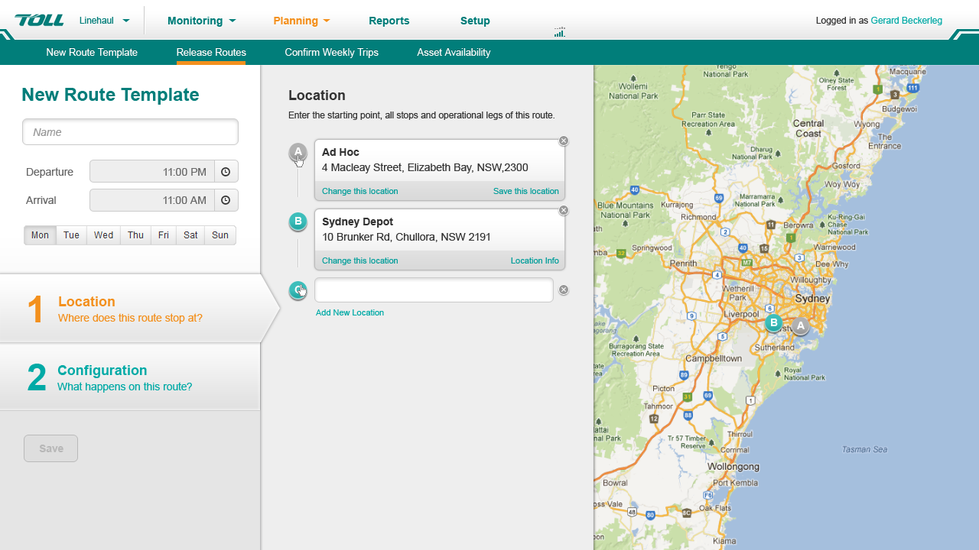
Figure: The scheduling board

Results
Toll was able to meet their compliance requirement sand understand the location of their drivers when emergencies occurred, and inform their clients of delays in real time. Something they could not do in the past.
This has revolutionised their business.

