
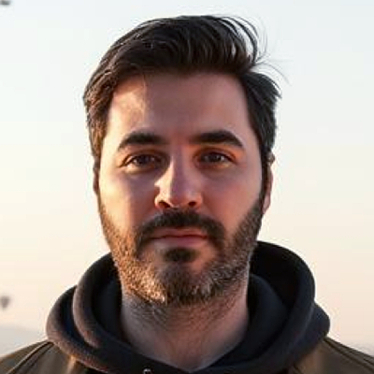

Santiago Salkin
FRONTEND DEVELOPER - EDUCATOR
Parana, Argentina | Whatsapp +(54) 9 343 4191727 | Calls +(54) 9 343 4571505 | salkinsantiago@gmail.com | Linkedin
Frontend-focused web developer with fullstack and blockchain experience. Passionate about building clean, efficient interfaces while leveraging backend knowledge. Committed to delivering high-quality results through attention to detail, efficient coding, creative problem-solving, and effective teamwork. For the past three years, I’ve taught over a thousand students to build real-world apps with modern web technologies
WORK EXPERIENCE
React JS Instructor - Coderhouse (06/2021 - Present)
- Teach live virtual bootcamps on React, guiding students in building e-commerce projects from scratch.
- Break down complex topics—like state management, performance optimization (memoization, Virtual DOM), and advanced patterns (context API, reconciliation)—into clear, engaging lessons.
- Integrate modern tools (Firestore, react-router, backend APIs) to give students real-world development experience.
- Continuously refine course material based on industry updates, ensuring students learn a relevant skillset.
React Course Content Developer - Coderhouse (04/2023 - 07/2023)
- Writer and developer for scripts and lesson plans in a new React course format, collaborating with instructors and designers to shape the curriculum.
- Focused on making complex topics intuitive—drafting clear explanations, hands-on exercises, and project guidelines used by hundreds of students.
- Built coding challenges and real-world examples to help students transition from learning to practice.

React JS Instructor - HackABoss (08/2023 - 10/2024)
- Taught React as part of a Full Stack bootcamp, mentoring students through projects and code reviews.
- Focused on practical learning with tailored exercises to solidify understanding.

Wordpress Content Manager - Multimedios Paraná (02/2019 - 01/2023)
- Managed and maintained landing pages and corporate websites mostly built with WordPress, including plugin administration, updates, and security configurations and improvements.
- Performed hosting-related tasks such as database creation, storage quota management, and user administration.
- Conducted CSS adjustments, responsive adaptations, and wordpress themes customizations.

Graphic Designer - FGS Media (05/2015 - 12/2022)
- Designed graphic, audiovisual, and interactive materials, including catalogs, magazines, branding assets, and video content for both print and digital media.
- Managed social media content and ad campaigns for various platforms such as facebook, instagram, and google.

EDUCATION
IT Systems Analyst - Autonomous University of Entre Rios (2012 - 2013)
Incomplete university degree.
Oro Verde, Entre Rios
High School Degree - Computing Technician - Technical Education School (2002 - 2008)
Completed secondary education with specialization on system analysis, programming, databases, networks, and technical English.
Villaguay, Entre Rios

SKILLS
Frontend: JavaScript - TypeScript - React - Next.js - Tailwind - Material UI
Backend: Node.js - Express - MongoDB - Mongoose - NestJS
Blockchain: Solidity - Smart Contracts - Hardhat framework - Web3 integration
Other: Git - Agile development method - Kanban/Jira

LANGUAGES
Spanish (Native)
English (Advanced - C1)

Parana, Argentina | Whatsapp +(54) 9 343 4191727 | Calls +(54) 9 343 4571505 | salkinsantiago@gmail.com | Linkedin

