## Group 47

Yijie Zhou 260622641

Sadnan Saquif 260499660

**Circuit name:** g47_16_4_Encoder

**Inputs:** BLOCK_COL (16 bits)

**Output:** ERROR(1 bit), CODE(4 bits)

**Description:**

The function of this circuit convert data from a 16-bit format to a 4-bit format with another 1 bit used for error detection. This is done by taking a 16-bit input and converting it into a 4 bit output in order to reduce the number of data lines needed. There are 16 valid inputs which represents the numbers 0-15, each of the data lines represent one of this 16 numeric values. For example if the data line representing the number 12 is active (has value 1), the 4 bit output is going to be “1100” and the error line is low. The error line is activated, has a value of 1, if all the input lines are 0 (i.e “0000000000000000”) else it has a value of 0. If we have more than one inputs, the 4 bit output will return the lowest index.

**Symbol diagram:**

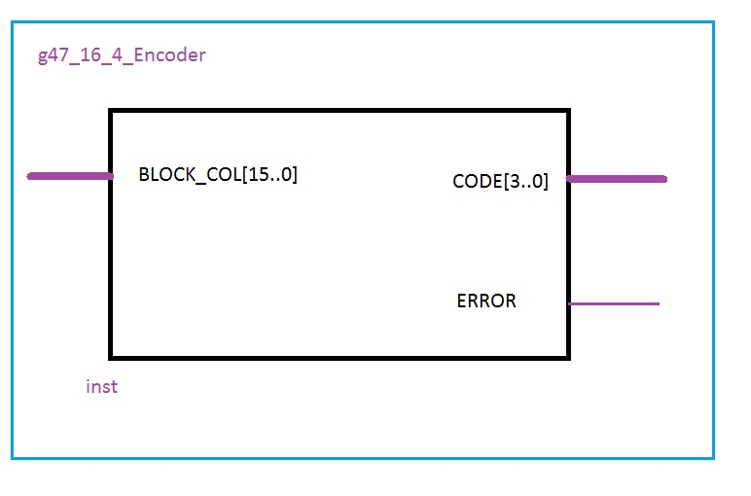

**Gate-level schematic diagram of the circuit:**

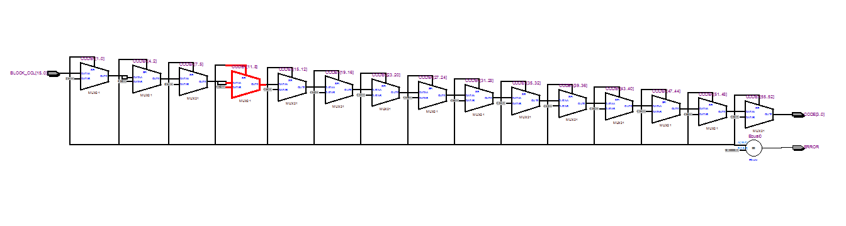

**Testing:**

First we test to see if we get the expected outcome with the valid inputs, i.e. there is only one bit with value 1 in the 16-bit input sequence. This is done using a for loop. Then we check if what the output is when all values in 16 bit sequence is 0 and finally we check the outcome when there is more than one 1s in the 16 bit input sequence.

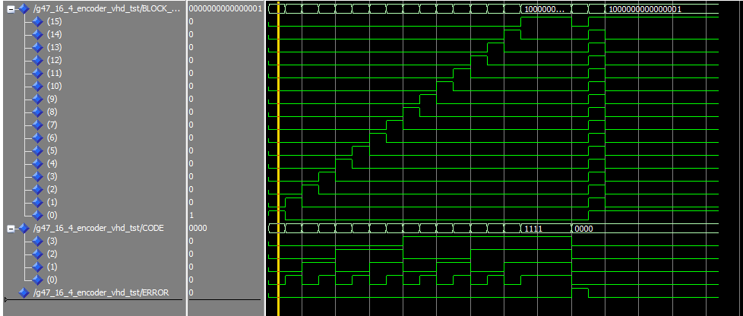

For the first case, when we only have one input line which is high, the 4 input lines should reflect the value of the input while the error line stays low. For the second case when all input lines ar at 0, the 4 output bits should be at 0 and the error line should have a value of 1. For the final case when we have two or more input lines that are high at the same time all 5 output lines should have a value of 0. Our wave diagram shows that the circuit behaves as expected.

**Grade sheet:**

