CDI COLLEGE
Assignment 2
Technical Analysis Using R
Preliminary Stage
BDA400 - Data Science Tools and Techniques

Student | Seyed Sasan Heydari
Course | BDA400 - Data Science Tools and Techniques
Assignment | A02 - Technical Analysis Using R, Preliminary Stage
Repository | https://github.com/SSasanHeydari/TechnicalAnalysis
File Name | Heydari_SeyedSasan_CA_BDA400_A02

1. Objective and Project Overview
This report documents the preliminary stage of a technical analysis project in R. The work includes GitHub repository setup, R/RStudio setup, package installation, portfolio configuration, stock-data import, calculation of basic statistics, and visualization of the imported stock data.
- AAPL - Apple Inc.
- MSFT - Microsoft Corporation
- GOOG - Alphabet Inc.

2. GitHub Account and Repository Setup
A public GitHub repository named TechnicalAnalysis was created. The Assignment02 subdirectory keeps the files for this assignment organized separately.
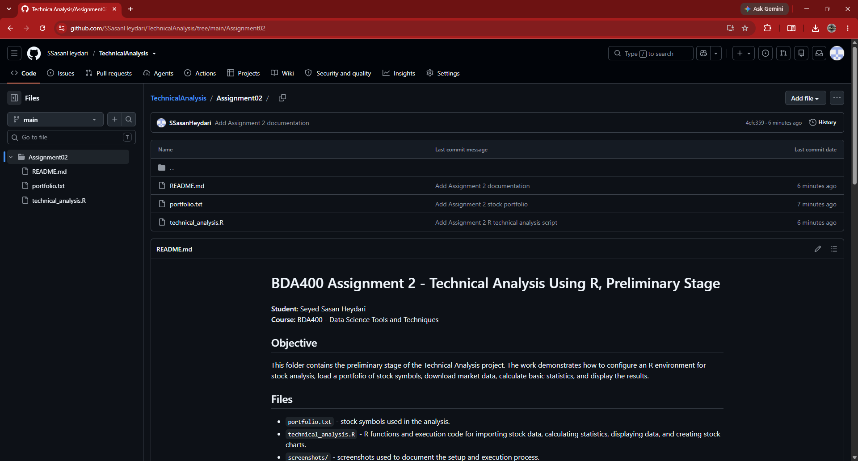
Figure 1. TechnicalAnalysis repository and Assignment02 folder on GitHub.
The folder contains README.md, portfolio.txt, and technical_analysis.R.

3. Local Project Setup
The repository was cloned to the local computer so that the R script and portfolio file could be executed from the same Assignment02 working directory.
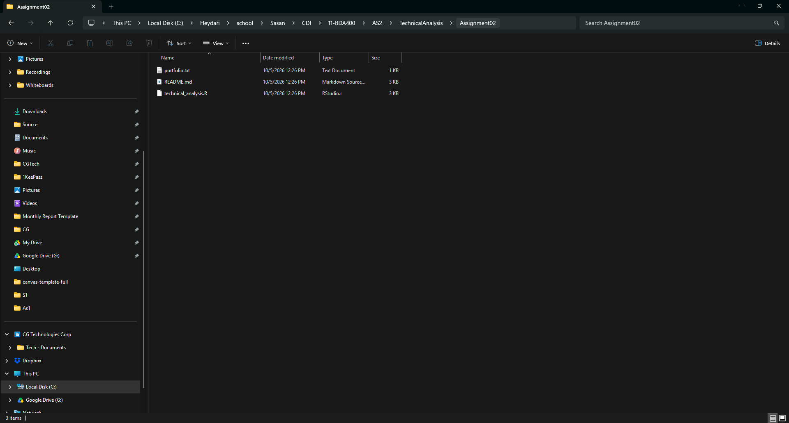
Figure 2. Local Assignment02 folder and project files.

4. R and RStudio Setup
RStudio was opened with R 4.6.1 and technical_analysis.R loaded from the Assignment02 directory. The console confirmed that R was running and the assignment folder was the active working directory.
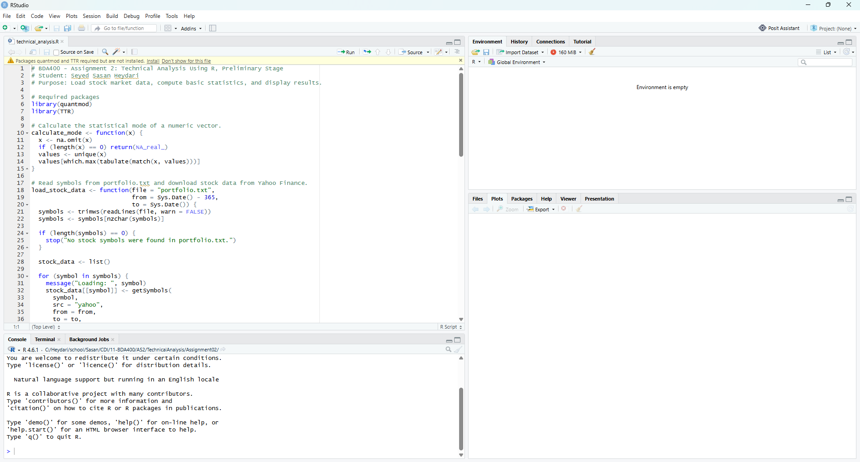
Figure 3. RStudio with R 4.6.1 and technical_analysis.R opened.

5. Required R Packages
The quantmod and TTR packages were installed from CRAN. quantmod is used to retrieve and display market data, while TTR provides technical-analysis functions such as the simple moving average.
install.packages(c("quantmod", "TTR"))
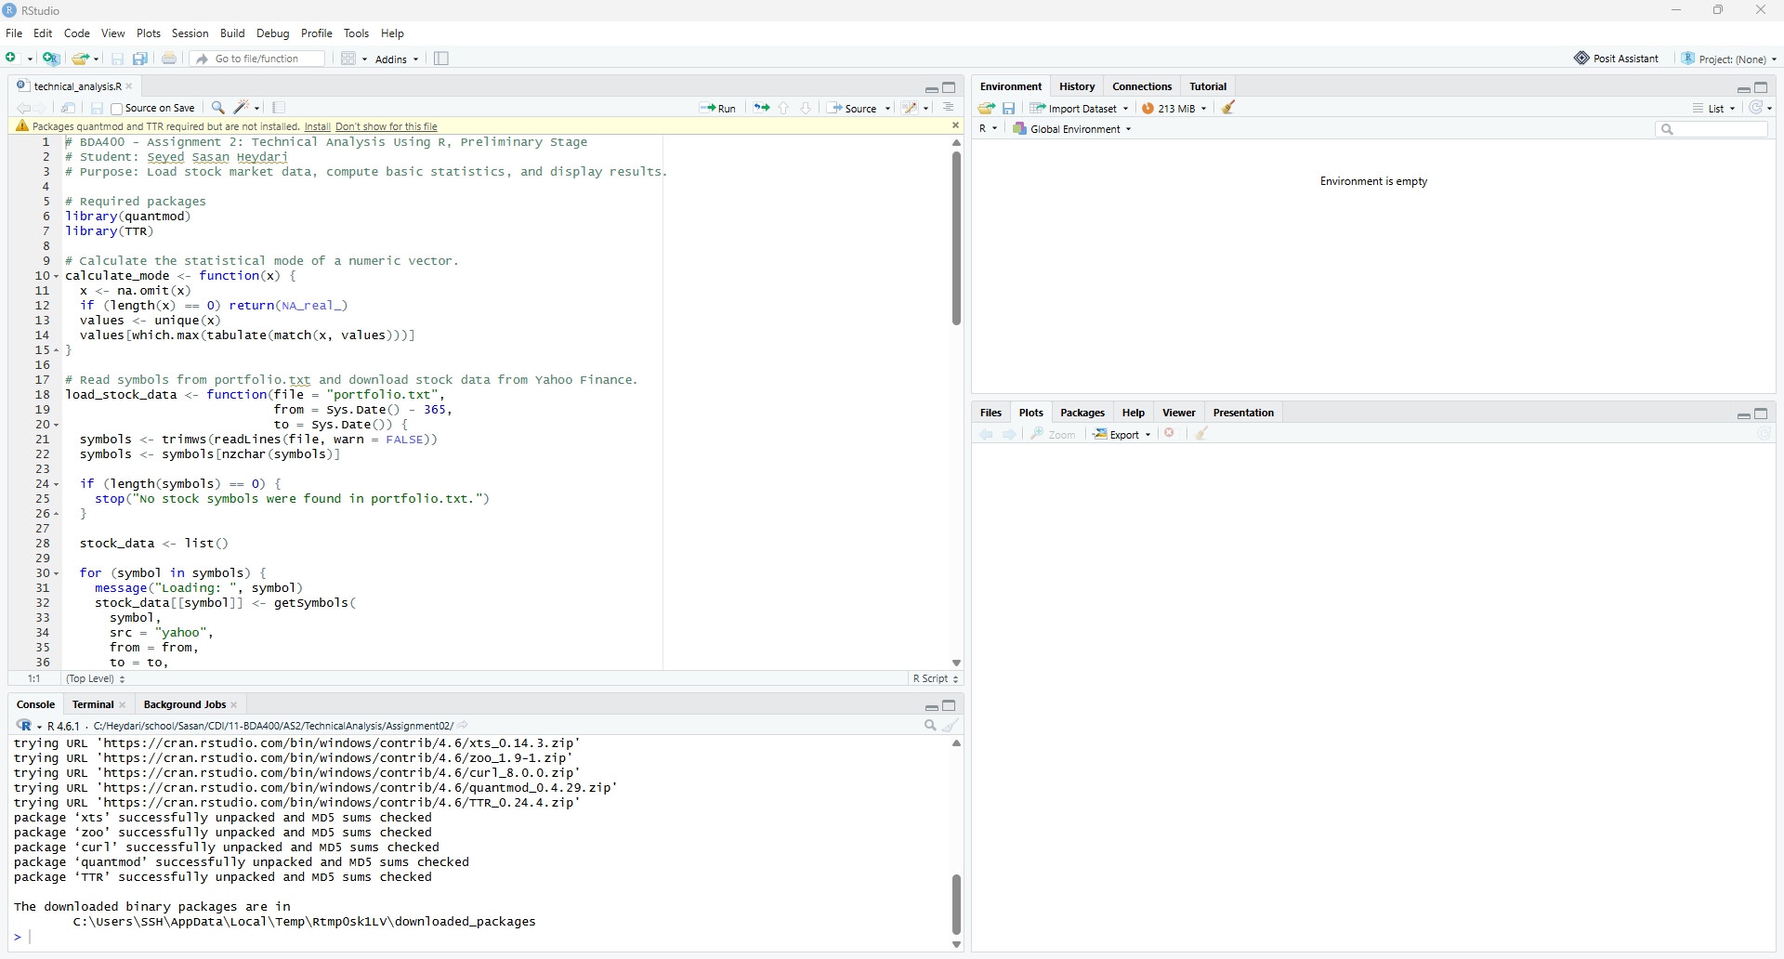
Figure 4. Successful installation of quantmod, TTR, and dependencies.
library(quantmod)
library(TTR)
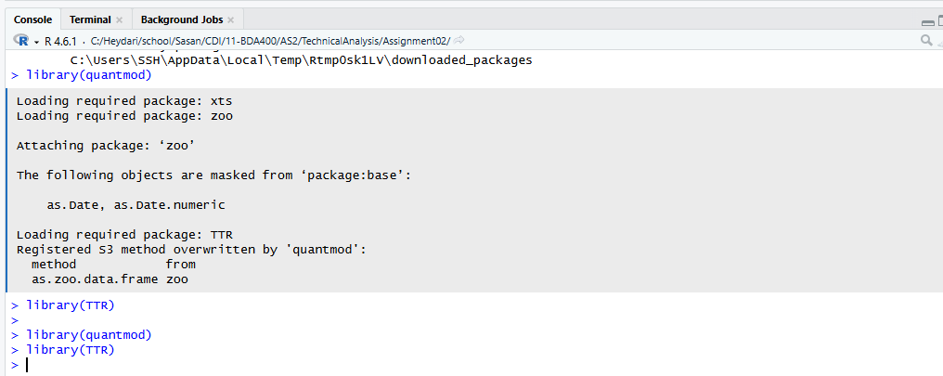
Figure 5. Required packages loaded successfully without errors.

6. Project Configuration and Initialization
The portfolio.txt file was created with one stock symbol per line:
AAPL
MSFT
GOOG
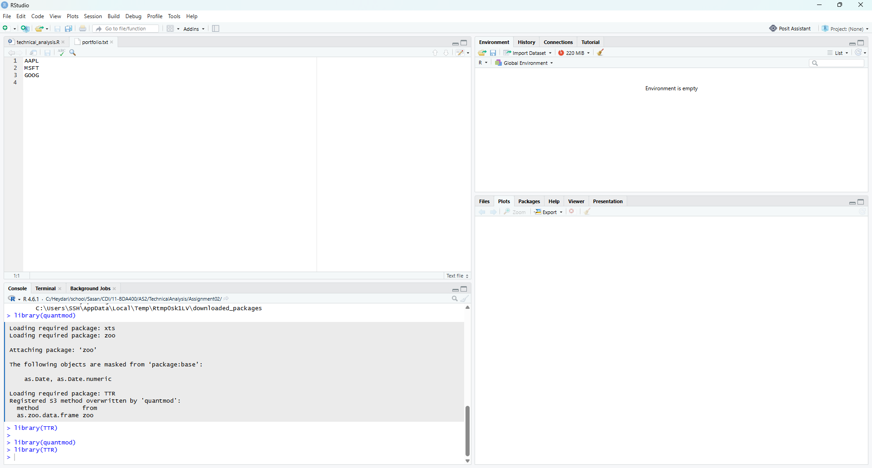
Figure 6. portfolio.txt with the three selected stock symbols.

7. Function for Importing Stock Data
The load_stock_data() function reads the symbols from portfolio.txt and downloads approximately one year of historical data for each symbol from Yahoo Finance using quantmod::getSymbols(). Each stock is stored as a separate object inside a named list.
load_stock_data <- function(file = "portfolio.txt",
from = Sys.Date() - 365,
to = Sys.Date()) {
symbols <- trimws(readLines(file, warn = FALSE))
symbols <- symbols[nzchar(symbols)]
stock_data <- list()
for (symbol in symbols) {
stock_data[[symbol]] <- getSymbols(
symbol, src = "yahoo", from = from, to = to,
auto.assign = FALSE)
}
stock_data
}

8. Function for Computing Basic Statistics
The calculate_statistics() function uses closing prices to calculate the required mean, mode, median, standard deviation, and 20-day simple moving average. A custom calculate_mode() function is used to calculate the statistical mode.
calculate_statistics <- function(stock, moving_average_period = 20) {
prices <- as.numeric(Cl(stock))
moving_average <- SMA(prices, n = moving_average_period)
data.frame(
Mean = mean(prices, na.rm = TRUE),
Mode = calculate_mode(prices),
Median = median(prices, na.rm = TRUE),
Standard_Deviation = sd(prices, na.rm = TRUE),
Latest_Moving_Average = tail(na.omit(moving_average), 1),
Moving_Average_Period = moving_average_period)
}

9. Successful Execution and Imported Data
The complete script executed successfully. The Global Environment showed stock_data and statistics as lists of three items, confirming that all three portfolio symbols were imported and analyzed.
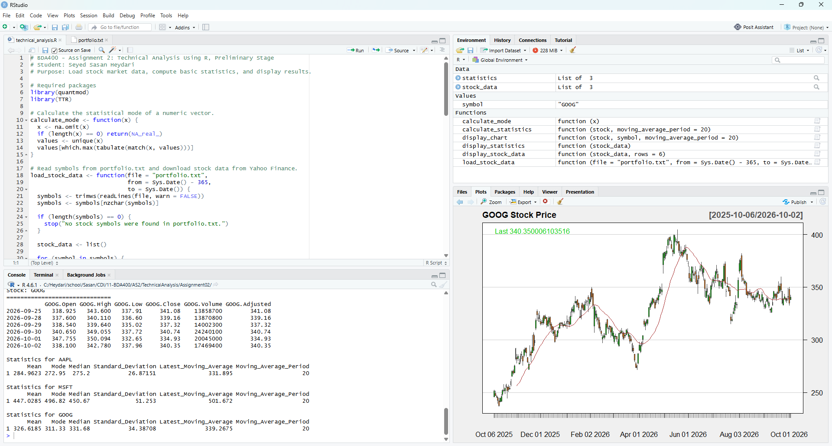
Figure 7. Successful execution with imported stock data, statistics, and visualization.

10. Statistical Results
The following values were produced by the R script from the imported closing-price data.
Symbol | Mean | Mode | Median | Std. Dev. | Latest 20-Day SMA | Period
AAPL | 284.9623 | 272.95 | 275.20 | 26.87151 | 331.895 | 20
MSFT | 447.0285 | 496.82 | 450.67 | 51.253 | 501.672 | 20
GOOG | 326.6185 | 311.33 | 331.68 | 34.38708 | 339.2675 | 20
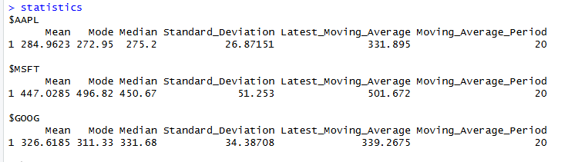
Figure 8. Console output showing the calculated statistics for all three stocks.

11. Data Display and Visualizations
The display_chart() function creates a stock-price chart for each symbol and overlays a 20-day simple moving average. These visualizations provide a preliminary technical view of recent price movement.
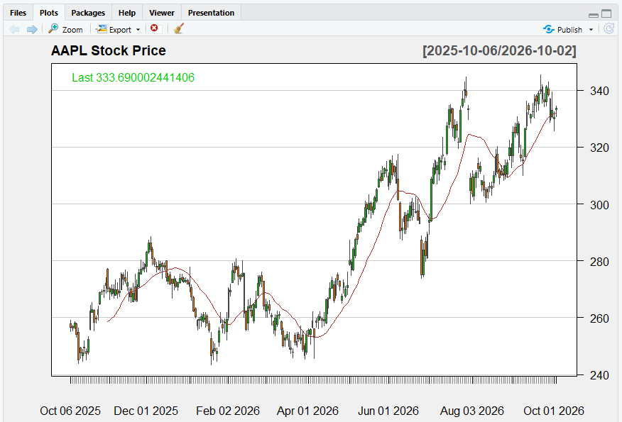
Figure 9. AAPL stock-price chart with 20-day simple moving average.
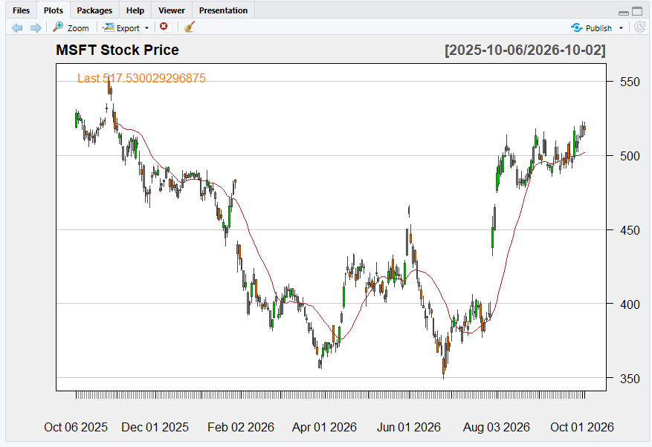
Figure 10. MSFT stock-price chart with 20-day simple moving average.

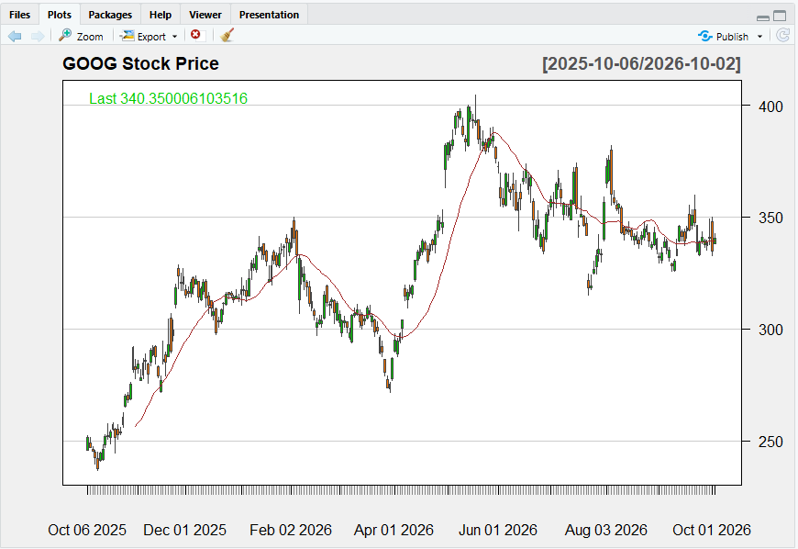
Figure 11. GOOG stock-price chart with 20-day simple moving average.

12. Conclusion
The preliminary technical-analysis environment was successfully configured and tested. The TechnicalAnalysis repository and Assignment02 folder were created, R and RStudio were used successfully, quantmod and TTR were installed and loaded, and portfolio.txt was configured with three stock symbols. The R script imported historical data for AAPL, MSFT, and GOOG, calculated all required statistics, and produced stock-price visualizations with a 20-day moving average.

13. Deliverables
- GitHub repository: https://github.com/SSasanHeydari/TechnicalAnalysis
- Assignment02/portfolio.txt
- Assignment02/technical_analysis.R
- Assignment02/README.md
- Assignment report: Heydari_SeyedSasan_CA_BDA400_A02.docx

