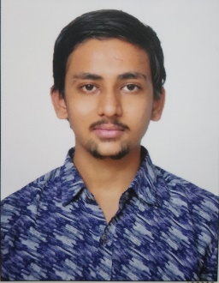\*\*\*\*\*\*\*\*\*\***RESUME**\*\*\*\*\*\*\*\*\*\*

**Name :** **Samir Satishbhai dube**

**Address :** Bazar Itola, Near railway station

Vadodara,391243

**Date of Birth :** 22/06/2000

**Nationality :** Indian

**Known Language :** Gujarati, Hindi, English

**Gender :** Male

**Email :** dubeysamir514@gmail.com

**Ph. Number :** 7226064677

**Portfolio :** <https://ssdcode.github.io/My-Portfolio/>

**EDUCATION**

* **10th Gujarat Secondary Education Board**

S.S.C-2015

52%

2015

* **12th Science Gujarat Higher Secondary Education Board**

H.S.C [12thCommerce]-2017

47%

2017

* **Balaji College of Computer Application, Chhani**

Bachelor of Computer Application [BCA]-2017 to 2020

Sem-I :61%

Sem-II :71%

Sem-III :60%

Sem-IV :68%

Sem-V :78%

Sem-VI :76%

**PERSONAL STRENGTH**

**I learn new things quickly and aren't afraid to try new ways of doing things.**

Fast Learner.