Introduction to HDL
Exam questions
8 Bit Adder
Problem
Design an 8-bit adder that adds two 8-bit binary numbers ‘A’ and ‘B’, and a carry, and outputs the result as ‘Sum’ and ‘Cout’.

Simplified Diagram
Simplified 8-bit adder diagram
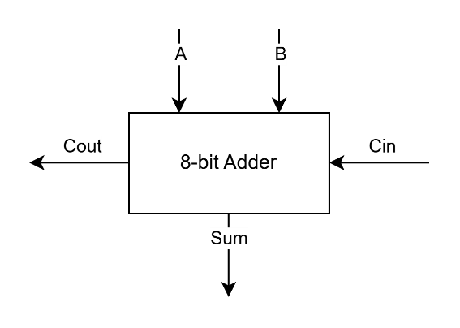
Extended 8-bit adder diagram
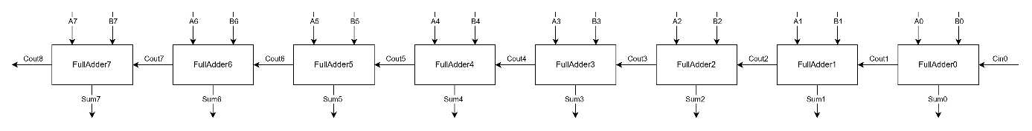

Supplemental knowledge
Full Adder Truth Table
A | B | Cin | Sum | Cout
0 | 0 | 0 | 0 | 0
0 | 0 | 1 | 1 | 0
0 | 1 | 0 | 1 | 0
0 | 1 | 1 | 0 | 1
1 | 0 | 0 | 1 | 0
1 | 0 | 1 | 0 | 1
1 | 1 | 0 | 0 | 1
1 | 1 | 1 | 1 | 1

