Introduction to HDL
Exam questions
8 Bit Adder / Subtractor
Problem
Design an 8-bit adder/subtractor that adds or subtracts two 8-bit binary numbers ‘A’ and ‘B’ based on a signal ‘Op’ (Op = 1 = subtraction), and outputs the result as ‘Sum’ and ‘Cout’.
Simplified Diagram
Simplified 8-bit adder / subtractor diagram
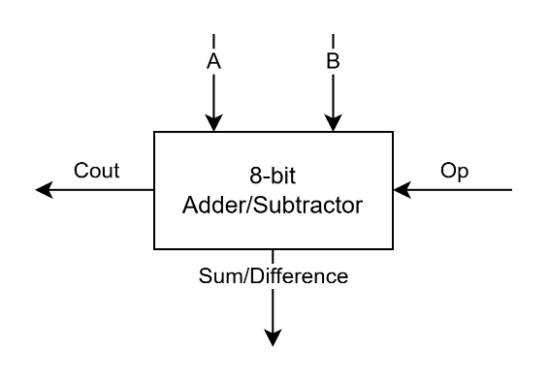
Extended 8-bit adder/subtractor diagram
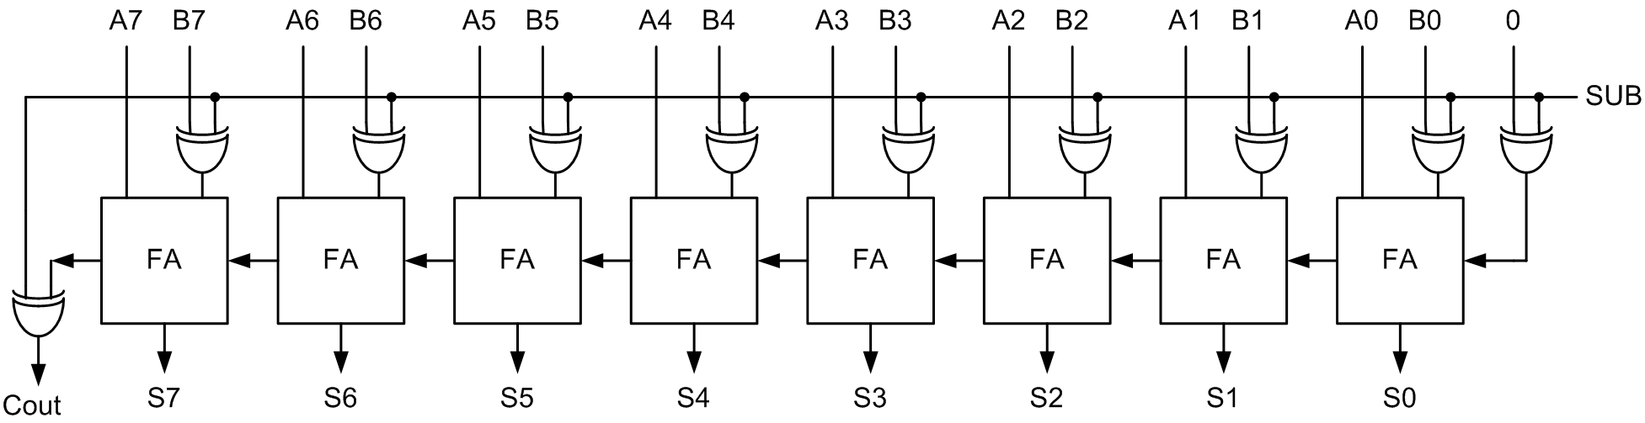
Supplemental knowledge
Full Adder Truth Table
A | B | Cin | Sum | Cout
0 | 0 | 0 | 0 | 0
0 | 0 | 1 | 1 | 0
0 | 1 | 0 | 1 | 0
0 | 1 | 1 | 0 | 1
1 | 0 | 0 | 1 | 0
1 | 0 | 1 | 0 | 1
1 | 1 | 0 | 0 | 1
1 | 1 | 1 | 1 | 1

