|  |  |
| --- | --- |
| An Anatomical Approach to Align Embryo Stages | |
| Author: | Shivang Singh |
| Collaborator(s): | Rebecca Young Brim, Hans Hofmann (PIs) |
| Department(s): | Dept. of Integrative Biology, Center for Computational Biology and Bioinformatics |

The developmental hourglass hypothesis holds that embryos of the same phyla more closely resemble each other at the midpoint of embryogenesis. To determine the underlying molecular mechanism, Young and Hofmann use a comparative meta-analysis of developmental gene expression profiles in multiple vertebrate species. However, one challenge that is posed in this analysis is a lack of intervals of comparisons along the developmental hourglass beyond the three intervals of early, middle and late. The challenge arises from the fact that embryos of different species develop on different time scales (e.g. it takes a mouse 29 days to develop while a zebra fish develops in 2.5 days). In order to compensate for these differences in rates and duration of embryogenesis, my ongoing research is focused on using anatomical characteristics of the embryos to align stages. Embryological anatomical ontologies that compile and document progression of characters through stages in embryonic development have been developed for the model organisms of *Danio rerio*, *Mus musculus*, *Xenopus laevis,* and to a lesser extent *Gallus gallus*. Cross species mapping of nomenclature has been developed using Uberon, integrated species ontology that lines up cross references anatomical nomenclature. Using stage and character mapping that these ontologies provide, I am developing an approach that uses the absence presence data that ontologies supply to cluster stages based on anatomy. My preliminary results show that we can use ontological data to make pairwise comparisons between stages using a Jaccard coefficient algorithm as well as a Euclidean distance metric. More generally, this approach will allow studies to compare embryogenesis in the species that I am developing a stage alignment for.

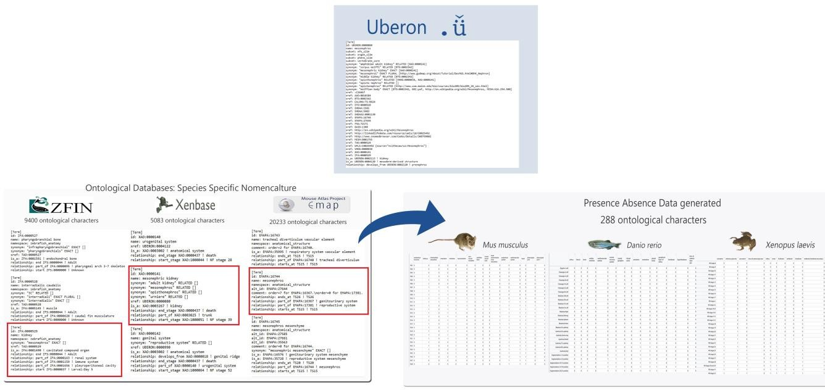

**Figure 1 :** The chart characterizes the species specific ontologies and the corresponding meta-analysis of the data. The preliminary analysis of the presence absence data has shown that this data can be used to align stages. One of the challenges in curating the data is the species specific nomenclature found in the ontologies. For example kidney, mesonephric kidney, and mesonephros represent the same anatomical feature (shown above). Currently, 288 ontological characters have been mapped across species, however through curation this number will continue to increase.

References

Bowes JB, Snyder KA, Segerdell E, Gibb R, Jarabek C, Noumen E, Pollet N, Vize PD. Xenbase: a Xenopus biology and genomics resource. Nucleic Acids Res. 2008;36(Database issue):D761– D767.

Howe DG, Bradford YM, Conlin T, Eagle AE, Fashena D, Frazer K, Knight J, Mani P, Martin R, Moxon SA, Paddock H, Pich C, Ramachandran S, Ruef BJ, Ruzicka L, Schaper K, Shao X, Singer A, Sprunger B, Van Slyke CE, Westerfield M. (2013). ZFIN, the Zebrafish Model Organism Database: increased support for mutants and transgenics. Nucleic Acids Res. Jan;41(Database issue):D854-60.

Mungall, C., Haendel, M., Dahdul, W., Ibrahim, N., Segerdell, E., Blackburn, D., Comte, A., Niknejad, A., and Decechi, A. (2016), Uberon Ontology,<http://purl.obolibrary.org/obo/uberon/releases/2016-> 01-26/uberon.owl

Richardson L, Venkataraman S, Stevenson P, Yang Y, Moss J, Graham L, Burton N, Hill B, Rao

J, Baldock RA, Armit C. (2014) , EMAGE mouse embryo spatial gene expression database: (2014 update) Nucleic Acids Res. 42(1):D835-44. doi: 10.1093/nar/gkt1155