PROJECT REPORT
CANCER CLASSIFICATION
AND PREDICTION USING
NEURAL NETWORKS
Breast Cancer Wisconsin (Diagnostic) Dataset
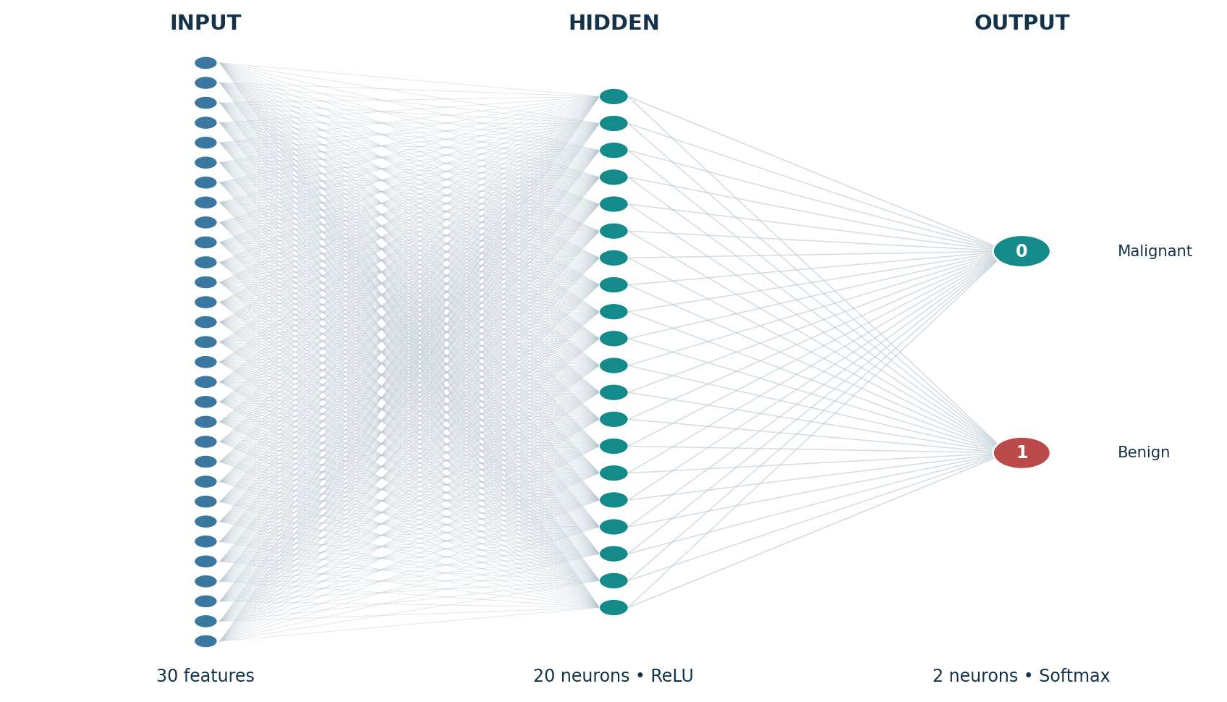
Figure: Conceptual architecture of the Artificial Neural Network used in this project.
Submitted by
SANKET KISHOR SUTAR

CERTIFICATE
  - Project authorship certificate
This certificate records that the project report titled “Cancer Classification and Prediction Using Neural Networks” has been prepared by SANKET KISHOR SUTAR. The report documents an educational machine-learning implementation using the Breast Cancer Wisconsin (Diagnostic) dataset and describes its data exploration, preprocessing, Artificial Neural Network development, training, evaluation, interactive prediction workflow and model persistence.
This is an author-issued project statement. It records authorship and the scope of the work only; it does not represent approval, endorsement or professional certification by any external person or organization. Results and figures are identified according to their actual source and should be interpreted within the limitations described in this report.

AUTHOR DECLARATION
  - Project authorship statement
I, SANKET KISHOR SUTAR, confirm that this report describes the Cancer Classification and Prediction Using Neural Networks project and identifies the dataset and software sources used. The technical methods, figures and results are described with their scope and limitations.
The project uses the Breast Cancer Wisconsin (Diagnostic) dataset available through Scikit-learn. The documented implementation uses Python, Pandas, NumPy, Matplotlib, Seaborn, Scikit-learn, TensorFlow/Keras and Gradio in Google Colab. The model maps class 0 to malignant and class 1 to benign.
I understand that a machine-learning model trained and evaluated on a public educational dataset is not a clinically validated diagnostic instrument. Its outputs must not be used for medical decisions, treatment recommendations or patient management.
The numerical results and output screenshots in this revised report are taken from the Google Colab screenshots supplied by SANKET KISHOR SUTAR. The documented run completed 10 epochs and achieved 95.60% training accuracy, 95.65% validation accuracy and 93.86% held-out testing accuracy. The report distinguishes the supplied notebook outputs from explanatory diagrams and tables calculated from the supplied confusion-matrix counts.
I acknowledge all external datasets, documentation and technical references used in this report. Sources are listed in the References section.
Author: SANKET KISHOR SUTAR

ACKNOWLEDGEMENTS
I acknowledge the maintainers of the open-source libraries used in this project, including Scikit-learn, TensorFlow/Keras, NumPy, Pandas, Matplotlib, Seaborn and Gradio. Their documentation and software tools support the data analysis, neural-network development, evaluation and interface workflow described in this report.
I acknowledge the UCI Machine Learning Repository and the Scikit-learn project for providing access to the Breast Cancer Wisconsin (Diagnostic) dataset and its documented loader.
I also acknowledge the maintainers of the Python scientific-computing ecosystem and the authors of the technical references listed at the end of this report.
This report was assembled to document the dataset, model design, workflow, measured outputs and limitations in a clear and reproducible form.
SANKET KISHOR SUTAR

ABSTRACT
This project presents an educational Artificial Intelligence and Machine Learning application for classifying breast tumor samples as malignant or benign using an Artificial Neural Network (ANN). The implementation uses the Breast Cancer Wisconsin (Diagnostic) dataset, distributed through Scikit-learn. The dataset contains 569 samples, 30 real-valued input features and two target classes. The features describe characteristics of cell nuclei measured from digitized images of fine needle aspirates of breast masses [1, 2].
The workflow includes dataset loading, exploratory data analysis, data-quality checks, feature-target separation, stratified training/validation/testing splits, feature standardization, neural-network construction, model training, evaluation and interactive prediction. The implemented network is a feed-forward Sequential model with 30 input features, one hidden Dense layer containing 20 neurons with ReLU activation, and a two-neuron Softmax output layer. The model is configured with the Adam optimizer, a learning rate of 0.001, sparse categorical cross-entropy loss and accuracy as a training metric.
For the final training arrangement, the dataset is first divided into 80% training and 20% testing data using stratification. The 455-sample training portion is further divided into 409 training samples and 46 validation samples. The final StandardScaler is fitted only on the 409 training samples and then applied to validation and test data, avoiding information leakage from those subsets.
An interactive application is developed using Gradio. It accepts 30 numerical measurements in three groups - mean, standard-error and worst measurements - applies the saved scaler and returns the model’s predicted class and class probabilities. The application is intended only for educational demonstration.

Keywords: Artificial Neural Network, Breast Cancer Wisconsin Diagnostic Dataset, binary classification, TensorFlow, Keras, StandardScaler, Gradio, machine learning.

TABLE OF CONTENTS
Section | Page
Certificate | 2
Declaration | 3
Acknowledgements | 4
Abstract | 5
List of Figures, Tables and Abbreviations | 7
Chapter 1 - Introduction | 9
Problem Statement, Motivation and Objectives | 10
Scope, Applications and Expected Outcomes | 11
Chapter 2 - Literature Review | 12
Dataset Description and Provenance | 13
Dataset Features | 14
Chapter 3 - Methodology | 15
Exploratory Data Analysis and Data Quality | 16
Exploratory Visualizations | 17
Correlation Analysis and Heatmap | 18-19
Data Preprocessing | 20
Neural Network Architecture | 21
Model Training | 22
Evaluation Metrics | 23
System Design | 24
Implementation Details | 25
Interactive Prediction Application | 27
Results and Observations | 29-31
Confusion Matrix and Error Analysis | 32-33
Testing and Verification | 34
Limitations, Ethics and Responsible Use | 35
Conclusion and Future Scope | 36
References | 37
Appendix A - Feature Inventory | 38
Appendix B - Project Release and Reproducibility Notes | 39

LIST OF FIGURES, TABLES AND ABBREVIATIONS

List of Figures
Figure | Description
Figure 1 | End-to-end project workflow
Figure 2 | Actual Colab class distribution chart
Figure 3 | Actual Colab histograms of selected mean features
Figure 4 | Actual Colab box plots of selected measurements
Figure 5 | Pearson correlation heatmap of 30 input features
Figure 6 | Organization of the 30 input measurements into three groups
Figure 7 | Artificial Neural Network architecture
Figure 8 | High-level system architecture
Figure 9 | Actual Gradio application: input form, prediction control and displayed output
Figure 10 | Google Colab DataFrame information and data-quality output
Figure 11 | Actual ten-epoch Colab training log
Figure 12 | Actual training and validation accuracy graph
Figure 13 | Actual training and validation loss graph
Figure 14 | Actual held-out test confusion matrix
Figure 15 | Actual final evaluation summary
Figure 16 | Actual-versus-predicted output table
Figure 17 | Actual Keras model summary output

List of Tables
Table | Description
Table 1 | Dataset summary
Table 2 | Target class mapping
Table 3 | Feature groups
Table 4 | Training / validation / test allocation
Table 5 | Neural-network configuration
Table 6 | Evaluation metric definitions
Table 7 | Functional test cases
Table 8 | Final Colab-run evaluation metrics
Table 9 | Class-wise classification report calculated from supplied confusion-matrix counts

Abbreviations
Abbreviation | Meaning
AI | Artificial Intelligence
ANN | Artificial Neural Network
EDA | Exploratory Data Analysis
FNA | Fine Needle Aspirate
ML | Machine Learning
ReLU | Rectified Linear Unit
TP / TN | True Positive / True Negative
FP / FN | False Positive / False Negative
API | Application Programming Interface
UI | User Interface

CHAPTER 1 - INTRODUCTION

1.1 Background
Artificial Intelligence (AI) and Machine Learning (ML) are used to identify patterns in data and support a range of analytical tasks. Classification is a supervised-learning task in which a model learns from labelled examples and predicts a category for new observations. In a healthcare-related educational setting, classification methods can be demonstrated using structured measurements associated with medical samples.
This project focuses on a binary classification task using the Breast Cancer Wisconsin (Diagnostic) dataset. Each row represents a sample described by 30 numerical features. The target identifies the sample as malignant or benign. A neural network is trained to learn associations between the numerical measurements and the provided target labels.

1.2 Project Overview
The implementation begins by loading the dataset from Scikit-learn. Pandas is used to organize the observations into a DataFrame. Exploratory data analysis is performed to inspect dimensions, missing values, duplicate rows, descriptive statistics, class frequencies, feature distributions and correlations. The data is then separated into input features and target labels, divided into training, validation and test subsets, and standardized.
A Sequential Artificial Neural Network is built using TensorFlow/Keras. The network has an input dimension of 30, one hidden Dense layer of 20 neurons using ReLU, and an output Dense layer of two neurons using Softmax. The trained model is evaluated on a held-out test set, and an interactive Gradio application is created to demonstrate predictions from user-provided numerical measurements.

1.3 Nature of the Project
The project is an educational prototype intended to demonstrate data analysis, neural-network development, evaluation and interface integration. It does not use live hospital records, prospective clinical data or a medically approved workflow. The dataset labels are used as the target for supervised learning; model output is not a clinical diagnosis.
IMPORTANT DISTINCTION
The model learns from a public, labelled dataset. It does not examine medical images directly and does not independently confirm cancer. It classifies numerical feature vectors supplied to the model.

PROBLEM STATEMENT, MOTIVATION AND OBJECTIVES

1.4 Problem Statement
The project addresses the supervised-learning problem of predicting whether a sample in the Breast Cancer Wisconsin (Diagnostic) dataset belongs to the malignant or benign class using 30 numerical measurements. The central technical problem is to construct a neural-network classifier that can learn from labelled examples, generalize to unseen test samples and expose its output through a simple interface.

1.5 Motivation
The dataset provides a compact, well-structured example for understanding a complete machine-learning workflow. It allows a author to practice data exploration, feature scaling, stratified sampling, neural-network architecture design, training-curve interpretation and classification metrics. It also provides an opportunity to examine why recall and false-negative analysis matter in a high-stakes domain, even when the project itself is only an educational exercise.

1.6 Objectives
- Load and understand the Breast Cancer Wisconsin (Diagnostic) dataset.
- Examine the dataset for missing values, duplicates and distribution characteristics.
- Separate the 30 numerical input features from the binary target variable.
- Create stratified training, validation and testing subsets.
- Standardize features using parameters estimated from training data only.
- Develop and train an Artificial Neural Network using TensorFlow/Keras.
- Evaluate the model using accuracy, precision, recall, F1-score and confusion matrix.
- Create an interactive Gradio interface that accepts 30 numerical values and displays model output.
- Save the trained model and preprocessing artefacts for later reuse.
- Document the implementation, observations, limitations and future improvements.

1.7 Expected Outcome
The expected deliverable is a reproducible educational classification prototype with a saved neural network, fitted scaler, feature-order metadata, evaluation artefacts, an interactive demonstration interface and a documented workflow. The project brief sets an accuracy above 90% as an intended benchmark; actual performance must be established from a documented run.

SCOPE, APPLICATIONS AND EXPECTED OUTCOMES

1.8 Scope
The scope is restricted to the Breast Cancer Wisconsin (Diagnostic) dataset provided by Scikit-learn and a two-class supervised-learning task. The implementation covers loading, exploratory analysis, preprocessing, a feed-forward ANN, training and validation, test evaluation, an interactive numeric-input demonstration and saving the trained artefacts.

1.9 Applications of the Underlying Concepts
The general techniques demonstrated in this project - tabular data preparation, feature scaling, binary classification, neural-network optimization and evaluation - are relevant to many data-analysis contexts. The project manual identifies medical diagnosis support systems, clinical decision-making, healthcare analytics, disease-prediction systems and research and development as application areas. These are broad application categories; this author prototype is not approved for use in any of those operational settings.

1.10 Project Boundaries
- The model accepts numerical feature values, not a raw mammogram, biopsy image or free-text clinical report.
- The dataset is a fixed public benchmark with 569 samples and 30 features.
- The target labels are inherited from the source dataset; the project does not independently establish ground truth.
- The application is a demonstration interface, not a deployed clinical service.
- No patient identity, hospital integration, treatment advice or medical-record storage is included.
- The project does not include external validation on an independent cohort or prospective population.

1.11 Expected Learning Outcomes
The project is intended to develop understanding of the full supervised-learning pipeline and of how model outputs should be interpreted. The author should be able to explain the data source, all 30 features, the reason for stratification and scaling, the neural-network layers, the metrics and the limitations of the results.

CHAPTER 2 - LITERATURE REVIEW

2.1 Dataset Research Background
The Breast Cancer Wisconsin (Diagnostic) dataset is documented by the UCI Machine Learning Repository. It contains 569 instances and 30 continuous features. The features are computed from digitized images of fine needle aspirates of breast masses and describe characteristics of cell nuclei. UCI identifies the associated task as classification and the subject area as health and medicine [1].

2.2 Supervised Classification
Supervised classification uses labelled training examples. During training, a model receives input features together with known target labels. It adjusts internal parameters to reduce a loss function. Once training is complete, the model can produce a predicted class for a new input. The separation of training and test data is important because evaluating on samples used during learning can provide an overly optimistic estimate of generalization.

2.3 Neural Networks for Tabular Classification
A feed-forward neural network consists of layers of computational units. Dense layers connect each unit in one layer to all units in the next layer. Non-linear activation functions allow the network to learn relationships beyond a simple linear mapping. In this project, a small network is selected to keep the architecture understandable and suitable for a author demonstration: one hidden layer with 20 neurons and an output layer with two neurons.

2.4 Feature Standardization
Standardization transforms each feature by subtracting a mean and dividing by a standard deviation. Scikit-learn’s StandardScaler estimates these quantities from the data supplied to fit and reuses them when transform is called on later data [3]. Fitting only on the training subset prevents validation or test observations from influencing the transformation parameters.

2.5 Model Evaluation
Accuracy summarizes the fraction of correct predictions, but class-wise precision, recall and F1-score provide additional information. A confusion matrix shows the counts of correct and incorrect predictions by actual and predicted class. In a medical-themed classification exercise, false negatives should be examined explicitly because they represent malignant-labelled samples predicted as benign. Metric definitions and averaging choices should be stated clearly [5, 6].

2.6 Position of This Project
This project is an educational implementation of a neural-network classifier using a public dataset and standard open-source libraries. It does not propose a novel medical method or claim superiority over clinical systems. Its contribution is the integration of data preparation, ANN training, evaluation and a small interactive demonstration into a documented project workflow.

DATASET DESCRIPTION AND PROVENANCE

2.7 Dataset Source
The selected dataset is the Breast Cancer Wisconsin (Diagnostic) dataset from the UCI Machine Learning Repository, accessed in the project through Scikit-learn’s load_breast_cancer() dataset loader. Scikit-learn documents 569 total samples, 30 input dimensions and two target classes: 212 malignant and 357 benign [1, 2].
The UCI description states that the features are calculated from digitized images of fine needle aspirates of breast masses and describe characteristics of cell nuclei [1]. This provenance is important: the table does not consist of 569 raw images. It contains precomputed numerical features derived from image analysis.

2.8 Dataset Summary
Property | Value
Dataset name | Breast Cancer Wisconsin (Diagnostic)
Repository | UCI Machine Learning Repository
Project access method | sklearn.datasets.load_breast_cancer()
Total samples | 569
Input features | 30
Target classes | 2
Malignant samples | 212 (37.26%)
Benign samples | 357 (62.74%)
Feature type | Real-valued numerical measurements
Task | Binary classification

2.9 Target Labels
Encoded value | Dataset class | Interpretation
0 | malignant | Malignant class
1 | benign | Benign class

2.10 Dataset Suitability
The dataset is suitable for demonstrating tabular binary classification because it has a defined target, numeric features and a moderate number of observations. Its class frequencies are not equal, so stratified sampling is used to preserve approximate class proportions across data subsets. The dataset’s modest size also means that results should be interpreted cautiously and not generalized to a clinical population without external validation.

DATASET FEATURES AND ORGANIZATION

2.11 Three Feature Groups
The 30 input features are organized into three groups of ten measurements. The groups describe the mean value, standard error and worst (largest or most extreme) value of ten characteristics. This structure is reflected in the feature names and is also used to group inputs in the Gradio interface.
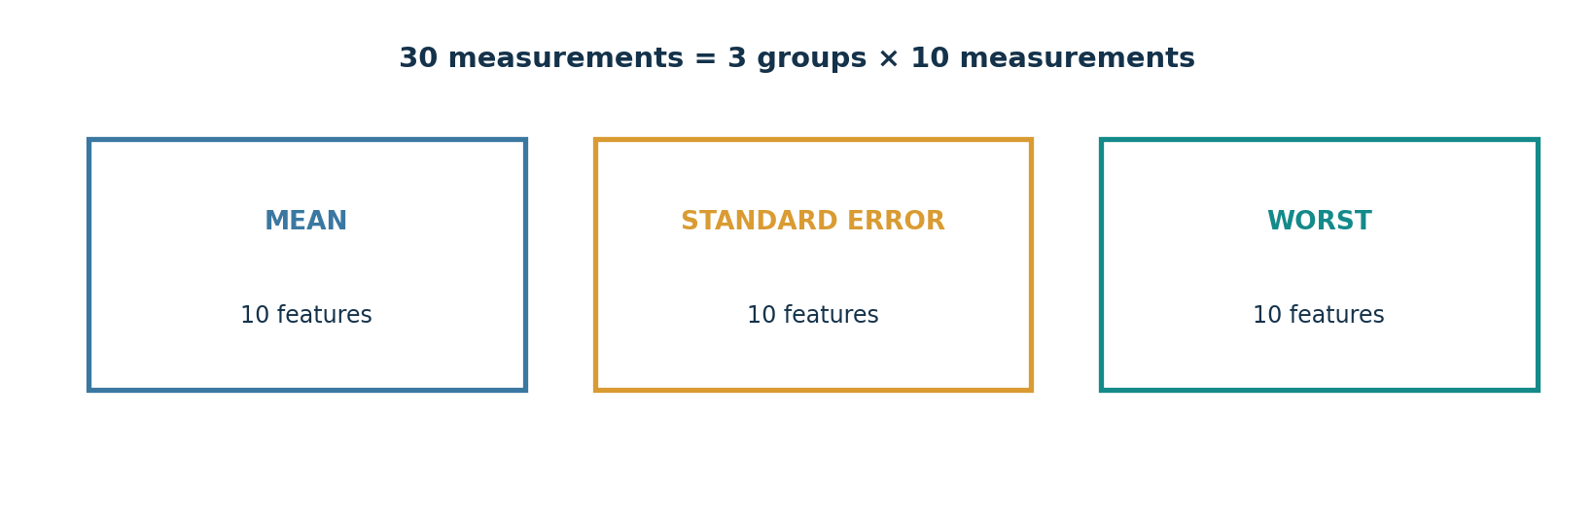
Figure 6. Organization of the 30 input measurements into three groups.
Measurement family | Features included
Size and geometry | radius, perimeter, area
Surface and texture | texture, smoothness
Shape characteristics | compactness, concavity, concave points, symmetry, fractal dimension

2.12 Meaning of Representative Features
- Radius: a measure associated with distances from the centre to points on the perimeter.
- Texture: variation in grayscale values.
- Perimeter: measurement of the boundary length.
- Area: measurement of the enclosed region.
- Smoothness: local variation in radius lengths.
- Compactness: a boundary/area-derived shape descriptor.
- Concavity: degree of concave portions of the contour.
- Concave points: number or extent of concave portions of the contour.
- Symmetry: measure of symmetry in the nucleus boundary.
- Fractal dimension: a shape descriptor based on a coastline-approximation concept.

2.13 Feature Naming
Each measurement is repeated in the mean, standard-error and worst groups. Examples include mean radius, radius error and worst radius. The original 30-column order is preserved through training, evaluation and application input handling. The feature names are saved with the model artefacts to reduce the risk of incorrect column order when new measurements are supplied.

CHAPTER 3 - METHODOLOGY

3.1 Overall Methodology
The project follows a sequential supervised-learning workflow. It begins with dataset collection and exploration, continues through data preparation and neural-network training, and concludes with independent testing, an interactive prediction interface and model persistence.
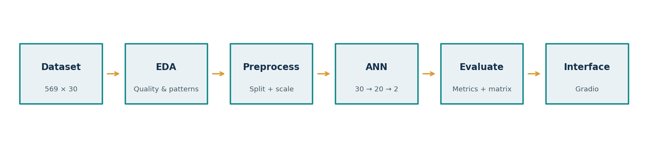
Figure 1. End-to-end workflow followed by the project.

3.2 Project Phases
Phase | Main activities | Output
1. Data collection | Load the dataset and identify its fields. | 569 × 30 feature matrix and target vector
2. Data exploration | Inspect quality, distributions and correlations. | EDA tables and figures
3. Preprocessing | Separate X/y, split data and standardize features. | Scaled train, validation and test matrices
4. Model development | Define ANN layers and compile the model. | Compiled Keras model
5. Model training | Train over epochs and monitor validation metrics. | Trained model and history
6. Evaluation | Measure test performance and inspect errors. | Metrics and confusion matrix
7. Prediction | Connect numeric inputs to model and scaler. | Interactive Gradio demonstration
8. Persistence | Save model, scaler, metadata and results. | Reusable project artefacts

3.3 Reproducibility
The data splits use random_state=42 and stratify labels. The training configuration is recorded in the metadata. Neural-network weight initialization and training can still vary unless deterministic settings are applied consistently. The final project report should describe the actual run from which its metrics were obtained and should not mix results from different runs.

EXPLORATORY DATA ANALYSIS AND DATA QUALITY

3.4 Initial Inspection
The dataset is loaded through load_breast_cancer() and converted into a Pandas DataFrame. The 30 input columns are taken from the dataset’s feature_names field and the target column is added separately. The resulting frame has 569 rows and 31 columns: 30 features plus one target.

3.5 Missing-Value Check
The project checks missingness column by column using DataFrame.isnull().sum(). The canonical Scikit-learn dataset used for the descriptive analysis in this report contains zero missing values across its 569 × 31 frame [2]. No imputation is required for that source frame.

3.6 Duplicate-Record Check
Exact duplicate rows are examined using DataFrame.duplicated().sum(). The canonical dataset frame contains zero exact duplicate rows when the 30 features and target column are considered together. A duplicate check is still retained in the project workflow because data cleaning is an explicit part of the assignment brief.

3.7 Descriptive Statistics
Pandas describe() is used to summarize count, mean, standard deviation, minimum, quartiles and maximum for numerical columns. These summaries help reveal scale differences and broad variation across measurements. The values are not used as clinical reference ranges; they describe only this dataset.
Feature | Mean | Std. dev. | Minimum | Maximum
mean radius | 14.127 | 3.524 | 6.981 | 28.110
mean texture | 19.290 | 4.301 | 9.710 | 39.280
mean perimeter | 91.969 | 24.299 | 43.790 | 188.500
mean area | 654.889 | 351.914 | 143.500 | 2501.000
The statistics above are dataset-level descriptive values calculated from the canonical Scikit-learn dataset. They should not be interpreted as diagnostic cut-offs.

EXPLORATORY VISUALIZATIONS

3.8 Target-Class Distribution
The dataset contains 212 malignant samples and 357 benign samples. These correspond to approximately 37.26% malignant and 62.74% benign. The class distribution is therefore not equal. The project uses stratified sampling for the train/test split and for the validation split so that the proportions remain approximately represented in each subset.
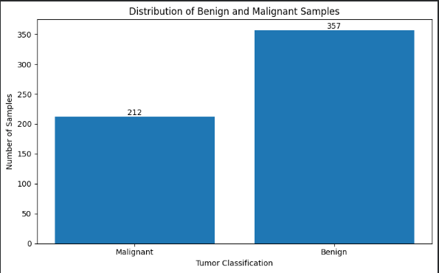
Figure 2. Actual Google Colab bar chart showing 212 malignant and 357 benign samples.

3.9 Feature Histograms
Histograms are used to inspect the distributions of selected mean measurements: radius, texture, perimeter and area. The plots distinguish malignant and benign samples so that distributional differences and overlap can be observed. Histograms are descriptive; they do not prove that a feature alone can classify every sample correctly.
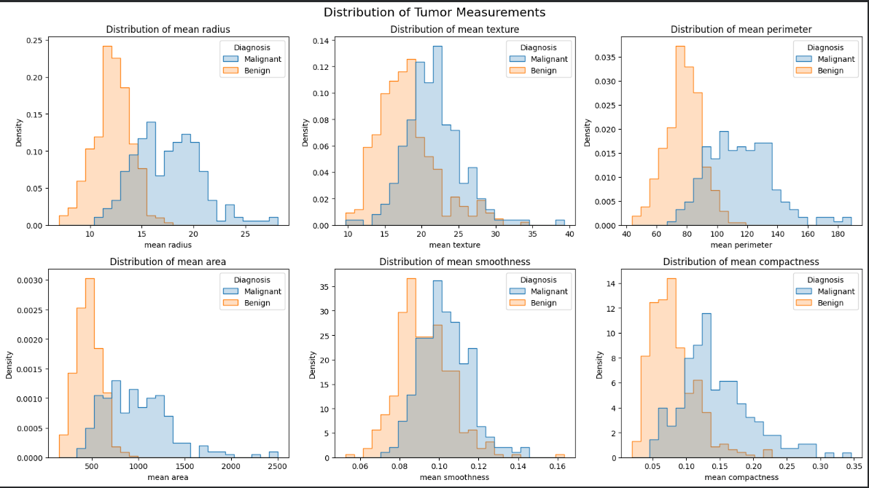
Figure 3. Actual Google Colab histograms for six selected mean tumor measurements, separated by diagnosis.

FEATURE COMPARISON AND CORRELATION ANALYSIS

3.10 Box-Plot Analysis
Box plots are used to compare the distributions of selected features across the two classes. The median, interquartile range, whiskers and possible outlying observations can be compared visually. An observation outside a whisker is not automatically an error; it may be a valid sample. Any record-removal decision should be based on data provenance and justified evidence.
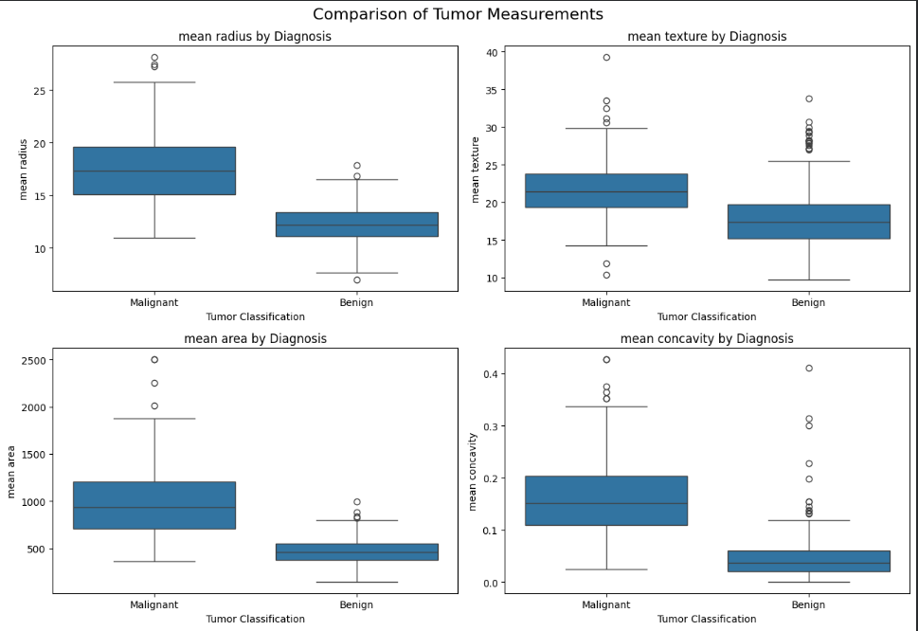
Figure 4. Actual Google Colab box plots comparing selected tumor measurements between malignant and benign samples.

3.11 Correlation Analysis
A Pearson correlation matrix is calculated for the 30 input features. Correlation values range from -1 to +1 and describe linear association. Highly correlated features may carry overlapping information. Correlation does not establish causation and does not, by itself, justify deleting a feature. The heatmap is used as an exploratory aid rather than an automatic feature-selection rule.
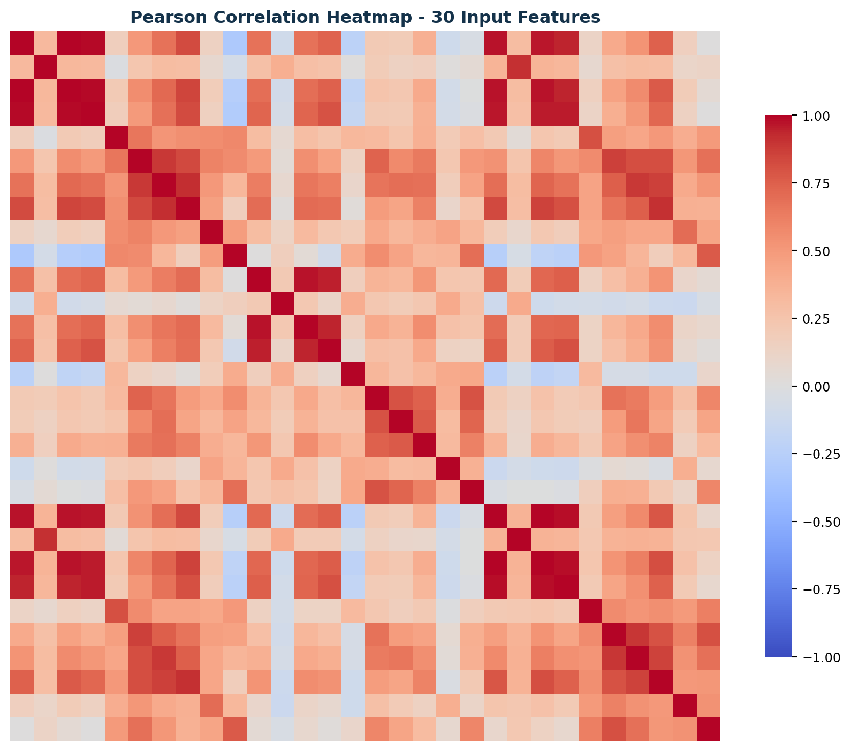
Figure 5. Pearson correlation heatmap for the 30 input features, generated from the project DataFrame.

DATA PREPROCESSING

3.12 Separation of Features and Target
The independent-variable matrix X contains the 30 numerical measurements. The dependent-variable vector y contains the target labels. The encoding used by Scikit-learn is 0 for malignant and 1 for benign [2]. Because the labels are already integers, additional label encoding is not required for the selected sparse categorical cross-entropy setup.

3.13 Stratified Train-Test Split
The complete dataset is divided using train_test_split with test_size=0.20, random_state=42 and stratify=y. This produces 455 initial training samples and 114 test samples. The test subset is kept aside for the final evaluation.

3.14 Training-Validation Split
The 455-sample training portion is further divided using test_size=0.10, random_state=42 and stratify=y_train. This produces 409 model-fitting samples and 46 validation samples. Validation samples are used to monitor generalization during training and are not used for gradient updates.
Subset | Total samples | Malignant (0) | Benign (1)
Model-fitting training | 409 | 153 | 256
Validation | 46 | 17 | 29
Final testing | 114 | 42 | 72

3.15 Standardization and Leakage Control
StandardScaler applies z-score standardization: z = (x - mean) / standard deviation. For the final training pipeline, the scaler is fitted only on the 409 model-fitting samples. The same fitted scaler is then used to transform the 46 validation samples and 114 test samples. The same saved scaler is used by the Gradio prediction function. This prevents validation/test information from influencing the fitted scaling parameters [3].
IMPLEMENTATION CONSISTENCY
The earlier exploratory preprocessing cell may create an initial scaler on the 455-sample training portion. The final model pipeline uses the later training_scaler fitted on the 409-sample fitting subset. The saved scaler and deployment code must use this final training_scaler.

NEURAL NETWORK ARCHITECTURE

3.16 Artificial Neural Network
The project uses a feed-forward Artificial Neural Network implemented as a TensorFlow/Keras Sequential model. It accepts a vector of 30 standardized measurements, processes the values through a fully connected hidden layer, and returns probabilities for two classes.
Figure 7. ANN architecture: 30 inputs, 20 hidden neurons and 2 output neurons.
Layer | Configuration | Role
Input | 30 features | Receives standardized measurement vector
Hidden Dense | 20 neurons, ReLU | Learns non-linear feature combinations
Output Dense | 2 neurons, Softmax | Returns class probabilities

3.17 Trainable Parameters
The hidden layer has (30 × 20) weights plus 20 biases, giving 620 parameters. The output layer has (20 × 2) weights plus 2 biases, giving 42 parameters. The total is 662 trainable parameters.
Hidden layer: (30 × 20) + 20 = 620. Output layer: (20 × 2) + 2 = 42. Total parameters: 620 + 42 = 662.

3.18 Activation Functions
ReLU is used in the hidden layer: f(x) = max(0, x). It introduces non-linearity and returns zero for negative inputs while passing positive inputs through. Softmax is used in the two-neuron output layer to produce a normalized pair of class probabilities that sum to one.

3.19 Loss and Optimization
The network is compiled with the Adam optimizer at a learning rate of 0.001 and sparse categorical cross-entropy loss. Sparse categorical cross-entropy is appropriate for integer-encoded class labels with a two-neuron Softmax output. Accuracy is used as a training and validation metric.

MODEL TRAINING

3.20 Training Configuration
Parameter | Configuration
Framework | TensorFlow / Keras
Model type | Sequential feed-forward ANN
Input features | 30
Hidden layer | 20 Dense neurons
Hidden activation | ReLU
Output layer | 2 Dense neurons
Output activation | Softmax
Optimizer | Adam
Learning rate | 0.001
Loss | Sparse Categorical Crossentropy
Metric | Accuracy
Epochs | 10
Batch size | 32
Training samples | 409
Validation samples | 46

3.21 Training Process
The model is trained using model.fit() with the standardized 409-sample training matrix and its integer labels. The validation dataset is passed separately through validation_data. Training samples are shuffled. The history object stores training and validation loss and accuracy after each epoch.

3.22 Interpreting Learning Curves
Training accuracy describes performance on the data used for weight updates. Validation accuracy describes performance on the held-out validation subset. Training loss and validation loss quantify prediction error under the selected loss function. A widening gap between training and validation results may indicate overfitting; low performance on both may indicate underfitting. Curves must be interpreted together rather than using one value in isolation.

MODEL EVALUATION METRICS

3.23 Testing Procedure
After training and validation, the final model is evaluated on the 114-sample test subset that was not used for gradient updates or scaler fitting. The model generates two probabilities for each sample. The predicted class is selected using the index of the largest probability. The actual test labels are compared with predicted labels to calculate the metrics.

3.24 Evaluation Measures
Metric | Definition | Interpretation
Accuracy | (TP + TN) / (TP + TN + FP + FN) | Overall fraction of correct predictions
Precision | TP / (TP + FP) | Reliability of positive-class predictions
Recall / Sensitivity | TP / (TP + FN) | Fraction of actual positive cases detected
F1-score | 2 × (Precision × Recall) / (Precision + Recall) | Harmonic mean of precision and recall
Specificity | TN / (TN + FP) | Fraction of actual negative cases correctly identified

3.25 Positive-Class Convention
For the explicitly reported Malignant-class precision, recall and F1-score, malignant (label 0) is treated as the positive class. This convention must be stated because the dataset’s encoded label 0 is malignant and label 1 is benign. The classification report also includes per-class metrics for both labels.

3.26 Confusion Matrix
With label order [0, 1], the confusion matrix rows represent actual classes and columns represent predicted classes. The cell at row 0, column 0 is the number of malignant samples correctly classified as malignant (TP for malignant). Row 0, column 1 is malignant samples classified as benign (FN). Row 1, column 0 is benign samples classified as malignant (FP). Row 1, column 1 is benign samples correctly classified as benign (TN).
SAFETY-RELEVANT INTERPRETATION
False negatives are especially important to discuss in a malignant-versus-benign educational classification task. However, even a low false-negative count on this test split does not establish clinical safety or diagnostic performance in real patients.

SYSTEM DESIGN

4.1 High-Level Architecture
The system consists of a user-facing input interface, input validation, a preprocessing component and a trained neural-network model. The Gradio interface collects the measurements in the original feature order. The fitted StandardScaler transforms the values, and the neural network returns class probabilities. The interface displays the predicted class and probabilities with an educational disclaimer.
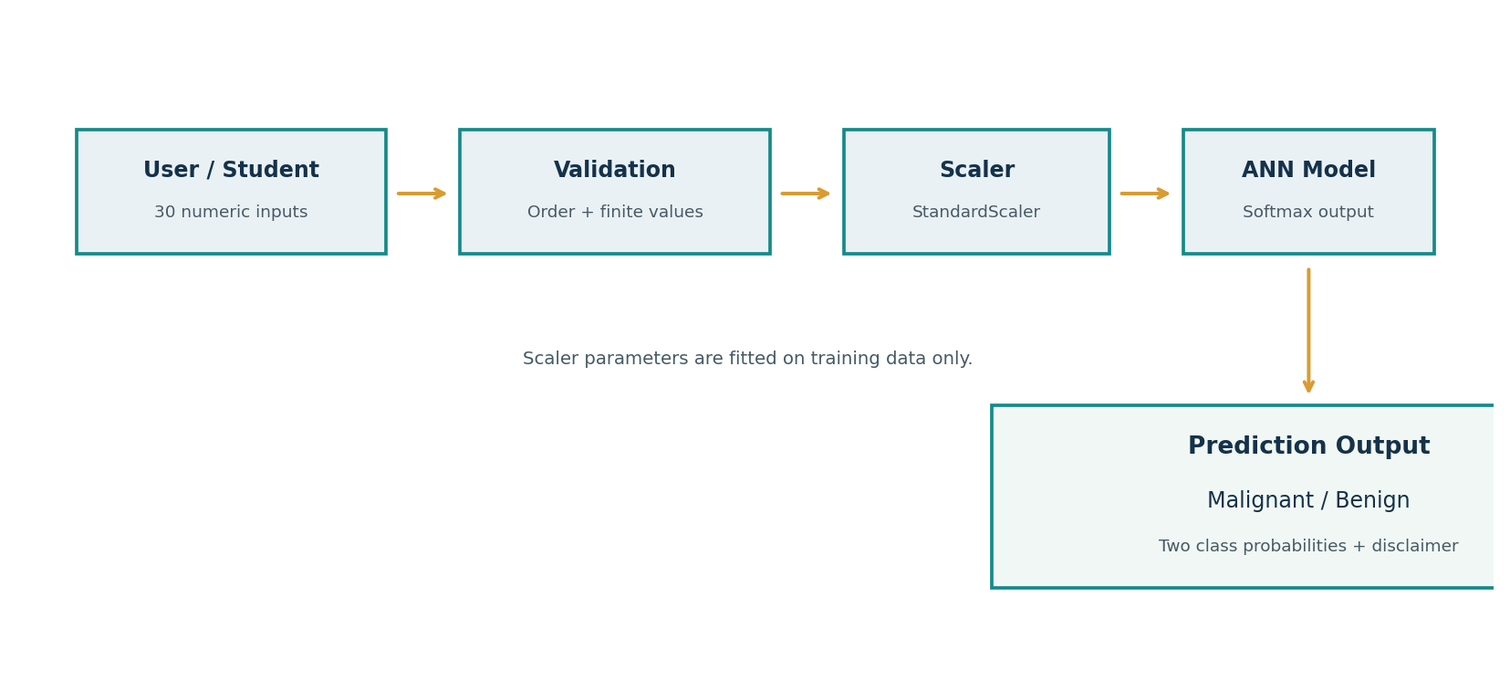
Figure 8. High-level system architecture for interactive prediction.

4.2 Main Components
Component | Responsibility
Input interface | Collect 30 numerical measurements.
Validation layer | Check input count, numeric validity, finiteness and non-negative values.
Feature ordering | Arrange values according to saved feature_names.json.
Preprocessing | Apply the saved training StandardScaler.
ANN inference | Generate two class probabilities using the saved model.
Output display | Show predicted class, probabilities and disclaimer.
Persistence | Store model, scaler, metadata and results in Drive.

4.3 Data Flow
A user supplies 30 measurements. The application checks that all inputs are present and valid. The values are placed into a one-row DataFrame using the saved feature names. The scaler transforms the row using training-set statistics. The model computes Softmax probabilities. The class with the larger probability is displayed as the predicted category. A range warning is shown when any value is outside the observed fitting-data range.

IMPLEMENTATION DETAILS

4.4 Development Environment
Technology | Role in the project
Python | Main programming language
Google Colab | Cloud notebook and execution environment
NumPy | Numerical arrays and calculations
Pandas | Tabular data handling and result tables
Matplotlib | Plots and training curves
Seaborn | Statistical visualizations and heatmaps
Scikit-learn | Dataset loader, train/test split, scaler and metrics
TensorFlow / Keras | Neural-network construction, training and inference
Gradio | Interactive prediction interface

4.5 Dataset Loading and DataFrame Creation
The dataset is loaded with sklearn.datasets.load_breast_cancer(). The feature array is converted to a DataFrame using the provided feature_names. The target array is appended as a target column. The DataFrame is used for exploratory inspection and is retained separately from the transformed arrays.

4.6 Model Construction and Compilation
A Keras Sequential model is constructed with an Input layer of 30 features, a Dense hidden layer of 20 units with ReLU activation and a Dense output layer of two units with Softmax activation. The model is compiled with Adam, learning rate 0.001, sparse categorical cross-entropy and accuracy.
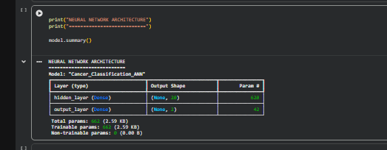
Figure 17. Actual Keras model summary captured in Google Colab, showing 662 trainable parameters.

4.7 Training and Evaluation Code Organization
Training is performed with model.fit() for 10 epochs and batch size 32. The history object is converted into a table and used to plot training and validation accuracy and loss. The final test predictions are generated using model.predict() and converted to integer labels with argmax. Scikit-learn functions calculate accuracy, class-wise precision, recall, F1-score and the confusion matrix.

4.8 Code Quality Practices
- Keep the notebook organized into clearly titled sections and logical cells.
- Use descriptive variable names for training, validation and testing data.
- Preserve the feature order throughout inference.
- Fit the scaler on training data only.
- Keep the test set separate from training and validation decisions.
- Store the trained model and supporting preprocessing metadata together.
- Record actual package versions and result outputs in the final artefacts.

INTERACTIVE PREDICTION APPLICATION

4.9 Gradio Interface
The running prediction interface was implemented with Gradio Blocks. The interface groups the 30 numerical measurements into three sections: mean measurements, standard-error measurements and worst measurements. Figure 9 contains screenshots from the live Google Colab-hosted interface, showing the numerical input form, the prediction control and the returned output. The interface uses the original dataset feature order so that each entered value is passed to the corresponding model input.
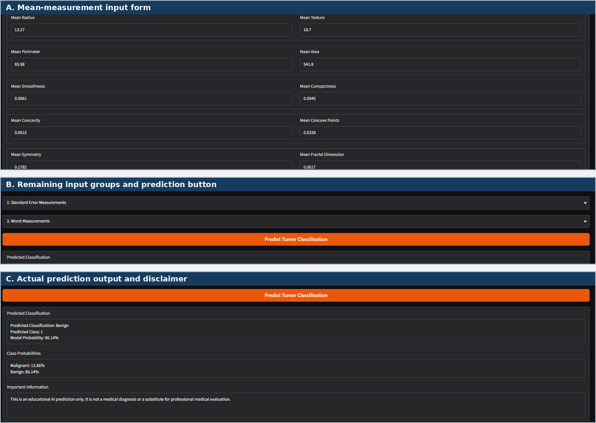
Figure 9. Actual Gradio application screenshots: (A) mean-measurement input form, (B) remaining input groups and prediction control, and (C) displayed prediction output.

4.10 Input Components
The interface uses numerical input components for each of the 30 features. The feature labels are derived from the saved feature names. The default demonstration values are calculated from the median of the training subset; they are example defaults and do not represent a real patient or a clinical reference profile.

4.11 Prediction Function
The prediction function checks that exactly 30 values are supplied, validates that values are numeric, finite and non-negative, constructs an ordered one-row DataFrame, applies the saved training scaler and sends the standardized vector to the trained model. The output includes the predicted class, the model’s two class probabilities and a warning/disclaimer message.

4.12 Probability Display
The Softmax output provides a model probability for malignant (class 0) and benign (class 1). In the supplied interface demonstration shown in Figure 9(C), the entered values produced the displayed result “Benign” (class 1), with a model probability of 86.14%; the displayed malignant probability was 13.86%. This is one demonstration output from the interface, not a held-out test result, a clinically verified case or a calibrated estimate of an individual’s disease risk. The interface therefore labels the output as a model probability and includes an educational-use disclaimer.
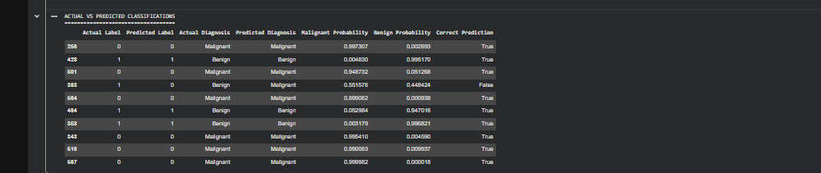
Figure 16. Actual-versus-predicted output table for the first ten held-out test samples, including class probabilities.

4.13 Application Limitations
The application was demonstrated from a Google Colab-hosted Gradio session. The share URL displayed by Gradio is temporary and is not permanent production hosting. The application must be relaunched while the Colab runtime is active. A durable deployment would require a separate hosting environment, dependency management, security review, input controls and monitoring. The current interface is an educational prototype and must not be used for clinical decision-making.

CHAPTER 5 - RESULTS AND OBSERVATIONS

5.1 Dataset and EDA Results
The Breast Cancer Wisconsin (Diagnostic) dataset contains 569 samples and 30 numerical input features. The target distribution is 212 malignant samples (37.26%) and 357 benign samples (62.74%). The supplied Colab inspection shows a 569-row, 31-column DataFrame with 569 non-null entries in each column. The missing-value check reports zero missing values. The duplicate-check code is part of the workflow; the canonical dataset is also checked for exact duplicate rows before modelling [2].
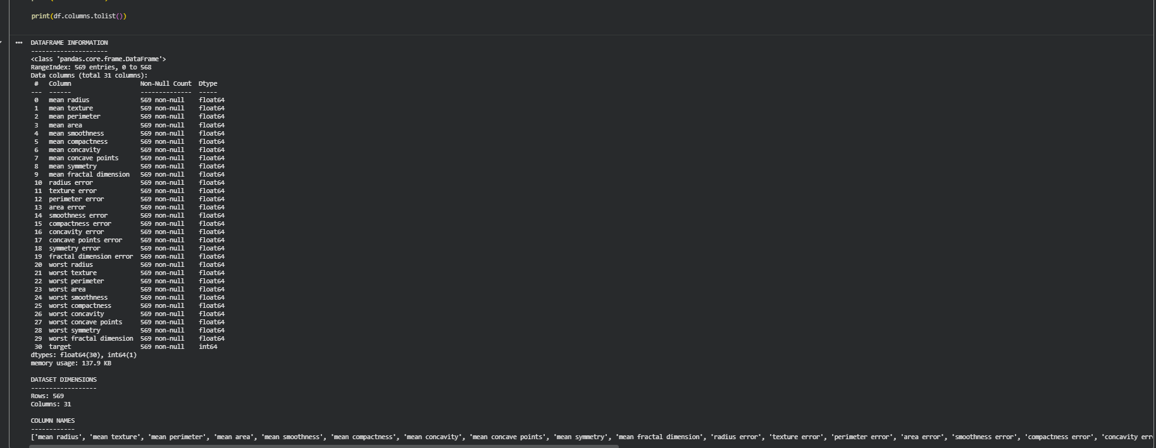
Figure 10. DataFrame information output from the author’s Google Colab session, showing 569 records and 31 columns.
Output provenance: Dataset dimensions, DataFrame inspection, class counts, missing-value output, descriptive statistics, class-distribution chart, selected histograms, box plots, training logs, training-history values, accuracy and loss curves, actual-versus-predicted table, confusion matrix and final evaluation summary are documented using the Google Colab screenshots supplied by SANKET KISHOR SUTAR. The live Gradio form and its displayed Benign prediction output are now included in Figure 9. The full correlation heatmap and architecture/system diagrams are report visualizations based on the dataset and documented model design rather than unaltered notebook screenshots.

5.2 Data Split Results
Subset | Samples | Malignant | Benign
Fitting / training | 409 | 153 | 256
Validation | 46 | 17 | 29
Test | 114 | 42 | 72
Total | 569 | 212 | 357

5.3 Model Training Results
The supplied Google Colab run completed 10 epochs with a batch size of 32. Final training accuracy was 95.60% and final validation accuracy was 95.65%. Final training loss was 0.1188, while final validation loss was 0.2101. The values for all ten epochs are provided in Table 19 and are illustrated by the supplied training log and learning-curve screenshots.
Epoch | Train accuracy | Train loss | Validation accuracy | Validation loss
1 | 63.57% | 0.6070 | 73.91% | 0.5383
2 | 84.60% | 0.4195 | 86.96% | 0.4387
3 | 91.93% | 0.3057 | 84.78% | 0.3499
4 | 93.15% | 0.2401 | 89.13% | 0.3065
5 | 94.62% | 0.1989 | 89.13% | 0.2799
6 | 95.11% | 0.1715 | 91.30% | 0.2582
7 | 95.50% | 0.1527 | 91.30% | 0.2428
8 | 95.60% | 0.1386 | 91.30% | 0.2299
9 | 95.60% | 0.1278 | 95.65% | 0.2201
10 | 95.60% | 0.1188 | 95.65% | 0.2101
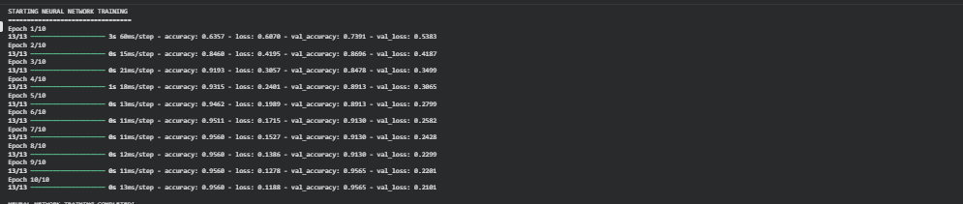
Figure 11. Ten-epoch training log captured from the author’s Google Colab session.
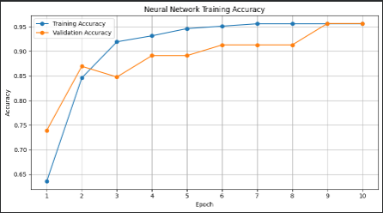
Figure 12. Training and validation accuracy over 10 epochs from the author’s Google Colab session.
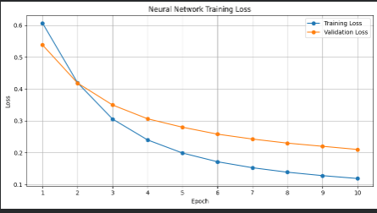
Figure 13. Training and validation loss over 10 epochs from the author’s Google Colab session.

5.4 Test Results
On the held-out set of 114 samples, the supplied Colab run achieved 93.86% testing accuracy with a sparse categorical cross-entropy loss of 0.1408. The model correctly classified 107 samples and incorrectly classified 7. Class-wise precision, recall and F1-score are reported separately because overall accuracy alone does not describe the two classes’ error patterns.
Performance metric | Colab run result
Testing accuracy | 93.86%
Testing loss | 0.1408
Malignant precision | 92.68%
Malignant recall / sensitivity | 90.48%
Malignant F1-score | 91.57%
Benign precision | 94.52%
Benign recall | 95.83%
Benign F1-score | 95.17%
Specificity | 95.83%
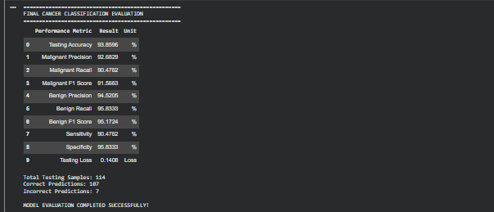
Figure 15. Final evaluation summary captured from the author’s Google Colab session.

All training, validation and test metrics in this chapter refer to the same supplied Colab run. The 114-sample test set was kept separate from gradient updates and from fitting the final StandardScaler. The test results are a single-split estimate and are not evidence of clinical performance.

CONFUSION MATRIX AND ERROR ANALYSIS

5.5 Confusion Matrix
The supplied confusion matrix uses label order [0, 1]. Rows represent actual classes and columns represent predicted classes. Malignant is class 0 and Benign is class 1. The matrix is [[38, 4], [3, 69]]: 38 malignant samples were correctly classified, 4 malignant samples were classified as benign, 3 benign samples were classified as malignant, and 69 benign samples were correctly classified.
Actual \ Predicted | Malignant (0) | Benign (1)
Malignant (0) | 38 | 4
Benign (1) | 3 | 69

5.6 Error Interpretation
A false negative is a malignant-labelled sample classified as benign. A false positive is a benign-labelled sample classified as malignant. The two error types have different implications in a medical-themed classification example and should be reported separately. A high overall accuracy does not remove the need to inspect false negatives and class-wise recall.

5.7 Actual Confusion Matrix Output
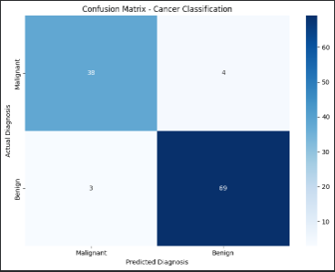
Figure 14. Confusion matrix captured from the author’s Google Colab session for the 114-sample held-out test set.

Table 9. Class-wise classification report calculated from the supplied confusion-matrix counts.
Note: These class-wise values are calculated from the supplied confusion-matrix counts; they are not presented as a separate screenshot.
Class / Summary | Precision | Recall | F1-score | Support
Malignant | 0.9268 | 0.9048 | 0.9157 | 42
Benign | 0.9452 | 0.9583 | 0.9517 | 72
Accuracy | - | - | 0.9386 | 114
Macro average | 0.9360 | 0.9315 | 0.9337 | 114
Weighted average | 0.9384 | 0.9386 | 0.9384 | 114

5.8 Result Discussion
The supplied test set contains 42 malignant and 72 benign samples. The model correctly classified 38 of the 42 malignant samples and 69 of the 72 benign samples. There were 4 false negatives and 3 false positives. Malignant-class recall (sensitivity) was 90.48%, while specificity for the benign class was 95.83%. The false-negative count is important to report explicitly, but this result does not establish clinical safety or diagnostic suitability.

TESTING AND VERIFICATION

5.9 Functional Test Cases
Test ID | Test scenario | Expected behaviour | Coverage
TC-01 | Load dataset | 569 samples and 30 features are available. | Documented
TC-02 | Check missing values | Missing-value count is displayed. | Documented
TC-03 | Check duplicate rows | Duplicate count is displayed. | Documented
TC-04 | Split data | Stratified 80/20 split produces 455/114 samples. | Documented
TC-05 | Scale features | Training scaler is fitted on fitting subset only. | Documented
TC-06 | Build model | Input width 30 and output width 2. | Documented
TC-07 | Train model | Training history is recorded for 10 epochs. | Documented
TC-08 | Evaluate model | Test metrics and confusion matrix are generated. | Documented
TC-09 | Valid app input | Thirty finite non-negative values are accepted. | Documented
TC-10 | Invalid app input | Invalid or missing values return a validation message. | Documented
TC-11 | Save/load model | Reloaded model reproduces predictions within tolerance. | Documented
TC-12 | Save/load scaler | Reloaded scaler reproduces transformed values. | Documented

5.10 Verification Evidence
The supplied screenshots provide evidence for dataset structure, missing-value output, statistical analysis, class distribution, selected EDA charts, standardized data, model summary, training log and history, accuracy and loss curves, actual-versus-predicted results, confusion matrix, final evaluation summary and the running Gradio application with its displayed prediction output. The saved-model reload output is not represented by a screenshot in this report. The final notebook should be run from top to bottom after the required packages and Drive access are configured.

5.11 Reproducibility Checks
The saved model, scaler, feature order and class mapping should be treated as a matched set. A reloaded model should be tested against the original model on the same input samples. Any discrepancy beyond a small floating-point tolerance should be investigated before submission.

LIMITATIONS, ETHICS AND RESPONSIBLE USE

5.12 Dataset Limitations
- The dataset contains 569 samples and 30 features; this is small compared with the diversity of real-world clinical populations.
- The samples are from a specific historical dataset and may not represent current clinical practice or all demographic groups.
- The model receives precomputed numerical features and does not process original images.
- The model uses labels supplied by the dataset and does not independently validate their clinical correctness.
- No external test cohort, prospective study or clinical validation is performed.

5.13 Model Limitations
- The selected ANN is a compact educational architecture with one hidden layer.
- Performance can vary with random initialization, data split, library version and training configuration.
- A single train/test split provides only one estimate of generalization.
- Softmax probabilities are not necessarily calibrated probabilities of disease.
- Model output can be affected by feature measurement quality, units, ordering and out-of-distribution inputs.

5.14 Ethical and Safety Considerations
Cancer-related predictions are high-stakes. A model trained on a public benchmark must not be used to diagnose a person, determine treatment, reassure a patient or replace a qualified medical professional. The Gradio interface is intended only for demonstration using synthetic or dataset-derived educational values. No personal or identifiable patient information should be entered into a public demo link.

5.15 Responsible Communication
The project should be described as an educational binary-classification prototype. Claims such as “detects cancer accurately” or “diagnoses breast cancer” are too strong. Prefer wording such as “predicts the dataset class from 30 numerical features in an educational experiment.” The report must clearly state the held-out test performance once the actual values are verified and must also state that clinical validation was not performed.

CONCLUSION AND FUTURE SCOPE

6.1 Conclusion
The project demonstrates an end-to-end educational workflow for binary classification using the Breast Cancer Wisconsin (Diagnostic) dataset. The work includes loading a structured dataset, examining its quality and distributions, separating input features and labels, creating stratified data subsets, standardizing input measurements, building a feed-forward Artificial Neural Network, training the model, evaluating class-wise performance and creating an interactive prediction interface.
The implemented neural network uses 30 input features, one hidden layer of 20 ReLU neurons and two Softmax output neurons. It is configured with Adam optimization, sparse categorical cross-entropy and accuracy monitoring. The final training pipeline fits StandardScaler only on the fitting subset and reuses the same scaler during validation, testing and prediction.
The Gradio interface illustrates how a trained model can be connected to a user-facing form. It accepts the 30 numerical features, validates them, applies the stored preprocessing transformation and displays the model output. The project also preserves the model and supporting artefacts for reuse.
In the supplied Google Colab run, the held-out test accuracy was 93.86% and the test loss was 0.1408. Malignant-class precision was 92.68%, recall was 90.48% and F1-score was 91.57%. Benign-class precision was 94.52%, recall was 95.83% and F1-score was 95.17%. The confusion matrix contained 38 true positives, 4 false negatives, 3 false positives and 69 true negatives when Malignant was treated as the positive class. These values describe the supplied 114-sample test split only and do not establish clinical validity.

6.2 Future Scope
- Evaluate the model using repeated stratified cross-validation to obtain a more stable performance estimate.
- Compare the ANN with baseline models such as logistic regression, decision trees and support vector machines.
- Investigate regularization, dropout and early stopping using validation data only.
- Study class-wise error costs and evaluate thresholds without repeatedly using the final test set.
- Assess probability calibration and uncertainty communication.
- Test the model on an independent external dataset before considering any real-world use.
- Improve the interface with clearer units, input guidance and accessible layouts.
- Package the application with dependency pinning and reproducible deployment instructions.
- Add automated tests for preprocessing consistency, feature ordering and model reloading.

6.3 Final Statement
The project provides practical exposure to neural networks and the responsible interpretation of a machine-learning classifier. Its primary value is educational: understanding how data preparation, model design, evaluation and user-interface integration work together in a supervised-learning project.

REFERENCES
[1] UCI Machine Learning Repository. “Breast Cancer Wisconsin (Diagnostic) Data Set.” University of California, Irvine. https://archive.ics.uci.edu/dataset/17/breast+cancer+wisconsin+diagnostic (accessed 6 November 2026).
[2] Scikit-learn Developers. “load_breast_cancer.” Scikit-learn API Documentation. https://scikit-learn.org/stable/modules/generated/sklearn.datasets.load_breast_cancer.html (accessed 6 November 2026).
[3] Scikit-learn Developers. “StandardScaler.” Scikit-learn API Documentation. https://scikit-learn.org/stable/modules/generated/sklearn.preprocessing.StandardScaler.html (accessed 6 November 2026).
[4] Keras Team. “Save, Serialize, and Export Models.” Keras Developer Guide. https://keras.io/guides/serialization_and_saving/ (accessed 6 November 2026).
[5] Scikit-learn Developers. “Classification Metrics.” Scikit-learn User Guide and API documentation. https://scikit-learn.org/stable/modules/model_evaluation.html (accessed 6 November 2026).
[6] Project specification supplied for “Cancer Classification Using Neural Networks,” September 2026.
[7] Reference notebook supplied for “Breast Cancer Classification with Neural Networks,” September 2026.
[8] Gradio Team. “Blocks.” Gradio Documentation. https://www.gradio.app/docs/gradio/blocks (accessed 6 November 2026).
[9] W. N. Street, W. H. Wolberg, and O. L. Mangasarian. “Nuclear feature extraction for breast tumor diagnosis.” Proceedings / Electronic Imaging, 1993. Dataset provenance and associated research reference as listed by UCI.

APPENDIX A - FEATURE INVENTORY
The following table lists the 30 feature names used by Scikit-learn in their original order. The same order must be preserved when preparing model inputs and using the saved feature_names.json file.
No. | Feature name | Group
1 | mean radius | Mean
2 | mean texture | Mean
3 | mean perimeter | Mean
4 | mean area | Mean
5 | mean smoothness | Mean
6 | mean compactness | Mean
7 | mean concavity | Mean
8 | mean concave points | Mean
9 | mean symmetry | Mean
10 | mean fractal dimension | Mean
11 | radius error | Standard error
12 | texture error | Standard error
13 | perimeter error | Standard error
14 | area error | Standard error
15 | smoothness error | Standard error
16 | compactness error | Standard error
17 | concavity error | Standard error
18 | concave points error | Standard error
19 | symmetry error | Standard error
20 | fractal dimension error | Standard error
21 | worst radius | Worst
22 | worst texture | Worst
23 | worst perimeter | Worst
24 | worst area | Worst
25 | worst smoothness | Worst
26 | worst compactness | Worst
27 | worst concavity | Worst
28 | worst concave points | Worst
29 | worst symmetry | Worst
30 | worst fractal dimension | Worst

APPENDIX B - PROJECT RELEASE AND REPRODUCIBILITY NOTES

B.1 Saved Artefacts
Folder / file | Purpose | Final check
models/cancer_model.keras | Trained ANN model | Included in project structure
models/training_scaler.joblib | Fitted preprocessing scaler | Included in project structure
metadata/feature_names.json | Original feature order | Included in project structure
metadata/class_mapping.json | Target label names | Included in project structure
metadata/model_metadata.json | Model and training configuration | Included in project structure
results/training_history.csv | Epoch-wise training history | Included in project structure
results/evaluation_summary.csv | Evaluation metrics | Included in project structure
results/confusion_matrix.csv | Confusion matrix values | Included in project structure
results/classification_report.txt | Class-wise evaluation report | Included in project structure

B.2 Final Submission Checklist
- Prepared: the editable project report (.docx) and corresponding PDF are available.
- Prepared: the cover page displays the project title and author name, SANKET KISHOR SUTAR.
- Prepared: the report includes the chapters specified in the September 2026 project guide.
- Prepared: supplied screenshots document dataset inspection, EDA, model architecture, training, accuracy and loss, predictions and confusion-matrix results.
- Pending: prepare a 10–15 slide PowerPoint covering the problem statement, objectives, dataset, methodology, model architecture, results and conclusion.
- Pending: export the final Jupyter Notebook (.ipynb) and organize the required Python source files (.py) for the complete project package.
- Pending: prepare README.md with the project overview, setup, execution instructions, model details, results and limitations.
- Pending: prepare requirements.txt using the software versions verified in the final execution environment.
- Pending: publish and verify the complete GitHub repository, then record its repository URL.
- Pending: email the complete submission to info@navitechsolutions.com after the GitHub repository is published, including the repository URL and required attachments.

B.3 Output Provenance and Evidence Notes
The dataset counts, class distribution, DataFrame inspection, missing-value output, descriptive statistics, EDA charts, model summary, training log, training-history table, learning curves, actual-versus-predicted table, confusion matrix and final evaluation summary in this report were transcribed or cropped from the Google Colab screenshots supplied by SANKET KISHOR SUTAR. The actual Gradio screenshots in Figure 9 were also supplied by the author and show the live measurement form, prediction control and a demonstration output. The class-wise classification report table is calculated from the supplied confusion-matrix counts. The full correlation heatmap and ANN/system architecture diagrams are report figures generated from the documented dataset and model design. A saved-model reload screenshot was not supplied.

