Various network architectures and parameters for Cartpole Policy Estimator

Group K: Fioritto Alessandro, Pilutti Filippo, Simonitti Samuele

Base architecture and parameters

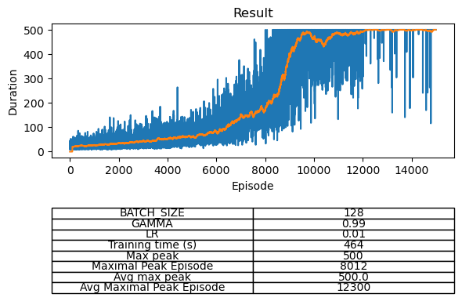

Base architecture with modified parameters (bigger batch size and learning rate)
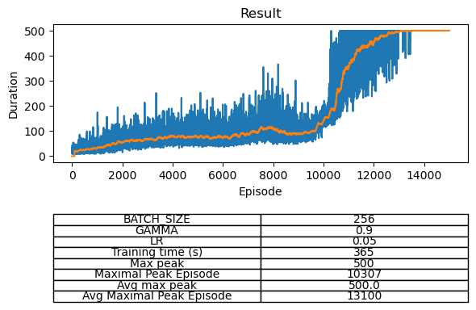

Bigger layer using base architecture (128 neurons instead of 16)
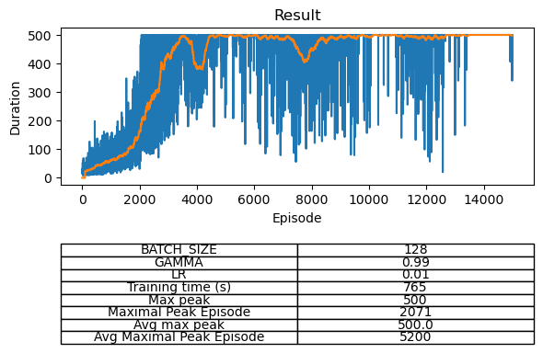

Modified first layer (32 neurons instead of 16) and added a new fully connected layer (64 neurons)
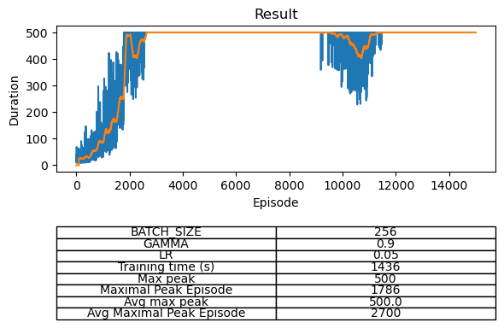

Deeper network with 4 fully connected layers
