Various network architectures and parameters for CartpoleDQN from Image

Group K: Fioritto Alessandro, Pilutti Filippo, Simonitti Samuele

Base architecture and parameters

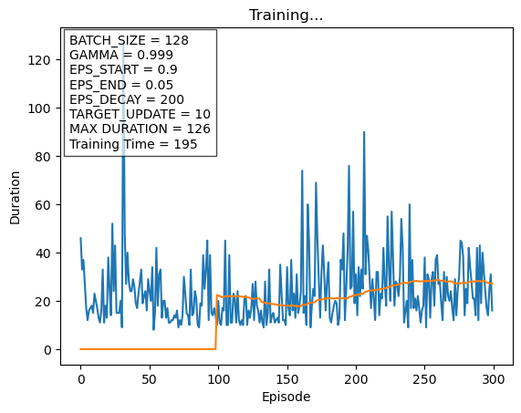

Base architecture with parameters from DQN cartpole
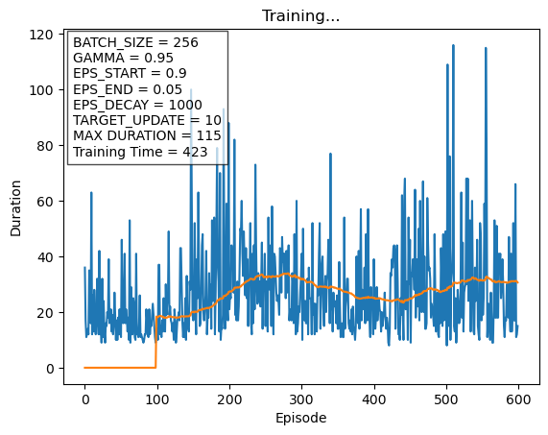

One additional convolutional layer with padding = 1, maintaining the same output dimensions from the previous channel
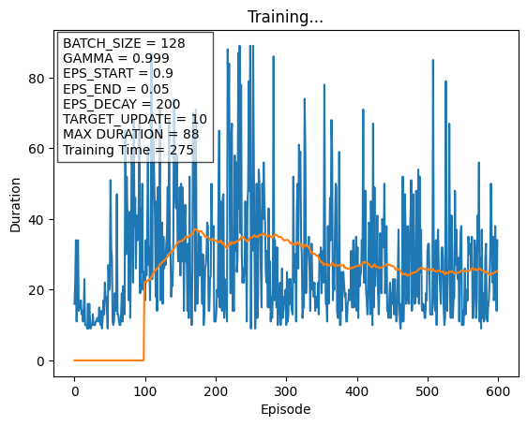

Same convolutional level but we added a fully connected layer with 128 neurons before the output layer
