Curriculum Learning – Group K

This is the homework assignment for Curriculum Learning for group K.
We will show the reward function used to compute the factorized reward. The different rewards used to compute the final one are collision avoidance, progress toward the goal, smooth steering, time to target and goal reaching.
We uploaded the turtlebot3_world.py file, in which the goal sampling curriculum is also implemented.

Reward Function
def _compute_reward(self, observations, done):
# --- 1. State and Distance ---
x, y, _ = self._get_robot_pose()
dist = self._distance_to_goal(x, y)

if self.prev_dist is None:
self.prev_dist = dist

# --- 2. Compute factorized components ---

# A. Progress Reward: based on distance difference (Reward Shaping)
# If diff > 0 the robot got closer, if < 0 it got farther
diff = self.prev_dist - dist
r_progress = self.w_progress * diff

# B. Safety / Collision Avoidance
# Compute min valid laser scan
valid_scan = [o for o in observations if not numpy.isinf(o) and not numpy.isnan(o)]
min_scan = min(valid_scan) if len(valid_scan) > 0 else 10.0

r_collision_avoid = 0.0
threshold_safe = 0.3 # meters
if min_scan < threshold_safe:
# Linear penalty: the closer it is, the more negative the reward
r_collision_avoid = -self.w_collision * (threshold_safe - min_scan)
else:
r_collision_avoid = 0.1 * self.w_collision # Small reward for being in a safe zone

# C. Smooth Steering
# Penalize if last action was not FORWARDS
r_smooth = 0.0
if self.last_action != "FORWARDS":
r_smooth = -self.w_smooth

# D. Terminal Rewards
r_terminal = 0.0
if done:
if self.reached_goal:
r_terminal = self.terminal_goal
elif self.steps >= self.max_steps_per_episode:
r_terminal = self.terminal_timeout
else:
# If done is True but not goal or timeout, it's a collision
r_terminal = self.terminal_crash

# E. Time Rewards
r_cumm_time = self.r_time * self.steps

# --- 4. Final computation and update ---
reward = r_progress + r_cumm_time + r_smooth + r_collision_avoid + r_terminal

# Update cumulative reward components
self.cum_r_progress += r_progress
self.cum_r_time += self.r_time
self.cum_r_smooth += r_smooth
self.cum_r_collision_avoid += r_collision_avoid
self.cum_r_terminal += r_terminal
# Update state variables for next step
self.prev_dist = dist
self.prev_action = self.last_action

# --- 5. Logging structure ---
self.last_reward_components = {
"r_progress": float(r_progress),
"r_time": float(self.r_time),
"r_smooth": float(r_smooth),
"r_collision_avoid": float(r_collision_avoid),
"r_terminal": float(r_terminal),
"dist": float(dist),
"min_scan": float(min_scan),
"goal_x": float(self.goal_xy[0]),
"goal_y": float(self.goal_xy[1]),
"r_total": float(reward),
"cum_r_progress": self.cum_r_progress,
"cum_r_time": self.cum_r_time,
"cum_r_smooth": self.cum_r_smooth,
"cum_r_collision_avoid": self.cum_r_collision_avoid,
"cum_r_terminal": self.cum_r_terminal,
"cumulated_reward": self.cumulated_reward,
}
self.cumulated_reward += reward
self.steps += 1

print("Step Reward: {:.2f} | Components: {}".format(
reward, self.last_reward_components))

return reward

Tests

Run 1
Deep learning model
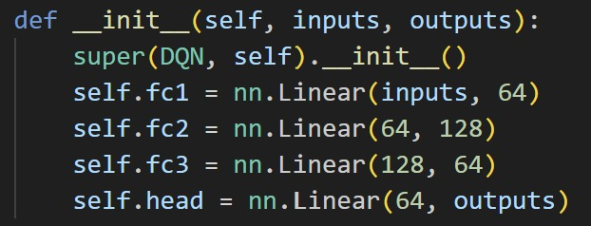
Rewards weights and values
Reward | Value
w_progress | 20.0
w_collision | 2.0
w_smooth | 0.15
terminal_goal | 100.0
terminal_crash | -25.0
terminal_timeout | -10.0
r_time | -0.05

Performance metrics
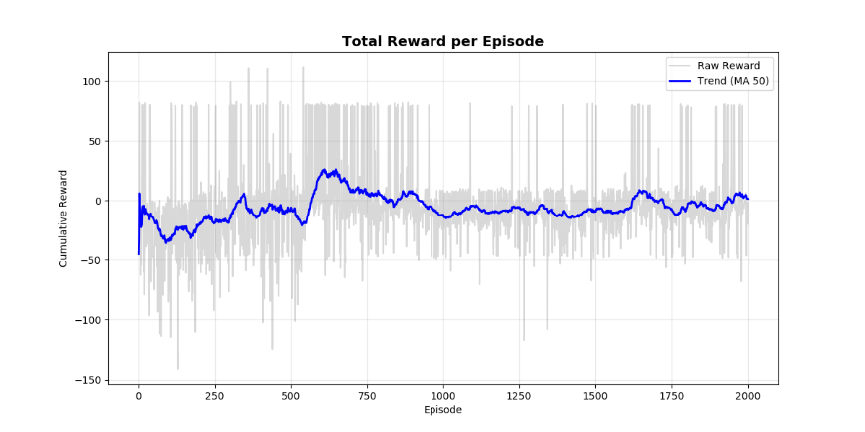
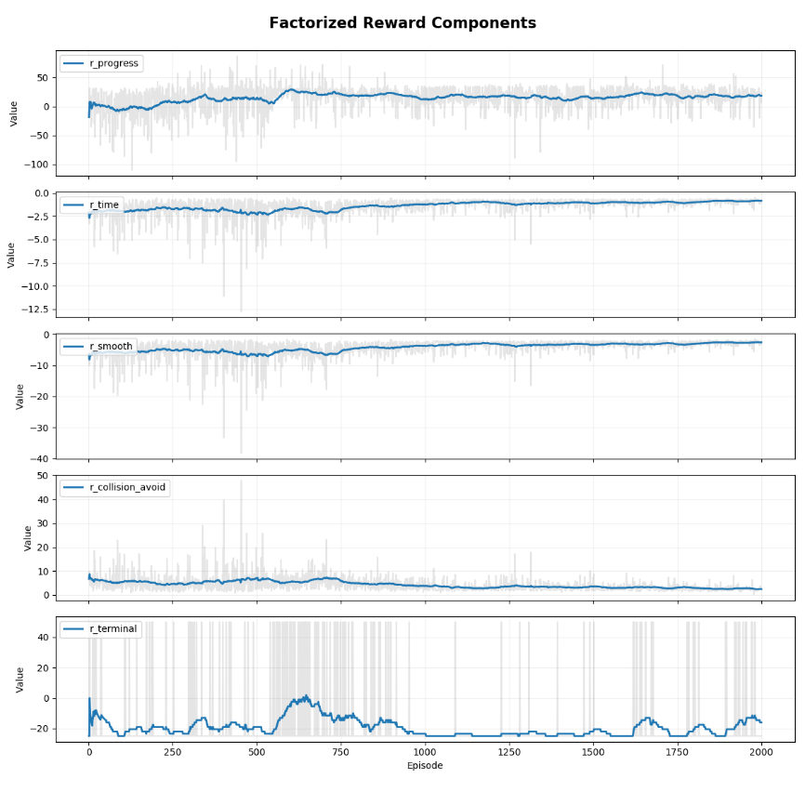
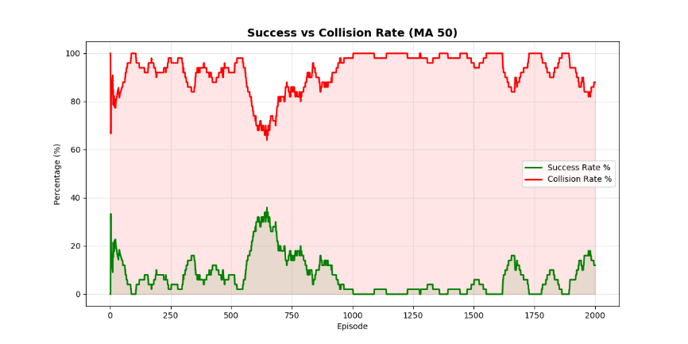

Run 2
Deep learning model
Rewards weights and values
Reward | Value
w_progress | 20.0
w_collision | 10.0
w_smooth | 0.1
terminal_goal | 150.0
terminal_crash | -100.0
terminal_timeout | -10.0
r_time | -0.05

Performance metrics
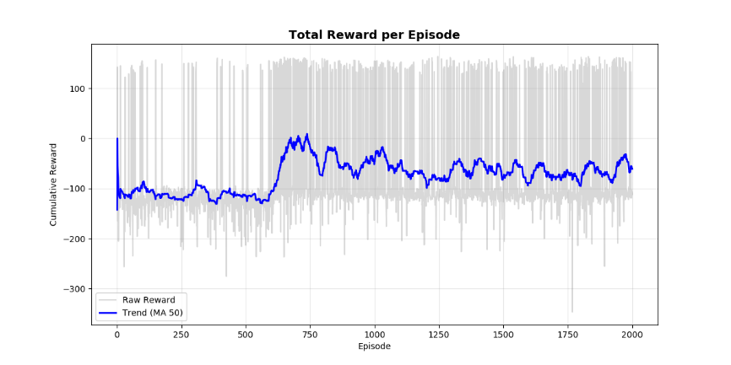
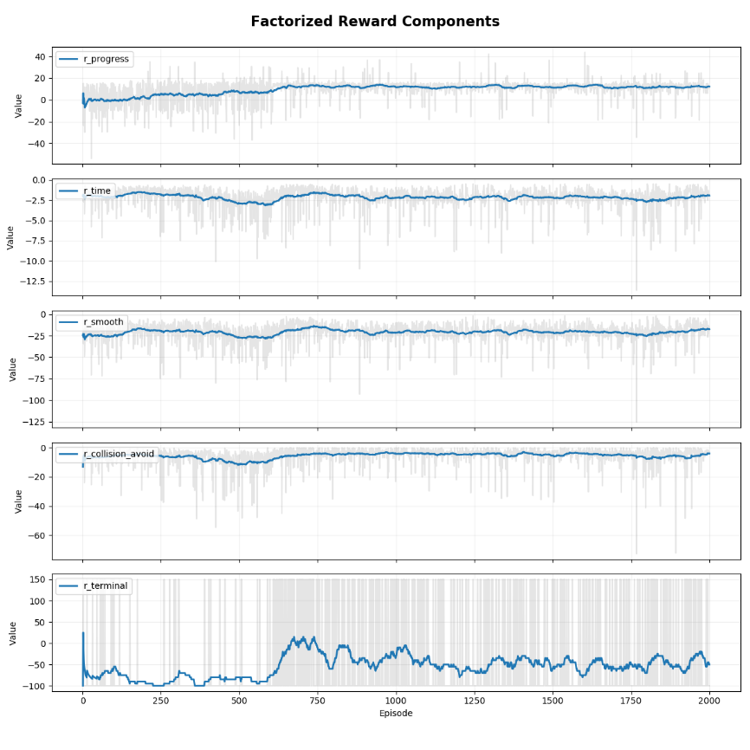
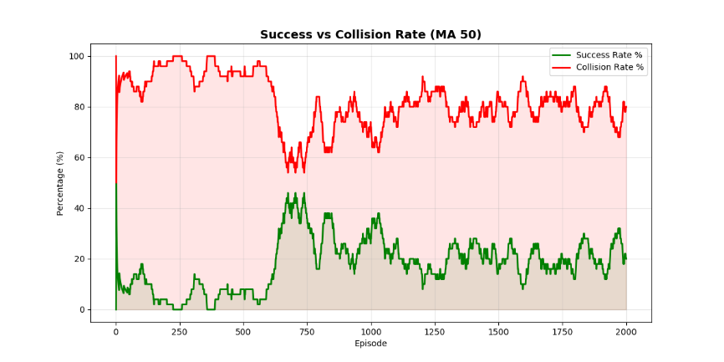

Run 3
Deep learning model
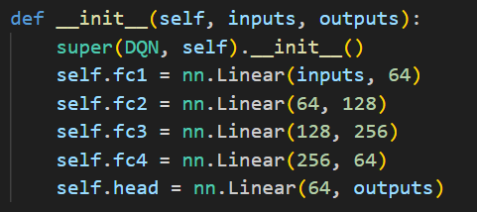
Rewards weights and values
Reward | Value
w_progress | 20.0
w_collision | 5.0
w_smooth | 0.1
terminal_goal | 100.0
terminal_crash | -50.0
terminal_timeout | -10.0
r_time | -0.05

Performance metrics
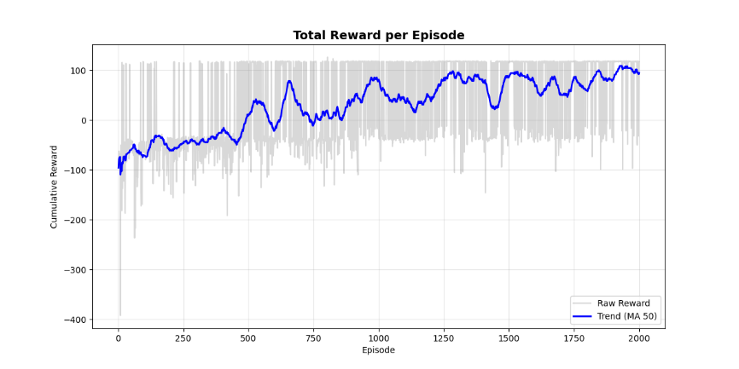
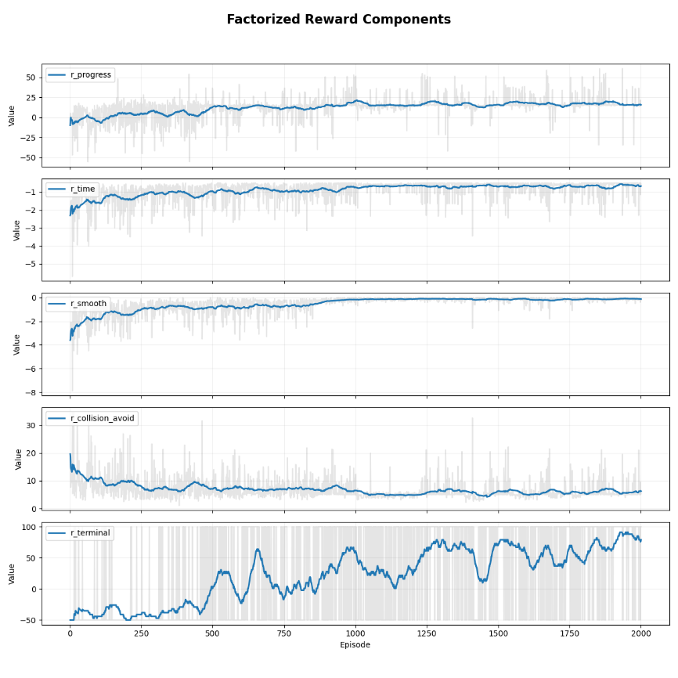
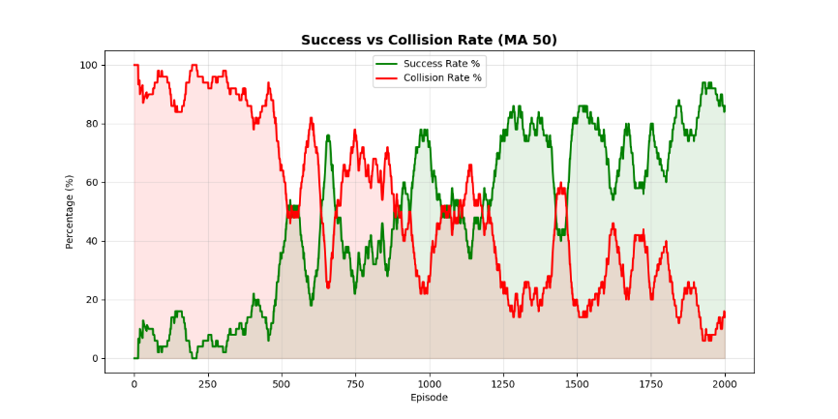

Run 4
Deep learning model
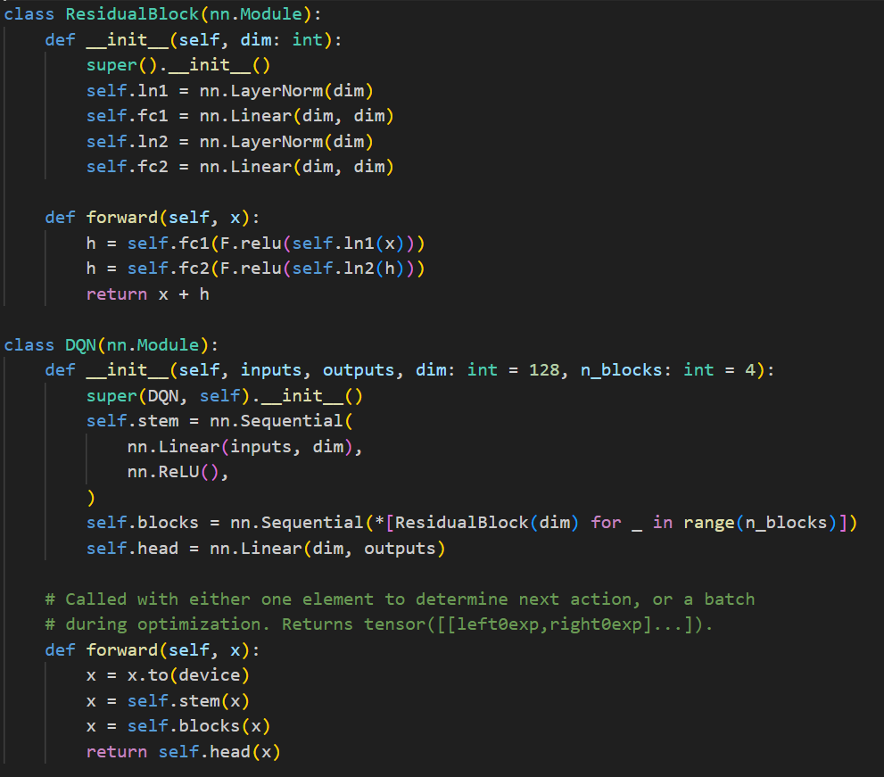
Rewards weights and values
Reward | Value
w_progress | 20.0
w_collision | 5.0
w_smooth | 0.1
terminal_goal | 100.0
terminal_crash | -50.0
terminal_timeout | -10.0
r_time | -0.05

Performance metrics
