**Installation steps**

**Step 1:** Navigate to the github link - [GitHub - SSingh4-21/Data_science_project: Project Repository for Data Science Project Group Course work](https://github.com/SSingh4-21/Data_science_project)Step 2: Download Zip file to local  
  
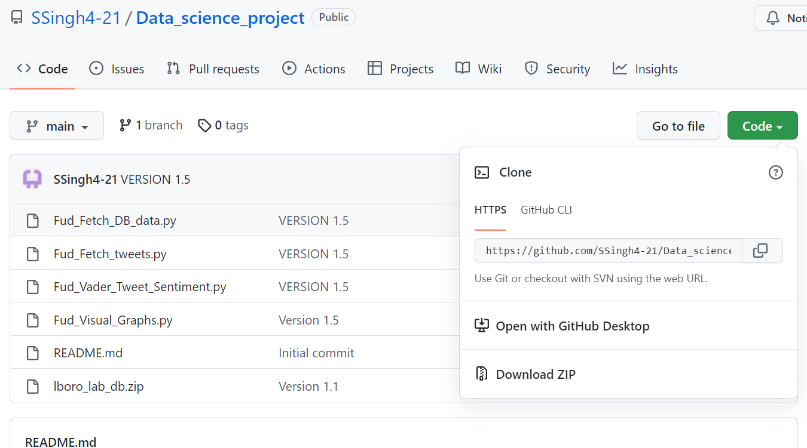

Step 3: Unzip zip file

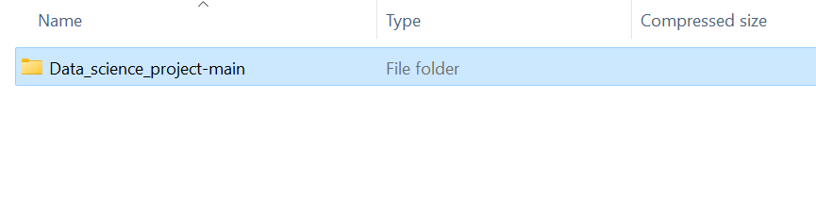

Unzip the lboro_lab_db.zip file and ensure the file is part of the Data_science_project-main folder as shown below

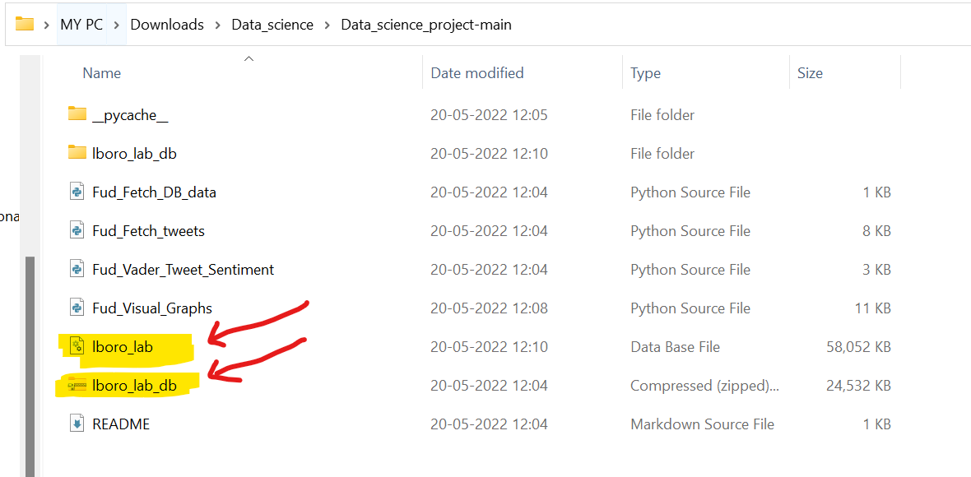

Step 4 : Open Anaconda and launch VS Code

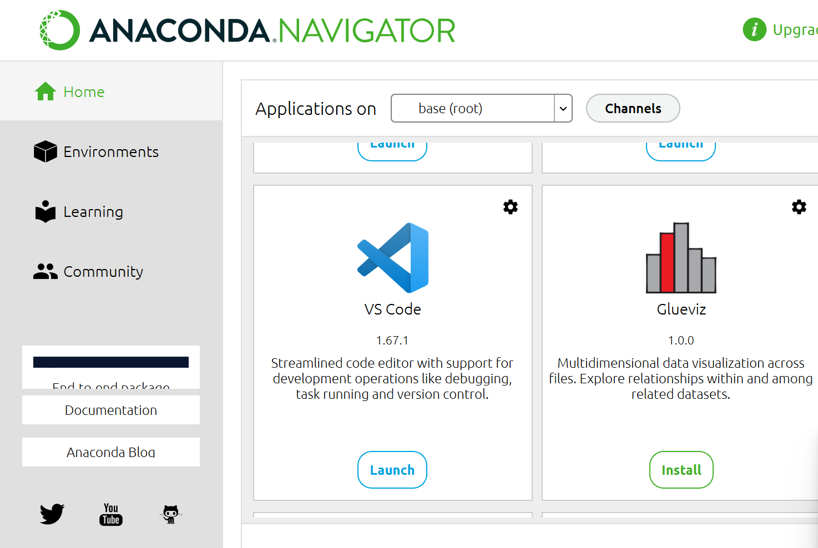  
  
Step 5: Open folder in VS code of the unzipped files

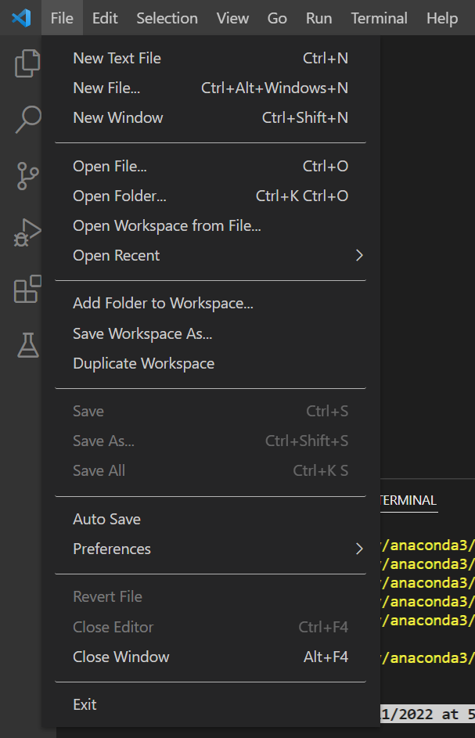

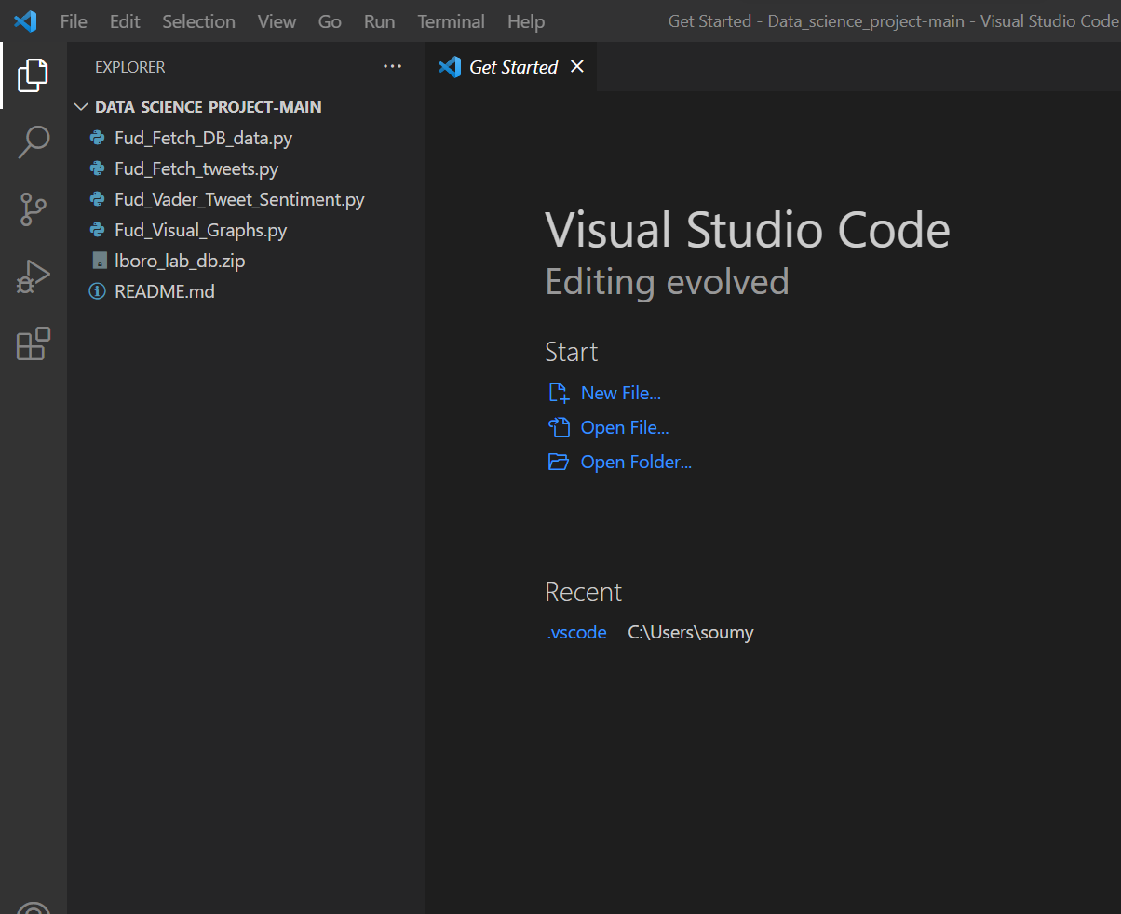

Step 6: Ensure the following python libraries are installed

pip install dash

python -m nltk.downloader stopwords

pip install pandas

pip install plotly

Pip install snscrape

Pip install vader  
pip install vaderSentiment  
  
In case of any additional errors refer to the list given below for a full list of libraries used  
  
Step 7: Now run the Fud_Visual_graphs program  
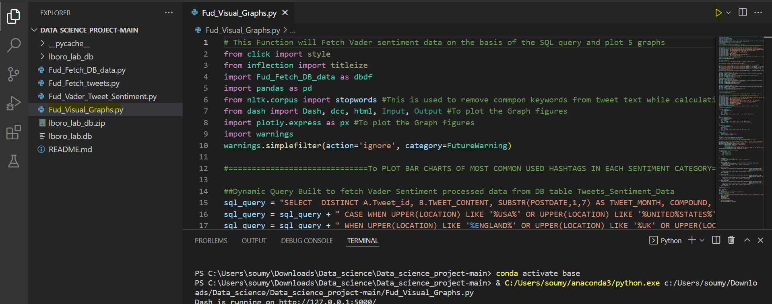  
  
  
Step 8: The web browser will now be opened to display the graphs

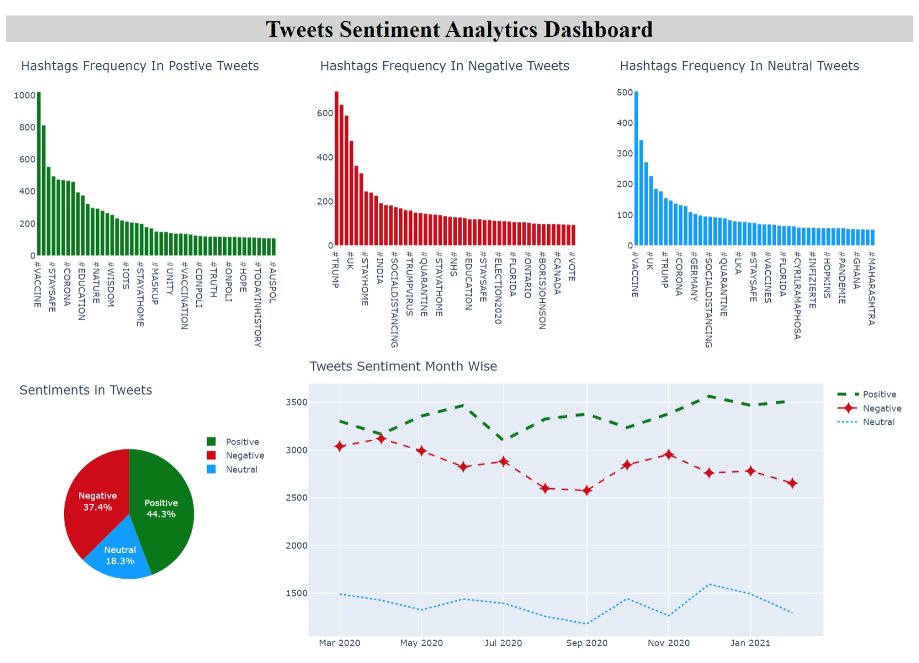  
  
Step 9 : In order to view the working of the other files please navigate to FUD_Fetch_Tweets  
  
Please enter the inputs for the prompts  
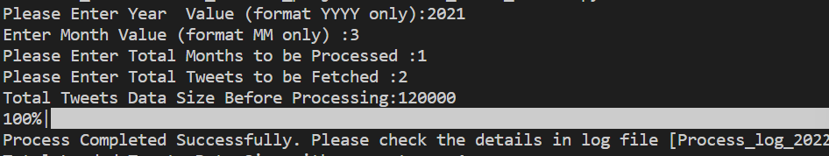  
  
Step 10 : to run sentiment analysis on tweets, open the FUD_Vader_Tweet_Sentiment and click run, here you will see the sentiment analysis being done for the tweets collected

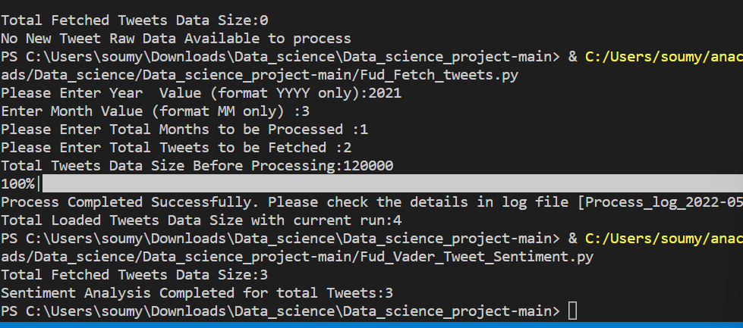

**Python Library Installation Steps:**

pip install sqlite3

pip install snscrape

pip install pandas

pip install datetime

pip install tqdm

pip install turtle

pip install time

pip install calendar

pip install re

python -m nltk.downloader stopwords

pip install dash

pip install plotly

pip install warnings

**Db File Deployment**

Copy the lboro_lab.db

**PY Files Deployment**

Fud_Fetch_DB_data.py

Fud_Fetch_tweets.py

Fud_Vader_Tweet_Sentiment.py

Fud_Visual_Graphs.py