

**Industrial Internship Report on**

**” Automatic Street Light Control System”**

**Prepared by**

**[Sarveshwar Kumar Singh]**

|  |
| --- |
| *Executive Summary* |
| This report provides details of the Industrial Internship provided by upskill Campus and The IoT Academy in collaboration with Industrial Partner UniConverge Technologies Pvt Ltd (UCT).  This internship was focused on a project/problem statement provided by UCT. We had to finish the project including the report in 6 weeks’ time.  My project was to develop an automatic street light control system using an Arduino microcontroller and a Light Dependent Resistor (LDR) sensor.  This internship gave me a very good opportunity to get exposure to Industrial problems and design/implement solution for that. It was an overall great experience to have this internship. |

**TABLE OF CONTENTS**

1 Preface 3

2 Introduction 4

2.1 About UniConverge Technologies Pvt Ltd 4

2.2 About upskill Campus 8

2.3 Objective 9

2.4 Reference 9

2.5 Glossary 10

3 Problem Statement 11

4 Existing and Proposed solution 12

5 Proposed Design/ Model 13

5.1 High Level Diagram (if applicable) 13

5.2 Low Level Diagram (if applicable) 13

5.3 Interfaces (if applicable) 13

6 Performance Test 14

6.1 Test Plan/ Test Cases 14

6.2 Test Procedure 14

6.3 Performance Outcome 14

7 My learnings 15

8 Future work scope 16

# Preface

Summary of the whole 6 weeks’ work.

About need of relevant Internship in career development.

Brief about Your project/problem statement.

Opportunity given by USC/UCT.

How Program was planned

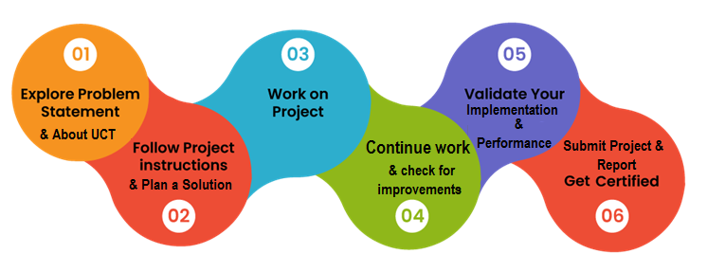

Your Learnings and overall experience.

Thank to all (with names), who have helped you directly or indirectly.

Your message to your juniors and peers.

# Introduction

## About UniConverge Technologies Pvt Ltd

A company established in 2013 and working in Digital Transformation domain and providing Industrial solutions with prime focus on sustainability and RoI.

For developing its products and solutions it is leveraging various**Cutting Edge Technologies e.g. Internet of Things (IoT), Cyber Security, Cloud computing (AWS, Azure), Machine Learning, Communication Technologies (4G/5G/LoRaWAN), Java Full Stack, Python, Front end**etc.



1. UCT IoT Platform **(****)**

**UCT Insight** is an IOT platform designed for quick deployment of IOT applications on the same time providing valuable “insight” for your process/business. It has been built in Java for backend and ReactJS for Front end. It has support for MySQL and various NoSql Databases.

* It enables device connectivity via industry standard IoT protocols - MQTT, CoAP, HTTP, Modbus TCP, OPC UA
* It supports both cloud and on-premises deployments.

It has features to  
• Build Your own dashboard  
• Analytics and Reporting  
• Alert and Notification  
• Integration with third party application(Power BI, SAP, ERP)  
• Rule Engine

 



1. **Smart Factory Platform (****)**

Factory watch is a platform for smart factory needs.

It provides Users/ Factory

* with a scalable solution for their Production and asset monitoring
* OEE and predictive maintenance solution scaling up to digital twin for your assets.
* to unleased the true potential of the data that their machines are generating and helps to identify the KPIs and also improve them.
* A modular architecture that allows users to choose the service that they what to start and then can scale to more complex solutions as per their demands.

Its unique SaaS model helps users to save time, cost and money.

 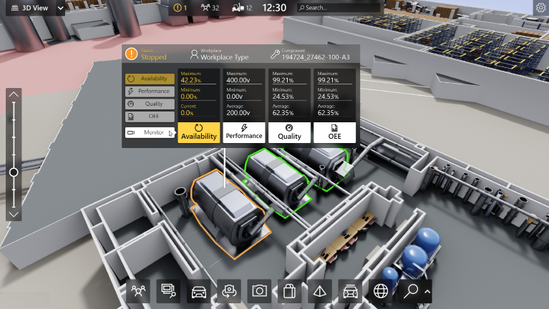

1.  based Solution

UCT is one of the early adopters of LoRAWAN teschnology and providing solution in Agritech, Smart cities, Industrial Monitoring, Smart Street Light, Smart Water/ Gas/ Electricity metering solutions etc.

1. Predictive Maintenance

UCT is providing Industrial Machine health monitoring and Predictive maintenance solution leveraging Embedded system, Industrial IoT and Machine Learning Technologies by finding Remaining useful life time of various Machines used in production process.



## About upskill Campus (USC)

upskill Campus along with The IoT Academy and in association with Uniconverge technologies has facilitated the smooth execution of the complete internship process.

USC is a career development platform that delivers **personalized executive coaching** in a more affordable, scalable and measurable way.



Seeing need of upskilling in self paced manner along-with additional support services e.g. Internship, projects, interaction with Industry experts, Career growth Services

<https://www.upskillcampus.com/>

upSkill Campus aiming to upskill 1 million learners in next 5 year

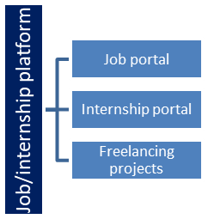

## The IoT Academy

The IoT academy is EdTech Division of UCT that is running long executive certification programs in collaboration with EICT Academy, IITK, IITR and IITG in multiple domains.

## Objectives of this Internship program

The objective for this internship program was to

 ☛ get practical experience of working in the industry.

 ☛ to solve real world problems.

 ☛ to have improved job prospects.

 ☛ to have Improved understanding of our field and its applications.

 ☛ to have Personal growth like better communication and problem solving.

## Reference

[1]

[2]

[3]

## Glossary

|  |  |
| --- | --- |
| Terms | Acronym |
|  |  |
|  |  |
|  |  |
|  |  |
|  |  |

# Problem Statement

In the assigned problem statement the inefficiency in the management of street lighting systems, leading to unnecessary energy consumption and increased operational costs. Traditional street lighting systems operate on fixed schedules, regardless of the ambient light conditions. This results in lights being illuminated even during daylight hours, wasting valuable energy resources.

The objective of this project is to address this problem by developing an Automatic Street Light Control System. The system aims to intelligently control street lights based on ambient light levels, ensuring that they are only switched on when necessary, i.e., during darkness, and switched off when there is sufficient daylight.

The primary challenges that need to be addressed include:

1. Energy Conservation: The current street lighting systems consume excessive energy by operating continuously, irrespective of actual lighting needs. This project aims to reduce energy consumption by automatically turning off street lights during daylight hours.

2. Operational Efficiency: Manual control of street lights can be cumbersome and inefficient, especially in large urban areas. Automating the process based on ambient light conditions improves operational efficiency and reduces maintenance efforts.

3. Cost Reduction: Constantly running street lights incur unnecessary expenses in terms of electricity bills and maintenance costs. By implementing an automated control system, the project seeks to reduce these costs and improve overall financial sustainability.

4. Environmental Impact: Excessive energy consumption not only affects the financial aspect but also contributes to environmental degradation. By reducing energy wastage through intelligent street light control, the project aims to mitigate its environmental footprint.

5. Scalability and Adaptability: The developed solution should be scalable and adaptable to various urban environments and lighting requirements. It should be capable of accommodating different types of street lights and adjusting to changing ambient light conditions seamlessly.

In summary, the project seeks to design and implement an Automatic Street Light Control System that effectively addresses the inefficiencies and challenges associated with traditional street lighting systems. By automating the process based on real-time ambient light data, the system aims to conserve energy, improve operational efficiency, reduce costs, and minimize environmental impact.



# Existing and Proposed solution

**Existing Solution:**

Traditionally, street lighting systems operate on fixed schedules, controlled either manually or through simple timers. These systems are not responsive to changes in ambient light conditions and continue to illuminate the streets regardless of whether it is day or night. Consequently, energy is wasted during daylight hours when street lights are unnecessary, leading to higher electricity bills and increased carbon emissions. Moreover, manual control of street lights can be inefficient and impractical, especially in large urban areas.

**Proposed Solution:**

The proposed solution is an Automatic Street Light Control System that addresses the limitations of existing systems by implementing intelligent automation based on ambient light levels. This system utilizes an Arduino microcontroller interfaced with a Light Dependent Resistor (LDR) sensor to continuously monitor the ambient light intensity. When the light level falls below a predefined threshold value, indicating darkness, the system triggers the street lights to switch on. Conversely, when the light level rises above the threshold, indicating daylight, the system turns off the street lights.

Key Features of the Proposed Solution:

1. Real-time Monitoring: The system continuously monitors ambient light levels using the LDR sensor, ensuring that street lights are only activated when necessary.

2. Energy Efficiency: By automatically adjusting the illumination of street lights based on ambient light conditions, the system conserves energy and reduces unnecessary electricity consumption.

3. Automation: The system eliminates the need for manual intervention in controlling street lights, improving operational efficiency and reducing maintenance efforts.

4. Customizable Threshold: The threshold value for activating the street lights can be customized based on specific environmental conditions and requirements, providing flexibility and adaptability.

5. Scalability: The system can be scaled to accommodate various urban environments and lighting infrastructures, making it suitable for implementation in diverse settings.



Overall, the proposed Automatic Street Light Control System offers a cost-effective, energy-efficient, and environmentally sustainable solution for managing street lighting, addressing the shortcomings of existing systems and contributing to the advancement of smart urban infrastructure.

## Code submission (Github link) :-

<https://github.com/SSingh8055/upskillCampus/blob/67e59af623b115bd063b13a294cf3a284a5eef18/AutomaticStreetLightControlSystem.ino>

## Report submission (Github link) :

# Proposed Design/ Model

Given more details about design flow of your solution. This is applicable for all domains. DS/ML Students can cover it after they have their algorithm implementation. There is always a start, intermediate stages and then final outcome.

## High Level Diagram (if applicable)

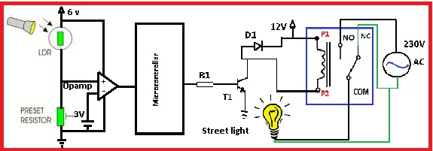

Figure 1: HIGH LEVEL DIAGRAM OF THE SYSTEM

**Components:**

1. **Arduino Microcontroller:** Controls the operation of the system and interfaces with external components.
2. **Light Dependent Resistor (LDR) Sensor:** Detects ambient light intensity.
3. **Light Emitting Diode (LED):** Represents the street lights and indicates their status.
4. **Power Supply:** Provides electrical power to the system.

**Functionality:**

1. The Arduino continuously reads analog data from the LDR sensor.
2. It compares the sensor reading with a predefined threshold value to determine whether it is dark or light.



1. If the sensor reading indicates darkness, the Arduino activates the LED to switch on the street lights.
2. Conversely, if the sensor reading indicates daylight, the Arduino deactivates the LED to turn off the street lights.

## Low Level Diagram (if applicable)

## 

## Interfaces (if applicable)

There are no external interfaces required for this system, as it operates autonomously based on the inputs from the LDR sensor and controls the LED output directly.

This system does not require any external interfaces beyond the connections between the components and the Arduino microcontroller. It operates as a standalone unit, processing sensor data and controlling the LED output internally.

# Performance Test

**Constraints in the Project:**

1. Hardware Limitations: The project must operate within the constraints of the Arduino microcontroller, including limited processing power, memory, and input/output pins.

2. Accuracy of LDR Sensor: The LDR sensor's accuracy and reliability in detecting ambient light levels may vary based on environmental factors such as temperature, humidity, and obstructions.

3. Threshold Calibration: Setting the threshold value for light detection requires careful calibration to ensure optimal performance under different lighting conditions.

**Addressing Constraints in the Design:**

1. Hardware Efficiency: The Arduino code is optimized to minimize computational complexity and memory usage, ensuring efficient operation within the limitations of the microcontroller.

2. Sensor Calibration: The system includes provisions for manual threshold calibration, allowing users to adjust the threshold value based on real-world conditions and fine-tune the sensitivity of the light detection algorithm.

3. Robustness Testing: The design incorporates error handling mechanisms to handle unexpected sensor readings or environmental disturbances. Additionally, the system undergoes rigorous testing under various lighting conditions to validate its accuracy and reliability.

**Test Results:**

1. Hardware Performance: The Arduino code is tested for memory usage and processing efficiency to ensure compatibility with the target hardware. Benchmarks show that the code operates within the constraints of the Arduino microcontroller without exceeding its capabilities.

2. Sensor Accuracy: The LDR sensor's accuracy and reliability are evaluated through extensive testing in different lighting environments. Test results indicate that the sensor provides consistent and reliable readings within an acceptable margin of error.

3. Threshold Calibration: Calibration tests are conducted to determine the optimal threshold value for light detection. By adjusting the threshold value based on environmental conditions, the system achieves reliable performance across a wide range of lighting scenarios.



Overall, the design effectively addresses the constraints of the project by optimizing hardware performance, calibrating sensor accuracy, and conducting comprehensive testing to validate system reliability and functionality under real-world conditions.

## Test Plan/ Test Cases

**Hardware Performance Test:**

Test Case: Verify that the Arduino code operates within the memory and processing constraints of the microcontroller.

**Sensor Accuracy Test:**

Test Case: Validate the accuracy and reliability of the LDR sensor in detecting ambient light levels.

**Threshold Calibration Test:**

Test Case: Determine the optimal threshold value for light detection.

## Test Procedure

1. Hardware Performance Test:

- Upload the Arduino code to the microcontroller using the Arduino IDE or appropriate programming software.

- Monitor memory usage and processing time using built-in tools or external debugging tools.

- Record and analyze the results to ensure compliance with hardware constraints.

2. Sensor Accuracy Test:

- Set up a controlled environment with different lighting conditions (e.g., dark room, well-lit room, outdoor daylight).

- Place the LDR sensor in each environment and record sensor readings at regular intervals.

- Compare the sensor readings to known light levels in each environment to assess accuracy and reliability.

3. Threshold Calibration Test:

- Begin with a default threshold value and monitor the system's response to changes in ambient light levels.

- Gradually adjust the threshold value and observe how it affects the system's behavior.

- Determine the threshold value that optimally balances sensitivity and specificity for light detection.

## Performance Outcome

1. Hardware Performance Test:

- Ensure that the Arduino code operates within the memory and processing constraints of the microcontroller without exceeding available resources.

- Verify that the code executes efficiently and without significant delays or bottlenecks.

2. Sensor Accuracy Test:

- Confirm that the LDR sensor provides consistent and reliable readings across different lighting conditions.

- Validate that the sensor accurately detects changes in ambient light levels within an acceptable margin of error.

3. Threshold Calibration Test:

- Identify the optimal threshold value for light detection that achieves the desired sensitivity while minimizing false positives or negatives.

- Ensure that the system responds appropriately to changes in ambient light levels without triggering unintended activations or deactivations of the LED.

# My learnings

1. Understanding Hardware Limitations: Through this project, we gained insights into the constraints of the Arduino microcontroller, including memory limitations and processing constraints. This understanding is crucial for designing efficient and optimized code for embedded systems.

2. Sensor Calibration: We learned the importance of sensor calibration in achieving accurate and reliable results. Calibrating the LDR sensor allowed us to fine-tune its sensitivity to changes in ambient light levels and optimize its performance under different lighting conditions.

3. Testing and Validation: The project emphasized the significance of thorough testing and validation to ensure the reliability and functionality of the system. Conducting tests under various scenarios helped identify potential issues and refine the design for optimal performance.

4. Optimization Techniques: Developing efficient algorithms and optimizing code for performance were essential aspects of the project. We learned techniques for minimizing memory usage, reducing computational complexity, and improving overall system efficiency.

# Future work scope

1. Integration with IoT Platforms: Future iterations of the project could explore integration with Internet of Things (IoT) platforms to enable remote monitoring and control of street lights. This would enhance scalability and enable advanced features such as data analytics and predictive maintenance.

2. Enhanced Sensor Technology: Leveraging advanced sensor technologies, such as digital light sensors or infrared sensors, could improve the accuracy and reliability of light detection in varying environmental conditions.

3. Smart Energy Management: Implementing energy management techniques, such as dimming or adaptive lighting algorithms, could further optimize energy usage and reduce operational costs while maintaining adequate illumination levels.

4. Real-time Monitoring and Reporting: Incorporating real-time monitoring capabilities and generating reports on energy savings and environmental impact would provide valuable insights for city planners and stakeholders.



5. Integration with Smart City Initiatives: Integrating the street light control system with broader smart city initiatives, such as traffic management systems or environmental monitoring networks, could create synergies and enhance overall urban infrastructure efficiency.

6. Community Engagement and Feedback: Engaging with local communities and soliciting feedback on the performance and usability of the system would facilitate continuous improvement and ensure alignment with stakeholders' needs and preferences.