Create a simple script file , with some data present it and push it to repo. Now Create a project in Jenkins connected to your GitHub repository. When a commit is made to your repo, automatically build must get triggered from Jenkins and the output must be shared to me via email.

Creating a Script file named jenkinsscript.sh

Vi jenkinsscript.sh

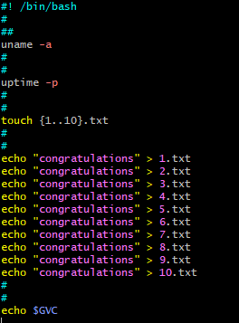

Pushing the script file to git repository

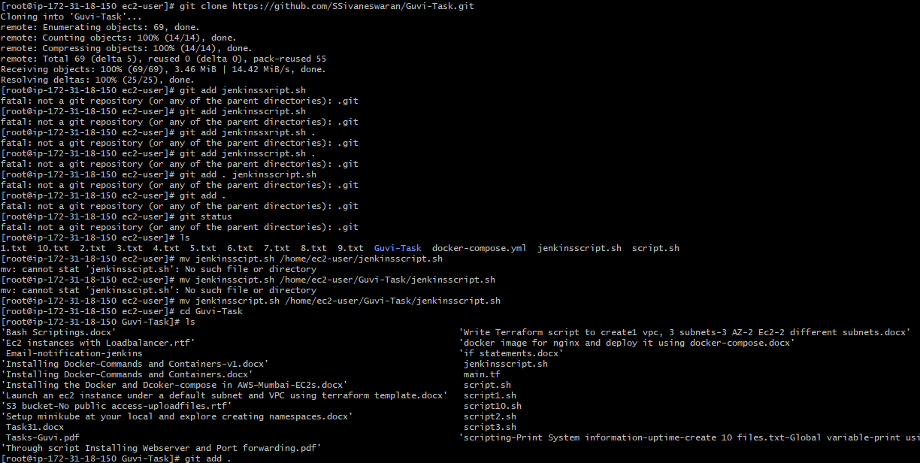

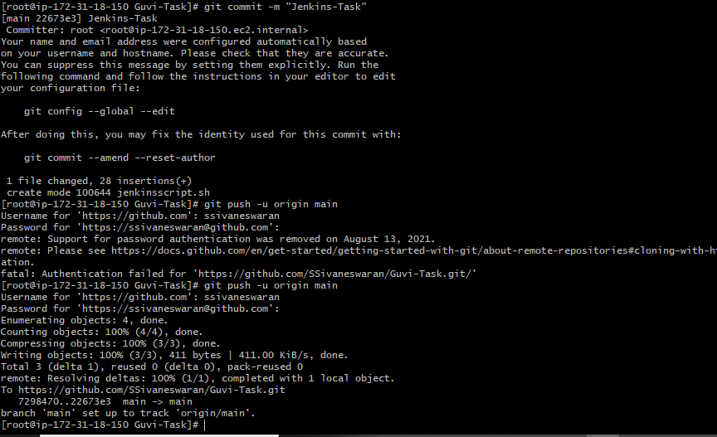

Configuring Jenkins and integrating the Githu repo to build automatically the script and triggering mail alert upon the successful completion.

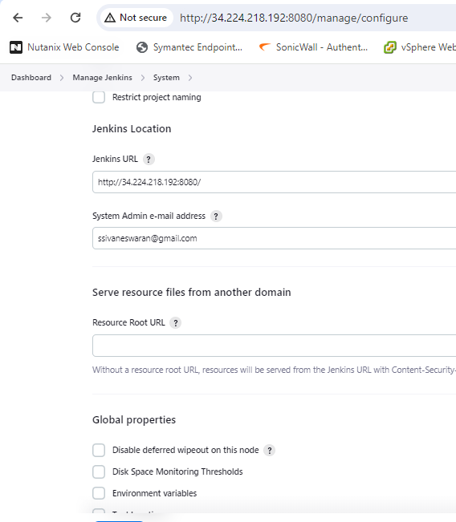

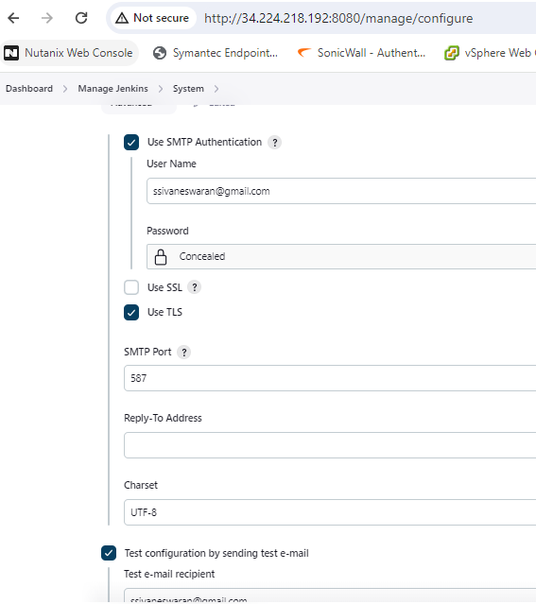

Jenkins Free style Project creation

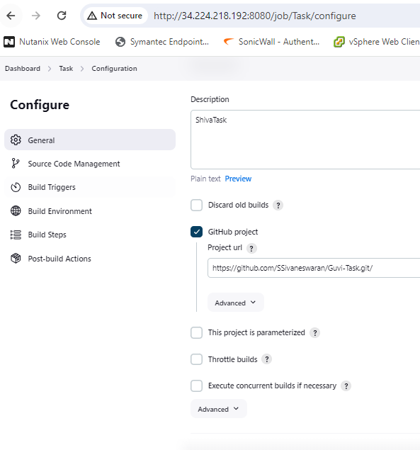

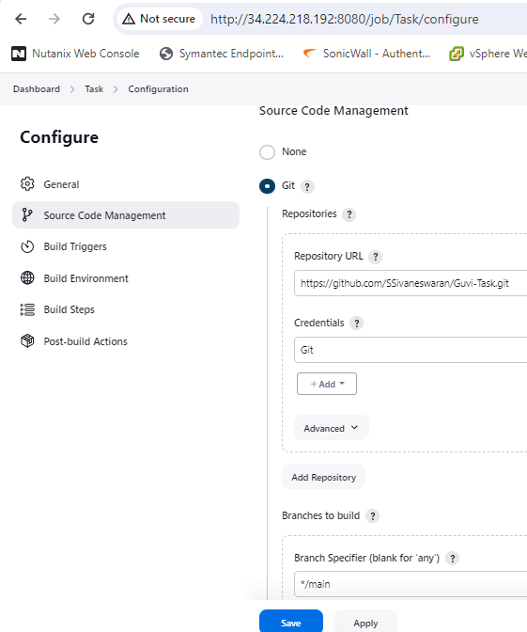

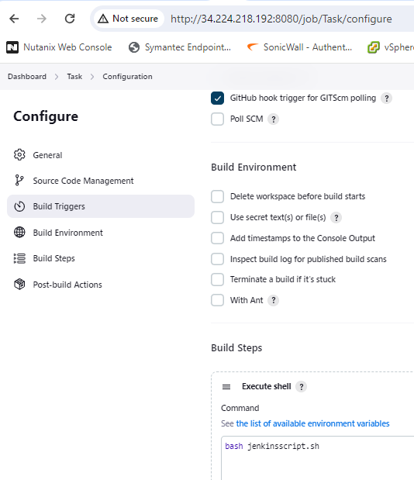

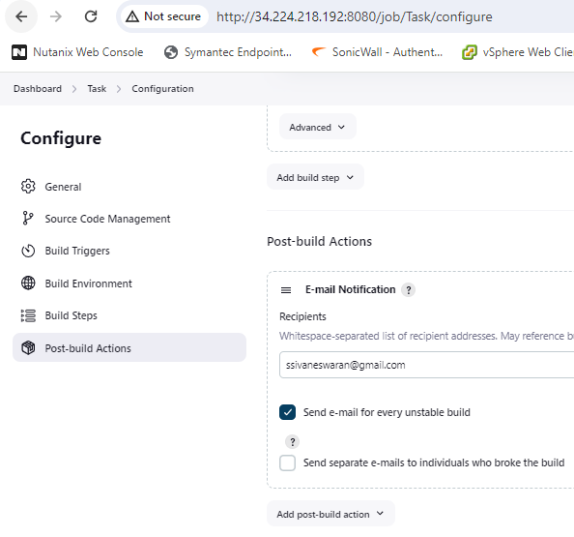

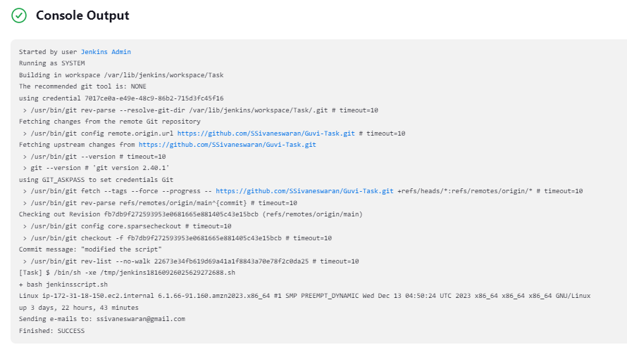

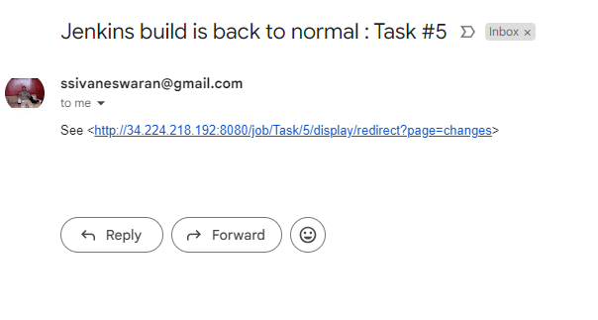

I changed the git repo name to check whether the email notifications are receiving properly if the build was unsuccessful.

I just changed the actual repo name \main to \master

I got the below alert so I conclude the email notification is working properly

