1. How to get IP address of a particular domain (guvi.in)

IP address of Guvi.in 🡺 172.67.70.207

There are three ways to get to know the IP address of a domain

A: Ping Command : ping guvi.in



B: Traceroute command : Traceroute guvi.in

C: Nslookup command: nslookup guvi.in

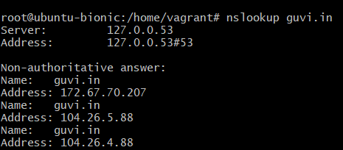

1. How do I find the CPU/memory usage of my server?

Command to see the usage of the CPU/Memory: vmstat

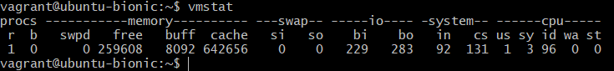

To check the memory usage: free (-m, -g)

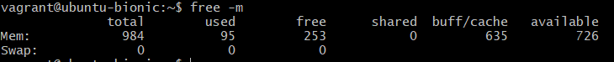

1. Test the connectivity between 2 nodes.

Command : ping “ipaddress of the second node”